YOU
VS
WALL
Blake Farrugia, Derek Petrtyl, Mohammad Rahmani, Mike Schanck
Version 0.32.0424
Table of Contents
Prologue - Design History
- Game Overview | 1
1.1 Game Concept | 2
1.2 Feature Set | 2
1.3 Genre | 3
1.4 Target Audience | 3
1.5 Game Flow Summary | 4
1.6 Look and Feel | 5
1.7 Project Scope | 5
- Gameplay & Mechanics | 7
2.1 Gameplay | 8
2.2 Screen Flow & Game Options | 9
2.3 Cheats and Easter Eggs | 9
- Story, Setting and Characters | 10
3.1 Story and Narrative | 11
3.2 Game World | 12
3.3 Characters | 12
- Level Layouts | 14
- Green Room | 15
- Alpha  - Beta  - Gamma  - Delta | 16  18  19  20
- Interface | 22
5.1 Control System | 23
5.2 Audio | 23
5.3 Help System | 23
- Artificial Intelligence | 24
- Enemy AI | 25
- Technical Specifications | 27
7.1 Target Hardware | 28
7.2 Development Hardware and Software | 28
7.3 Development Procedures and Standards | 28
7.4 Scripting Language | 29
- Game Art | 30
8.1 Concept Art | 31
8.3 Characters | 38
8.4 Environments | 41
- Secondary Software | 43
9.1 Content Creation | 44
9.2 Additional Editors | 44
9.3 Source Control | 44
- Management | 45
10.1 Detailed Schedule | 46
10.2 Risk Analysis | 48
10.3 Test Plan | 48
- Appendices | 49
11.1 Asset List - Models | 50
11.2 Asset List – Sound | 60

Design History
1-20-11: Began design document/development.
2-12-11: Design Milestone: Base Alpha map is completed, with no major changes happening before the alpha is to be presented.
2-14-11: Design problem: Custom models not affixing to UDK framework. Some models need to be redone for beta version.
2-22-11: CLASS MILESTONE: Alpha displayed to class. Unofficially wins Best in Show.
3-2-11: A lot of work happened. It was all pretty tedious.
3-30-11: Displaying beta. So many people love it.
4-1-11: Gather ideas for ending and new traps.
4-2-11 to 4-21-11: Complete beta levels, bonus level, final level and ending, and much more.
4-22-11: Gold release.
4-24-11: Final Documentation Changes.

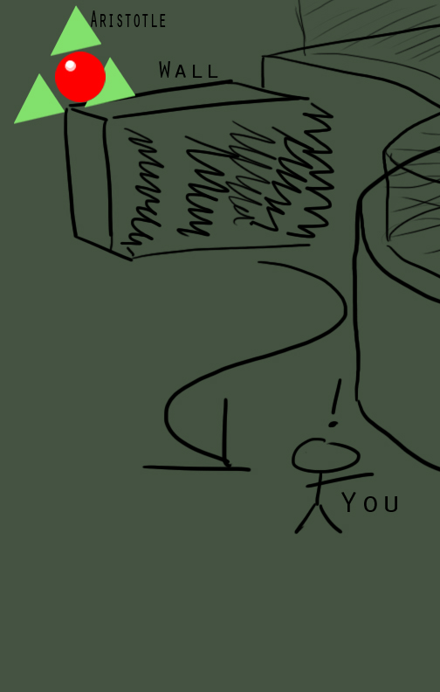
- Game Overview

  - Game Concept
Unreal was pioneered in the first-person shooter days of power that was the 1990s. Over a period that stretched well into the new millennium, Epic Games released new iterations of their Unreal Engine with standard FPS clones of their original success, with a penchant for focusing more on multiplayer than on singleplayer attitudes. With that in mind, it was the goal to create an idea or modification (“mod”) of the game that used the graphical capabilities of the Unreal 3 Engine while adding strictly singleplayer aesthetics to the field. You Vs Wall was the end-result of that brainstorm.
You Vs Wall takes the standard FPS camera view and juxtaposes it to a run-or-die mentality. The main concept is fairly simple: A giant wall approaches the player from behind, and the player must reach the end of the linear level. Touching the wall or other instant-death items that litter the environment will cause the player to return to their starting position, thus resetting the entire level. Concepts of trial-and-error as well as speed and agility are heavily emphasized to the player.
As the wall chasing the player, the Crusher, is for all intents and purposes part of the background environment, platforms, traps, and puzzles add to the challenge for the player from reaching point B from A. This is the standard concept behind the modification You Vs Wall, and characters and storyline are detailed further within this design document.
  - Feature Set
The list of features that You Vs Wall adds to the Unreal 3 Engine could be considered by many as “yesteryear” concepts, but the team considers these older concepts as highly valid building blocks to successful game design. Mainly, the design of consistent replayable death towards the player through variable high difficulties was aimed for, and was dubbed successful.
Here is a list of the design features that were necessary for the base design of the game:
- Wall with variable speeds to increase tension on the player
- Environmental steps that working collusion with the Wall to trap and stress the player
- Pits in each section that will kill the player when jumps are not completed or puzzles are incorrectly solved
- Static and Dynamic Platforms, each with specific conditions for use
- Differing speed and damage effects for Dynamic Platforms
- Set-in-stone conclusion that if the player does nothing, they will die
As the team was put together, other ideas made their way into the design that only differed slightly from original plans so scope was still within reasonable limits. Additional testing from classmates and friends during the alpha and beta tests also gave us additional ideas to incorporate, such as:
- Timed spike traps
- Rotating platforms
- Projectile-launching spaces
- Custom Models
- Custom Textures
- Projectile turrets
- Trap doors
- Gears of death
- Various gear related puzzles and traps
- Land Mines
- Secret Room
- Ending
- Checkpoints

  - Genre
You Vs Wall extends upon the first-person genre while removing a key concept first thought mostly viable for the genre, “shooter”. As a game of speed-runs, delicate timing, and puzzle engineering, the genre You Vs Wall comes to be known as is “first-person platformer”, as it shares many similarities with such high caliber platformers as Kid Chameleon, Prince of Persia, and Crash Bandicoot.
  - Target Audience
The subject matter that You Vs Wall delves into is not for those under the age of 14. As such, the target audience, or more likely the group of individuals who would be able to understand the game in a fitting way, is aimed at 14-30 year old males. As many of the concepts implemented in You Vs Wall do not necessarily “reinvent the wheel”, any lover of platforming games can enjoy You Vs Wall.
The humor in the game is very clean, and as such can entertain a number of different age groups with underlying sarcasm and layered humor.

  - Game Flow Summary
The game uses the default UDK menus and user interface; it was decided that we would be more effective spending all of our time on directly building the game levels and content, as opposed to sacrificing much of that to reverse engineer menus and HUD screens and replace them with our own.
You vs. Wall has the following level layout:

While most of the levels are linear, Gamma has two possible endings depending on where the player goes. A branch of the level out of most players’ fields of view leads to the true ending in Delta:

The player is transitioned throughout each level via Player Capsules situated around the game show. These Capsules transport the player through each new section of the game show until the very end. The capsule will be revealed in detail when explaining each custom model.

  - Look and Feel
The game is comprised of cold futuristic elements. Lights create no real warmth while the metallic clanking of the floor surfaces provide most ambient noise. Combined with the revving engine of the Wall of Death behind the player proves to be an unfeeling and uncaring environment.
All of this is the internal environment of the Trench that holds the Crusher. Along the environment, multiple devices that are used to either inhibit or enhance the player are mechanical, although functional. This drives the feeling that the player is alone.
The only bits of humor that the player may find difference from the cold environment are humor from Aristotle, Socrates, and the Safety Wizard. Aristotle’s musings border on silly while the Safety Wizard posters include “helpful” tips on trying to survive. Each is normally against the player, but both provide a bit of hope to the world of complete cynicism that is You Vs Wall.
All of this is juxtaposed to the environment portrayed outside. Clear blue sky with green fields along the edges of the Trench. Most of the time, the player will never see this, usually due to performance constraints on school computers.
  - Project Scope

Number of Locations – 1
The Tuskulka Prison is the setting of our game show. It is also a place for death row inmates to spend their last days, either sent for execution in the vast acid vats or try their hand at You Vs Wall. It has been many a year since the show had to actually force prisoners to play.
Number of Levels – 2, (5 planned)
- Green Room – (Starting area) Area where much of the backstory is told to the player via Aristotle and posters along the wall. No gameplay, just fancy looking items.
- Alpha Level (Tutorial area) – Level thrown into the mix and billed as a tutorial level for beginners. It is everything but. There are 4 sections: Pit, Lava, Maze, Acid. It has been labeled as very difficult.
- Beta – (Beginning of main game) 4 sections – collapsing bridge, spinning gears, maze, and an ending zone situated over a pit.
- Gamma –A large mound switches the course from uphill to downhill, with a sliding pit as the main attraction of death. The sections of this level include running through a spike field, timing your jump properly through a wall that has few openings, climbing up spinning gears, navigating a platform field then a mine field, then jumping while dodging turret projectiles, finally you must navigate through a set of trapdoors which may drop or throw you.
- Secret Endings – (Play the game to find out) – ITS A SECRET.
Number of NPCs – 3
Aristotle and Socrates are NPCs in the vaguest sense of the label. Aristotle’s grim vernacular and great delivery seemingly brings out the best in the game. Without him, YVW is just a very violent obstacle course.
In addition to the two voiceover characters, there are several active turrets on the last two levels that actively target the player. While not characters per se, they directly interact with the player.
Number of Custom Models – 38
Number of Custom Materials – 180
Number of Custom Sounds - 92
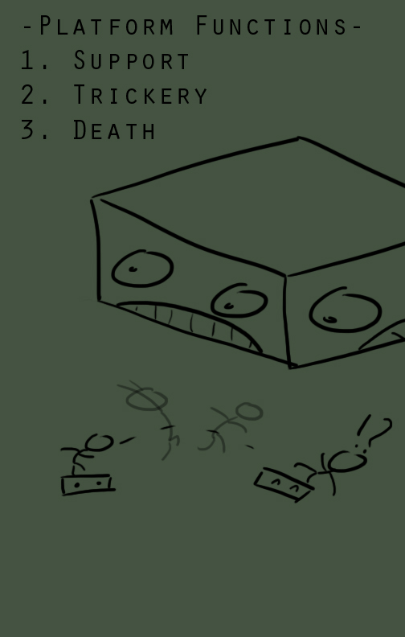
- Gameplay and Mechanics

  - Gameplay and Mechanics
You Vs Wall pits the player against a timed, track-set machine of death named The Crusher that advances towards the player in a long hallway. The only way to escape death is to keep moving forward on the differing platforms that make up the level. These platforms can have differing attributes such as spikes, fire, slickness, and elasticity. The player will have to run and jump when necessary as well as collect keys or press buttons to advance through any locked areas that may block the player’s path.
The Crusher is a massive killing contraption. A large base wall had been constructed for the games original show format as a spiked wall. The sides of this wall house large wheels with spikes on them which serve as the guiding rails for the walls movement. This model has been recently reintroduced due to popular demand of fans. There is not popular advertising placed onto the wall at this time.
General map flow is set in a plane of grass. Cut into this picturesque scene is a long manmade trench that acts as the roam-able portion of the map. The trench is lined with metal, with no visible exits. At the start of the map is the Crusher, and in front of the Crusher by 20-30 ft will be the player. The trench is massive in width to house the Crusher, and this space is used by the level designer to create an adequate platforming arena with which to slow down the player, raising the chance of killing him.
Platforms are specific blocks that connect or act separate from one another to build the entire path of the level. Some platforms are special in their attributes and these can be used against the player in any way. Spikes or miniature crushers can be used as traps to kill the player by surprise, as there is no meaning to the word cheap in this world. This, along with the Crusher, keeps the pace of the game fast and allows for multiple retries.
Physically, gameplay is the same as the real world, with the exception of two oddities. The first is that the player can double jump; this ability is granted through his prison suit as a kind of handicap for use in the YVW gameshow. The second, though unseen to the player, is regenerating health. This was originally implemented for fire platforms in the gamma level and was kept to level the playing field in the turret areas of gamma and delta. When not being directly hit, the player regains health at a rate of one hit point per second, up to a maximum of 100 points.
The protagonist is silent, but can interact with the environment with the Use key. This activates such features as doors, walls, and buttons in the map.

  - Screen Flow & Game Options
There are no interface screens or menu screens to You Vs Wall. At game start, the player is thrust into Green Room, or whichever map currently being tested. Level transitions will propel the game through the entire level sequence. The game in itself can be completed relatively easily and does not require onscreen interface to be enjoyed properly. They just get in the way.
Since there are no menu screens, no options can be edited for You Vs Wall. For these purposes of demoing/university studies, You Vs Wall was meticulously calculated to run on Game Lab machines that comply with UDK requirement aspects as of January 2011.
  - Cheats and Easter Eggs
- Cheating has been disabled by enabling the games Cinematic Mode. This mode also removes weapons, HUD, and all other items of disinterest to the game.
- Easter Eggs find their way along the player’s path in the form of Hello Kitty, Wizard Jer references, Safety Wizard phrases, and direct commentary by Aristotle. There are also a few friendly jabs at the game’s competitor, Death from Above.
- There is a secret room level for those who can find it.

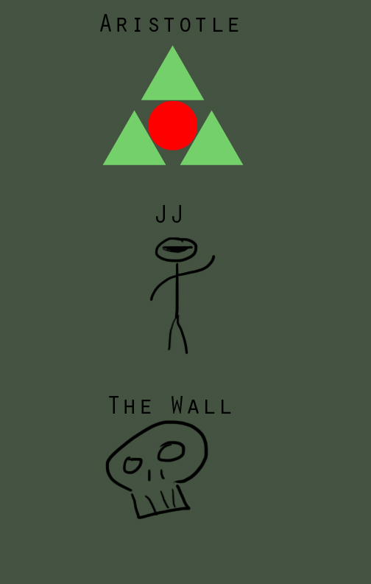
- Story, Setting, and Character

  - Story and Narrative
In 2107, the game show You Vs. Wall became an international hit. Ratings pouring into the show that seemingly let the world put down its problems, and focus on the problems of one man. Families came together, religions put down most of their squabbles, and bets were made on the sport, and in some rare cases, quarters of entire countries GDP stemmed from a season of the show. The show has woven itself into the zeitgeist of most developed nations, and it has plans for a spin-off in the not too distant future.
The game has been reviewed as a “sadistic and cruel misrepresentation of entertainment, values, and shifting cultural acceptance to capital punishment,” as well as “ranking among the worst crimes of humanity,” by lesser nations and human rights groups, but these are all swept under the table for more trusted, sponsored TV critic reviews such as, “Intelligent for you and for the world,” as well as “the most fun you can have with a death row inmate from the comfort of your own home”. The show generates so much in revenue, its hard to not place it in almost every view screen across the world.
But why all the fuss? The format of the show is extremely simple, albeit horrifically morbid: a man on death row enters the show and will be killed by a giant grinding war machine if he does not move forward through the obstacles put forth by the shows designer, chief architect, and announcer extraordinaire, Aristotle. The show is based in Tuskulka Penitentiary where a multibillion dollar obstacle course has been created using the best technology available (A plus of mostly world peace is a skyrocketing technological boost). Some people take offense at the idea, but it sells well enough.
Prisoner JJ6942 is next on the chopping block. Only prison ID tags are shown to the viewers. Crimes or any other personal information is masked. The contestants are chosen by secret lottery at random. All of this is controlled through Aristotles masterful algorithms.
“JJ” only vaguely remembers being brought into the prison from the hospital ward. He was told by Aristotle that he managed to injure himself getting off the transport ship. Head slightly throbbing, body fairly numb, JJ was given some morphine from an automated medical system and shuffled towards a large gate. Aristotle yells through the prison PA system that taping is about to commence. “We need the star. You want your freedom. Lets make a deal?”
The sun shines brightly onto the wafting grass below. Slashed into grassy topsoil lies a large, almost otherworldly metallic carving into the ground that stretches for miles. JJ steps off a connection bridge onto a platform in the middle of this metal trench. To his right sits one of the most popular entertainment pieces in the world, as well as the most brutal killing machines on this planet. JJs clasps are then released from his arms and feet. As he tosses them onto the connection bridge, the weight shifts and the bridge begins to recede revealing a deep pit below him. A voice coughs into the microphone. After clearing his throat, red lights that line the manmade inlet shift from red to green. The voice bellows, “Well hell-o everyone! This is your favorite announcer Aristotle here wondering … Whos ready to win some FREEDOM!?”
  - Game World
Not much is seen of the setting, Tuskulka Penitentiary. All that is known is that it is based somewhere in North America. The rest of the game takes place is separate rooms or areas that consist of recreational areas and the actual gameshow.
The Trench is a deep pit carved into wide fields and interspersed with traps that differ each week of the show. Sometimes, different trenches are switched around by way of Capsules that transport the player. This provides entertainment value for the fans and a bit of extra difficulty for the players, as they are unaware of what traps will be in store for them.
  - Characters
- Prisoner JJ6942 – tied to the first person perspective of this death row inmate, little is told about the antiheros crimes or past. The story is not about him, but his journey of face the Wall. Goes by “JJ” for short. General gray prisoner garb with a large black visor on his helmet. His ID is printed on the helmet for easy identification.

- Aristotle – The disembodied voice that goads JJ across the map. Aristotle is a caricature of common game show hosts: loud voice, pleasing tone, and able to rile up the crowd with his wit and humor. The outline of his skull is only seen with a large cowlick running upwards. No discerning features can be defined, only a large green question mark that masks everything. He wears a checkerboard sports coat with overly large shoulder pads and beige pants. His legs curve together as his figure moves closer to his feet. Aristotle is labeled as the chief designer and announcer of the show.

- Socrates – Aristotle’s predecessor on the show, Socrates has been all but retired and only runs the course when Aristotle is offline for maintenance or is otherwise engaged in something more important. He tends to be more sympathetic to the player than his counterpart, and toward the end actively encourages the player to escape. His silhouette is shown similar to Aristotle, but with a blue pentagon replacing Aristotle’s green triangle.

- The Safety Wizard – A caricature posted throughout the courses of You Vs Wall to inform the player of helpful tips when crossing the tracks. However, much of his information is derelict and unhelpful, usually to the point of basic common sense. Aristotle has admitted that while he does not think the Safety Wizard is helpful, he boosts ratings.
The objects below are not players, but their background should help understand the look and feel of the modification we are trying to produce.
- The Crusher – From the official website: “Recreated from an experience Aristotle had at a butchering warehouse, the design of the Crusher has become a world-wide cultural icon.” The base is a kind of shelf holding four large pillars. The columns from top to bottom are spikes, blades, spiked maces, and the dreaded gear. They cover the width expanse of the trench and cannot be escaped unless the finish line is reached.

- The Eye – A monolithic wall black as coal that shines against the sun with a large red bulbous sphere in its middle. The Eye targets the player and, after a set interval, shoots the player with a death ray. The player can be any place on the map and still be shot by the death ray unless the Eyes view of the player is blocked off.
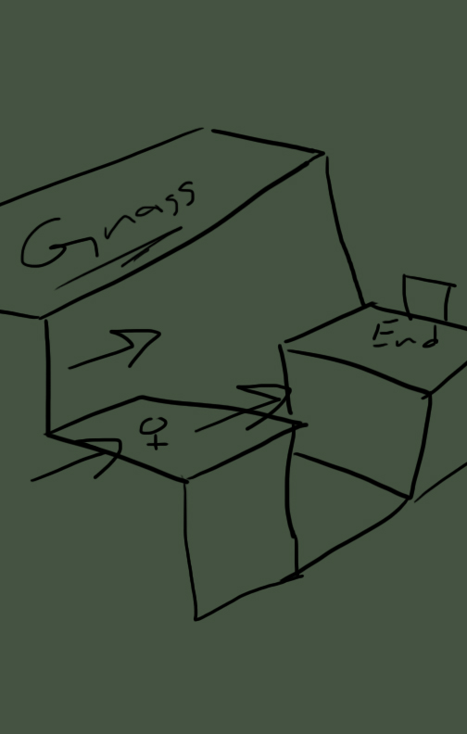
- Levels

  - Green room (Tutorial)
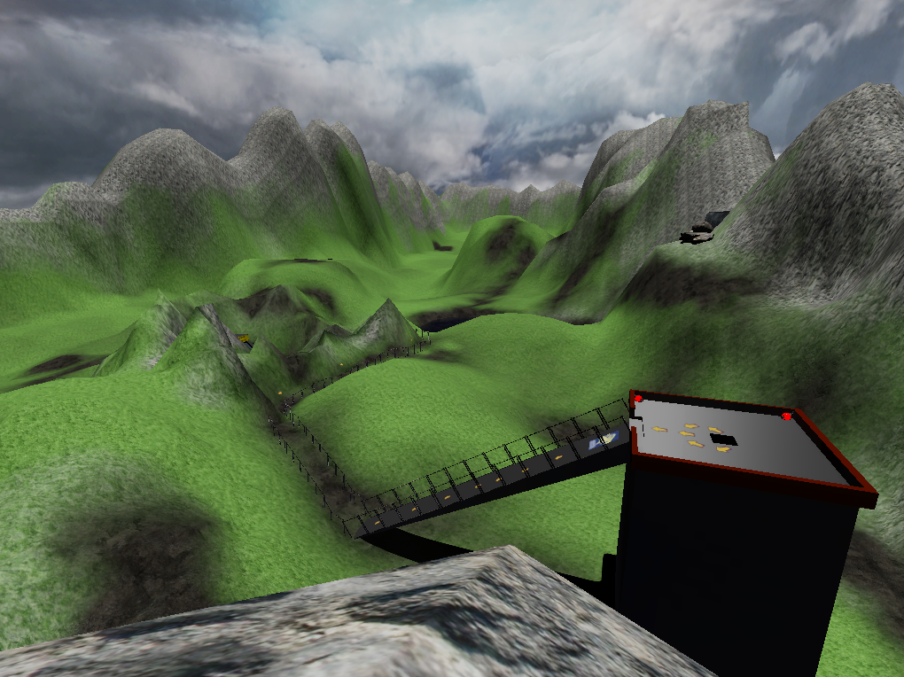
The green room is a very basic tutorial level designed to ease the player into the more difficult courses, and also to introduce the main character and story. Aristotle, Socrates, and the Safety Wizard all make an appearance; the wall, however, does not.
Players spawn in a very basic room with only one way out. There are no immediate ways the player can die, with the exception of an elevator that can crush the player, and an electric fence that they are warned not to approach. This was done by design so players can get used to the movement and controls of the game before being forced to use those skills under time pressure from the wall. In the event that the player does manage to get themself killed, however, Aristotle will respond with particularly annoyance at the ineptitude shown by a prisoner being killed before even entering the actual game.

  - Alpha Level
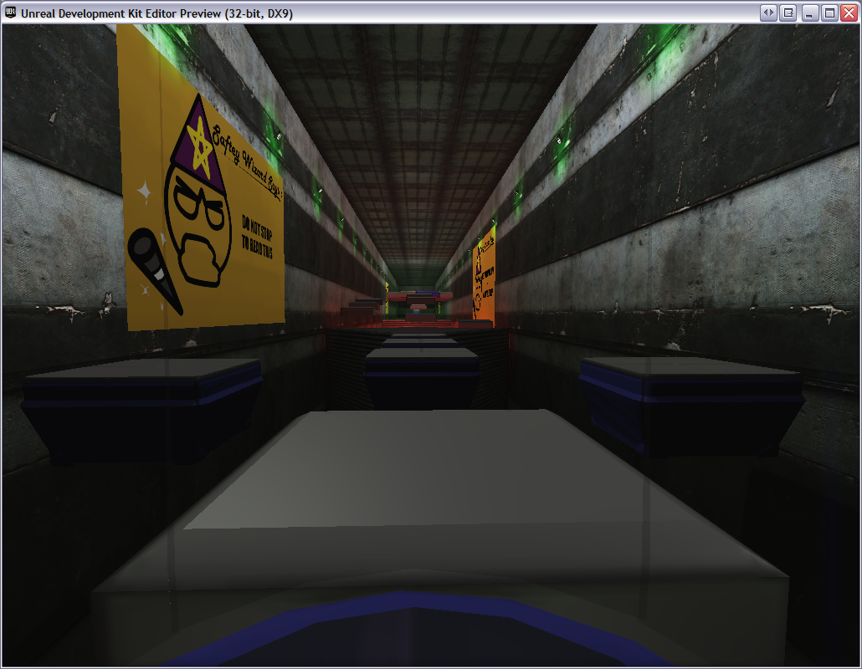
Alpha provides the first set of obstacles the player must face, and places a particular focus on speedy progress. It has one of the most aggressive wall speeds out of the levels, forcing players to take very quick jumps without pausing to consider. By contrast, most of the jumps are fairly simple; there are only two moving platforms in the entire area.
Upon spawning, the player finds themselves in a dark area. Aristotle begins speaking over the loudspeaker introducing the player to the “tutorial” level. The player is moved out of the small dark area to the area beneath the starting platform. Players are given a basic set of instructions, then the game begins.
The map is split into different sections:
- Pit – A large area with several platforms over it for traversing. Each platform is disconnected.
- Lava Pit – Area with several stairs leading up to a large floor of static platforms. At the end of this floor is a small jump to another platform, followed by a large leap to the next section.
- Maze – A zig-zag maze is created when walls fly up from the ground. The player must traverse it while the wall slows to a crawl and follows behind. Holes are in the floor, so the player must be cautious.
- Acid Vat – A large vat of acid with several platforms over it. All are disconnected and must be jumped to. There is a long bridge platform that stretches to the end of the game. There is a string of spike traps that are triggered on this.
At the conclusion, the player opens a door with a trigger and enters a small room. Aristotle is seen on a monitor and tells the player congratulations and to get ready for the actual course.

  - Beta Level
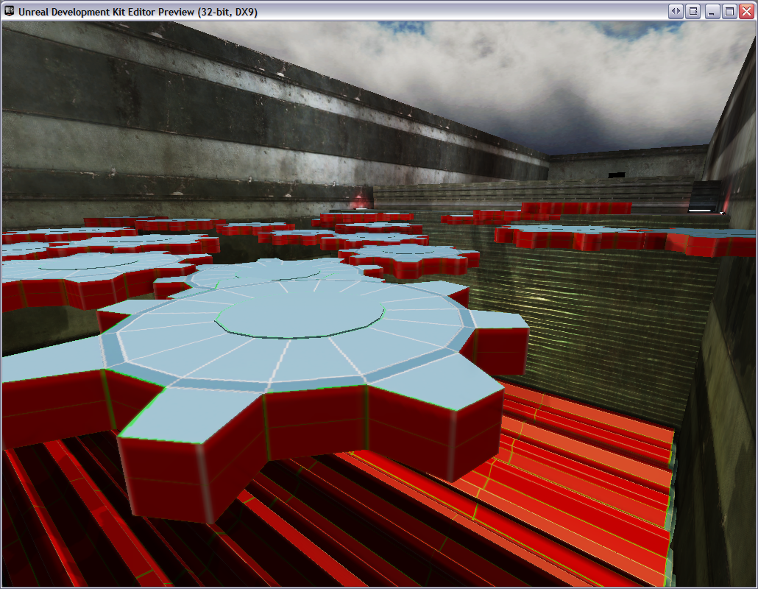
Beta level ramps up the difficulty level of the jumps the player has to perform by adding a variety of moving obstacles. These range from dynamic platforms and hidden spikes to quickly spinning gears.
Upon spawning, the player finds themselves in a dark area, and Aristotle begins speaking over the loudspeaker introducing the player to the level. The player is moved out of the small dark area to the area beneath the starting platform and the game begins.
The map is a combination of areas featured in Alpha with several added features:
- Pits – A small pit area over the starting area. It is a very easy area to cross.
- Acid Vat – A bridge is seemingly placed over the vat, but as the player gets close, the bridge drops leaving two platforms. The platforms zig-zag across the area in different directions.
- Gears – A large pit with many gears at the bottom that will crush the player. Above, many gears with varying speeds of rotation act as platforms.
- Maze – Two mazes that are mirrors of each other with varying trap placements. One side has many spikes, the other has many Stompers.
- More Pit – A large hole above the ground with a platform raising and descending to the empty pit. Another platform circles around and one must use both of these to jump into the Capsule.

  - Gamma level
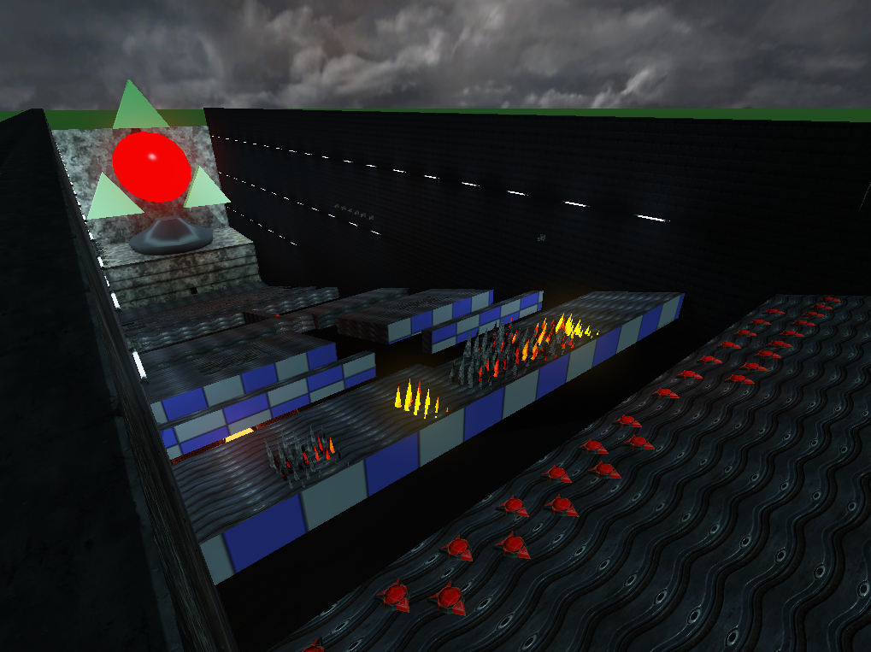
The gamma level is a cumulative test of all the obstacles the player has had to face thus far, with a few new ones thrown in for good measure. In addition to dynamic platforms, spikes, and gears, it also features the addition of live land mines and turrets that can knock the player off course, or kill them directly.
Players spawn on an elevated platform above a rising maze of flaming spikes, and must run through the spikes before the wall can catch up to them. New to this level is a checkpoint system, which allows players to save their progress at various points in the level. There are two checkpoints: one at the ending of the spike section, and another just prior to ending finale, which is arguably the most difficult point in the game. Given the length of the level, checkpoints were a must for players to have any sort of fair chance to finish the level.
The game play in the level sections is differentiated by the instances of the wall used. The first area uses a spike wall; the second section of the level uses the same rolling gear that was used in the beta level, before bringing up the spikes wall again in the final area.
Also new to the level are elevation changes to add a bit of visual interest and variation to the gameplay. The beginning and ending sections are marked by long ramps, while the middle contains a variety of increasingly difficult jumps between static platforms of varying height.
  - Delta Level (secret)
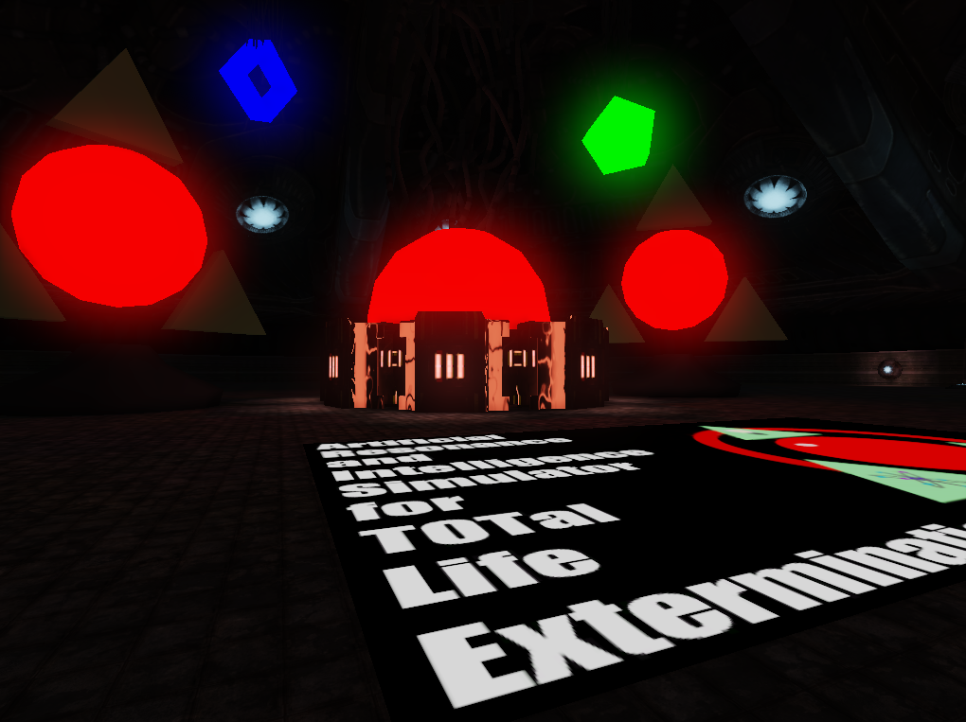
Significant changes occurred in the secret level dubbed Delta. The storyline called for the level Gamma to kill off the player, no matter what path they took to reach the end. It seemed to be too nasty of a gesture towards the player, who had played thus far successfully to reach the supposed end of the game. A secret entrance to the Delta level was placed in Gamma, a maintenance tunnel that circuitously leads to Aristotle's inner sanctum.
The game starts with a warning to the player as they face writing on the back of their entrance. Aristotle and Socrates begin to speak, trying to find the player, who can unwittingly hear them through his helmet microphone. As the player enters the first room, his first image is of the Safety Wizard beckoning them to "take a leap of faith" into a large pit. The pit has acid at the bottom, and kills the player if they make this choice. Gears run along the sides and lead to the next floor that is a circular pathway around the main room. The gears have general kill triggers that would work in cases where if a player were standing, it would be believable if they died by being crushed in such places. Once the top of the room is reached, the players round a corner and trigger a checkpoint. Going further triggers the alarm system as well as the first turret.
Three holes are in the roof of the maintenance room. As the player makes their way across the path and passing the gear obstacles that lie on each face of the room, two more turrets lower from the roof and fire upon the player. The timings of each bullet make for varied or linear projectile-firing. After clearing the last gear obstacle, the player presses a button at the end of a hallway, opening the door, and rides an elevator to the next floor. A checkpoint is gained, several more doors and buttons are found, and then the player meets Aristotle.
Aristotle is billed as the chief creator and architect, wherein he is actually an AI construct programmed to run the facility. Humans are gone, for whatever reason, but violence is not alluded to as being the main culprit. Aristotle starts off friendly, and then motions to a capsule that will supposedly take the player to a safe zone. They are actually taken to another room that was apparently used for storage for the game. A wall lowers and the Eye is shown. After some lights and alarm sounds go off, the Eye will fire 2 rockets at the player. The player must use the pillars along the Eye's sides to get to the top where an exit is shown.
After a short speech from Socrates and introduction from Plato, the player leaves and is teleported to the credits room, a square room with textures that list all creative credits for the game.
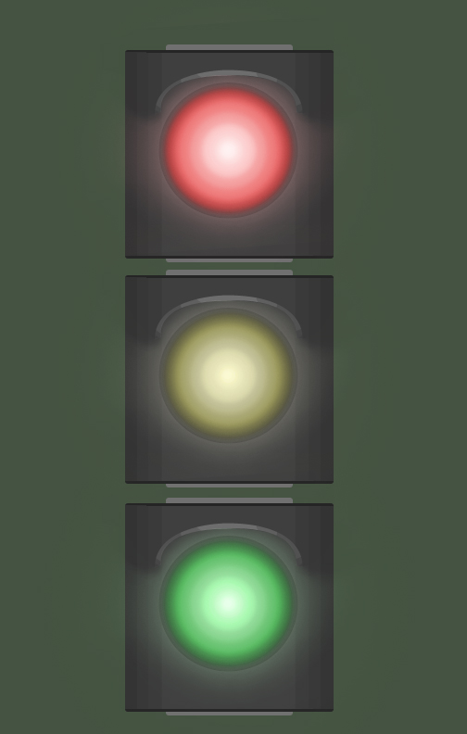
- Interface

  - Control System
The control system for the game follows standard first person archetypes set in many of the “twitch shooters” that litter the market today. These are as follows:
Forward – W
Back – S
Strafe Left –A
Strafe Right – D
Jump – Space or Mouse 2
Double Jump – Double Space
As for HUD-based controls and appearance, there are none. The HUD has been removed from game as well as menus and all other items that interfere with gameplay; nearly all threats to the player result in instant death, negating the need for a health bar. Removing the HUD provides a cleaner interface for the player, since there is nothing blocking the player’s view of the various obstacles.
  - Audio
All custom audio in You Vs Wall is either triggered by Kismet to play on the death of the player, helpful tips that are triggered whenever the player meets a specific point in the game, and in sequence with Matinee animations with proper looping aspects.
Multiple sounds/animations that are already native to UDK are inside of the game already. These are used for demonstration purposes and will not be sold or profited upon in anyway.
  - Help System
The entire help system, disregarding Aristotle’s voice, is the patented Safety Wizard approach. Using posters, the Safety Wizard guides players with reminders of certain aspects of gameplay.
- Artificial Intelligence

  - Enemy AI
The main enemy of the game is Aristotle, but he does not legitimately control the entire game area. The obstacle course and the Crusher are the main enemies of the game. The timings, traps, and layout all form into one singular enemy. Aristotle will always goad the player, but never increase difficulty.
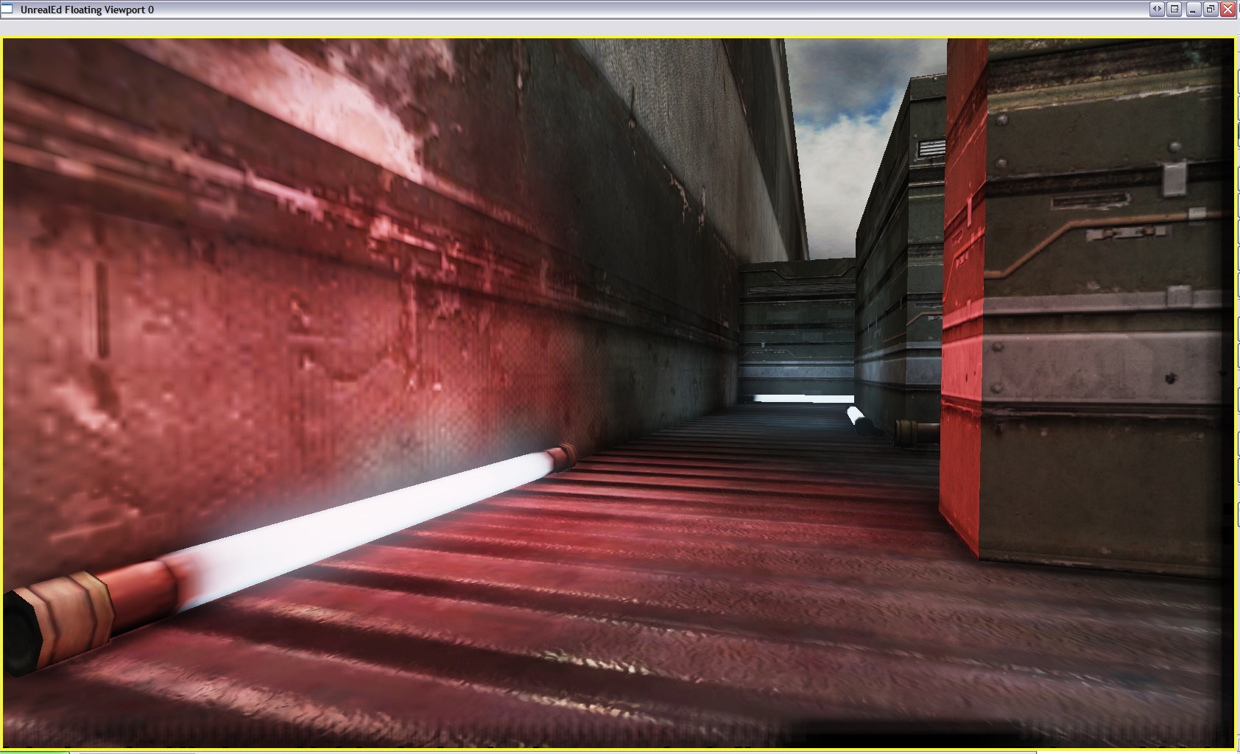
This goes for the Crusher as well. The Crusher is tied to distinct points on the map for ease of coding. No UnrealScript was able to be made in a timely enough fashion to try and make the map more dynamic.
In the final “secret” level (Delta), there is also a set of turrets that actively target the player and attempt to kill him. These are activated and controlled through Kismet scripts.
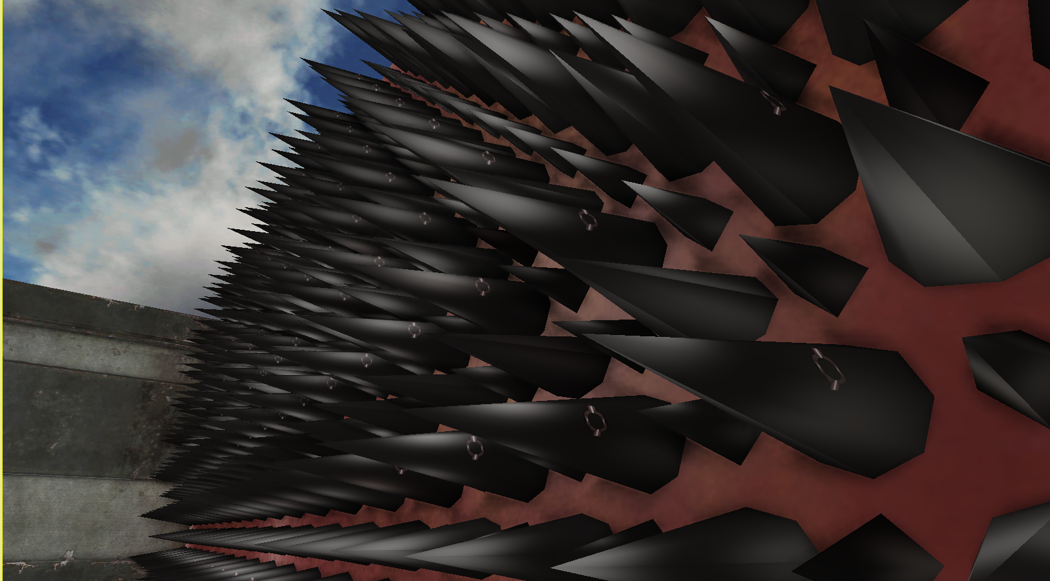
Turrets
The turrets were design features that were conceived during Beta development. Each turret is a scripted event usually grouped with other turrets to keep grouping and organization of sections. These levels are Gamma and Delta.
A turret is made of several physical items and multiple Kismet items. The physical items are as follows:
- Turret Static model
- Location to fire projectile from, usually next to turret
- Location to fire projectile at, usually attached to section, but can be attached to player
Gamma uses turrets heavily at the end of the level. Both a coordinated sequence of firing to set points on the map to a large amount of player-targeting turrets is put to use. In Delta, a scripted alarm sequence steadily increases difficulty with 3 strong turrets centralized in the starting room.
Turrets begin with either node attachment to the player or an activation trigger. What follows is Kismet gathering the location of the node and passing it to a fire projectile action, which fires a select class of projectile. After getting the location, the node also branches to a delay of set time whose out goes back to the location node, resetting the firing mechanism so that it may repeat.
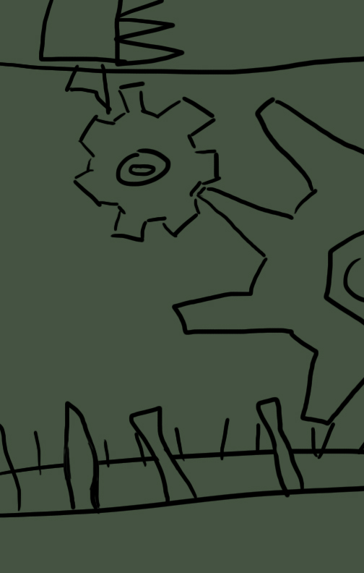
- Technical

  - Target Hardware
Target hardware for You Vs Wall follows standard requirements for the Unreal Development Kit. No large changes were made to hardware goals due to the lack of serious physics interpolation, graphics rendering, and particle usage.
  - Development HarDware and Software
Hardware
School development machines were Dell systems equipped with Intel Core 2 Duo processors and relatively powerful GeForce 8600 GTs.
Home machines were also used in development with slightly greater technical specifications than school development machines. A slightly used laptop was also used due to differences in work location and school location at times.
Software
UDK January 2011 Build
Photoshop CS (Student License)
3ds Max 2011 (Student License)
Audacity Sound Recorder (Freeware)
Visual Studio 2010 Professional
nFringe
UnCodex
Notepad++
Dropbox (Free with account)
  - Development Procedures and Standards
Team work begins with weekly meetings to decide on the weeks tasks and to review previous tasks. It is from here that a schedule is produced for the following week. The team then split to their assigned duties. A follow-up meeting was each Wednesday to show the progress and answer any follow-up questions that may still exist.
Work products like custom models and textures are created and then placed into Dropbox before being placed into the correct UPK. The UPK and all other changed materials are uploaded to Dropbox via a batch script. Before any of this happens, a batch script is run to take all new items and copy them to their respective directories. This way each member stays up to date with the others work.
This process is repeated en mass.
  - Scripting Language
The Unreal3 Engine used by UDK uses two forms of scripting:
- Kismet – A visual object-oriented scripting language per level that uses nodes and branches to do actual work. This is the majority of scripting in the game, and it shows with many scripted sequences.
- UnrealScript – A text-based script that is more similar to javascript and C++. This language controls all of the inner workings of the game engine and is what is modified to allow for extreme changes to game code.
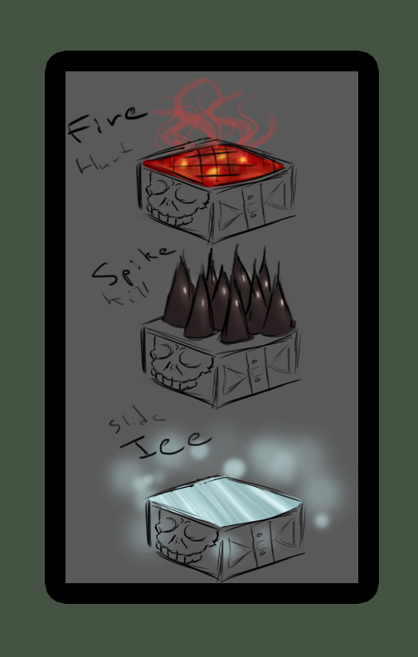
- Game Art

  - Concept Art
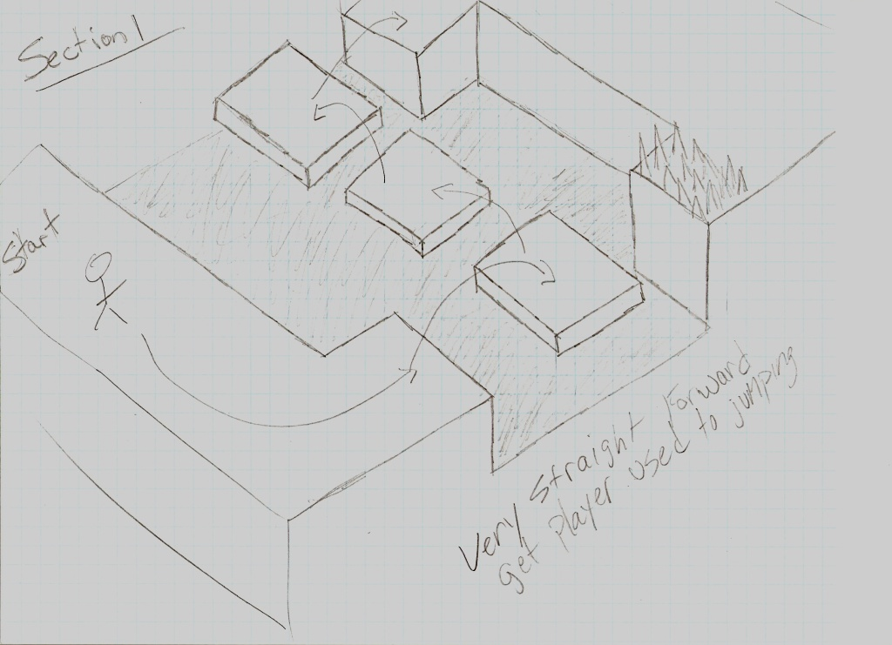
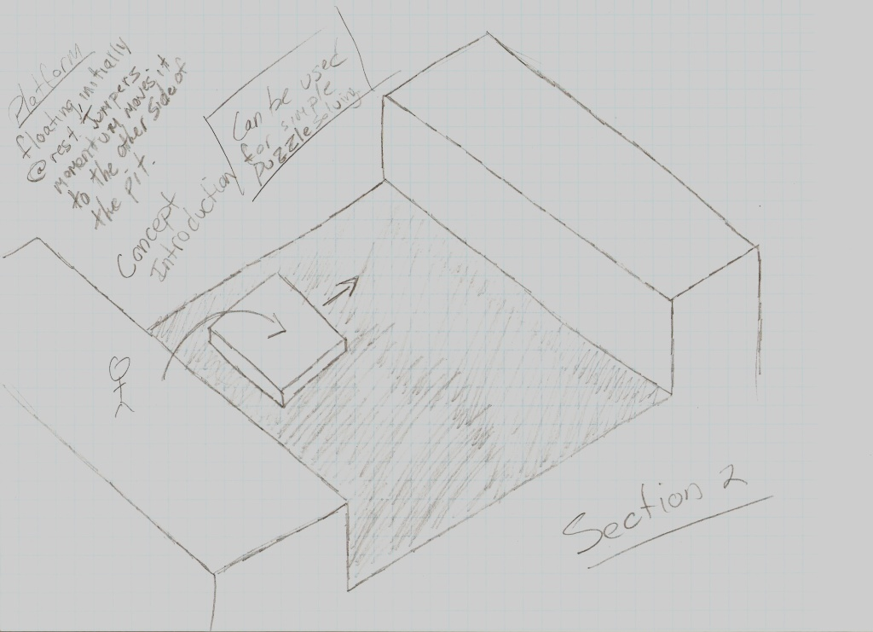
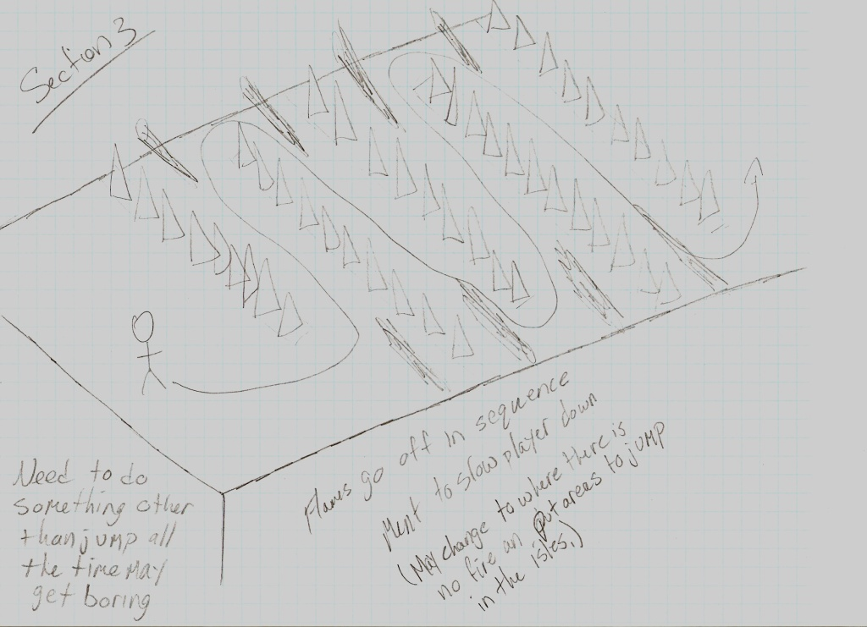
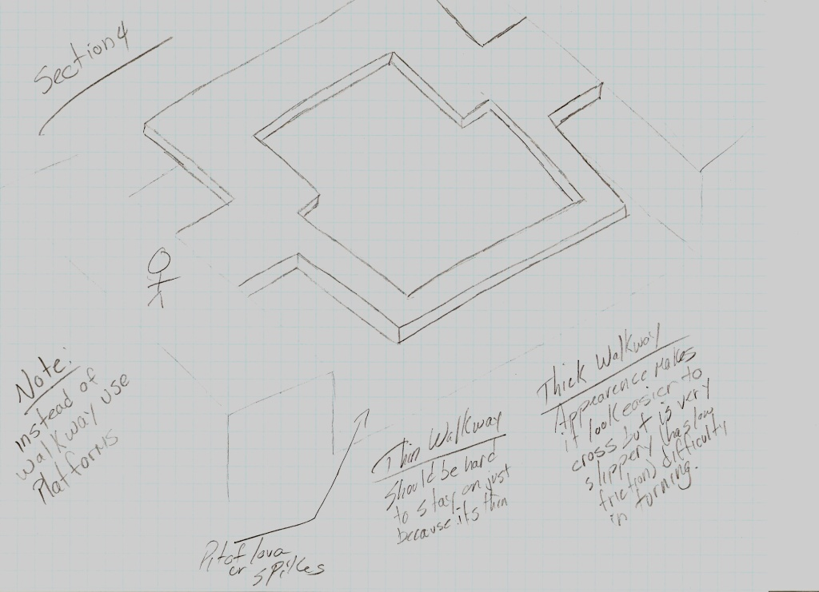
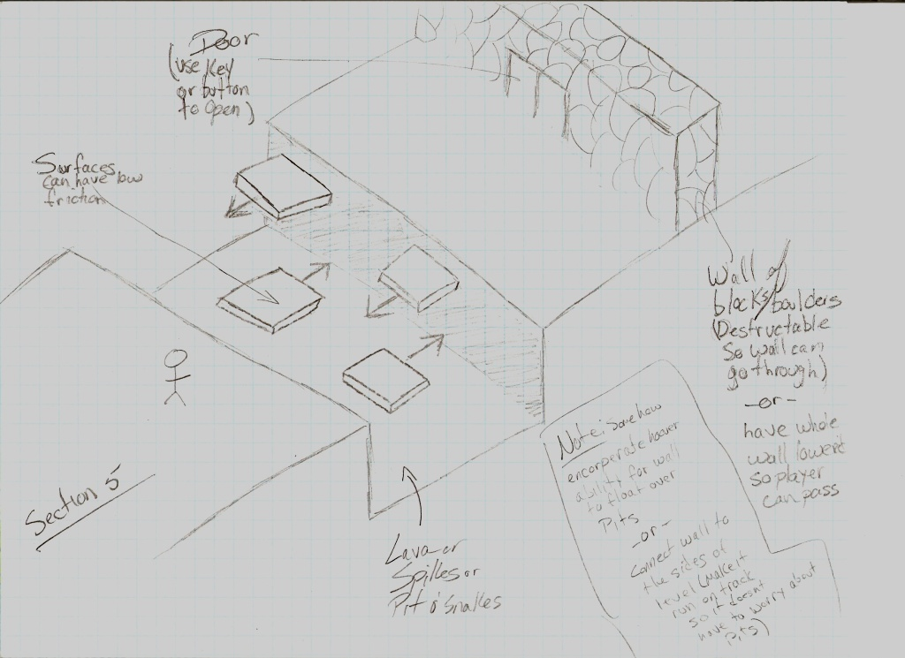
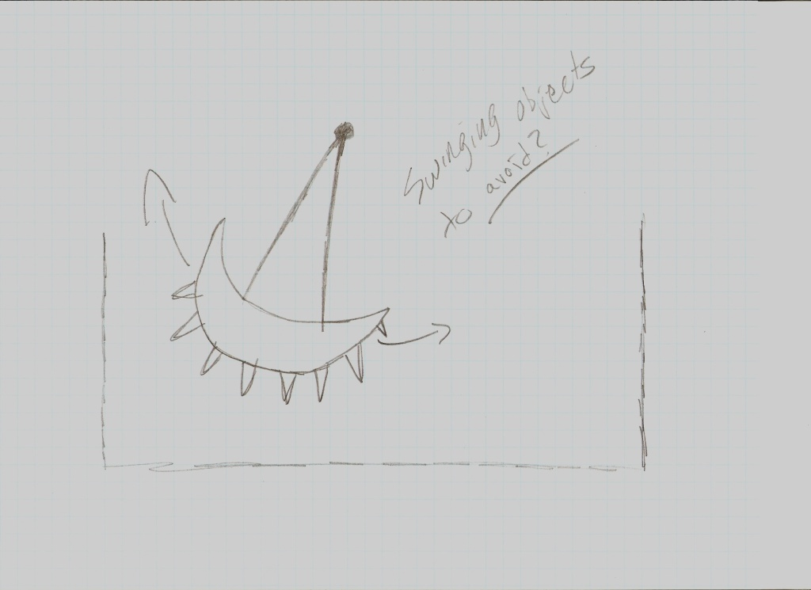

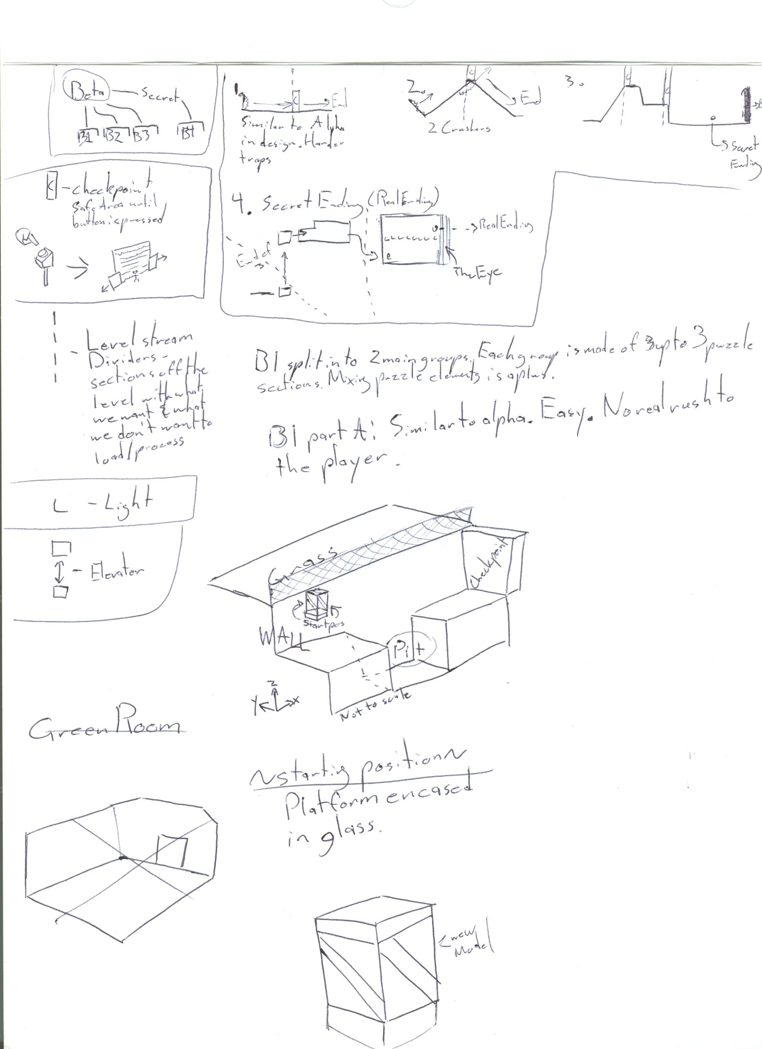
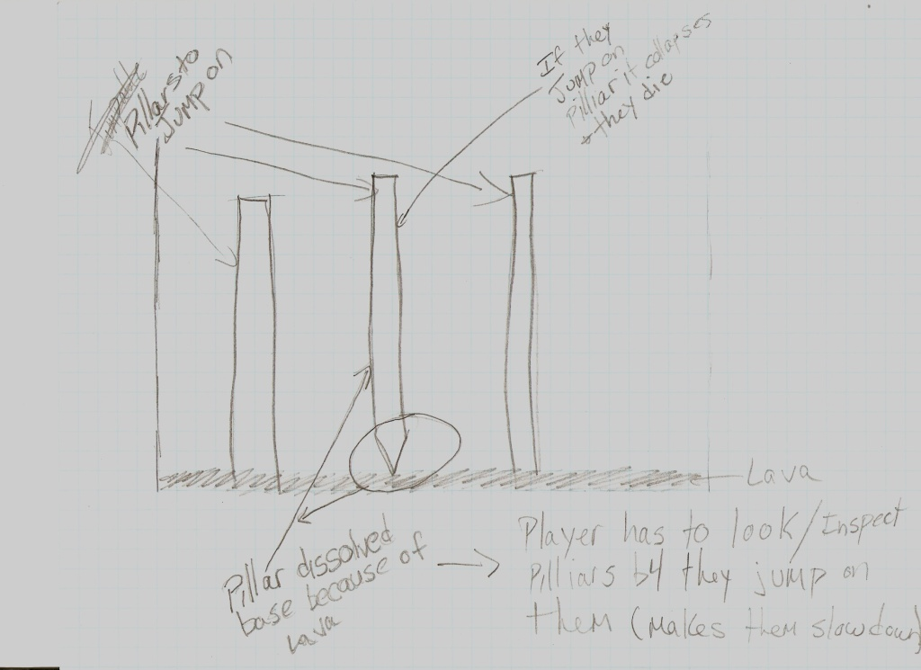
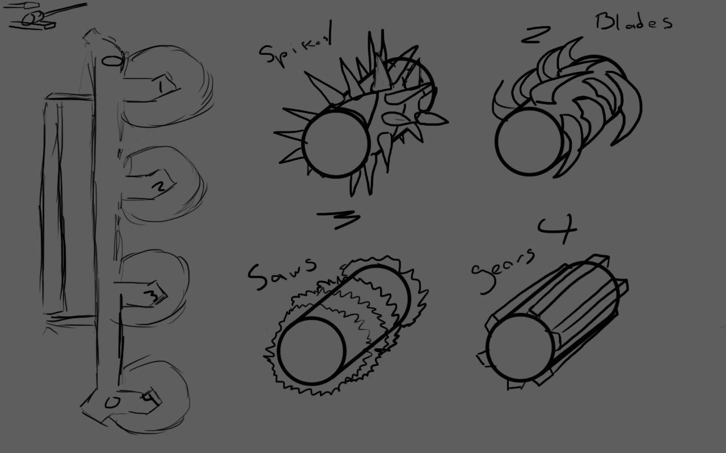
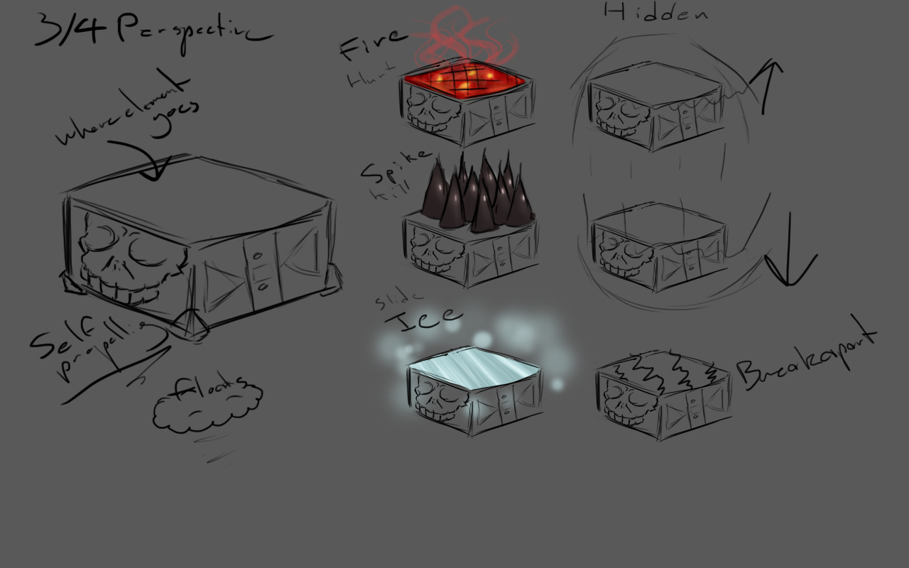
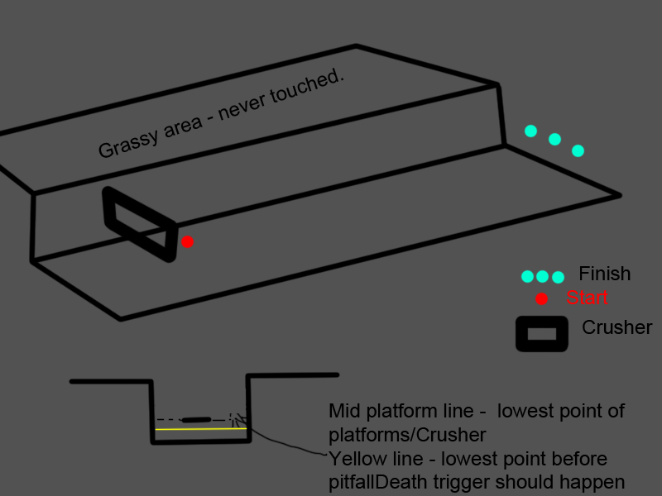

  - Characters
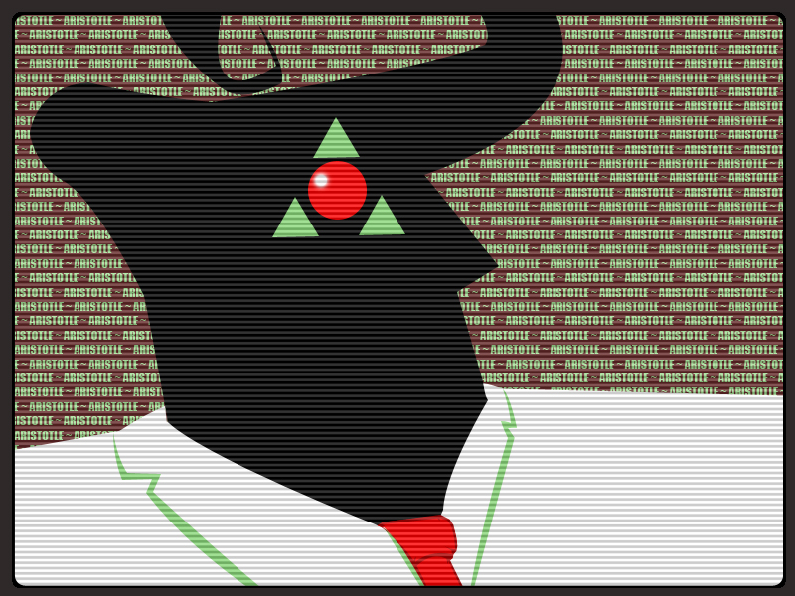
Aristotle – Note the bulbous, cyclopean eye
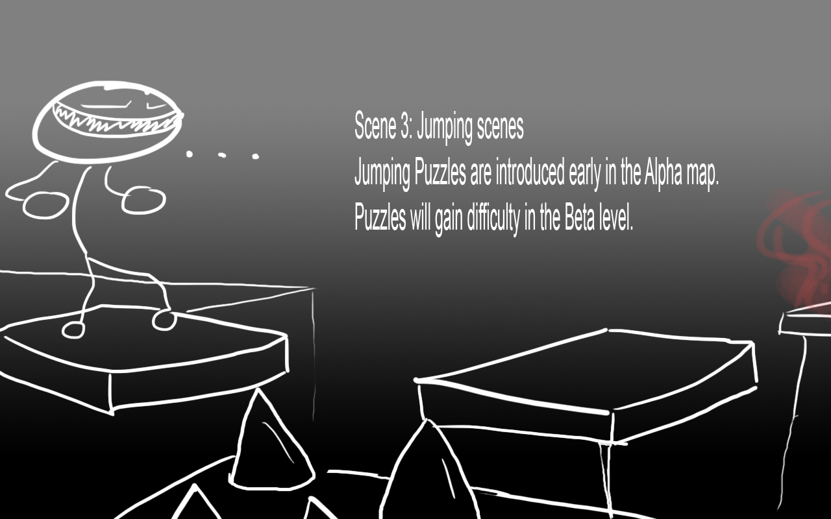
Prisoner JJ-6942 “JJ”
Safety Wizard
  - Environments 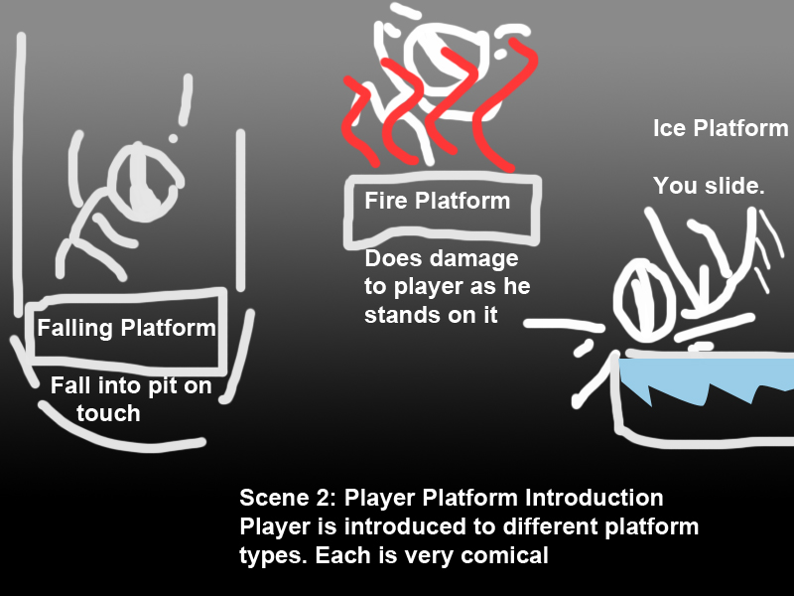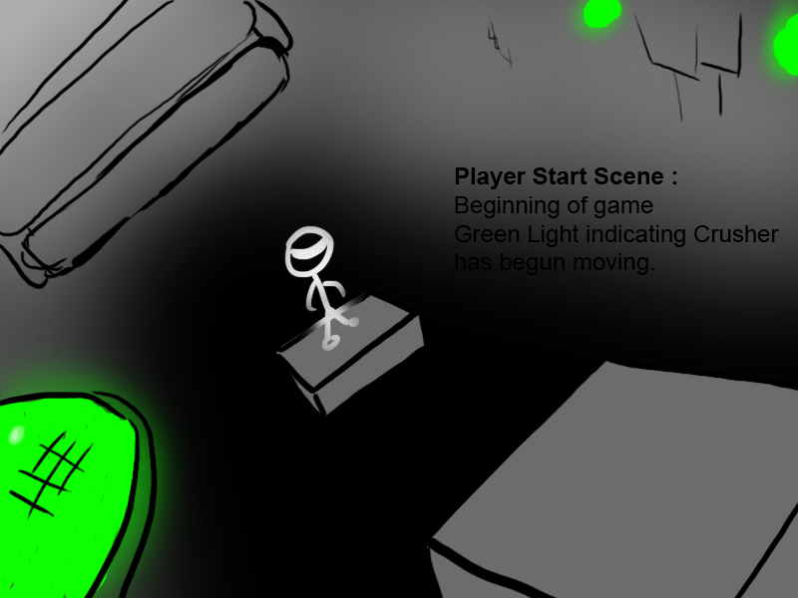
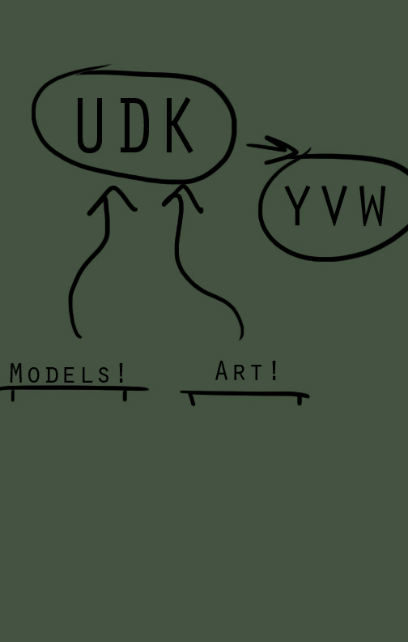
- Secondary Software

  - Content Creation
All custom models were created using the student version of 3ds Max 2011 32 bit. This is the choice of the modeler, Blake Farrugia, as he has had prior experience with the software.
All custom textures were created using the student version of Photoshop CS. This is the choice of the texture artist, Blake Farrugia, as he has had prior experience with the software.
All custom sounds were created using Audacity, a freeware sound recording tool. This is the choice of the voiceover artist, Blake Farrugia, as he has had prior experience with the software.
  - Additional Editors
To edit UnrealScript, the main scripter, Mohammad Rahmani, used Visual Studio 2010 in conjunction with nFringe and UnCodex to modify base code files of the engine.
  - Source Control
Dropbox was used for all source control. It offers free service to those who register accounts as well as enough space for all YVW components.
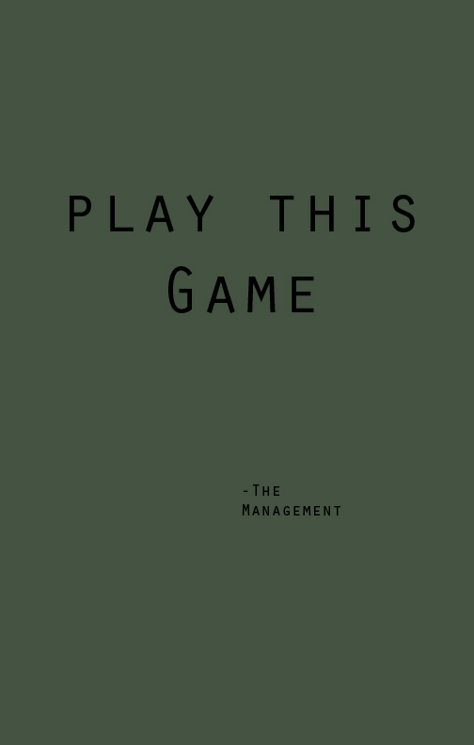
- Management

  - Detailed Schedule
Meeting Schedule – Weekly Skype meetings Saturday at 4PM. Progress reports on days we have class. Discuss Tuesday as possible meeting day.
Week Deadlines – Rough deadlines that may change due to complications. One month until alpha is to be presented. Goals are presented during each week given.
1-23 - 1-29 Week 1: Ideas and Testing UDK Week – Each member of the team should try out UDK and come up with rough ideas for the game as per their roles that were discussed on 1-22s Skype meeting.
- Alpha level design – Group Design
- Unreal Units scale test complete – Mike
- Level design notes complete – Mike, Blake
- Platform design complete – Blake
- Crusher design complete - Blake
- Basic scripting overview – Mohammad, Derek
- Completed list of all scriptable elements to the game – Group Design
- Custom modeling begins - Blake
1-30 – 2-5 Week 2: Base Week – Level modeling using editor must start here. Level editor must be aware of how platforms, starter positions, light, and script tying/processing work by the end of this week. Custom models must be finished so animation can begin.
- Alpha level modeling base begin/end – Mike
- Basic Level Textures - Mike
- Hard level design begin – Mike, Blake
- System tests and Work placement - Group
2-6 – 2-12 Week 3: Alpha Shape Week – Alpha level should be completed by this point. Design for harder end level will begin now based off Alpha. Scripting must continue and should be at least 40% complete. UI design must happen this week.
- Alpha level modeling Platform section begin – Mike, Blake
- Hard level design complete – Mike, Blake
- Custom Modeling continuation/end - Blake
- Custom Modeling Animation begin - Blake
- Custom Model Texturing begin - Blake
- UnrealScripting elements schedule – Mohammand, Derek
- Basic Scripting tests – Mohammad, Derek
2-7 – Project 2 document due. Class Pitch of team game.
2-13 – 2-26 Week 4 & 5: Alpha Crunch Weeks – Last minute changes for the Alpha presentation/level are done here. UI and Menu added and begin work on any custom sounds. Alpha presentation due near the start of week 5.
- Modified Player class – Jump height, showing weapons
- Implementation of exported models
- Basic UI Design MENU/Damage – Group
- Some Custom Sounds if needed
  - Aristotle voice acting
  - Raising platforms/walls
  - Crusher Sound
- Custom Visual Queues
  - Camera Fade-in/Fade-out
- Basic scripts
  - PlayerStart – trigger start of in-game events
  - PlayerFinish – Stop Crusher, play final sound of Alpha
2-23 – Alpha build of game presentation to class.
2-27 – 3-6 Beta Week 1: Ideas Week AKA Spring Break – Work on ideas for Beta, bringing items up to code.
- Beta map design – Mike and Blake
- Alpha map critique – Group Design
- Mine design – Derek
- Projectile design/implementation – Derek
- UnrealScript Overviewing – Blake and Mohammad
- Story write-up – Group Design
Week 2: Construction Week – Try to implement ideas from previous week. Major work begins on model skins and level design. Model skins will take some time, so these will be left up for the next few weeks. Scripting needs some actual work products out of this timeframe.
- Beta map design advanced – Group design
- Level flow system ideas – Group design
- Mine and Projectile Completion – Derek
- UnrealScript Products for Testing – Mohammad and Blake
- Story Finalization – Blake
- Model Skinning – Blake
- Extra Modeling (Turret, Mine) - Blake

  - Risk Analysis
Common Risks:
- Game will not play on school machines
- Game cannot run specified custom models
- Game cannot compile scripts
- Game cannot build levels
- Game cannot transition levels correctly
- Game cannot render levels correctly
- Game cannot be won
Gold Risks:
- Does not live up to standards set by Alpha and Beta
- Some models untextured
- Some textures unfinished
- Ease of use
- Inability to play game
- Lessening of challenge
  - Test Plan
You Vs Wall has followed high standards of rigorous in-game and development testing. It was even play tested by high schools and their parents. A wide audience was tested. The basic test plan followed was a two-tier iteration system that each member of the team was responsible for. Although they were responsible for it that does not mean it was usually followed.
Testing began with rough iteration of a certain aspect of the game. This aspect was criticized thoroughly until it was deemed ready for actual in-game use. If problems arose, they were solved. Rarely was there a problem that was unable to be solved with this system.
During development of the Beta and Gold builds, much more emphasis was given on playtesting. During level builds, we would routinely test the progress we had made by calling people over to try out sections of the level to test for difficulty and bugs. Playtests were invaluable and finding and correcting many of the problems with the map – killzone glitches, overzealous platform timing, and many other problems were fixed.
We also playtested the game in a more structured fashion when building the levels alone. A typical test of a new feature of the level had the following parts:
- Preliminary test – did the initial trigger or action work? If not, what aspects were broken, and which broken pieces were interrelated?
- Multiple trigger test – how did the object in question behave when confronted by multiple triggers or player spawns? Often objects would fail to reset or respond when a player respawned.
- Direct interference test – what happened to UnrealMatinee’d objects when colliding with the player? A variety of problems were found this way – spinning gears might stop, for instance, or the player might get stuck in the animation, or the animation might force the player into an unanticipated position.
We also performed a series of informal tests to make sure that players could not escape the different maps. This involved attempting to jump over boundary walls, scale natural borders (such as the cliffs in Green room), and searching for ways to escape the moving walls or get behind them. This last problem was a key point, as once a player was stuck behind the wall it would be virtually impossible to beat the level – though it would give them ample opportunity to explore.
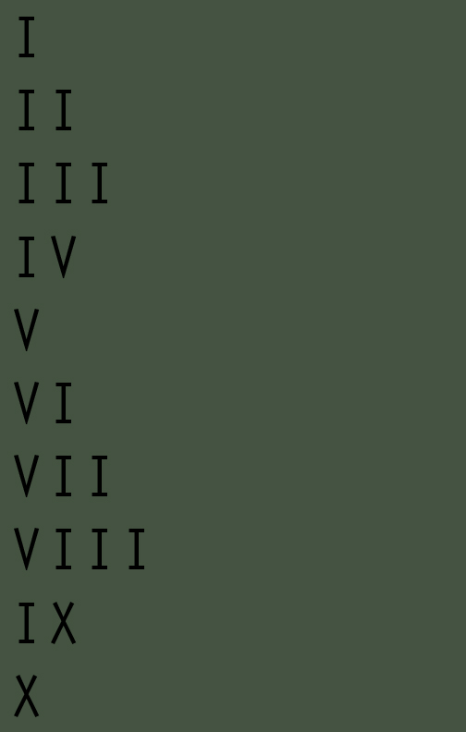
- Appendices

  - art List
Models
Legend:
PF – Prefabricated item
List:
yvw_Applause
yvw_Arrow
yvw_CrusherSlim
yvw_CrusherWide
yvw_Eye
yvw_EyePillar
yvw_EyeWall
yvw_Mine
yvw_MultiWall_Short
yvw_PF_Button
yvw_PF_Camera
yvw_PF_Capsule
yvw_PF_DyPlat_Fire
yvw_PF_Monument
yvw_Platform_Dynamic
yvw_Platform_Static
yvw_Platform_Static_Tongue
yvw_Plato
yvw_Socrates
yvw_Spikes_Floor
yvw_TheEye
yvw_Turret
yvwAtistotleMonument_Base
yvwAristotleMonument_Tri
yvwButton
yvwButtonStand
yvwCamera_Eye
yvwCamera_Hold
yvwCapsule_Door
yvwCapsule_Floor
yvwCapsule_Glass
yvwCapsule_Spike_Base
yvwDoor
yvwGear_Large
yvwGear_Medium
yvwGear_Small
yvwPlane
yvwStaticHQ
Textures
Legend:
SHQ – Static Headquarters
DC, DCL – Decal
MAT – Material
NM – Normal Map
TX – Texture
SW – Safety Wizard
List:
Arispost
Arispost_Alpha
Camera0_Aristotle_SceneCapture
Camera0_GR_SceneCapture
CameraCaptureMat
Capsule_Glass
FireMat
FireParticles
FullMat_Plato
FullMAT_Socrates
FullMAT_White
grassMat
GrassMat2
HeatMat
Hello-kitty-fredscorner
Hello-kitty-fredscornertx
Rock_2_4w
Rock_2_4wMat
SHQ_Bricks
SHQ_Concrete
SHQ_Metal
SHQ_Sign
SmokeMat
SparkMat
Tri_Green
TX_MATT1
TX_MATT2
Yvw_AristotleExplained
Yvw_Credits1
Yvw_Credits2
yvw_Credits3
yvw_Credits4
yvw_DC_ArisPoster-v1
yvw_DC_ArisPoster_v2
yvw_DC_AristotleExplained
yvw_DC_AristotleMonitor
yvw_DC_Arrow
yvw_DC_Exit
yvw_DC_HK
yvw_DC_Matt_v1
yvw_DC_Matt_v2
yvw_DC_Philosophers
yvw_DC_PSA1_v1
yvw_DC_PSA1_v2
yvw_DC_PSA2_v1
yvw_DC_PSA2_v2
yvw_DC_PSA3_v1
yvw_DC_PSA3_v2
yvw_DC_PSA4_v1
yvw_DC_PSA4_v2
yvw_DC_PSA5
yvw_DC_PSA6
yvw_DC_PSA7
yvw_DC_PSA8
yvw_DC_SocratesMonitor
yvw_DC_Storage
yvw_DC_SW_A1
yvw_DC_SW_A2
yvw_DC_SW_A3
yvw_DC_SW_A4
yvw_DC_SW_B1
yvw_DC_SW_B2
yvw_DC_SW_B3
yvw_DC_SW_B4
yvw_DC_SW_B5
yvw_DC_SW_Control
yvw_DC_SW_CP1
yvw_DC_SW_CP2
yvw_DC_SW_CP3
yvw_DC_SW_F1
yvw_DC_SW_F2
yvw_DC_SW_F3
yvw_DC_SW_F4
yvw_DC_SW_F5
yvw_DC_SW_F6
yvw_DC_SW_F7
yvw_DC_SW_GR1
yvw_DC_SW_GR2_v1
yvw_DC_SW_GR2_v2
yvw_DC_SW_GR3_v1
yvw_DC_SW_GR3_v2
yvw_DC_SW_GR4
yvw_DC_SW_PFinal
yvw_DC_SW_PWarn
yvw_DCL_Arrow
yvw_DCL_ArrowAlpha
yvw_DCL_SW_P1
yvw_DCL_SW_P2
yvw_DCL_SW_P3
yvw_DCL_SW_P4
yvw_DCL_SW_P5
yvw_DCL_SW_P6
yvw_DCL_SW_P7
yvw_DCL_SW_P8
yvw_DCL_SW_P9
yvw_DCL_SW_P10
yvw_DCL_SW1
yvw_DCL_SW2
yvw_DCL_SW3
yvw_DCL_SW4
yvw_DCL_SW5
yvw_DCL_SW6
yvw_DCL_SW7
yvw_DCL_SW8
yvw_DCL_SW9
yvw_DCL_SW10
yvw_DCL_SW11
yvw_DCL_SW12
yvw_DCL_SW13
yvw_DCL_SW14
yvw_Exit
yvw_Exit_Alpha
yvw_MAT_Black
yvw_MAT_CameraEye
yvw_MAT_Capsule_Base
yvw_MAT_Crusher_1
yvw_MAT_Crusher_2
yvw_MAT_Crusher_3
yvw_Mat_DoorMat
yvw_MAT_Gears
yvw_MAT_Grass
yvw_MAT_NoEntry_Mat
yvw_MAT_Platform_Dynamic
yvw_MAT_Platform_Static
yvw_MAT_Platform_Static_Tongue
yvw_MAT_SpikeSet
yvw_MT_Credits1
yvw_MT_Credits2
yvw_MT_Credits3
yvw_MT_Credits4
yvw_MT_Door
yvw_MT_LandMine
yvw_MT_Gear
yvw_MT_StaticPlatform
yvw_NoEntry
yvw_Philosophers
yvw_Philosophers_alpha
yvw_PSA_Alpha
yvw_PSA2
yvw_PSA3
yvw_PSA3_Alpha
yvw_PSA4
yvw_PSA4_Alpha
yvw_PSA5
yvw_PSA6
yvw_PSA7
yvw_PSA8
yvw_Storage
yvw_Storage_alpha
yvw_TX_AristotleMonitor
yvw_TX_CameraEYE
yvw_TX_Capsule_Base
yvw_TX_Capsule_Rail
yvw_TX_CrusherMat1
yvw_TX_CrusherMat2
yvw_TX_CrusherMat3
yvw_TX_Door
yvw_TX_DynamicPlatform
yvw_TX_DynamicPlatform_Lightmap
yvw_TX_FloorTrigger
yvw_TX_Gear
yvw_TX_LandMine
yvw_TX_Mine
yvw_TX_SpikeGear
yvw_TX_SpikeSet
yvw_TX_SPTongue
yvw_TX_StaticPlatform
yvw_TX_Turret
yvwDoorMaterial
YVWPSA_1
YVWPSA_Alpha1
yvwSocrates
yvwSW_Control
yvwSW_CP1
yvwSW_CP2
yvwSW_CP3
yvwSW_PFinal
yvwSW_Poster_Alpha1
yvwSW_Poster_Alpha2
yvwSW_PWarn
  - Sound List
MachineEngine
Vehicle.VehicleSurface_TireMetal01Cue
Vehicle.VehicleSurface_TireWood01Cue
yvw_Acid_Deaths
yvw_Alarm
yvw_Alarm_Ambient
yvw_Ambient_DoorOpen
yvw_Ambient_Stomper_Cue
yvw_Aristotle_Numbers_Ambient
yvw_ButtonFail_Cue
yvw_ButtonSuccess_Cue
yvw_CapsuleRaise
yvw_CapsuleRaise_Cue
yvw_Checkpoint
yvw_Checkpoint_Ambient
yvw_DyPlatformRaise_Cue
yvw_Gear_Deaths
yvw_GR_Acid_Deaths
yvw_GR_Elevator_Deaths
yvw_Pit_Deaths
yvw_Socrates_Pit_Deaths
yvw_Socrates_Spike_Deaths
yvw_SpikeWall_Deaths
yvw_Stomper_Deaths
yvwA_AcidEnd
yvwA_Ambient_Spike
yvwA_Ambient_Spike_Cue
yvwA_death
yvwA_EndingAlpha
yvwA_Intro2
yvwA_Lava
yvwA_Middle
yvwA_nearend
yvwA_Spikes
yvwA_Start
yvwA_Trick
yvwB1_Death_Acid1
yvwB1_Death_Acid2
yvwB1_Death_Acid3
yvwB1_Death_Gear1
yvwB1_Death_Gear2
yvwB1_Death_Generic1
yvwB1_Death_Generic2
yvwB1_Death_Pit1
yvwB1_Death_Pit2
yvwB1_Death_Spike1
yvwB1_Death_Spike2
yvwB1_Death_Stomper1
yvwB1_Death_Stomper2
yvwB1_End
yvwB1_Intro
yvwB1_Stomper_Inc
yvwButton_Fail
yvwButton_Success
yvwD_Ambient_Aristotle
yvwD_Aristotle_Banter
yvwD_Aristotle_Explaination
yvwD_Aristotle_Found
yvwD_Socrates_Explaination
yvwD_Socrates_Final
yvwG_Soc_Checkpoint1
yvwG_Soc_Checkpoint2
yvwG_Soc_Death_Generic1
yvwG_Soc_Death_Generic2
yvwG_Soc_Death_Generic3
yvwG_Soc_Death_Generic4
yvwG_Soc_Death_Pit1
yvwG_Soc_Death_Pit2
yvwG_Soc_Death_Pit3
yvwG_Soc_Death_Pit4
yvwG_Soc_Death_Pit5
yvwG_Soc_Death_Pit6
yvwG_Soc_Death_Spike1
yvwG_Soc_Death_Spike2
yvwG_Soc_Death_Spike3
yvwG_Soc_GameIntro
yvwG_Soc_HelmetIntro
yvwG_Soc_NearEnd
yvwGR_Acid_1
yvwGR_Acid_2
yvwGR_Acid_3
yvwGR_Aris_1
yvwGR_Aris_2
yvwGR_Door
yvwGR_DyPlatform_Rise
yvwGR_DyPlatform_Rise
yvwGR_Elevator_1
yvwGR_Generic_1
yvwGR_Generic_2
yvwGR_Generic_3
yvwGR_Generic_4
yvwGR_Socrates_Intro

