Game Design Document Outline

Version 1.0 April 30, 2010

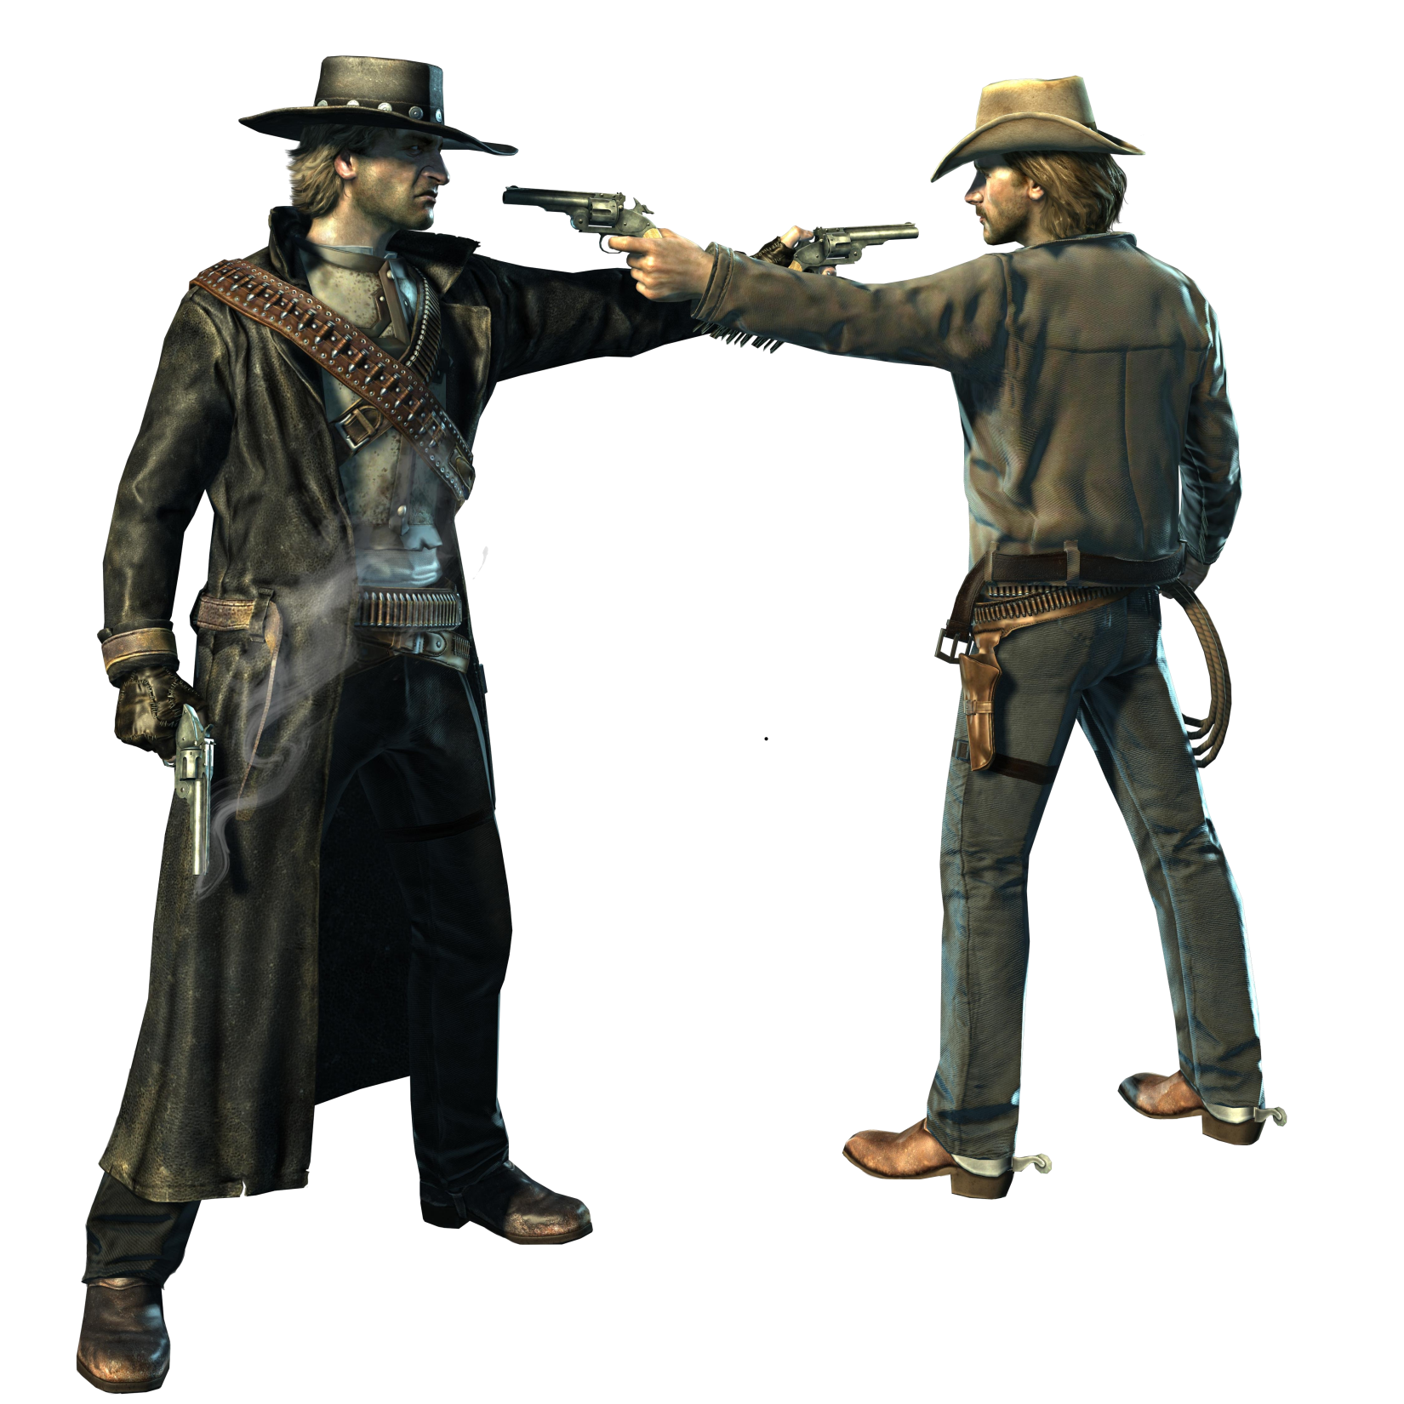
By Hook or Crook

Table of Contents
- Section I - Game Overview
  - Game Concept
  - Feature Set
  - Genre
  - Target Audience
  - Game Flow Summary
  - Look and Feel
  - Project Scope
- Section II - Gameplay and Mechanics
  - Gameplay
    - Game Progression
    - Mission/challenge Structure
    - Puzzle Structure
    - Objectives
    - Play Flow
  - Mechanics
    - Physics
    - Movement
    - Objects
    - Actions
    - Combat
    - Economy
  - Screen Flow
    - Screen Flow Chart
    - Screen Descriptions
  - Game Options
  - Replaying and Saving
  - Cheats and Easter Eggs
- Section III – Story, Setting and Character
  - Story and Narrative
    - Back story
    - Plot Elements
    - Game Progression
    - License Considerations
    - Cut Scenes
      - Cut scene Intro
      - Cut scene Outro
  - Game World
    - General look and feel of world
    - Level 1 – Card Game
    - Level 2 – Train Station
    - Level 3 – Stagecoach Run
  - Characters
    - Hondo Lane
    - Black Hats
    - Deputies
    - Hoss’ Men

- Section IV – Levels
    - Level 1 – Card Game
    - Level 2 – Train Station
    - Level 3 – Stagecoach Run
  - Training Level
- Section V - Interface
  - Visual System
  - Control System
  - Audio
  - Music
  - Sound Effects
  - Help System
- Section VI - Artificial Intelligence
  - Opponent AI
  - Enemy AI
  - Non-combat Characters
  - Friendly Characters
- Section VII – Technical
  - Target Hardware
  - Development hardware and software
  - Development procedures and standards
  - Game Engine
  - Network
  - Scripting Language
  - etc.
- Section VIII – Game Art
  - Concept Art
  - Style Guides
  - Characters
  - Environments
  - Equipment
  - Cut scenes
  - Miscellaneous
- Section IX - Secondary Software
  - Editor
  - Installer
  - Update software
- Section X - Management
  - Detailed Schedule
  - Budget
  - Risk Analysis
  - Localization Plan
  - Test Plan
- Appendices
  - Asset List
    - Art
    - Sound
    - Music

- Section I - Game Concept
  - First Person Shooter basics
  - Wild West Shoot ‘em up with a film noir style twist
  - Male 13-48 years old, anyone who loves film noir or westerns
  - Players can move through each level trying to complete the game’s single player levels. They also may play heads up against other human players in multiplayer
  - Film noir style narration with the feeling of very gritty atmosphere
  - Project Scope –
    - One main location
    - Three levels
    - Three NPCs – blackhat, hoss henchmen, deputies
    - Three weapons – peacemaker, henry rifle, coach gun

- Section II - Gameplay and Mechanics
  - Gameplay
    - Flee the card game -> Get to the train station -> Find other transportation -> Find contact -> Battle boss -> Win
    - Player must fight through levels full of enemies
    - Must determine when to fight or flee, not enough ammo to fight everyone
    - The main objective is to survive!
    - The game follows the main character’s journey to deliver his package to the man in the east
  - Mechanics
    - Realistic physics of Earth – Newton’s Laws
    - Movement
      - Standard person movement found in FPS
      - Can side step to avoid shots (double tap strafe keys)
    - Objects
      - Can pick up objects by moving over them
      - Cannot move objects
    - Actions
      - There are no buttons which need interaction
      - The player can pickup, drop, and equip weapons
    - Combat
      - The combat is of a typical first person shooter, which involves moving and shooting. The main character is stuck between two factions in a trust no one environment
  - Game Options
    - The game options are very simplistic and do not effect game play to any large extent
  - Replaying and Saving
    - You can save the mission at any point, also during the game there are checkpoints which keep you from starting each level over

  - Cheats and Easter Eggs
    - You can enter the saw mill and hide places normally you wouldn’t think you could – in multiplayer at least…

- Section III – Story, Setting and Character
  - Story and Narrative
    - You play as Hondo, a drifter who makes money anyway he can – whether off gambling, odd jobs, or other peoples misfortunes. The only thing that concerns you is your next score of gold. The story will follow the main character as he progresses through his quest to deliver a package. This will be told over five levels. The game will start with the card game and end with a showdown with a boss character at the city to the east.
    - Plot Elements
    - Player will progress through the levels attempting to fulfill the object of each area leading to an overall completion of the game.
      - Flee the card game -> Get to the train station -> Find other transportation -> Find contact -> Battle boss -> Win
    - License Considerations - none
    - Cut Scenes
      - Cut scene #1 - Intro
        - Actors – Card players, Black Hat, Hondo
        - Card game goes bad
        - Storyboard
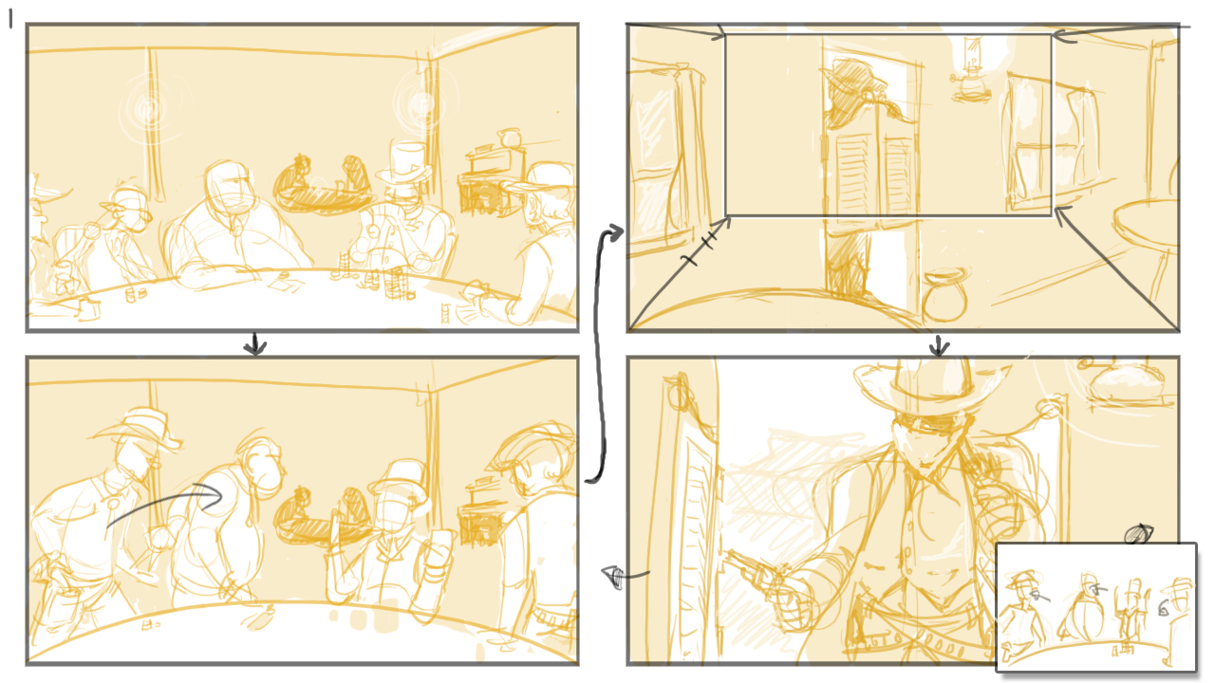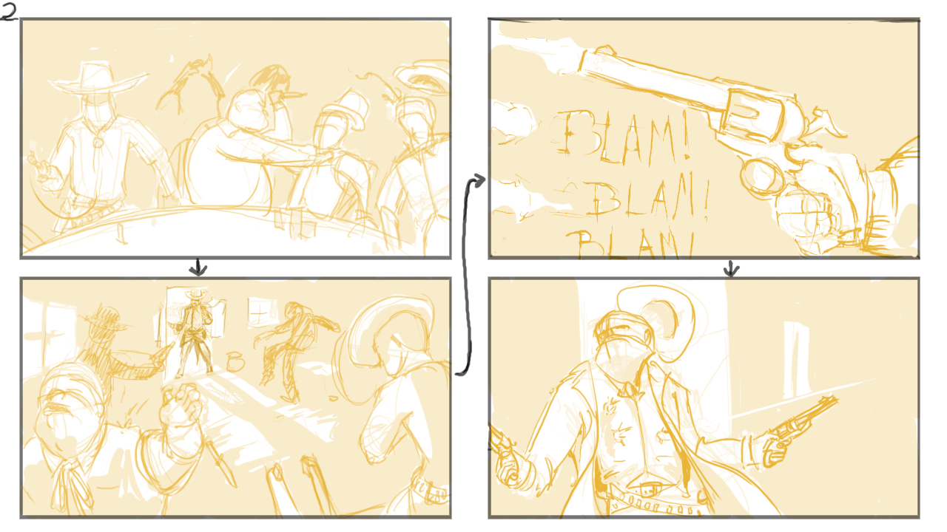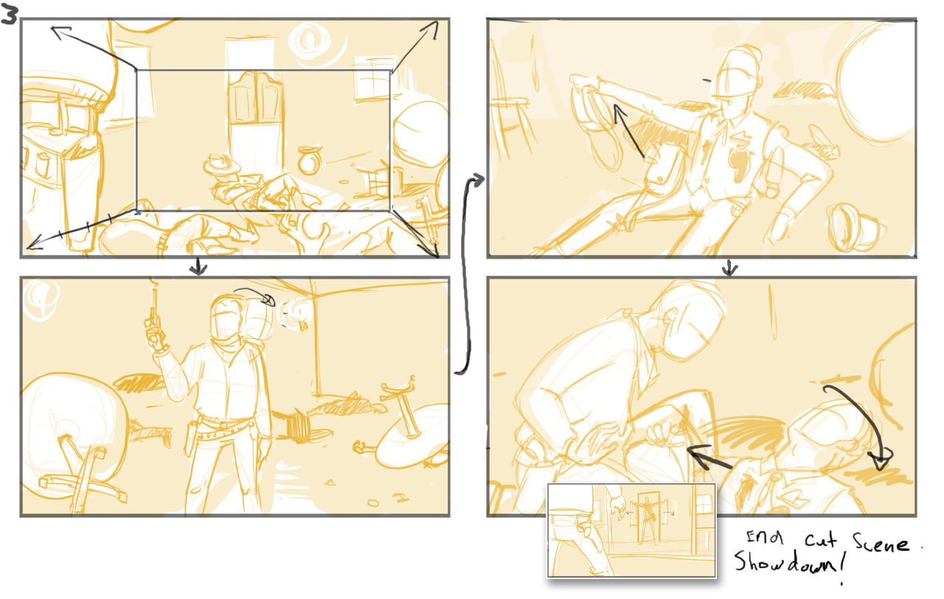

      - Cut scene #2
        - Actors – Hondo, Hoss’ Henchmen
        - Armored wagon flips as Hondo reaches East City
  - Game World
    - Area #1 – Wild West circa 1890
      - Old, Dirty, Dank, Gritty, Dark, Restless
      - Levels 1-2-3 use this area
      - No connections to other areas
  - Characters
    - Character #1 - Hondo
      - A drifter always looking for his next dollar.
      - Hondo is a shifty guy, you really can’t trust him
      - Look
        - Scruffy, tired, shifty eyes
      - No special abilities
      - Main character
    - Character #2 - Deputies
      - Normal sheriff
      - Personality – good guys
      - Look
        - Normal sheriff appearance
      - No special abilities
      - These guys are not sure who to trust so they try to shoot both Hoss’ guys and you
    - Character #2 – Hoss’ Henchmen
      - Grunts working for the main bad guy Hoss
      - Mean, very mean
      - Look
        - Typical cowboys, grungy yet nice for the period
      - No special abilities
      - These are the main enemies you will fight
      - Hoss’ Henchmen are trying to kill you and deputies!

- Section IV – Levels
  - Level #1 – Card Game
    - Hondo finds himself at a card game when all hell breaks loose
    - Intro cut scene starts showing when all hell breaks loose up until Hondo receives his mission from the well dressed man
    - Flee town!
    - The level takes place at night in a small little town
    - You must find your own path through the town
    - The player will encounter many firefights throughout the level as he attempts to flee

Level Walkthrough
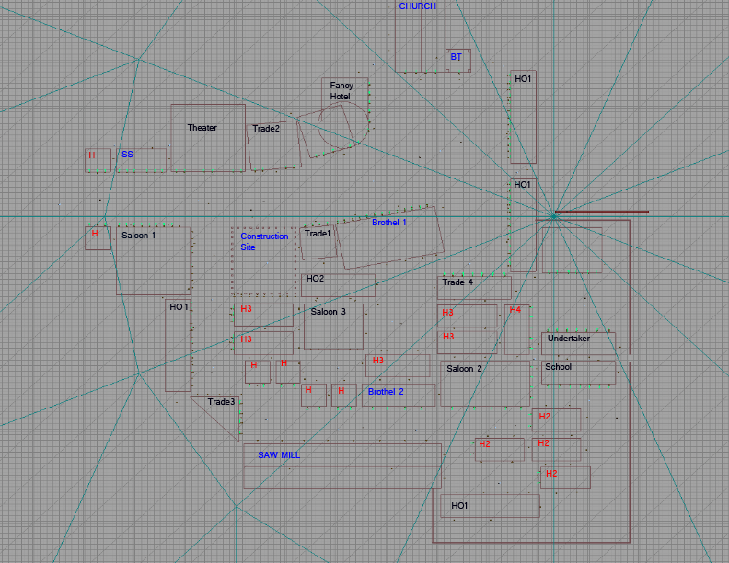
  - Level #2 – Train Station
    - Hondo finds himself looking for transportation outside the city
    - There is no cut scene for this level but the level itself is intuitive
    - Find Transportation
    - The level takes place on the outskirts of the previous level’s town at dawn
    - You must find your own path to transportation
    - At the start the player will not see anyone, thinking he is safe, he proceeds to the train station
  - Level #3 – Carriage Ride
    - Hondo finds himself without a train but with other transportation, he then makes his way to the city via the carriage
    - The cut scene that ends the game will show the carriage flipping over in a hail of gun fire, leading up to
    - Make it to the eastern city
    - The level takes place on city’s train station just outside of town
    - The carriage will move throughout the canyons and valleys trying to flee and make it alive to the city in the east.
- Section V - Interface
  - Visual System
    - 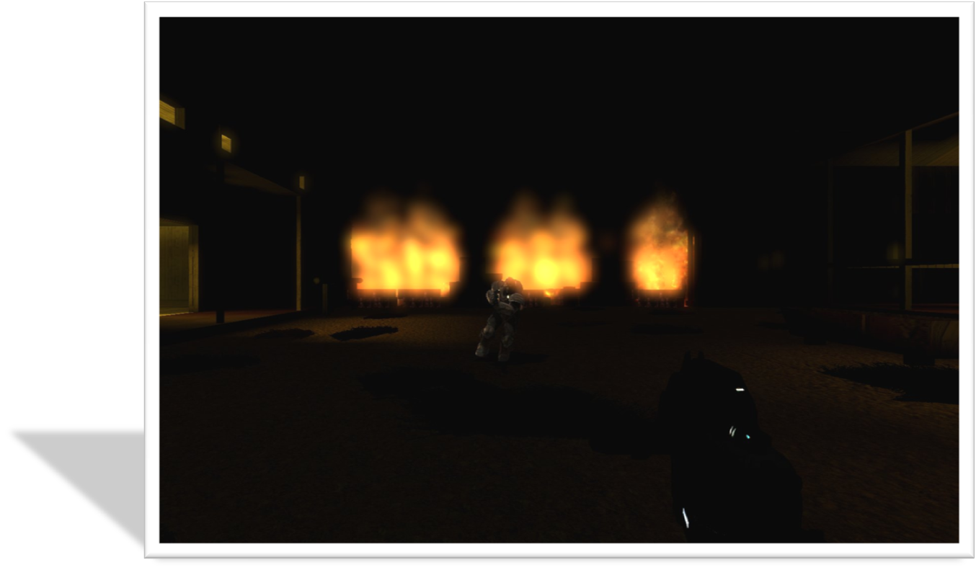
    - 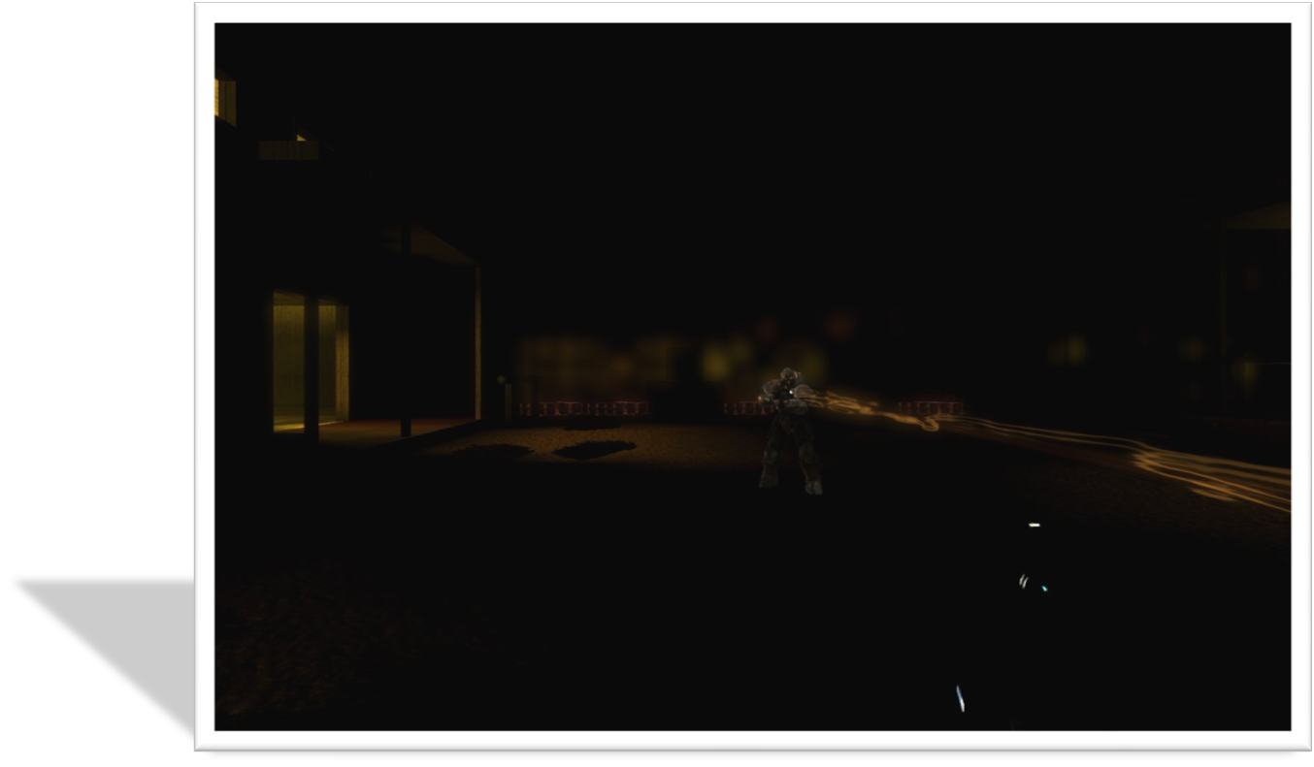
  - Control System
    - Movement
      - W - Forward
      - A - Left
      - S - Back
      - D – Right
    - Camera View
      - Mouse Movement
    - Weapon Fire
      - Primary- Left Mouse Click
      - Secondary- Right Mouse Click
  - Help System
    - Escape – Help and pause menu
- Section VI - Artificial Intelligence
  - Opponent AI
    - Sherriff
  - Enemy AI
    - Black Hats
    - Sherriff’s Men
  - Friendly AI
    - Sherriff’s Men
  - Support AI
    - Showdown scripted battle
- Section VII – Technical – This may be abbreviated with most in the Technical Bible.
  - Target Hardware
    - Windows XP SP2 with DirectX 9.0c
    - 2GHz or better CPU
    - 2+ GB RAM
    - A graphics card with Shader Model 3.0 support
  - Development hardware and software
    - Windows XP SP2 with DirectX 9.0c
    - 2GHz or better CPU
    - 2+ GB RAM
    - A graphics card with Shader Model 3.0 support
    - Maya
    - 3DS Max
    - Photoshop
  - Game Engine
    - Unreal 3 Engine
  - Scripting Language
    - Kismet
    - Unreal Scripting
- Section VIII – Game Art - This may be abbreviated with most of the content in an Art Bible.
  - Concept Art
    - Concept Intro Art
  - Characters
    - Hondo
    - Black Hat
    - Sherriff’s Men
  - Equipment
    - Boxes
    - Barrels
    - Blocks
    - Package
    - Weapons
  - Cut scenes
    - Intro
    - Outro
- Section IX - Secondary Software
  - Editor
    - Unreal 3 Editor
    - Maya
    - 3DSMax
    - Photoshop
    - Paint
  - Installer
    - Excelsior Installer 2.0.
  - Update software
    - Unfuddle Account
    - TortoiseSVN
- Section X - Management
  - Detailed Schedule
    - Level Design:
Level One: FINAL 3/24
Change game mode from death match to team death match
Create linear path to follow by blocking off specific areas
Finish places buildings and static items
Finish lighting schemata
Level Two: FINAL 3/24
Finish level layout
Create instructional powerpoints for team if needed
Level Three: FINAL 3/24
Finish level layout
Create instructional powerpoints for team if needed
Level Two/Three: FINAL 3/31
90% overall completion
Textures/Sky/Statics
    - 3D/2D:
3D: FINAL 4/4
Get firearms into the game
Get player models into the game
Continue work on level assets
    - 2D: FINAL 4/4
Intro/Outro (I: card game, O: Wagon flips)
Loading Screen
Concept art
  - Budget
 | Cost | Unit
2D Art | $4,800 | 1 @ 1920 hrs
3D Art/Level Design | $24,000 | 5 @ 960 hrs
Scripting | $14,400 | 3 @ 576 hrs
Tools | $1000 | Unfuddle, Unreal 3, etc
Laptops | $16,000 | 10 @ $1600 avg cost
Total Cost: | $60,200

  - Risk Analysis
    - 4th Quarter Sales (High)
      - Risk: Not releasing the final version before the Christmas rush
      - Mitigation: Team leaders need to report out regularly to the project lead to maintain a visual on the schedule
      - Monitoring: Project time projections that exceed the beginning of 4th quarter will trigger this risk
      - Management: Low priority game features will have to be dropped if the schedule is not holding
    - Incompatible requirement with dev environment (Medium)
      - Risk: A requirement is not capable of being implemented in the current environment
      - Mitigation: Teams need to report there ongoing research findings to team leads
      - Monitoring: A determination will have to be made whether a requirement can be implemented
      - Management: The requirement will have to be rewritten to work in the current environment or removed. A review of impacted requirements will have to be done as well to avoid other failures
  - Test Plan
    - 4/8 – 4/14
      - Play testing/Integration testing of AI code
      - Play testing/Integration testing of Showdown
    - 4/15 – 4/20
      - Play testing/Integration testing of AI code
      - Play testing/Integration testing of Train
      - Play testing/Integration testing of Stagecoach
    - 4/21 – 4/26
      - Final System testing/play testing
- Appendices
  - Asset List
    - Art
      - Model and Texture List
        - A_BHC_Music.upk
        - Chapter_3_LevelAssets.upk
        - Chapter_04_Physics.upk
        - Chapter_4_BrushDemo.upk
        - Chapter_08_TerrainDemo.upk
        - Chapter_09_KismetContent.upk
        - Chapter_052_Particles.upk
        - Chapter_0522COPY_Particles.upk
        - Nate1.upk
      - Animation List
        - A_BHC_Music.upk
        - Chapter_3_LevelAssets.upk
        - Chapter_04_Physics.upk
        - Chapter_4_BrushDemo.upk
        - Chapter_08_TerrainDemo.upk
        - Chapter_09_KismetContent.upk
        - Chapter_052_Particles.upk
        - Chapter_0522COPY_Particles.upk
        - Nate1.upk
      - Effects List
        - A_BHC_Music.upk
        - Chapter_3_LevelAssets.upk
        - Chapter_04_Physics.upk
        - Chapter_4_BrushDemo.upk
        - Chapter_08_TerrainDemo.upk
        - Chapter_09_KismetContent.upk
        - Chapter_052_Particles.upk
        - Chapter_0522COPY_Particles.upk
        - Nate1.upk
      - Cut scene List
        - Intro-Card game
        - Outro- Wagon Flipping
    - Sound
      - Environmental Sounds
        - Unreal 3 Walking sound
        - Unreal 3 Running sound
        - Unreal 3 Vehicle sound
        - Unreal 3 Impact sound
      - Weapon Sounds
        - Unreal 3 Gunfire Clips
      - Interface Sounds
        - Unreal 3 Click sound
    - Music
      - Ambient
        - Kool Moe Dee – “Wild Wild West”
      - “Action”
        - Link Wray – “Rumble”
      - Victory - none
      - Defeat - none

