Infiltration
Design Document

Game Design
04-08-2009

John Palgut
Alex Zammitt
Destin Centala
Chris Grelik
Overview
Game Concept
Infiltration takes place in a dystopian future where the world has been scorched, broken, and demolished. Most of Earth’s wreckage is due to mankind’s wars with one another and the use of nuclear weapons.
Seizing its chance at Earth’s weak moment several alien races have decided to invade and terraform the Earth to serve their own needs. Making use of advanced alien cloning and terraforming technology, the invading alien armies have managed to establish several bases. Each base has a seed-ship which is responsible for terraforming the surrounding area to suit the alien’s resource needs. Aliens can use some of the gathered resources to clone monsters that will protect the seed-ship and the surrounding area.
As a last ditch attempt to prevent the earth from being completely taken over by invading alien forces, the United States puts together a special ops cleanup team to attack, contain, and destroy these alien terraforming bases.
Leading a team of highly trained commandos, Commander Cody must use superior strategy to cut off enemy resources and destroy each seed-ship. The fate of the remaining peoples of earth is in their hands.
Target Audience
This game is targeted towards anyone between 13 and 30. However it is possible for someone younger or older to enjoy the game, we will be designing it based on this target.
Game Flow Summary
The game is a fast paced first person shooter death match. The flow of the game starts by one player hosting the game on their computer. Then the other players join the host’s game. The game begins when the host presses the start game button. Before starting the game, the host may set victory conditions such as kill amount or time limit. The game goes on until the win condition is met.
Look and Feel
The appearance for infiltration will be a dark, heavily mutated earth. For a good visual think of the destroyed earth from “The Matrix”. The sky should be dark.
The ground should be pretty barren, although there are spires of rock, perhaps buildings in some abandon cities, which provide the commando team with cover.
Weapons for the commando team are old, worn, and battered. You should get the feeling that they were pulled from old stashes or were previously used. Armor is tattered, although useable. You should get the feeling this is a last ditch effort, and the team is worn down.
Project Scope – Use Cases & Requirements
Use Cases
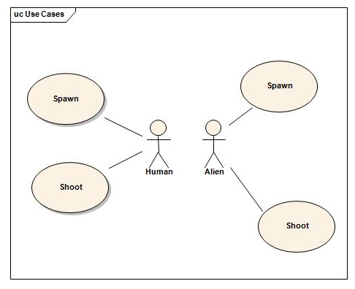

Project Requirements
- Develop a working multiplayer game
- The game must be developed in unreal 3
- The game must have two sides, alien and human
- The alien side must be an RTS overhead mode
- The humans must be a FPS view
- For the humans to win they must destroy the aliens
- For the aliens to win they must gather enough resources before the humans win
Game Mechanics
Game Play
This is a fast paced first person shooter death match game. Each person must do whatever it takes to have the most kills. Throughout the infiltration map there are different weapons that players can use to their advantage.
Mechanics
The players will spawn at pre determined spawn points on the infiltration map. When the game begins, the objective is to survive and kill as many other players as you can. When a player dies, he has to wait a certain amount of time before he can re-spawn at a randomly selected spawn point.
Game Options
The default Unreal 3 options will be allowed. The user should be able to change screen resolution, adjust sound levels and change graphic quality.
Replaying / Saving
Because of the nature of multiplayer games, this game cannot be saved. If a player wishes to end, he must forfeit the game or trust in his teammates to win. The game can be replayed by either restarting while in the middle of the game or by reloading the game after it is over.
Story and Characters
Story and Narrative
Infiltration takes place in a dystopian future where the world has been scorched, broken, and demolished. Most of Earth’s wreckage is due to mankind’s wars with one another and the use of nuclear weapons.
Seizing its chance at Earth’s weak moment several alien races have decided to invade and terraform the Earth to serve their own needs. Making use of advanced alien cloning and terraforming technology, the invading alien armies have managed to establish several bases. Each base has a seed-ship which is responsible for terraforming the surrounding area to suit the alien’s resource needs. Aliens can use some of the gathered resources to clone monsters that will protect the seed-ship and the surrounding area.
As a last ditch attempt to prevent the earth from being completely taken over by invading alien forces, the United States puts together a special ops cleanup team to attack, contain, and destroy these alien terraforming bases.
Leading a team of highly trained commandos, Commander Cody must use superior strategy to cut off enemy resources and destroy each seed-ship. The fate of the remaining peoples of earth is in their hands.
Game World
The game takes in a world where aliens have infiltrated the earth and are using its resources for their gain. The world is torn and worn down from battle. Buildings are abandoned, the ground is scorched.

Character Bibles
Commander Cody – This is the leader of the human group. His enemies run in fear when he is present.
Sergeant Stephanie – She is one of the toughest chicks you will ever meet.
Alien Leader – He is the leader of the alien’s army. He shows no mercy for anyone that gets in the way of his objectives.
Level Summaries
Level Outline
The level will take place in a city where the aliens and human have been in battle for a long time. The area is highly damaged from all the fighting. There will be spawn points where all players can randomly spawn from.
User Interface
Visual System
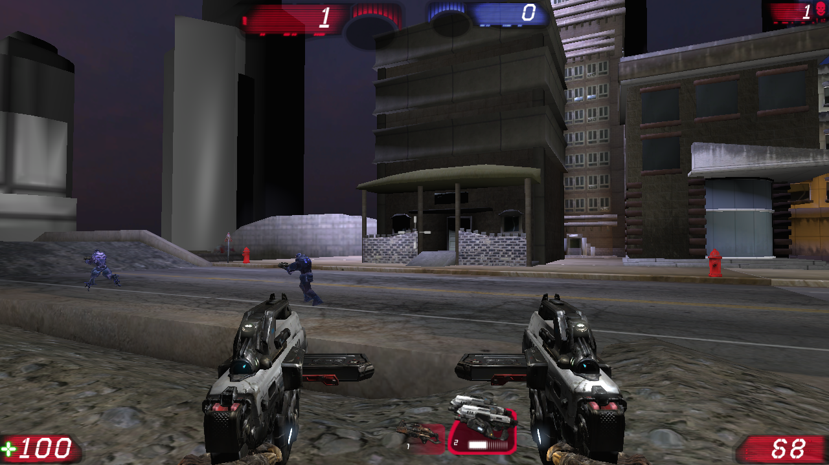
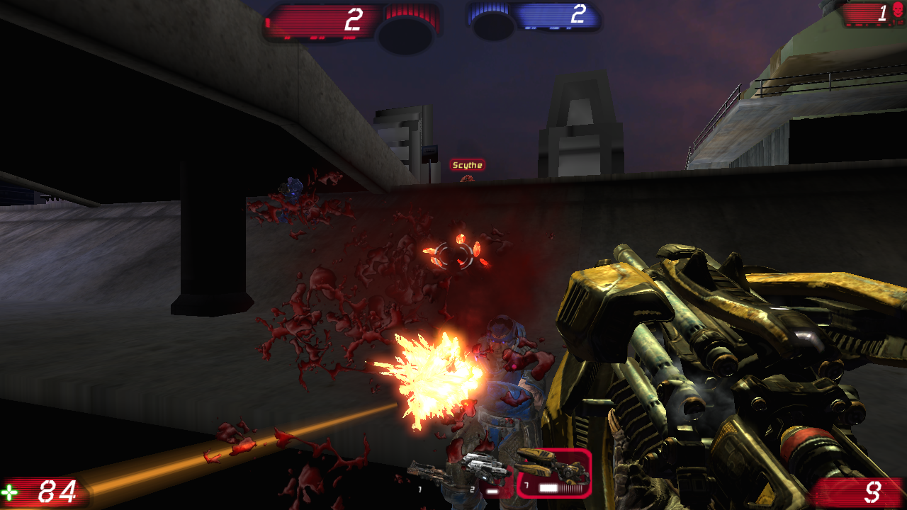
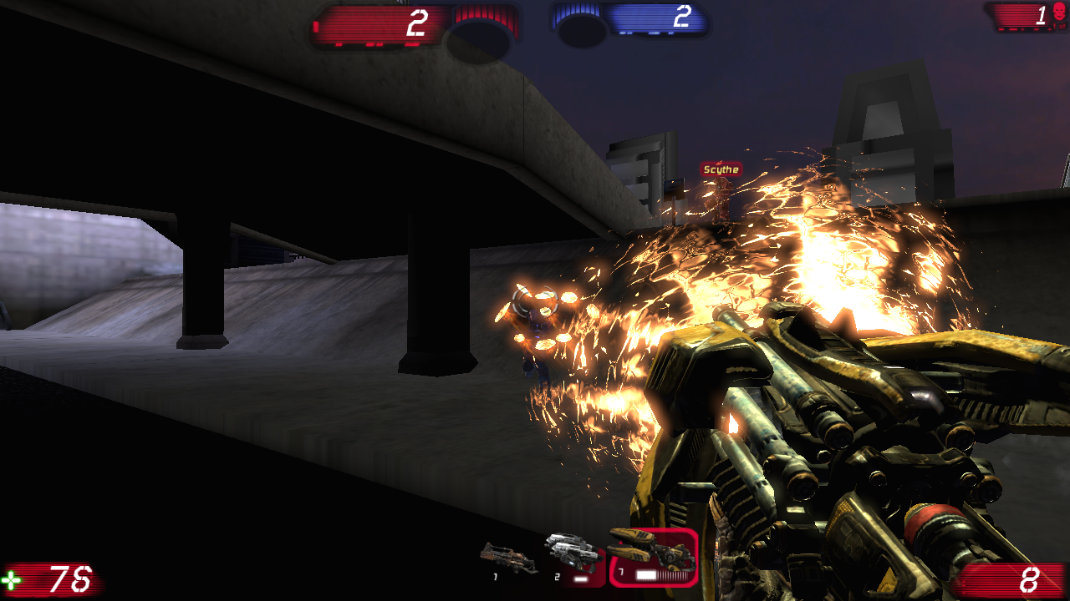
Control System
Human players
- Move – WASD
- Control Camera – Mouse move
- Fire – Left click
- Change weapons – Mouse wheel
Alien player
- Select button – Left click on button
- Move camera – Move mouse to each side of the screen
Audio
The game uses the default Unreal 3 sound
Artificial Intelligence
You may play this game against bots if you have no one to play with. The bots can be set at different skill levels in the settings before the match begins. The bots simply spawn at the spawn points and look for other players to kill.
Technical
Hardware
Minimum Requirements
CPU: 2.8Ghz
RAM: 512MB
Graphics: Geforce 6 series
Recommended System
CPU: 3-4Ghz
RAM: 1024MB
Graphics: NVIDIA 6800GT/Ultra or 7800GT/GTX SLI
Software
Operating System – Windows XP or higher
Procedures and Standards
TODO: Not sure what is needed here
Art
Concept Art
Alien & Ship
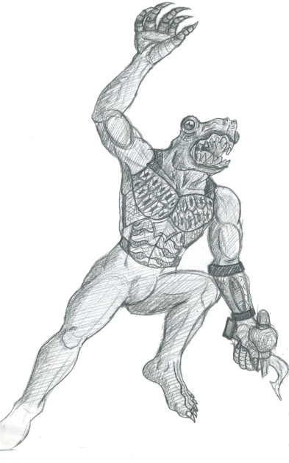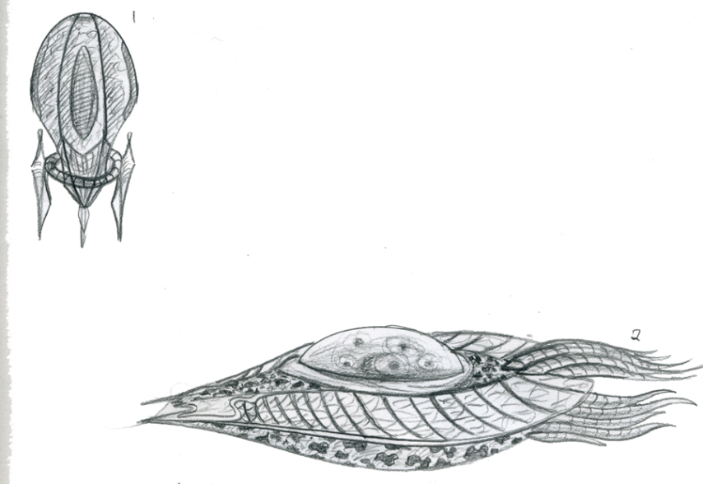
Human


Characters
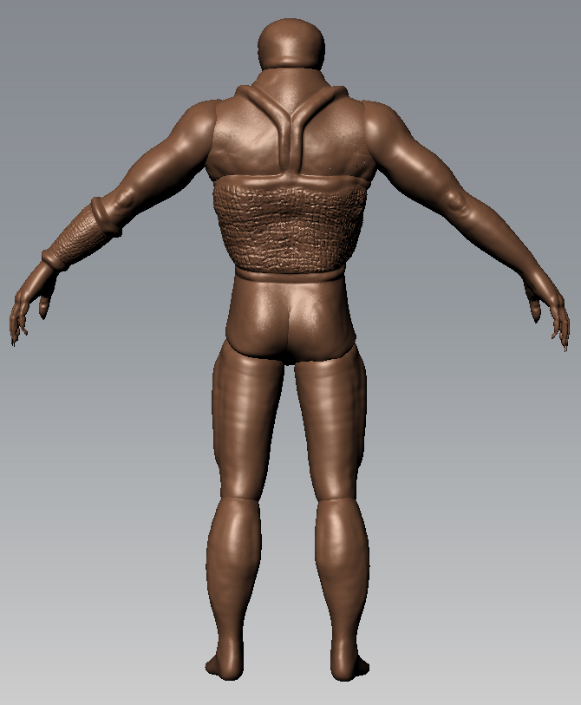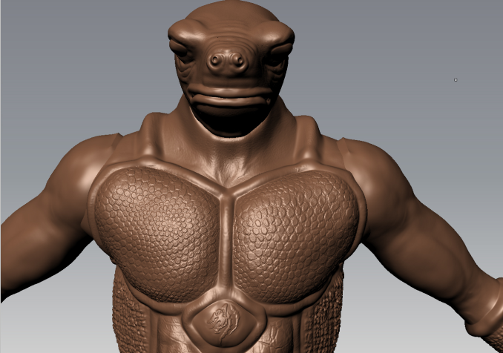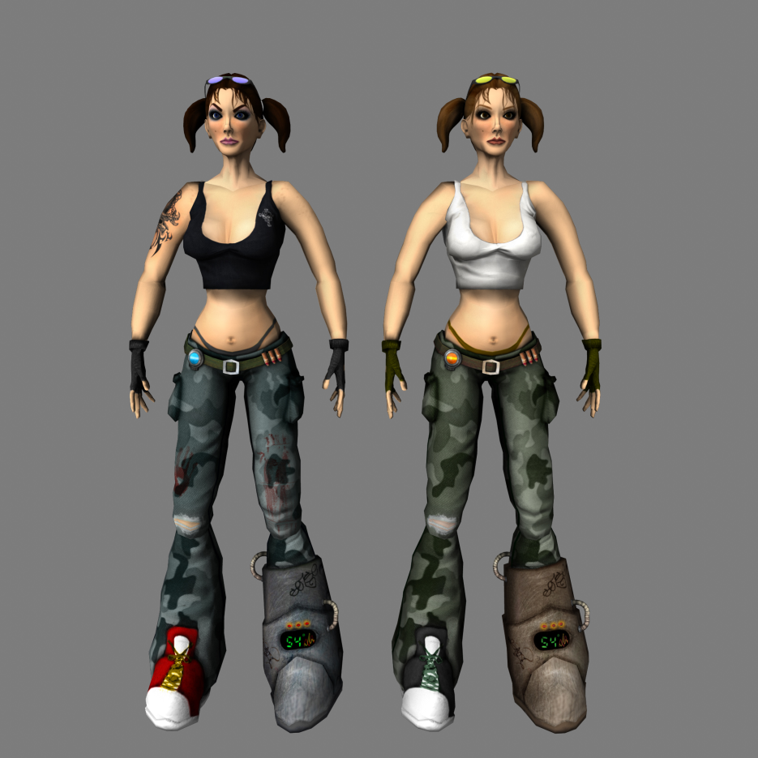
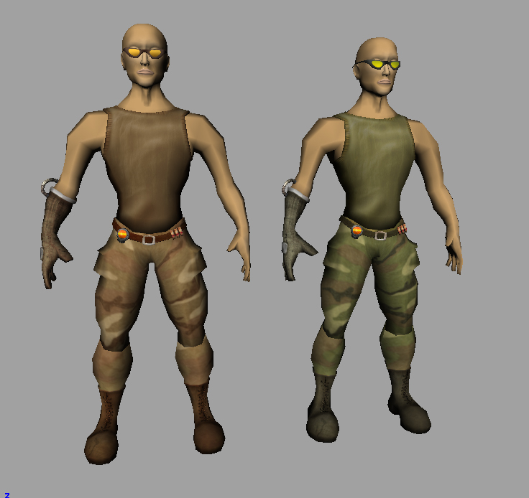
Environments
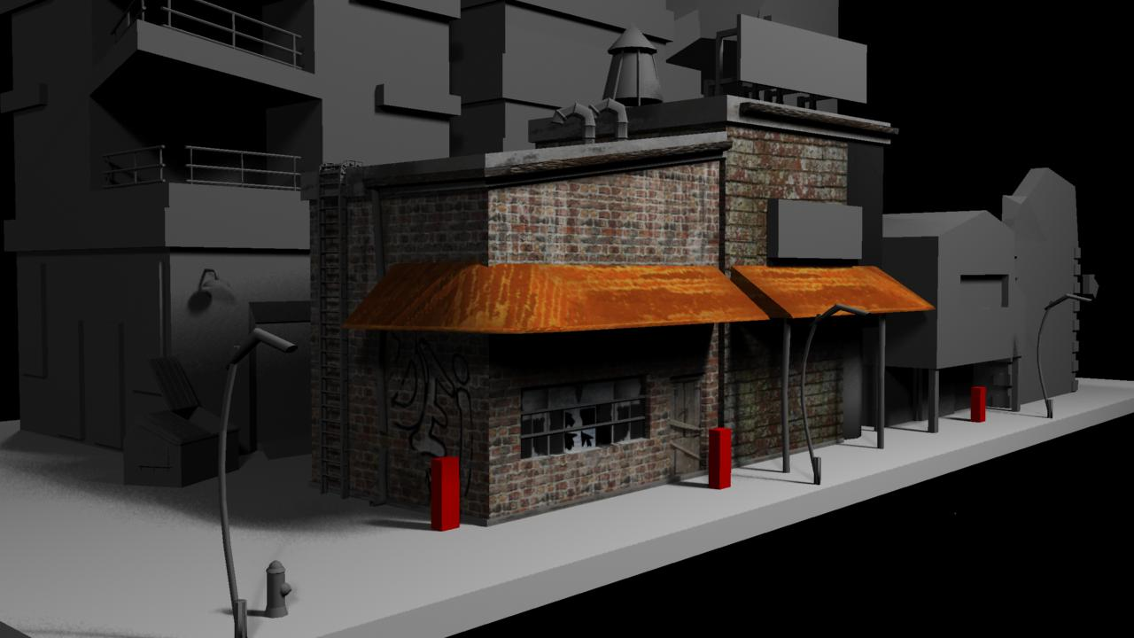
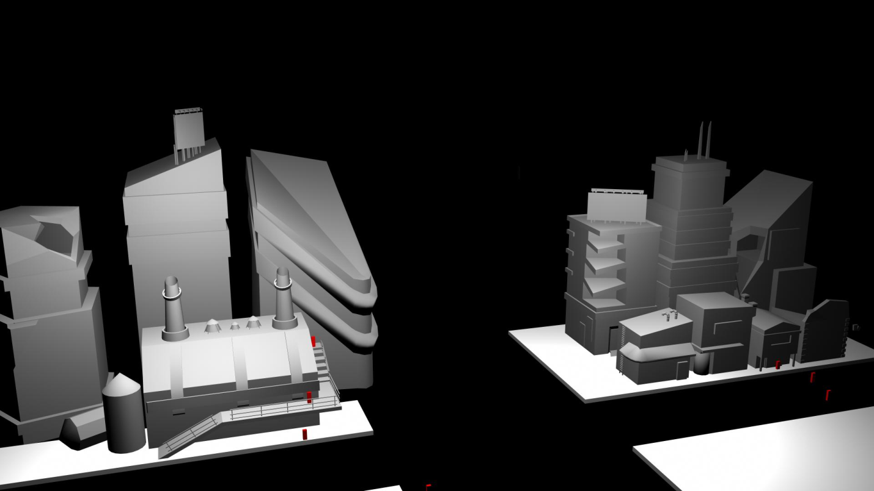
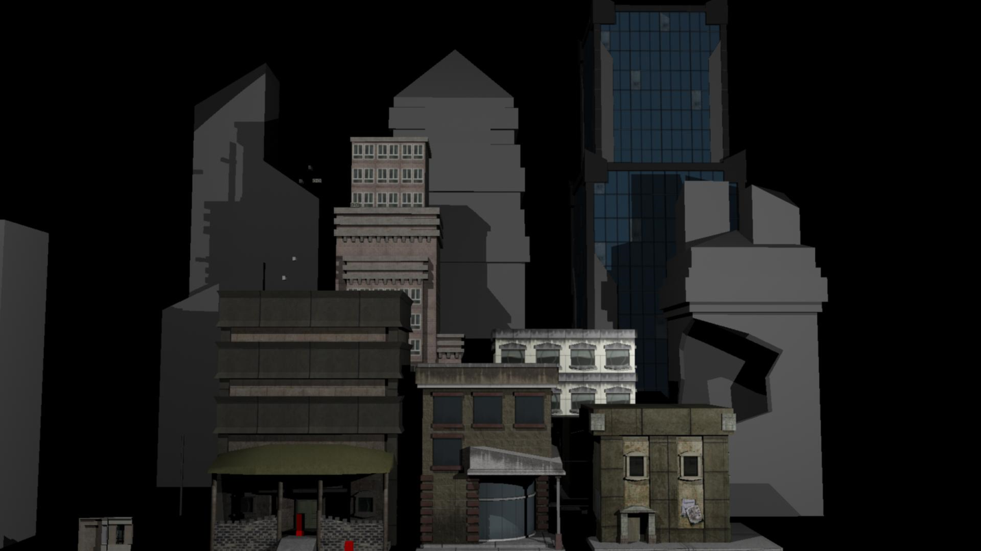
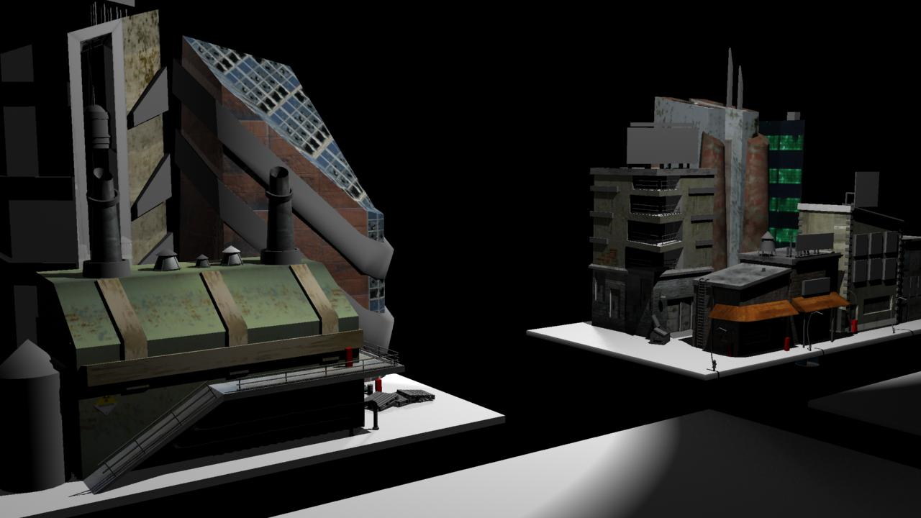
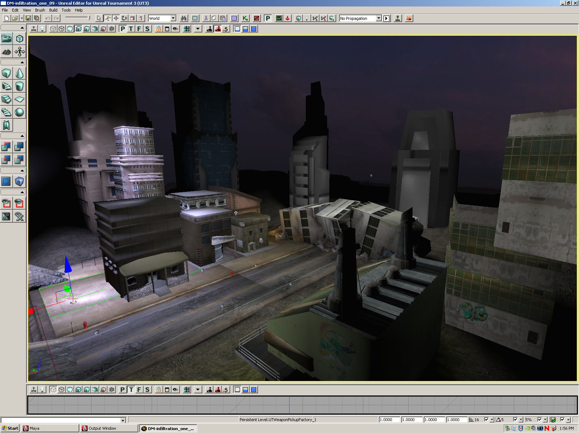

Management
Schedule
The game will be produced in a 20 week period.
Programming
Programmers will be given a 4 week period to learn the environment and structure of the scripting language. Once the programmers have familiarized themselves with the environment they will begin with creating the human side client for the game. The human side client will take an estimated 5 weeks. After the human side client will be the alien side client, which will take an estimated 6 week period. Following will be a synergy of the clients over a server which will take 3 weeks. Following this there will be testing for 2 weeks to ensure that the two clients interact properly and that the game functions as intended.
Art
Art will be managed by students from CCS.
First sketches of the characters and buildings will be made. 2 weeks.
Next a model of characters and buildings will be made. 3 weeks.
Hit boxes will be added to the characters and buildings. 1 week.
The levels will be created. 4 weeks.

Budget
The budget will be $40 so the game can be purchased. No more money is needed since both artists and programmers are college students and do not require payment.
Risk Analysis
Risks to be considered:
Programmers cannot learn the language in time- This will set the project back the amount of time it actually takes to learn the environment minus the time estimated to learn the environment. This risk cannot be managed aside from stressing to learn the environment faster.
RTS controls/camera will not work- Currently unknown if the current compiled version of unreal engine 3 will support an RTS mode. The fix for this will be to convert the game into a deathmatch game.
Test Plans
Strategy
UI Testing
- Test human player HUD, correct health & ammo
- Test in game settings
- Test options menu
- Test main menu
Game Play Testing
- Test player hit boxes
- Test weapon damage
- Test win conditions
- Test controls while playing the game
Other Testing
- Test installer
- Test sound effects and audio
Schedule
Week of 4/5/2009 – Finish Beta and determine test plan
Week of 4/12/2009 – Work on final version with Beta Reviews in mind
Week of 4/19/2009 – Test final version and tweak balance of humans and aliens
Week of 4/26/2009 – Finish game and testing
Test Results
Strategy
UI Testing
- Test human player HUD, correct health & ammo - Success
- Test in game settings - Success
- Test options menu - Success
- Test main menu - Success
Game Play Testing
- Test player hit boxes - Success
- Test weapon damage - Success
- Test win conditions - Success
- Test controls while playing the game - Success
Other Testing
- Test installer - Success
- Test sound effects and audio – Success

Test Result Summary
All tests were successful.

Failures
In our attempt to implement the RTS style camera for our game, we first tried the built in kismet scripting editor. The Kismet editor uses visual style “puzzle pieces” to simply the unreal 3 scripting process. Simple programming techniques such as the use of loops and variables are available throught kismet. However, through trial and error, as well as consulting online sources, we determined Kismet was limited in its ability. It was restricted to moving pre-built level objects, and not complex tasks like manipulating the camera. This left us with approaching the changing of the camera through the use of written scripting.

Without a textbook to assist us with learning the subtleties and structure of the unreal 3 scripting language, we turned to the Internet. Our main source of information came from the Unreal Development Network(UDN), located at http://udn.epicgames.com/Three/UT3ModHome.html . Unfortunately the tutorials on this site left much to be desired. Aside from the language syntax tutorial, a majority of the documentation consisted of a brief description, and then directed us to read the source code. We were able to determine the file structure, as well as how to compile our code from various forum posts, the most notable being http://forums.epicgames.com/showthread.php?t=638009&highlight=total .

We began by creating a custom game type; the Infiltration game type. After downloading the source code for the unreal 3 scripting engine(freely available at UDN) we modified the PlayerController class which handles the player's control during the game. Several online sources recommended that we change the player controller to release the camera used and attach it to a floating pawn object. First we tried creating a subclass of the PlayerController to maintain proper object oriented design. However upon compilation, we found that this did not produce any change in the game play of our Infiltration game type. So purely for testing purposes, we modified the original PlayerController.uc class file. After doing a full recompilation with no errors, we found that once again after moving the compiled .u files to the proper directory, that again nothing changed in our game type. Unable to move beyond this setback, we tried to change a different aspect of our game.

Using tutorials from the UDN we began trying to do a simple HUD change for our game type. We began by following the UDN tutorial exactly to get a base HUD mod off the ground. After creating a subclass of the proper HUD.uc file, we recompiled the code and got several errors, seen in the below screenshot.
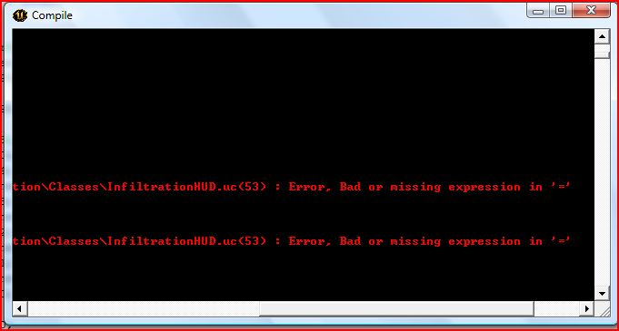
This error was puzzling, as the line in the code not only had proper expressions, but was taken from a working online tutorial for testing purposes. After a week or so of searching for the reason it would not work, we determined creating out own HUD was not feasible with our current knowledge of the unreal 3 technology.

