Overview
Concept
In the future, combat sports are the most popular form of entertainment. Drone Hockey, a descendent of an ancient game, stands out as the most popular of all combat sports. Players compete for fame, fortune, and glory in the brutal hockey arenas of the Galactic Drone Hockey League (GDHL).
Drone Hockey is a FPS/Sports game hybrid. Players can enjoy blasting each other and the puck across the arena as they vie for dominance.

Target Audience
The target audience for this game is males in the teen-young adult range who enjoy multiplayer FPS-type games. The mechanics that appeal to this demographic are competition (especially with other human players), violence, and overcoming obstacles/solving problems.

Game Flow Summary
The player begins in a Drone Hockey Arena teamed up against other human players. Using the weapons available to them, players attempt to push the Drone through the opposing team’s goal. When one team accomplishes this, they score points and everyone is transported back to their starting location, and a new Drone is dropped. Players continue as before until one team reaches the game score limit or time is up and one team is ahead.

Look and Feel

Project Scope (Use Cases & Requirements)
Functional Requirements:
Weapon fire moves the Puck Drone
Puck attempts to evade players
A goal is scored once puck enters the goal
Weapon Crosshairs should work the way they’re supposed to
Puck briefly enters stunned state once hit’
Puck should respawn after death
Game goes into sudden in case of a tie at time over

Non-Functional Requirements
Weapons should have unique feel to them
Opening should have a matinee
Weapons should have unique skins

Game Mechanics
Game Play
Game play is like any other First Person Shooter, save for the objective of the game is to Basic game play works much like other FPS. Players use various ranged weapons to hit targets. Object of the game is to score points by blasting the puck-drone into the opponents goal.

Mechanics
The players have weapons available to them that they fire to apply an impulse to game characters such as other players or the Drone. They travel around the arena and use these weapons to push the Drone into a goal in an attempt to score points for their team.

Screen Flow
[Main Menu]=>[Map Selection]=>[Loading Game]=>
[Waiting for Players]=>[GamePlay]

Game Options
There are no special options for Drone hockey.

Replaying/Saving
Drone Hockey is a brutal and dangerous sport. There is no room for mistakes or weakness. Just like real life, if you make a mistake or walk away, you must live with the consequences.

The game is infinitely replayable, due to the multiplayer nature.

Story & Characters
Story & Narrative (flowchart)
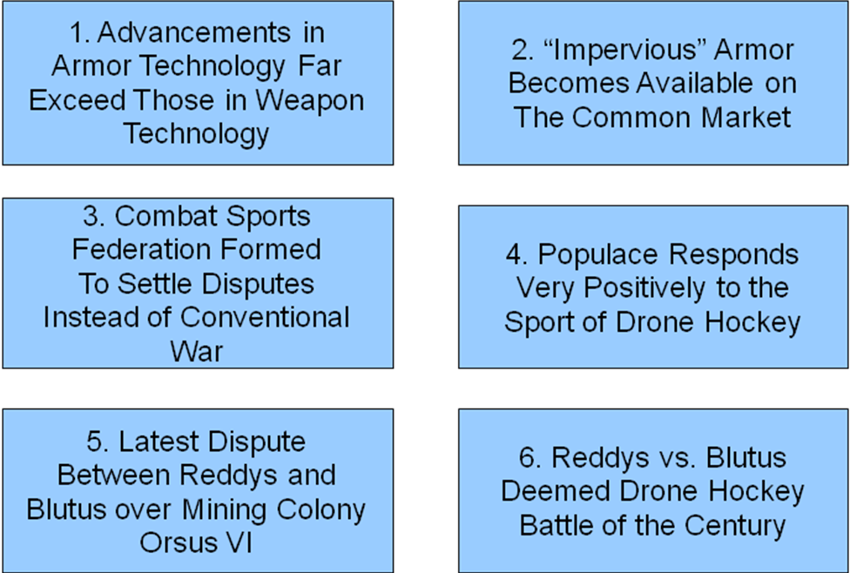

Game World
The world of Drone Hockey centers around the Arena. Drone Hockey is the most popular form of entertainment in the galaxy, and as such it is the focus of thousands of planets and species. As the sport is an acceptable alternative to armed conflict, entire Empires rise and fall with the success of their sponsored teams.

Character Bibles
See power point presentation

Level Summaries
Level Outlines
See power point presentation or levdesemp.doc for more details
Training Level Details
There is no training level

User Interface
Visual System (screenshots)
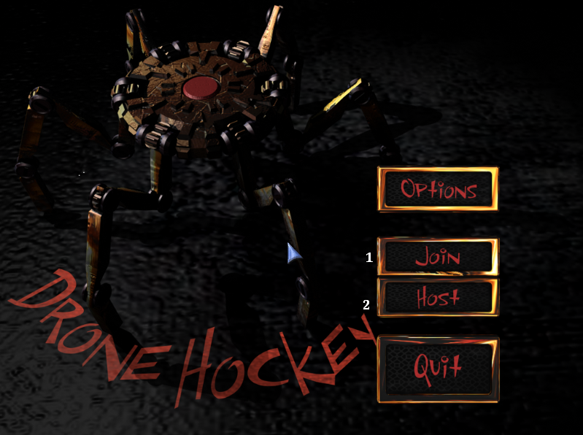

Control System
The players use keyboard and mouse to control their avatar. Keyboard controls are customizable but default to WASD for movement, SPACE to jump. Mouse controls are also customizable and default to Left-click to fire the primary mode of their weapon, Right-click to fire the secondary effect.

Audio
Bot screams like R2D2 when hit, emits other robot noises

Music
We are currently looking for appropriate hockey music

Sound Effects
The standard sound effects from Unreal Tournament will be used to provide player feedback. Firing sound will indicate the use of guns, grunts and yells will be heard to indicate action against players. A voiceover will indicate when a team has scored and will countdown to the new round.

Help System
No special help system is planned for this game.

Artificial Intelligence
Opponent AI
All opponents in the game are played by humans, so there is no opponent AI.

Enemy AI
The Drone, although it does not fight the players, is considered the enemy. Its behavior consists of moving erratically around the arena in an attempt to survive. It will also generally try to flee from nearby players.

Non-combat Characters
There are no innocent bystanders in Drone Hockey.

Friendly Characters
All friendly characters to the player (i.e. teammates) are played by humans.

Support AI
The game handles scoring and game logistics. It detects when the drone has entered a goal and allots points to the scoring team. It also resets players to the start locations and handles the introduction of a new Drone.

Technical
Hardware
UT2K4 SPECS

Software
Software used includes:
- Unreal Tournament 2004
- UnrealEd
- Maya
- 3D Studio Max

Procedures & Standards
- Baldwin Game Design Template
- UML (Use Case, Class, State, and Activity Diagrams)
- Flowcharts
- Waterfall/Incremental Model

Art
Concept Art
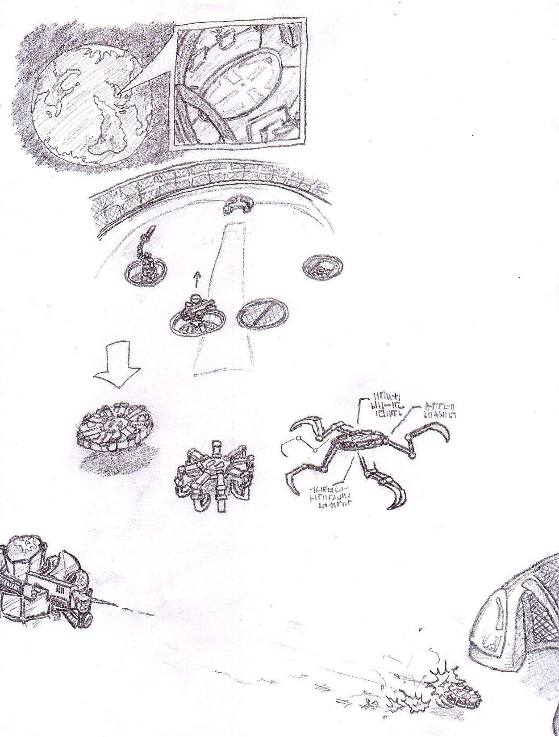
Characters
Players will be represented by the standard models provided by Unreal Tournament 2004. The Drone will be a special model borrowed from previous projects.

Environments
The game takes place entirely within a Drone Hockey arena. This arena is modeled after a real hockey arena and Drone Hockey specific models have been created and added to the arena.

Management
Schedule
In management documents

Budget
In management documents

Risk Analysis
In management documents

Test Plans
Strategy
The testing will concentrate on the player experience to ensure the game behaves as appropriate to the game concept. The game engine will be assumed to behave correctly. The following mechanics will be tested:
- Weapon fire / effects
- Scoring
- Game end
- Drone behavior
More info in testing documents

Schedule
More info in testing documents

<USER MANUAL> (In documents)
<PROTOTYPE> (In documents)
<COMMENTED SOURCE> (see http://www-personal.engin.umd.umich.edu/~aaronmcc/DroneHockeyGold.zip)

