Final Design Document
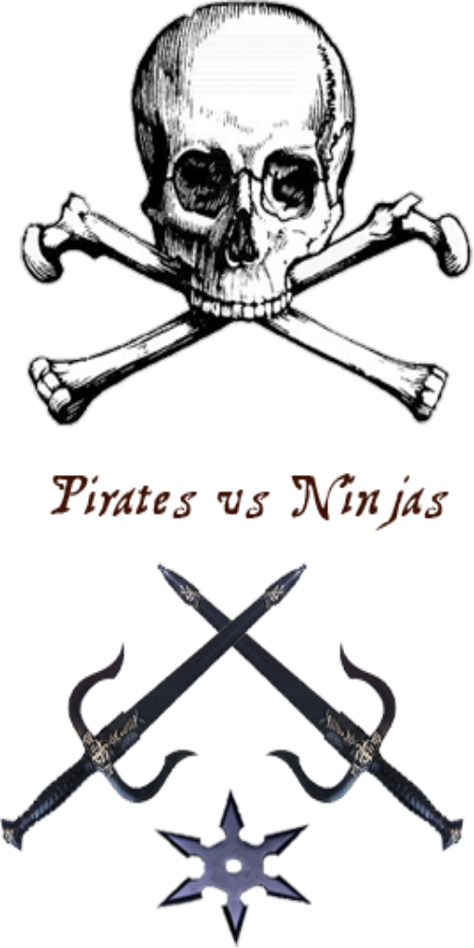
James Walker
Don Lonser
Mike Alff
Chris Pieprzak

1. Overview 3
1.1 Requirements 3
1.2 Use cases 3
2. Game Mechanics 4
2.1 Overview 4
2.2 Camera Position 4
2.3 User Interface Design 4
2.4 Replaying and Saving 4
2.5 Control Summary 4
2.6 Game Play Details 5
2.7 Cut-Scenes 5
2.8 Storytelling 5
2.9 Level Summary 5
3. Artificial Intelligence 7
3.1 Opponent AI 7
3.2 Player Detection 7
3.3 Motion 7
3.4 Path Finding 7
3.5 Special Actions 7
3.6 Combat 7
3.7 Non-player Characters 7
3.8 Puzzles and Traps 7
4. Game Elements 8
4.1 Data dictionary 8
4.2 Character Bibles 9
4.2.1 Standard Pirate 9
4.2.2 Standard Ninja 9
4.2.3 Grimjaw 9
4.2.4 Mr. Miagi 9
5. Story Overview 10
5.1 Storyboard 10
5.2 Plot Summary 12
6. Game Progression 13
6.1 Setting 13
6.2 Introduction 13
6.3 Flowchart 14
6.4 Level and Scene Details 14
7. Testing Information 16
7.1 Strategy 16
7.2 Test cases 16
7.3 Schedule 17
8 UML Diagrams 18

1. Overview

1.1 Requirements
Pentium III or AMD Athlon 1.0 GHz processor (Pentium® or AMD 1.2GHz or greater recommended)
128MB RAM (256MB RAM or greater recommended)
5.5GB HDD space REQUIRED
8X CD-ROM or DVD
Windows® compatible sound card
32 MB video card required (64 MB NVIDIA or ATI hardware T&L card recommended)
DirectX® version 9.0b (included on game disc)
Internet (TCP/IP) and LAN (TCP/IP) play supported. Internet play requires a 33.6 kbps or faster modem (broadband recommended)

1.2 Use cases
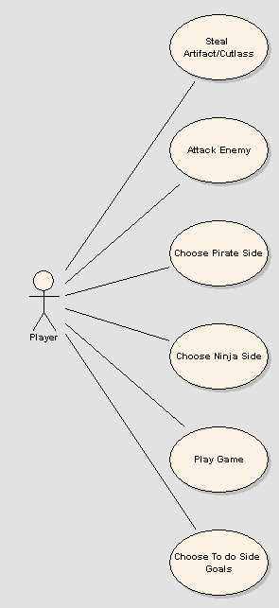

2. Game Mechanics

2.1 Overview
The game will be a first and third person view shooter. The player will run around the environment and combat the other team using melee and ranged weapons. The environment will range from a rugged pirate ship, to a colorful and lush jungle, to a dark and shadowy ninja base

2.2 Camera Position
Camera position will be third person view by default with the option of switching to a first person view.

2.3 User Interface Design
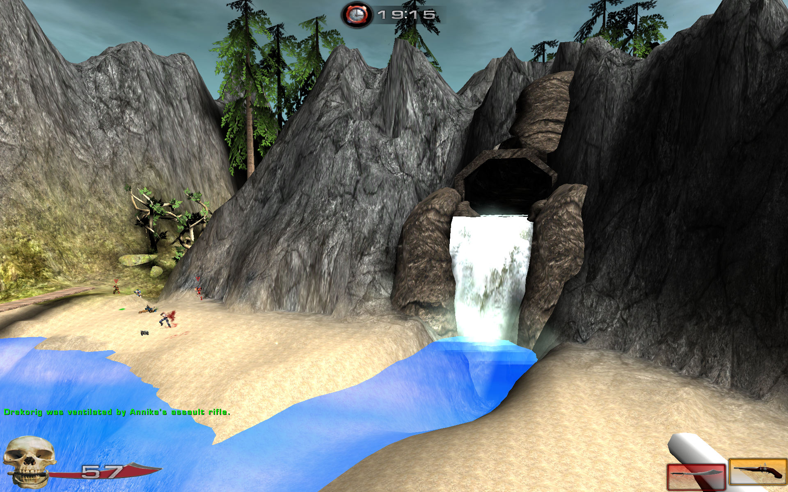
The PVN User Interface features a clock at the top, the weapons on the bottom right (With the selected weapon being larger), and on the left a numeric display of health with a team specific icon. The pirates see the skull and sword, and the ninjas see a Dragon and katana.

2.4 Replaying and Saving
You cannot save your game. When you finish the game you may replay it and choose sides again.

2.5 Control Summary
W – Move Forward
A – Move Left
S – Move back
D – Move Right
Space – Jump
Left Click – Main attack
Right click – Special attack
1 – Melee Weapon
2 – Ranged Weapon

2.6 Game Play Details
The player will choose to either be a pirate and will join in the open war against the ninjas. There will be other pirate and ninja NPCs that are constantly fighting and they should be fairly stable with no side winning without player involvement. The player’s role is to tip the scales by either open combat or by completing tasks.

Strategies and Motivations
Open assault against either side should be fairly ineffective unless the player is skilled. If they want to fight on open ground without strategy they should be allowed to do so, but the easier way would be strategically place themselves in the environment and utilize their team mates to overcome the enemy forces.

2.7 Cut-Scenes
There will be two cutscenes in the game, the intro cutscene where the player is introduced into the game by the pirate Grimjaw, and the ending cutscene where the player successfully brings the relic back to the ship.

2.8 Storytelling
The primary storytelling will take place using the intro, which will describe the situation to the player. Also, during the first cutscene the player will be exposed to more of the storyline. The ending of the story will be done with the ending cutscene.

2.9 Level Summary
The level will be divided into three parts, the pirate ship, the beach/forest area, and the ninja base.

The pirate ship will be an overly elaborate and moderately large ship that the pirates will start out at and spawn from. It will be made of wood and will have detailed decorations inside of it. It should be gritty and real, but not overly worn or ragged. It should have multiple levels for players to interact with and complete goals. The pirate ship would come close to the shore and the players should be able to either jump off into the water and wade towards the shore, or use the singular walkway down it.

The forest area curves around a mountain in an upward fashion and has thick vegetation. There is a river and a waterfall that runs through it close to the ninja base, and has a bridge to cross the river. At the end of the river is a cave that can be used to quickly arrive at the pirate ship.

The ninja base should be mostly underground with above ground defense areas and mechanisms to repel the pirate invaders. Inside it should be a fairly unelaborated dungeon type area with lots of features that help the ninjas fight, such as dark corridors and close quarters.

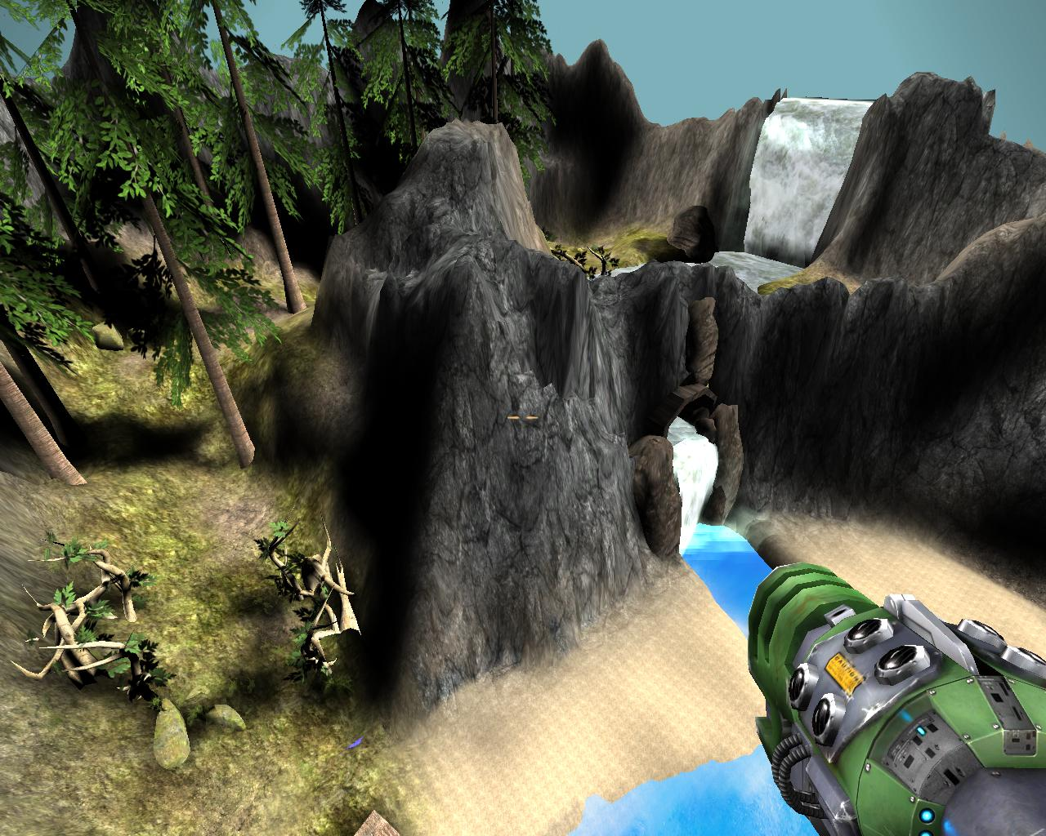

3. Artificial Intelligence

3.1 Opponent AI
The opponent AI will largely use the UT2004’s AI system. The ninjas and pirates will spawn and be destined to attack the main base. However, the two bosses will be specially programmed to stay near their bases and defend them.

3.2 Player Detection
The player detection mechanism will be the standard mechanism used by UT2004

3.3 Motion
The motion of the bots will be pre-programmed animation files that are embedded within the models themselves.

3.4 Path Finding
The path finding of the bots will utilize the waypoint system that will be placed throughout the map.

3.5 Special Actions
The special actions that the bots will carry out are the two bosses that will guard their respective bases.

3.6 Combat
The bots will use their swords and guns/stars against the player and other bots of the opposite teams.

3.7 Non-player Characters
The NPCs in the game are your teammates and your opponents. The pirate boss will be more interactable and will play a role in the first cutscene.

3.8 Puzzles and Traps
There will be no puzzles or traps in Pirates vs. Ninjas

4. Game Elements

4.1 Data dictionary
CutlassPickup | UTWeaponPickup | Weapon Pickup | -
Katana | Weapon Config | Weapon | -
KatanaAltFire | WeaponFire | Weapon Fire | DestroyEffects, DoFireEffect, PlayFiring, StopFiring, TakeHit, StartBerserk, StopBerserk, StartSuperBerserk, SetBrightness, DrawMuzzleFlash, Timer,
KatanaAmmo | Ammunition | Cutlass Ammo | -
KatanaAttachment | ShieldAttachment | Attachment | -
KatanaFire | WeaponFire | Weapon Fire | DestroyEffects, InitEffects, DrawMuzzleFlash, AdjustAim, DoFireEffect, ModeHoldFire, IsFiring, Timer, GetFireStart, StartBerserk, StopBerserk, StartSuperBerserk, PlayPreFire, PlayFiring,
KatanaPickup | UTWeaponPickup | Weapon Pickup | -
PirateGun | Weapon config | Weapon | replication, Loaded, PostNetBeginPlay, WeaponCentered, RenderOverlays, RenderDualOverlay, DetachFromPawn, AttachToPawn, DrawWeaponInfo, BestMode, HandlePickupQuery, MaxAmmo, GetAIRating,
PirateGunAttachment | ShieldAttachment | Attachment | -
PirateGunFire | WeaponFire | Weapon Fire | DestroyEffects, InitEffects, DrawMuzzleFlash, AdjustAim, DoFireEffect, ModeHoldFire, IsFiring, Timer, GetFireStart, StartBerserk, StopBerserk, StartSuperBerserk, PlayPreFire, PlayFiring,
PirateGunPickup | UTWeaponPickup | Weapon Pickup | -
pvnHUD | HudBase | HUD | GrowHUD, ShrinkHUD, UpdatePrecacheMaterials, PostBeginPlay, CustomCrosshairsAllowed, CustomCrosshairColorAllowed, CustomHUDColorAllowed, SetCustomCrosshairs, SetCustomCrosshairColors, SetCustomHUDColor, CheckCountdown, UpdateHud, DrawTimer, CalculateHealth, IsInCinematic, DrawSpectatingHud, GetInfoString, DrawHUDAnimDigit, DrawHUDAnimWidget, DrawCrosshair, DrawEnemyName, DisplayEnemyName, FadeZoom, ZoomFadeOut, DrawHudPassA, DrawHudPassC, DrawWeaponBar, DrawLevelAction, LoadLevelActionFont
PvNPawn | xPawn | Pawn | -
PvNtGame | xCTFGame | Game | -
Shuriken | Weapon config | Weapon | replication, Loaded, PostNetBeginPlay, WeaponCentered, RenderOverlays, RenderDualOverlay, DetachFromPawn, AttachToPawn, DrawWeaponInfo, BestMode, HandlePickupQuery, MaxAmmo, GetAIRating,
ShurikenAmmo | Ammunition | Cutlass Ammo | -
ShurikenAttachment | ShieldAttachment | Attachment | -
ShurikenFire | WeaponFire | Weapon Fire | DestroyEffects, InitEffects, DrawMuzzleFlash, AdjustAim, DoFireEffect, ModeHoldFire, IsFiring, Timer, GetFireStart, StartBerserk, StopBerserk, StartSuperBerserk, PlayPreFire, PlayFiring,
ShurikenPickup | UTWeaponPickup | Weapon Pickup | -

4.2 Character Bibles

4.2.1 Standard Pirate
The standard pirate is your class. Other pirates will spawn at the pirate ship and will path towards the ninja base. The standard pirate is a dirty and lumbering drunk that comes equipped with a cutlass and a pistol.

4.2.2 Standard Ninja
Ninjas will spawn at the ninja base and will path towards the pirate ship. The standard ninja is a clean and sneaky person that comes equipped with a sword and ninja stars.

4.2.3 Grimjaw
Grimjaw is the boss pirate and will stay near the pirate ship as his pirate underlings assault the ninja base. Grimjaw possesses similar abilities, but greater power than normal pirates.

4.2.4 Mr. Miagi
Grimjaw is the boss ninja and will stay near the ninja base as his ninja students assault the pirate ship. Mr. Miagi possesses similar abilities, but greater power than normal ninjas.

5. Story Overview

5.1 Storyboard
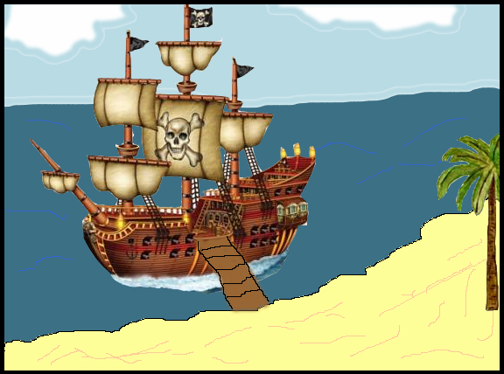
The pirate Grimjaw docks his boat near the ninja base, Ch’I, sending his pirates after the ancient relic.
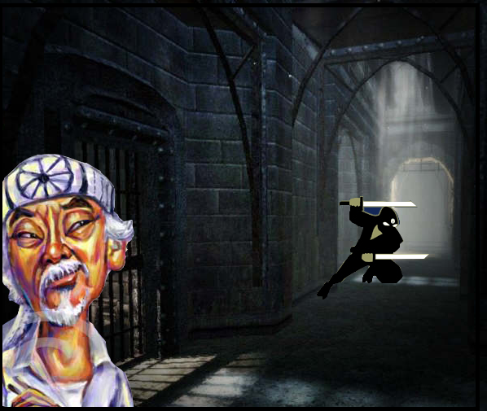
Sensing the arrival of Grimjaw, the ninja master, Chojun Miyagi, instructs his ninjas to both defend the base and go kill Grimjaw
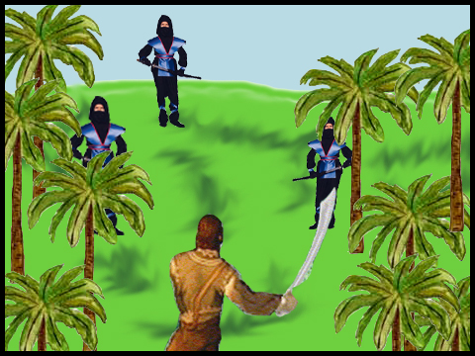
A pirate / ninja battle ensues in the forest between the ship and ninja base.
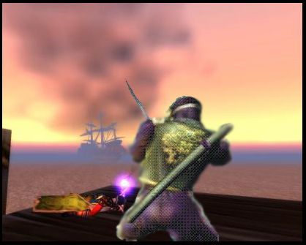
The ninja forces approach the pirate ship with the intention of killing Captain Grimjaw
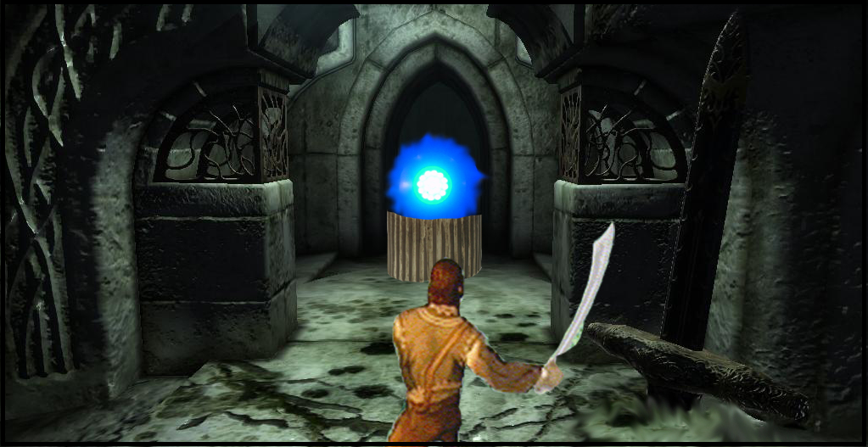
The pirates find the mystical relic and take it in the name of Captain Grimjaw
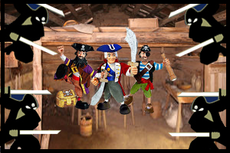
In a fierce final battle, the ninja battle Captain Grimjaw and his first mates.

5.2 Plot Summary
The nefarious pirate, Grimjaw, sets out to command his fleet of scurvy cohorts towards the ninja base of Ch’I. In this ninja base is a valuable ancient relic that gives mystical powers to its inhabitants.

The ninja leader, Mr. Miagi has been aware of the pirate assault for many days and has prepared his ninjas to fight it. He knows that the only way to stop the invasion is to kill their leader.

6. Game Progression

6.1 Setting
The setting of the game is a beachhead with a mountainous jungle that holds a ninja base. The pirate ship is a rugged and decorative ship straight out of Pirates of the Caribbean.

6.2 Introduction
The game starts with a title screen that shows the pirate and ninja symbols and the name of the game. When the player presses a button it moves to the next part of the game that shows the introduction cut scene. When the cut scene finishes, the player resumes control and can play the game.

6.3 Flowchart
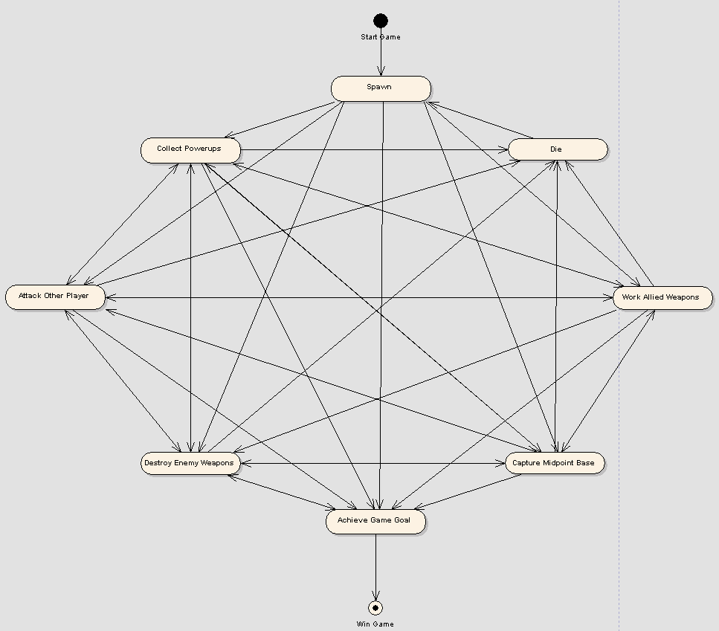

6.4 Level and Scene Details
The map will be split up into 3 sections, the pirate ship, the beachhead/forest area between the ship and the pirate base, and the pirate base itself.

The pirate ship will be an overly elaborate and moderately large ship that the pirates will start out at and spawn from. It will be made of wood and will have detailed decorations inside of it. It should be gritty and real, but not overly worn or ragged. It should have multiple levels for players to interact with and complete goals. The pirate ship would come close to the shore and the players should be able to either jump off into the water and wade towards the shore, or use the singular walkway down it. It should also contain assault mechanisms to kill pirates or weaken their defenses.

The beach head/forest should be fairly standard and not encompass much space. It is there as the open field for the player to fight in and for the ninjas to have an open space to defend against the pirates.

The ninja base should be mostly underground with above ground defense areas and mechanisms to repel the pirate invaders. Inside it should be a fairly unelaborated dungeon type area with lots of features that help the ninjas fight, such as dark corridors and close quarters.

7. Testing Information

7.1 Strategy
As developers produce content they check it for correctness before combining it with the game. After Beta and final games are ready to be examined, a comprehensive test that examines each major game element and ensures it meets specification. Only moderate consideration given to ensure that PvN game is compatible with all computers. If a player meets system specifications, they should be capable to run PvN.

7.2 Test cases
Test Name | Passed?
Player Starts Correctly | Yes
Intro Cutscene performs Correctly | Yes
Player Can Swim | Yes
Invisible Walls near Pirate Ship perform correctly | Yes
Waterfall near Pirate ship moves correctly, has correct mist. | Yes
Pirate ship looks and behaves correctly | Yes
Grimjaw has correct actions and health | Yes
Sand looks and sounds correct. | Yes
Vegetation looks correct and has correct shadows | Yes
Rocks and Mountains on the path to the ninja base look correct | Yes
Waterfall near Ninja Base moves correctly, has correct mist. | Yes
Enemy Ninjas perform correctly | Yes
Guard Cutscene is correct | Yes
River near ninja base moves correctly | Yes
Bridge near ninja base works correctly | Yes
Ninja base looks and behaves correctly | Yes
Mr. Miagi has correct actions and health | Yes
Artifact pickup performs correct sound and events | Yes
Player Returning artifact performs correct cutscene | Yes
End Cutscene performs correctly | Yes
Game ends correctly after cutscene is over | Yes

7.3 Schedule
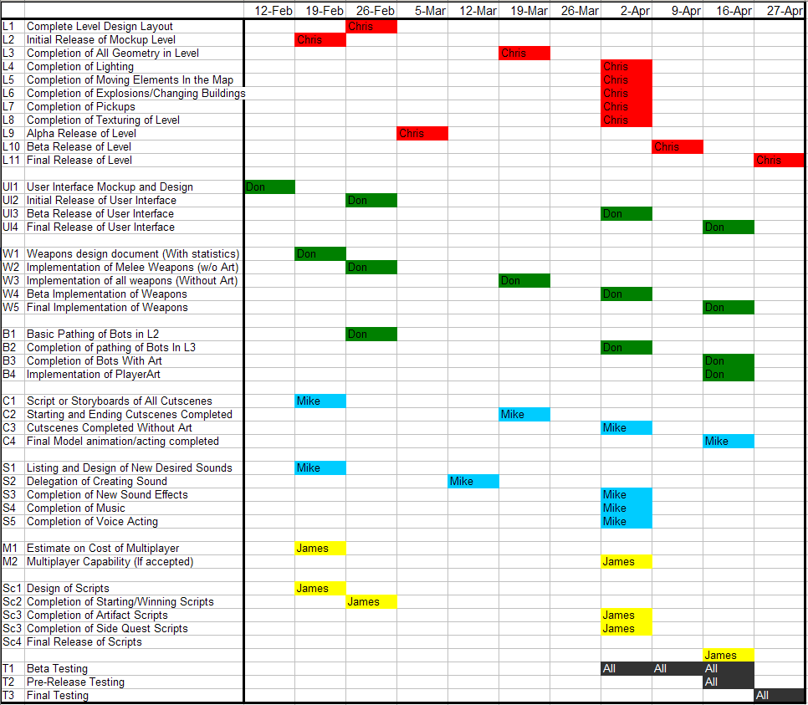

8 UML Diagrams
8.1 Class
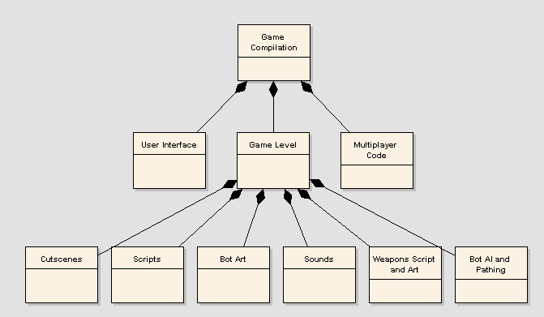
8.2 Use case
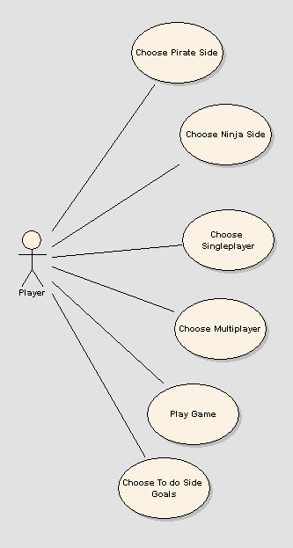
8.3 Sequence
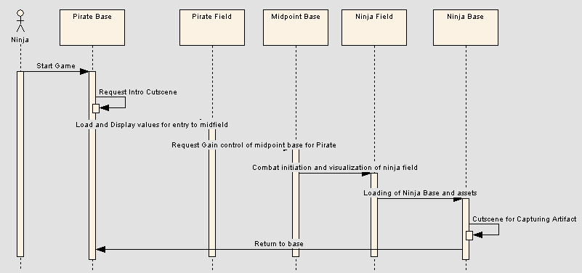
8.4 Collaboration
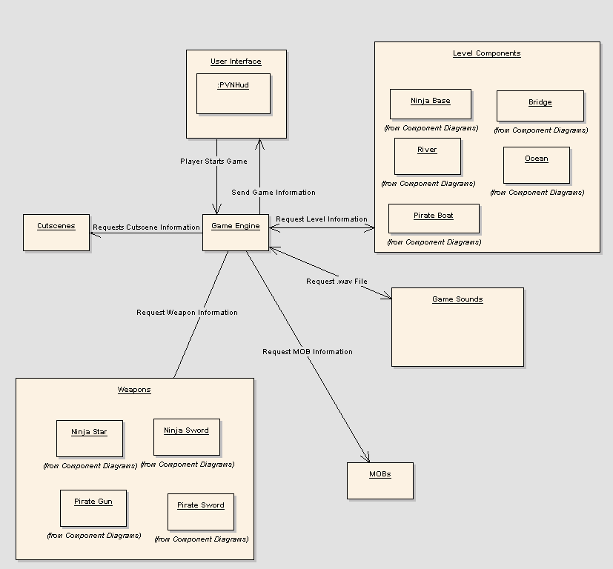
8.5 State
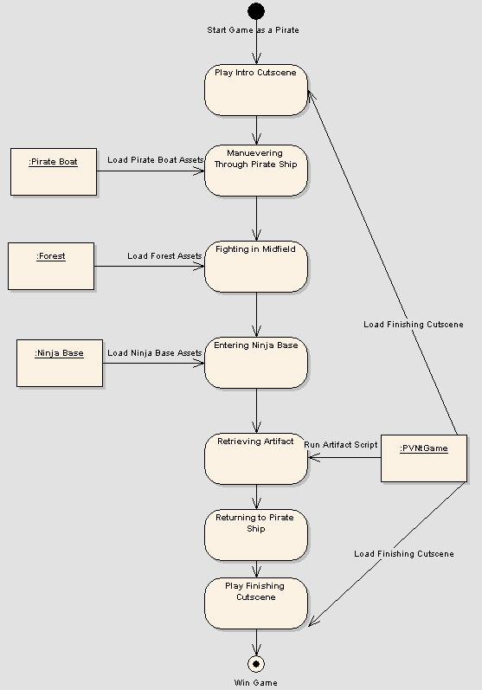
8.6 Activity
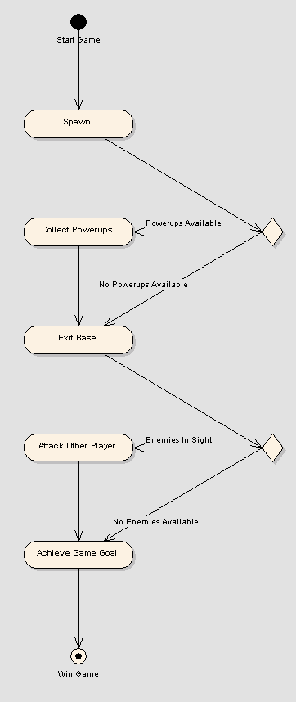
8.7 Component
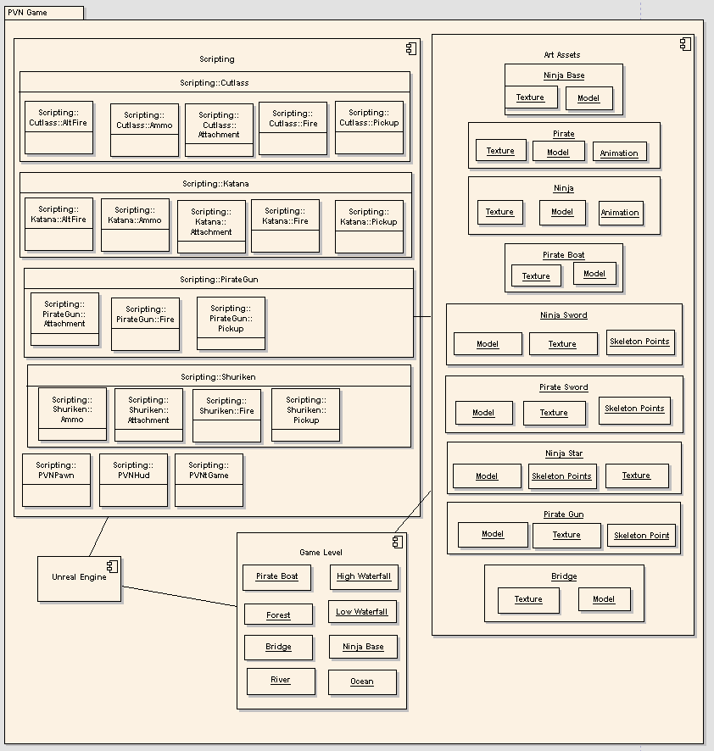
8.8 Deployment


