Senior Citizen Death Squad from Z Future

Design Manual

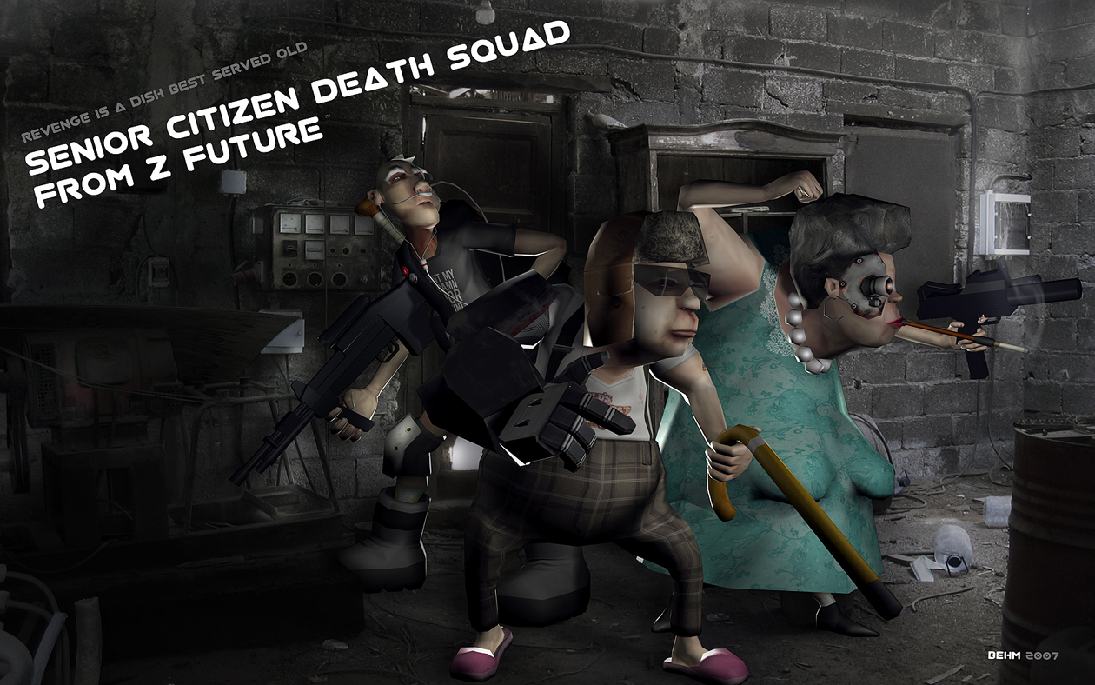

CIS 488
Winter 2007

John Gaffrey
Aaron Stokes
Peter Kinnunen
Michael Manard
John Ljungman

Table of Contents
Design Manual 1
Overview 3
Requirements: 3
Use Cases 3
Game Mechanics 4
Camera 4
Game types 4
Replay ability 5
User Interface Design 5
Controls 6
Level Summary 6
Game Elements 7
Game Elements 8
Character Bibles 8
Data Dictionary 9
Data Dictionary 10
All data are specific unreal classes or .uc files for each object of the game. Other data are the map file, textures, animation/mesh and sound files 10
The specific .uc files are: 10
Artificial Intelligence 10

Overview

Requirements:

- Implement a vehicle combat based game
- Implement four unique characters and vehicles
- Utilize the unreal tournament 2004 engine
- Utilize sound voices and animations to create an overall dark humor atmosphere
- Have realistic physics for each vehicle type
- Create unique game types: Death match, Last man Standing, racing
- The HUD should take up little space, so as to not block the users view of vehicle and surroundings, so only a timer and Health display are necessary

Use Cases
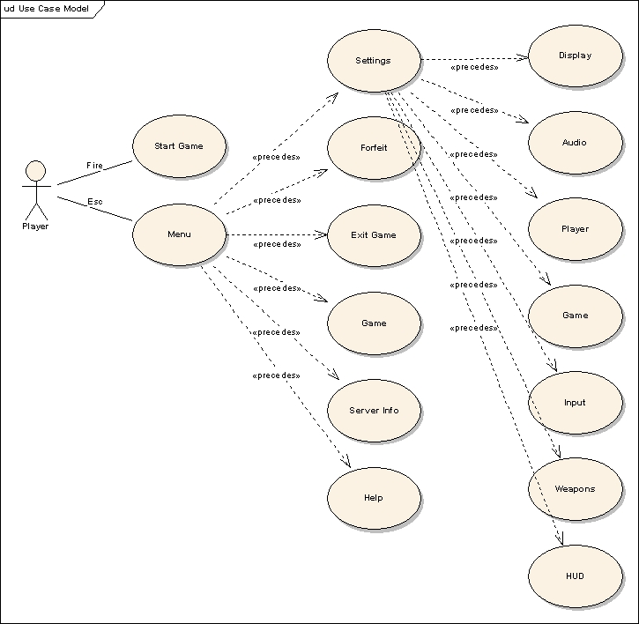

Game Mechanics

Camera

The user will view each vehicle in the third person view by default. A first person is optional and easily changed by using a mouse wheel or the F4 key. Using the mouse wheel can also alter the overall third person view distance of the vehicle. The third person perspective is the preferred view as it gives the best view of the character and vehicle as well as the surroundings.

Game types

Because of the short games, there will be no save feature implemented. In the basic Deathmatch game type, the user must simply battle the other three computer A.I vehicles, and all compete to destroy one another for the highest score. The last man standing gametype is simply a sudden death type of play where the last surviving vehicle wins. There is also a racing type gametype planned to implement if time allows.

Replay ability

Although there is only a single map available to play, playing as one of four unique vehicles and three game types should add to the uniqueness of each time playing. The map also has unique areas and varied terrain that adds to the replay ability.

User Interface Design

Upon starting the death squad mod, the gametype selection menu will be displayed. Upon choosing one, the character select screen will then be displayed for the user to select one, and then the map will load. The HUD (heads up display) only displays a timer at the top of the screen, and a character portrait in the low left corner. The portrait displays an image of the character health status as well as an appropriate color outline based on the player health of the user. There are three portraits for each color.
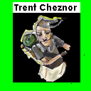
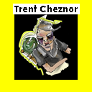
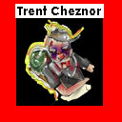

0%-33%
Health
33%-66% Health
66%-100% Health

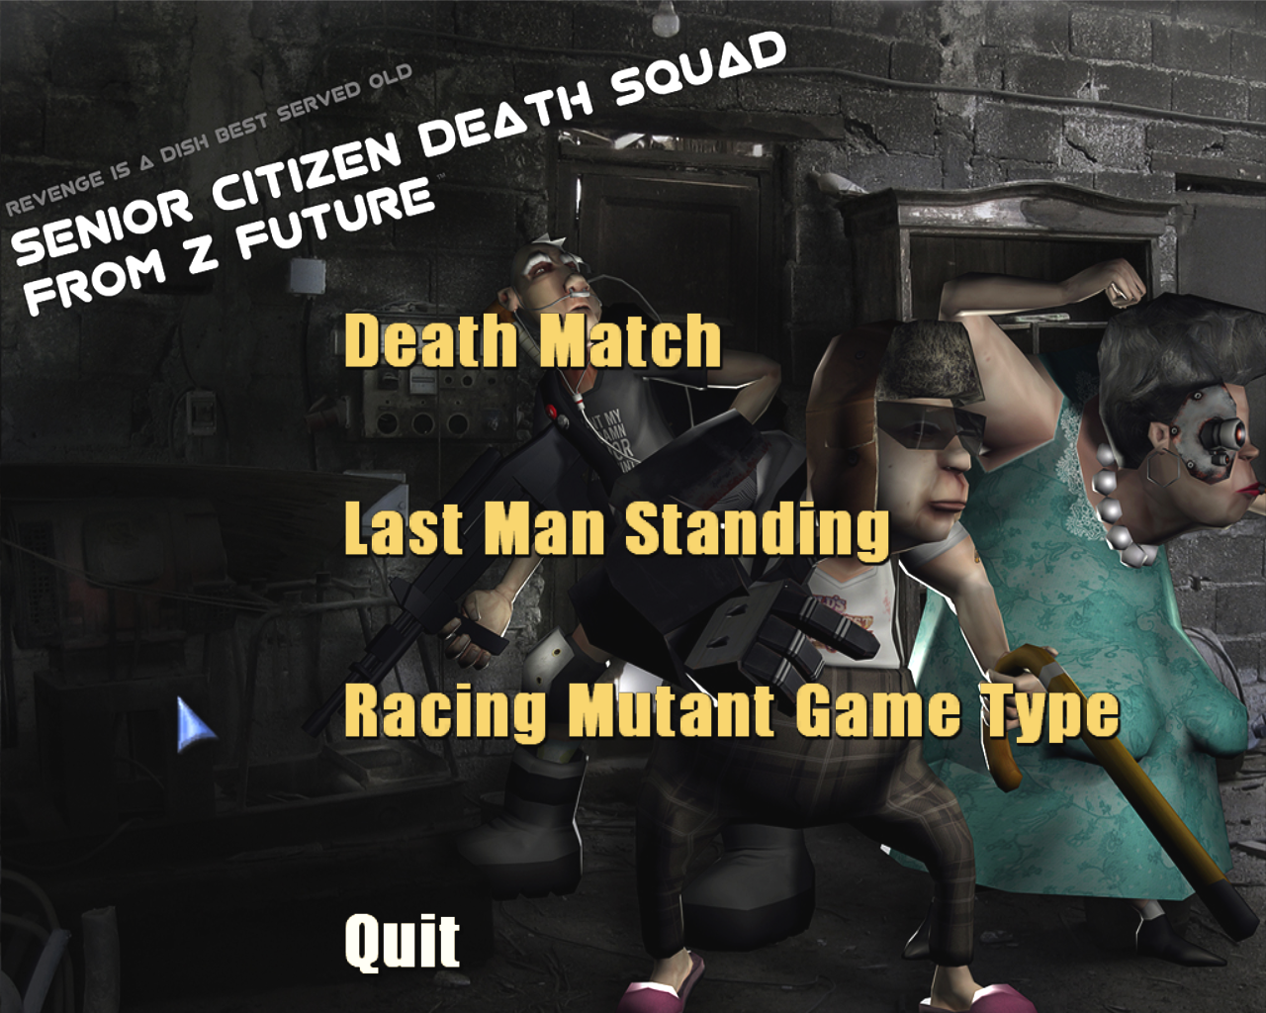
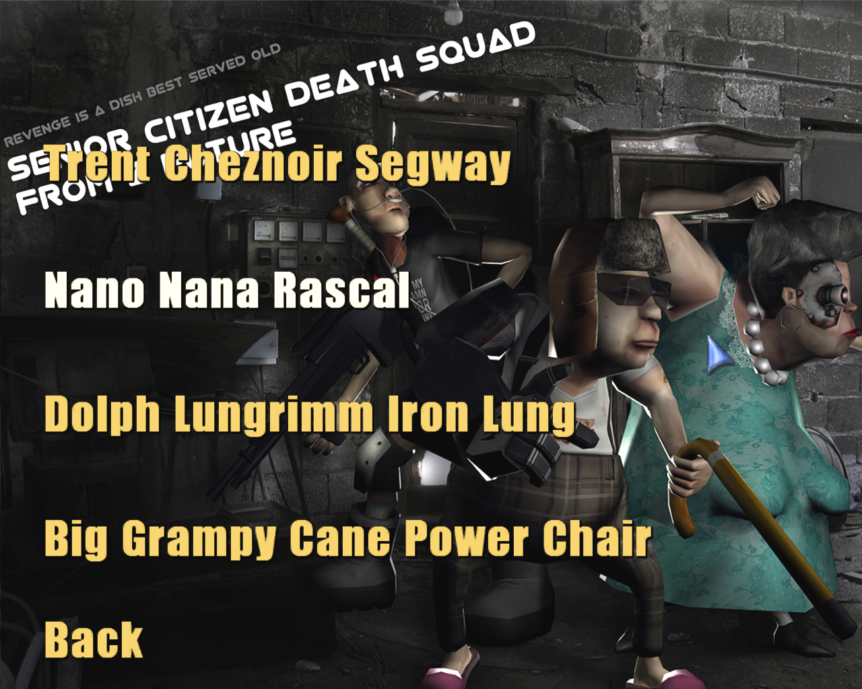

Controls

The only supported input devices are a keyboard and mouse.

Keyboard
Movement | Key
Fire | Left Mouse Button
Alternate Fire | Right Mouse Button
Move Forward (Accelerate) | Up Arrow (or W)
Move Backward (Reverse) | Down Arrow (or S)
Steer Left | Left Arrow (or A)
Steer Right | Right Arrow (or D)
Exit, ut2004 menu | Esc
Change Perspective | F4
Change view distance | Mouse wheel

Level Summary

The map is a futuristic death arena, that sort of looks like a motor derby battle arena. Differant parts of the map are advantagous or disadvantagous to certain vehicles. The map contains some ramps for lighter vehicles, and high points for slower bulkier vehicles to defend
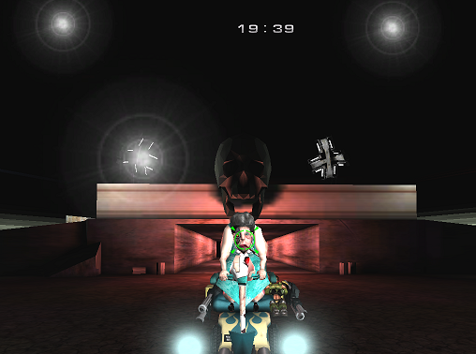

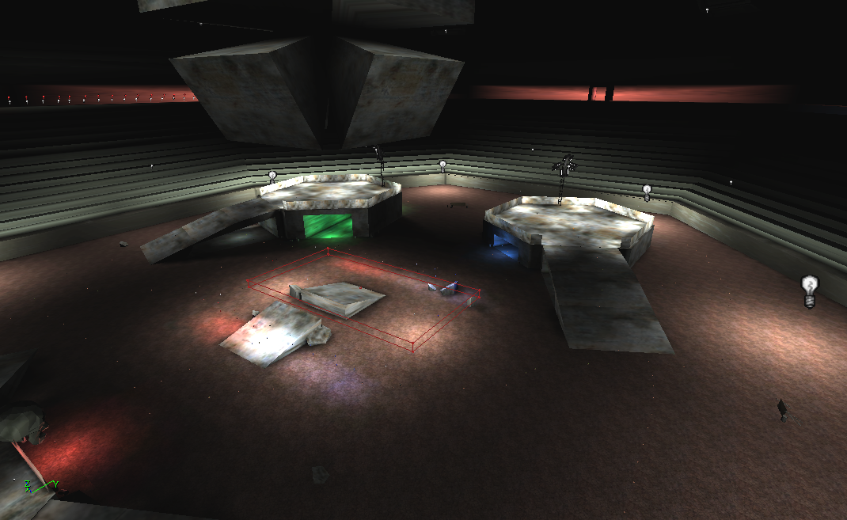

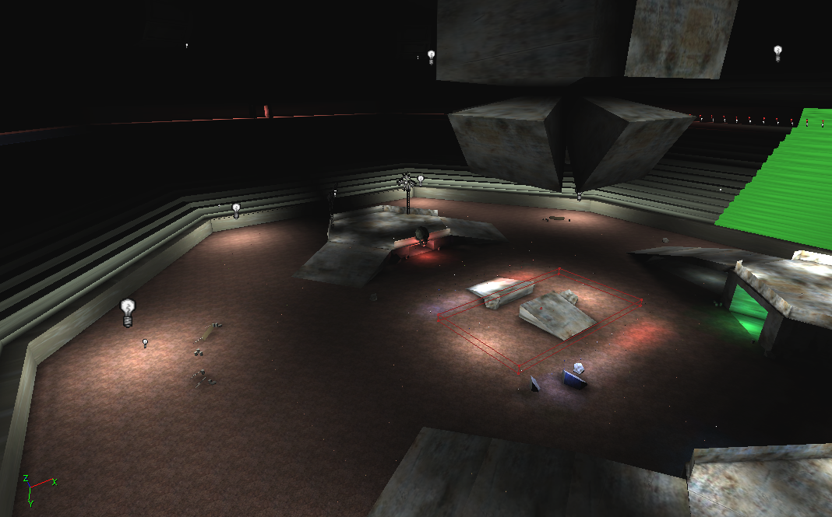

Game Elements

Character Bibles
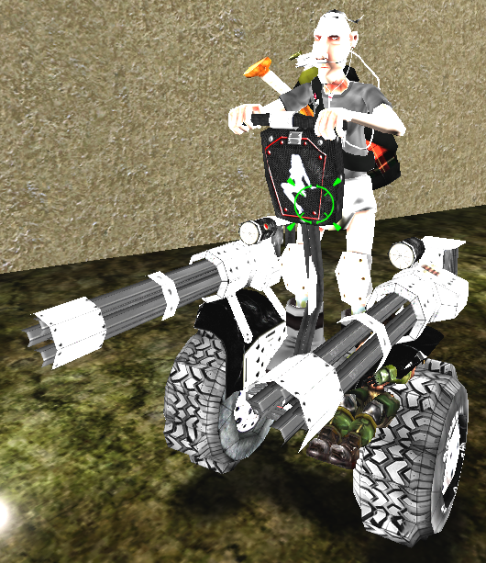
Vehicle: Segway
Driver: Trent Cheznoir
Weapon: Mini Guns
Strengths: Fast
Weaknesses: Low Health, Hard steering, spin outs
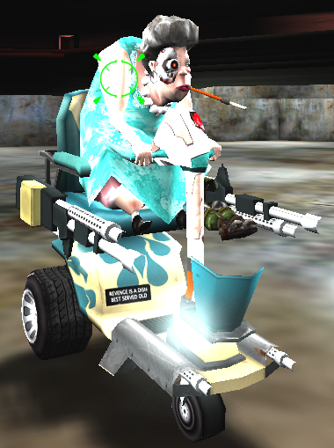

Vehicle: Rascal Scooter
Driver: Nano Nana
Weapon: Energy Guns
Strengths: Easy Steering
Weaknesses: Average Weapon and Speed

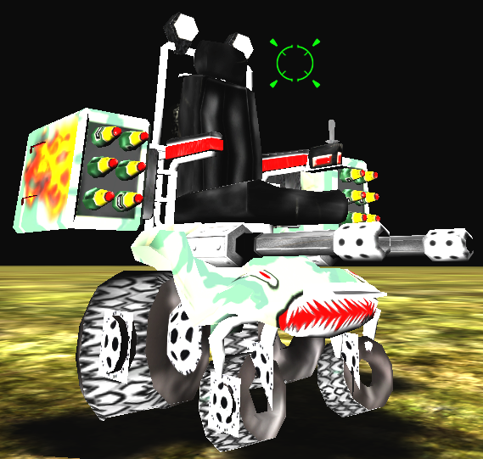
Vehicle: Power Wheel Chair
Driver: Big Grampy Cane
Weapon: Rocket Cannons, Mini Guns
Strengths: High health, strong rocket cannons, biggest arsenal
Weaknesses: Slow, bulky
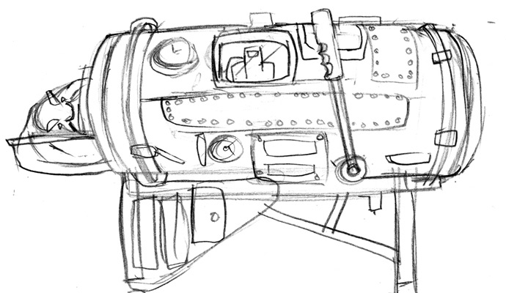
Vehicle: Iron Lung
Driver: Dolph Lungrimm
Weapon: Super Cannon
Strengths: Highest health, strongest weapon
Weaknesses: Slowest, bulkiest

Data Dictionary

All data are specific unreal classes or .uc files for each object of the game. Other data are the map file, textures, animation/mesh and sound files

The specific .uc files are:
- DSHUD – Head up display class
- VDeathmatch- modified Deathmatch, forces players into vehicles, and spawning and respawning functionality
- DSSegway – includes vehicle, player and weapons attaches and projectiles
- DSPowerChair – includes vehicle, player and weapons attaches and projectiles
- DSRascal – includes vehicle, player and weapons attaches and projectiles
- DSIronLung – includes vehicle, player and weapons attaches and projectiles (not included at game fair)
- DSMainMenu – Gametypes selection, sub menus for each for each character selection

Artificial Intelligence

All the death squad vehicle’s use the default vehicle AI’s from UT2004, with some modification. Ideally vehicle AI would use the maps region to benefit themselves the most. Bot pathing will be used extensively for the vehicle AI’s to navigate. For detecting player, the default AI will be used. The gametype automatically will set all other vehicles to AI other than the vehicle the user selects. Specific map puzzles will not be implemented due to the combat based gameplay and gametype goals. Hopefully, the map will serve to create traps for certain vehicle types. Ideally, special actions by vehicle weapons will result from special phsycis for each unique weapon.
Story Overview

Storyboard

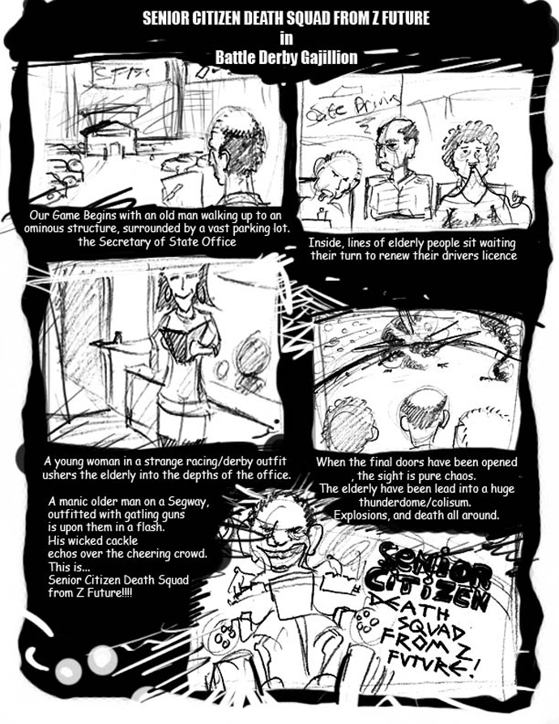

Plot Summary
In Z future the leaders of men from Generation Z have deemed the world’s elderly: “Worthless liabilities that are no longer capable of serving a functional purpose in society.” Thus, the gradual extermination of the world’s existing senior citizen population became the hidden agenda for Gen Z, who believed that no human being should be allowed to live past the age of forty. Unaware of the plot against them, our nations ‘over the hill’ suddenly found themselves in desperate life or death situations while attempting to perform simple, everyday tasks like renewing a driver’s license, enjoying a round of golf, or patronizing a local buffet style restaurant. The spectacle of such events (who wouldn’t want to watch a bunch of old people killing each other for a meatloaf dinner at Bob Evans?) quickly becamethe primary source of entertainment the new world over. Soon, much more elaborate facilities and competitions were developed by Gen Z (The Secretary of State’s Sunday Driver Renewal Arena in Boca Raton, Florida) to further capitalize on the insatiable frenzy of the bloodthirsty youth.
Millions of seniors were ‘retired’ mercilessly in these battles, and before long - Gen Z’s totalitarian vision of a world that would no longer be hindered by the old and useless was on the verge of becoming reality. In fact, according to salvaged data from Z future, there were only four human beings over forty in existence on the planet the day of the final Battle Derby Gajillion driver’s license examination.
Everyone knew their names; the world’s eyes were all daggers for years now. They came up out of the blood, guts and artificial hips - a small but relentless band of silver haired death machines who somehow managed to survive every single battle they fought. Despite their age and obvious mental and physical disabilities, they adapted remarkably well to their life of random violence and soon Trent Cheznoir, Dolph Lungrim, Nano Nana, and Big Gramy Cane became the international champions of the senior citizen death arenas.
This day was inevitable. The public demanded it. This was the day Gen Z was waiting for. This was the Champ, Ultimate Champ match between the toughest, most deadly (and only) seniors on Earth. This was the media event of the millennium. This was the best of the best to the death. This was how they met each other. This was the day they found out what was really going on. This was the day the SCDSFZF was born in blood and the future was saved.

Game Progression

Setting

The setting is in the distant future where the totaliarian Generation Z has deemed that the elderly population is just a liability and is to be subsequently liquidated. The focal point is the Secretary of State’s Sunday Driver Renewal Arena in Boca Raton, Florida. There, our four elderly heroes must face each other, forced to fight to the death.

Introduction

The introduction is a fairly simple flyby of the level, showing the arena where the elderly are forced to fight to the death.

Flowchart

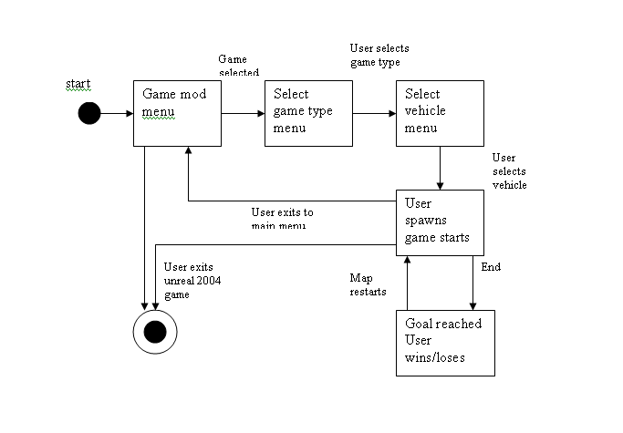

Test Plan

Strategy

The overall strategy for the testing of the game mod is to treat each part as a seperate entitiy before trying to combine them. In essence there will be a hierarcy of testing.

First phase:
- Vehicle driving/fireing
- Interface implementation
- Bot spawning
Second phase:
- Bot pathing
- Weapon balance
- Vehicle balance
Third phase:
- Main Menu testing
- Map testing
- Installer Testing

Schedule



