Noon of the Dead
User Manual

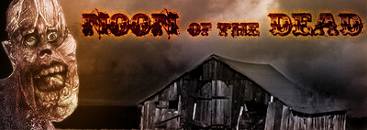

University of Michigan – Dearborn

John Andzelik | Dustin Kelley | Eric Nelson
Todd Pugh | Robert Rak | Brian Schroeder

Center for Creative Studies

Kevin Bindschadler | Jason Briney | Rex Hamilton
Justin Harrison | Adrian Haynes | Carl Vogler
Table of Contents

- Design Team
- Specifications
- Story
- Installation
- User Interface
  - Menu
    - Load
    - Options
  - Controls
- Weapon Systems
  - Tommy Gun
  - Shotgun
  - Pistol
- Character Bios
Production Team

Software Engineering Team:

- John Andzelik – Documentation
- Dustin Kelley – Programming Lead / Documentation / Triggers Programming
- Eric Nelson – Creature AI / QA / UML
- Todd Pugh – Save/Load / Sounds
- Robert Rak – User Interface / Scripting / Design / Testing
- Brian Schroeder – Design / 3D Programming / Game Mechanics / Weapons

Artistic Team:

- Kevin Bindschandler – Environment Modeling and Texturing / Props
- Jason Briney – Environments / Level Design
- Rex Hamilton – Ripper Demon Artist / Sounds
- Justin Harrison - Zombie Artist / Art Lead
- Adrian Haynes – Hellfist Demon Artist / Music / Sfx
- Carl Vogler – Environments / Props

Specifications

Operating System:
- Windows 98/SE/ME/2000/XP
Processor:
- Pentium III 500
Memory:
- 128 MB RAM
Video Card:
- OpenGL or DirectX Compatible 3D Graphics Accelerator, DirectX compatible
Disk Space:
- 90 MB available hard disk space

The Story

In an uncertain year, within an unknown location, you play as a stone mason who after working for 247 consecutive days on a very large project gets his well deserved time off. You decide to return to your home in a small rural town and spend this free time in peace and quiet.

When you arrive at the house in the evening everything seems to be in perfect order, however after some hours of peaceful sleep you are suddenly waken by some very strange and disturbing noises outside. When you look at the window it is dark outside and you think that it is the middle of the night, but after glancing at the alarm clock you realize that it is almost noon. Disturbed, you approach the window only to see that the moon is covering the sun almost completely causing this darkness. At that time you think that this eclipse will soon be over and everything will return to normal. However, as time passes by and there is no change you start worrying more and more as to what is causing this strange phenomenon.

Feeling that something horrible has happened you reach under the mattress to grab a pistol and head outside to find other people who might have some explanation to the whole situation. Right after you leave the house heading toward the center of the city, you notice that the once familiar surroundings no longer resemble anything you can recognize. Suddenly you again hear those strange noises that woke you up and after a while you see many small dark shapes moving toward you from all directions. As the shapes get bigger you also notice that some creatures start to crawl up from the ground nearby. They look human but move very unnaturally and make frightening growling noises. The first thing that comes to your mind is … zombies! Immediately you pull out your pistol and start shooting at the attacking creatures, but their numbers overwhelming and you can barely defend yourself. You start running away from the creatures noticing that they cannot keep up the pace. After a while you realize that you need some kind of transportation and head to the nearby big city where it is more likely to find some information.

While running away from the zombies, you notice some cars on the parking lot and luckily one of them has the keys inside the ignition. You start up the car and head toward the big city. Unfortunately, after traveling some distance the car spins out of control and you crash into some downed trees in the road, forcing you to find another means of transportation. Recognizing that you are on the outskirts of a nearby small agricultural village, the chances of finding a new car are very high. However, you also realize that this task might not be so easy as you might face these horrible zombies again, and you think to yourself: “This is starting to look like a great day off…”
Installation Process

Noon of the Dead uses a basic install package so that you are able to play the game off of an icon directly after install. The steps are as follows:

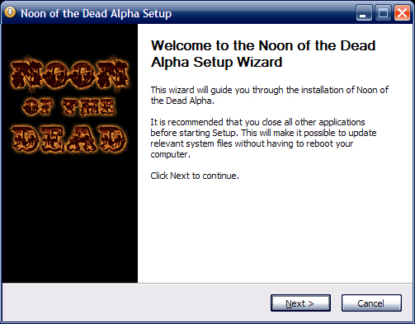

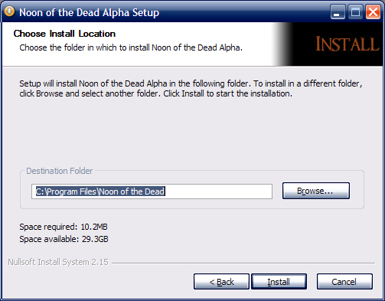

User Interface:

Main Manu Interface

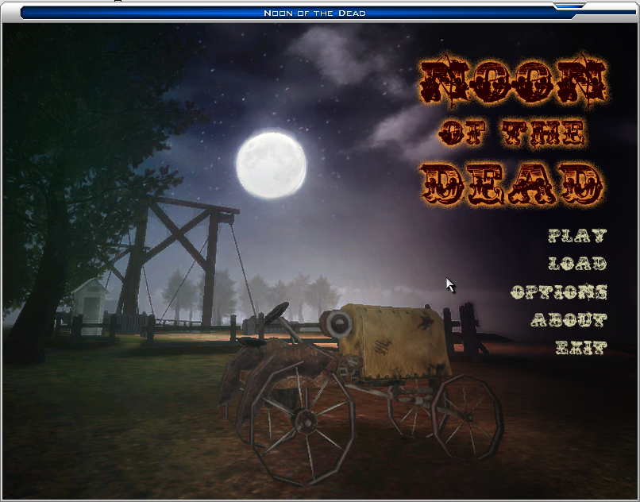

The main menu of the game, which is displayed after starting the application, contains five options:

- Play
- Load
- Options
- About
- Exit

Play:

After selecting this option, the main game mission will be loaded and the game play will commence.

Load:

Selecting this option provides access to previously saved games. A list of saved games will be presented in a new window. Selecting one of the entries on the list and clicking the load button will resume the previously saved game state.

Options:
This option allows setting a variety of features for the game. These features include three main categories of options, which can be adjusted:

- Graphics Settings
- Sound Settings
- Controls Settings

About:

This option displays a new window containing information about the game and the development team.

Exit:

This option is used to exit from the game completely.

User Interface

The GUI

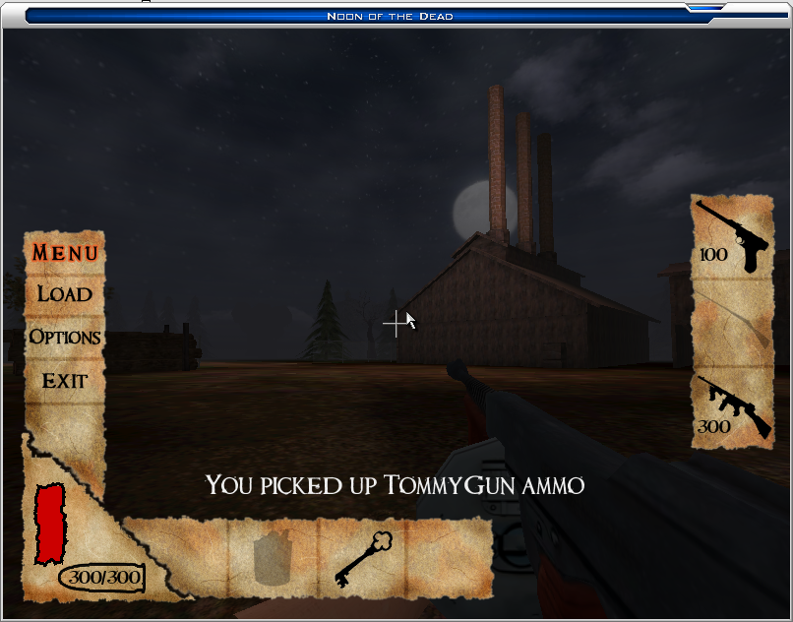

t

Menu Toggling: The main GUI will display only the Health and ammo bars. By pressing “M” you will be able to bring up the Main Menu, which will display:
- Load
- Options
- Exit
Once displayed, this pauses the game. Pressing “M” again will hide the menu, and game play shall resume.

Load: Once implemented, this option will allow the user to restart from a given save point in the game. The option to save will be scattered throughout the game.

Options Once implemented, this option will allow the user to set a variety of features for the game. These features will include, but not limited to:
- Video quality
- Sound Quality
- Speed

Health Bar: Graphical representation of the total number of life points the player currently has. It is represented by the red bar in the lower left hand corner of the GUI. The bar diminishes as the life point total decreases.

Ammo Bar: Graphical representation of the amount of ammo the player has for the current weapon system. It is represented by the bullet in the lower left hand corner of the screen. It uses the format of current rounds/maximum rounds. The Current rounds will decrease as ammo is spent.

Inventory List A short list that extends outward from the right side of the main GUI. It is displayed only when the user presses the inventory button (default is “I”). It does not interfere with game play. It displays a silhouette of the items that can be gathered in the current level. When an item is collected, the silhouette will change to a colored image of the collected item.

Weapons List: A small display on the right-hand side of the screen which shows the current amount of ammo for each weapon the player has obtained. This menu is brought up using the designated weapons menu (default is “O”).

Controls

The game is controlled by using the keyboard and mouse. Keyboard is used mainly for movement and performing specific actions, whereas mouse is used for aiming, looking around, and firing weapons. Key assignment can be changed by accessing the “Controls” tab in the “Options” menu. By default, the following key assignments are used:
Action | Key
Move Forward | W
Move Backward | S
Move Left | A
Move Right | D
Jump | Space
Fire Weapon | Left Mouse Button
Shovel | 1
Pistol | 2
Shotgun | 3
Tommy Gun | 4
Previous Weapon | [ , Mouse Wheel Up
Next Weapon | ] , Mouse Wheel Down
Inventory Menu | I
Weapons Menu | Tab
Game Menu | M

Weapon Systems

Shovel:
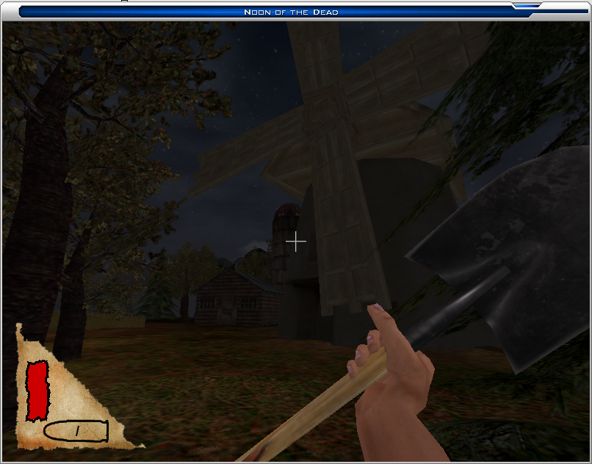

Hand Gun:

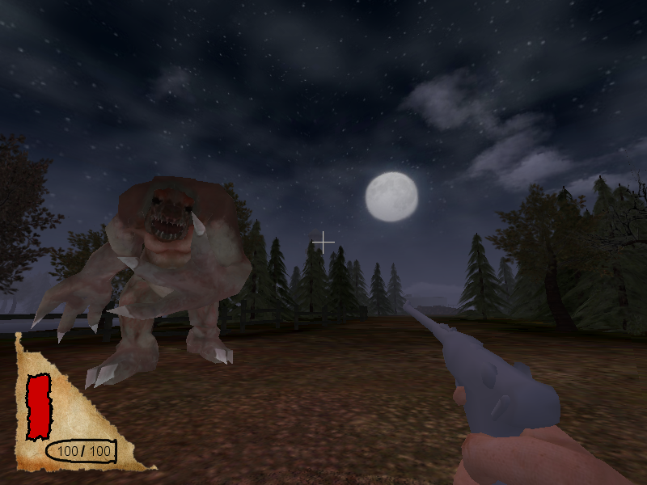

Shotgun:
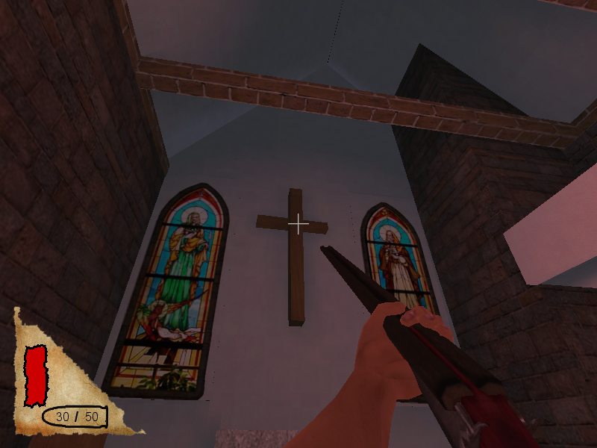

Tommy gun:
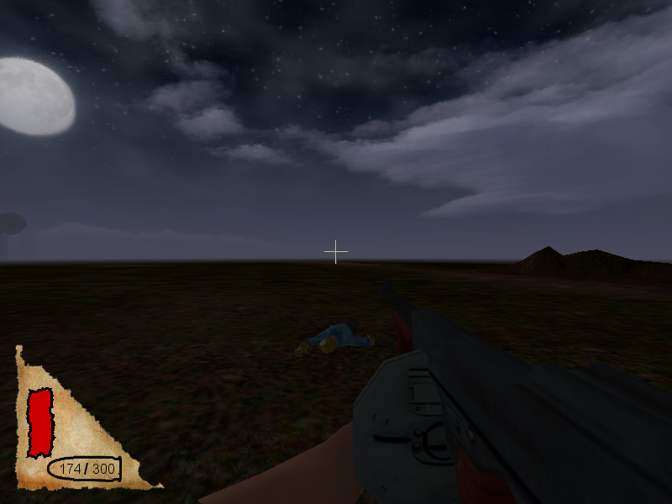

Character Descriptions

Player

Description:

The player’s character does not have a specific name or a model. The statistics devised for this character are used as a reference for all the enemies in the game. Thus the main characteristics like speed or hit point are equal to 100.

Statistics:

Name | Player
HP | 100
Speed | 100%
Jump | 1ft
Attack1 Type | Ranged pistol
Attack1 Damage | 2d7+7 (9-21)
Attack1 Rate of Fire | 0.6 sec
Attack1 Clip Size | 8
Attack1 Range | 150ft
Attack1 Spread Ratio | 1:30
Attack2 Type | Ranged shotgun
Attack2 Damage | 3d4+5 (8-17) (per hit)
Attack2 Rate of Fire | 4sec
Attack2 Clip Size | 1
Attack2 Num shots | 12
Attack2 Range | 50ft
Attack2 Spread Ratio | 1:3
Attack3 Type | Ranged Tommy gun
Attack3 Damage | 4d2 (4-8)
Attack3 Rate of Fire | 0.2 sec
Attack3 Clip Size | 50
Attack3 Range | 200ft
Attack3 Spread Ratio | 1:15 (decreases)
Sight Range | 200ft
Hearing Range | 150ft

Zombie

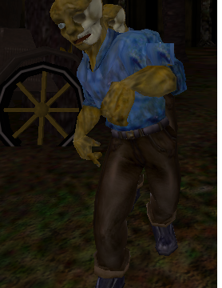

Description:

The zombie is a generic slow moving enemy character. Though he has a charge attack ability activated randomly when near the player, he is the easiest enemy to kill with only 70 hit points. There will be two types of zombies in the game; one type equipped with a weapon and the other without. A gun-wielding zombie will be more dangerous to the player, however his accuracy will not be very high.

Statistics:

Name | Zombie
HP | 60
Speed | 50%
Charge Speed | 80%
Attack1 Type | Melee attack
Attack1 Damage | 1d4+5 (6-9)
Attack1 Rate of Fire | 1.5sec
Attack1 Range | 2ft
Attack1 Threat Area | 2π/3 rad
Sight Range | 100ft
Hearing Range | 50ft
Charge Range | 20ft

Ripper

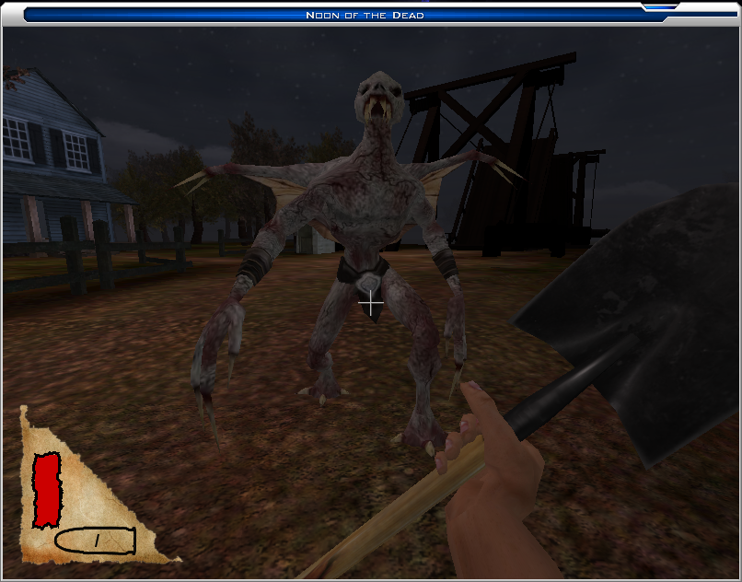

Description:

The Ripper is a very agile enemy that uses his speed to his advantage. He is a typical example of a medium difficulty character. Although he only has 180 hit points, he can move 40% faster than the player’s character, making him a very hard target to hit. Additionally, he has a powerful leap attack with which he can surprise the player.

Statistics:

Name | Ripper
HP | 180
Speed | 140%
Jump | 3ft
Attack1 Type | Melee attack
Attack1 Damage | 1d5+7 (8-12)
Attack1 Rate of Fire | 1-1.5sec
Attack1 Range | 3ft
Attack1 Threat Area | π/2 rad
Attack2 Type | Leap attack
Attack2 Damage | 3d7+20 (23-41)
Attack2 Rate of Fire | 8 sec
Attack2 Range | 20ft
Attack2 Threat Area | 2π/3 rad
Sight Range | 400ft
Hearing Range | 500ft

Hellfist

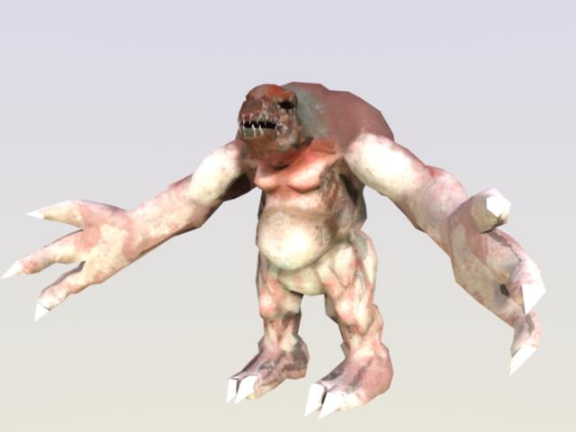

Description:

The Hellfist demon is a very large and slow enemy, but his powerful ranged attack makes him a very dangerous opponent. He can move with speeds of up to 60% of normal player speed but he has 480 hit points, which require the player to fire several rounds of ammunition in order to defeat the Hellfist.

Statistics:

Name | Hellfist
HP | 480
Speed | 60%
Attack1 Type | Melee attack
Attack1 Damage | 2d17+30 (32-64)
Attack1 Rate of Fire | 3sec
Attack1 Range | 8ft
Attack1 Threat Area | 4π/3 rad
Attack2 Type | ranged attack of some sort
Attack2 Damage | 1d11+9 (10-20)
Attack2 Rate of Fire | 5sec
Attack2 Clip Size | infinite
Attack2 Range | 60ft
Sight Range | 300ft
Hearing Range | 200ft

