Game Design and Specification



 | Center for Creative Studies
Andrew Beattie | Don Behm |  | James Kells
Paul LaFond | Jeff Nofs |  | Mike Prentice
 | University of Michigan - Dearborn
Michael Choppa | Chris Lesnieski |  | Nick Mezza
Scott Tluczek |  | Nicholas Zakhar

Table of Contents
Table of Contents 2
Overview 4
Requirements 4
Game Progression 4
Setting 4
Introduction 4
Flowchart 5
Level and Scene Details 5
Story Overview 7
Storyboard 7
Plot summary 8
Game Mechanics 10
Overview 10
Camera Position 10
UI Design 10
Loading and Saving 11
Game controls 12
Game Play Details 12
Models 13
Level Summary 14
Sounds 15
Artificial Intelligence 15
Overview 15
Opponent AI 16
Player Detection 17
Path Finding 17
Special Actions 18
Combat 19
Non-player Characters 19
Puzzles and Traps 19
Game Elements 21
Character bibles 21
Data dictionary 24
Diagrams 25
Class Diagram 25
Use Case 26
Sequence 27
Collaboration 29
Activity 32
Component 34
Deployment 35
Test Plans 36
Strategy 36
Results 36
Schedule 38
Post Mortem – Chris Lesnieski 39
Post Mortem – Mike Choppa 40
Post Mortem – Nick Mezza 41
Post Mortem – Scott Tluczek 42
Post Mortem – Nick Zakhar 43
Team Evaluations – Chris Lesnieski 44
Team Evaluations – Chris Lesnieski 45
Team Evaluations – Mike Choppa 46
Team Evaluations – Nick Mezza 47
Team Evaluations – Scott Tluczek 48
Team Evaluations – Nick Zakhar 49

Overview

Requirements
Some of the requirements for this project are as follows:

Simple in-game user interface: We are gunning to have a simple user interface, one where at least 80% of the commands used in the game can be executed using the mouse. Most RTS games use all of the keyboard and multiple combination keys to help the player micromanage every aspect of the game. We desire to cut this out and let the player focus solely on strategy and tactics.

Moderate AI: This includes not only an enemy that can navigate it’s way around the map using A* but also one that is able to make tactile decisions and have some sort of strategy for the applicable areas of offense and defense.

Original game assets: Working with students at CCS affords us the chance to have original and quality artwork and sounds.

Game Progression

Setting
The battlefield itself will feature various terrains in various settings. These include the kitchen, sandbox, living room, etc. Each setting will have different terrains, like sand, tile, wet sand, carpeting, etc, as well as obstacles, bases, and other terrain elements.

At the start of each level, the player will control an army made up of various types of insects, ants, spiders, roaches, etc. and a starting base. The player’s goal is to take over other the enemy player’s base. There are other secondary bases around the map that the player and this opponent can takeover. All the bases provide a spawning point for any insects that have died in the level. The level ends when the player’s main base, or the opponent’s main base is takeover.

Introduction
The outdoor insects decided that the outdoors was not suitable for them to live in, so an invasion of the indoor territory began. It was up to the indoor insects to fight off their invaders and protect the home that they have grown to love.

Flowchart
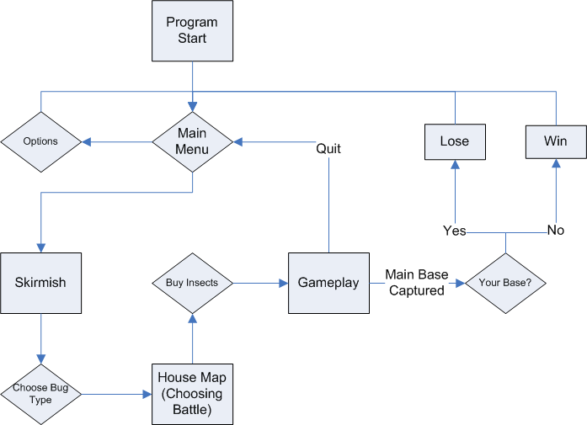

Level and Scene Details

Sandbox

The sandbox level is relatively small, due to the fact that we want to have constant battles happening in our game. There is a magnifying glass that will eventually roast insects that get near it. Wet sand is planned on being implemented, which will slow all insects that don't fly. Some objects that can be seen are the sandcastle, sides of the sandbox, and we will add some scenery around the sandbox, such as shrubs and such.

Basement

The plan for the basement is to have the bugs walk on an intricate maze of piping. One base would be on the water heater, while the other on top of another large object. Some boards are laid across the top to add more pathways to the maze. The pipes will restrict the number of insects that can cross them. Hazards in this level are undecided.

Kitchen

The kitchen is planned on being split into two levels. The kitchen floor will be one level, and the counter top the other. The plan is to get the counter top level implemented, and if time permits then we can do the floor. For the counter top, hazards would include things such as the stove range shooting off at timed intervals, and puddles of water that may slow the insects. This level will be larger than the basement and sandbox. Unlike the other levels, this level is shaped like an 'L' rather than a square.

Story Overview

Storyboard
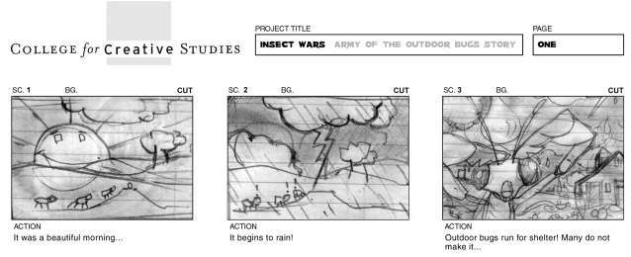
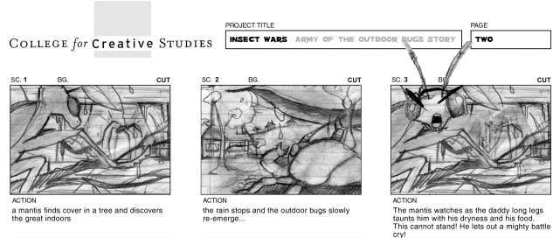
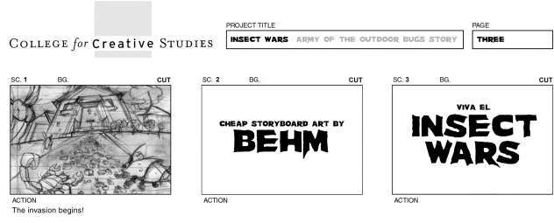
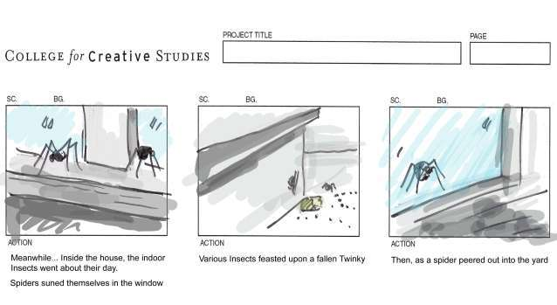
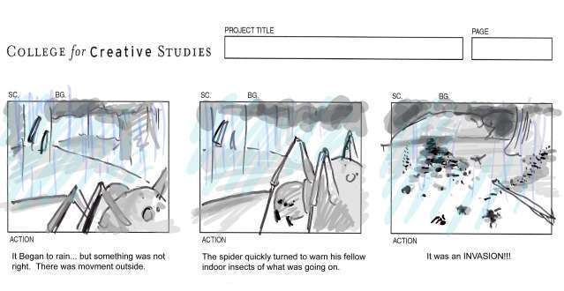

Plot summary

From the Outdoor Insects’ Point of View
It was a beautiful morning, and the outdoor insects soaked up the sun. They enjoyed the warm, crisp rays hitting their exoskeletons and went about their day as merrily as a group of insects could.
However, later in the day, it began to rain. Rain is not much to be afraid of, except when the perspective is that of an insect. Large bodies of water crashed down, hitting the insects that couldn’t find shelter, disorienting many of them. Many of them even died during this downpour due to the violent crashing of the droplets or by drowning in large puddles of water that suddenly formed during the storm.
As a mantis found cover in a tree – the leaves blocking the pouring rain and being high enough not to be affected by flooding – it peered into the nearby house. The mantis noticed a daddy long legs ruffling through the window, as dry as if the sun was still out. There it sat, almost mocking the mantis.
When the storm cleared, the insects that found shelter started to come out slowly, nursing their wounds as best they could. Each of them noticed the daddy long legs in the window which was now eating an ant. The mantis envied the daddy long legs sitting there without a care in the world. The termites knew they were the lowest on the food chain but there would be less dangers in the house.
It was the last straw. The remaining insects looked at each other as if all thinking the same thing and then slowly turned their stares toward the house: it was time for an invasion.
From the Indoor Insect’s point of view
It was another beautiful morning. A daddy long legs went out seeking food. As it made it’s way out of it’s hive, a loud noise was heard. He could’ve sworn it was thunder from the storm coming but instead it was a loud shriek.
“SPIDER!! SPIDER!! AHHHHHHHH!!!”
A few moments later, the daddy long legs weaved and dodged past a human swatting a newspaper at it. He managed to scramble to cover behind a kitchen cabinet, feeling safe there in the dark. It didn’t realize, however, that the stove was on. Hot steam rose behind the cabinet and if the large spider didn’t get out of there, he would burn.
Peering cautiously around the corner, it found an ant crawling along a window sill. The spider, making it’s way up the wall and across the ceiling, made it’s way to the window where rain droplets started to ease up.
The spider pounced on the ant and enjoyed a good, albeit hasty, meal for what he saw out the window was alarming. A gigantic swarm of insects were marching towards the house. The daddy long legs caught a glimpse of a large mantis as it climbed up to the window, making small clinking noises as it rapped on the pane, as if pointing out who exactly he was coming for.
A fly that was leisurely flitting around, happened to spot the spider and looked outside at the oncoming invasion. It flew around the house, buzzing about the impending doom to any insect that would listen. Several insects came out, prepared to defend their homes. Unfortunately, the humans and their pesky appliances like the stove and sink, slowed the rally but the remaining insects were prepared to defend their dangerous home at all costs.

Game Mechanics

Overview
This section provides an explanation of the most common mechanics and controls of the game.

Camera Position
The player controls the action from a free-floating and freely positioned camera. The only limitation currently is that the player is always looking in a northerly direction and the camera cannot be rotated left or right.

In the final version of the game, the camera will be tweaked to start at a closer zoom level and be allowed to zoom in closer to the action.

UI Design
The Main Menu is the first menu screen that a player can interact with. There the player can start a single player game, open up the options, or quit the game.

The next menu screen after clicking on the single player button is the choose side screen. There, the player can choose to be either the inside or outside bugs.

After deciding which team to play as, the player moves onto the size screen, which allows the player to pick how many points they will get to pick bugs with. The small size will give the player 10 points, the medium size will give them 20 points, and the large size will give them 30 points.

The next screen is the level select, where the player can choose what area of the house they want to play in. One is the kitchen, complete with all the dangerous trappings of a modern kitchen. The next is the dark and dingy basement, home to all things creepy and foul. The third is the sandbox, including a magnifying glass focusing the sun’s rays into a burning hot spot.

After that, the next menu screen is the bug selection screen, which is different for which side the player had chosen to play as. There is a picture of the bugs next to a box that shows how many are going to be deployed in the stage, and a final box on the right hand of the screen that has the remainder of how many points a player has left to spend.

After that, the mission loads. The map is in the lower left hand of the screen, and whenever a player selects a bug, a command window opens up in the lower right. In this window, the player can select the attack, move, and a few other commands. The move and attack commands work, but the others have not been tested yet. The player can also order their units to move by right clicking on an empty spot or to attack by right clicking on an enemy unit.

The rest of the screen is the playing field, where the player can see their bugs moving across the field. When a bug is selected, a health bar appears over the unit. The player can zoom in with the mouse wheel and move the camera with the keyboard arrow keys or by moving the mouse to the edge of the screen.

Loading and Saving
Loading and saving will only be allowed in the Arena Selection screen. This is for a couple of reasons. One is that there are many variables to keep track of in the middle of a game. These save files could become quite large and take a lot of time to save and load. But the main reason is that we intend for the levels to be quicker than traditional RTS games. There is strategy involved but resource management and player creation has intentionally been left out of the game.

When a player is at the Arena Selection screen, they can either load previous games (the games must have been saved on the same difficulty level as the current game) or save their current game.

Games will be saved in a text file. However, the stats will be scrambled to deter people from cheating and giving themselves an advantage. Also encrypted will be the kind of difficulty level the game is so that a person playing on the “Hard” level cannot use a save game from one of their campaigns on “Easy”.

Game controls
Most of the game will be controlled through the use of the mouse. Clicking on an ally unit will select that unit. If you wish to select a group of units, you can click and drag or click while holding the CTRL key to add them.

With the unit (or group of units) selected, you can do two things. One is to attack a base or enemy units. Do this by focusing the mouse pointer over the targets and right clicking. The other thing they can do is move. To do this, simply click on the terrain to have them move to that spot.

The other controls are concerned with the camera movement. Using the just the mouse wheel the player can zoom in and out on the terrain. If the CTRL key is held down while the mouse wheel is scrolled, the tilt angle of the camera is changed. If the ALT key is held down while the wheel is scrolled, the camera rotates.

Game Play Details
Insect Wars is a Real Time Strategy game, that lets the player control an army of various insects and fight over battlefields in a war over who will control the abundant food supplies of the House.

At the beginning of the game, the player chooses a group of insects to play; the inside bugs, or the outside bugs. This choice determines the starting location of the player’s side, as well as which insects the player will control. The player is then given a map of the House, and asked to pick an area which to attack.

At the beginning of each battle the player chooses which insects he wishes to buy using a set amount of points. Each insect has a different point cost depending on the abilities and powers for that unit. The player starts the game with a set amount of points, and gains more points after completing a level of the game.

When a level begins, the player and the computer both start out with an army of bugs and a main base. Scattered throughout the map are other secondary bases that start under no ones control. These secondary bases can be taken over by the player or the computer. The player’s goal is to take over the main base of his opponent.

The player can move his bugs around the map and have them attack the opponent’s insects, and use them to takeover the secondary bases and the main base of the opponent. The bases act as respawn points for insects that have died in the battle. As an insect dies, it is put into a queue. When a base becomes available, the insect will start to respawn there. The more bases the player controls, the more insects the player can have respawning at the same time.

If the player or the computer moves one of his insects over to a secondary base that is neutral, the base will slowly convert to that player’s side. Once the base is captured it will start to act as a respawn point for that group of insects. If the player or the computer moves one of his insects over to a secondary base that is controlled by the other side, then that base will stop respawning it’s insect and slowly convert to that player’s side. A base that is being contested will not produce insects, and must be defended or it will convert to the other player’s side.

The main bases will act slightly differently. If a side moves its units to the main base of it’s opponent, that base will slowly convert to its side. However, the conversion process on a main base will take significantly longer then a secondary base, and the side that controls the base will be able to still respawn insects at that base, even if it is being contested. If one side’s main base is converted, then that side loses the level.

Each side has six different insects that it can use in its army. Each insect has specific strengths, weaknesses, and special abilities. Each side has different insects but each insect pairs with an insect on the other side in terms of statistics and powers. The main difference is the art and animations for the different sides. For example, the ant unit for the inside bugs corresponds to the termite unit for the outside bugs. The units have different art and animations, but are identical in stats and powers. This way both sides in the game are balanced with each other.

Models
Unit and object modeling was done by CCS. Every unit type has its own 3d model and texture. Some buildings (bases) have an idle animation (such as the main base – a sac of larvae) while others have no animation. Currently, buildings do not change texture to indicate the owner team, and instead, this will be replaced with a separate colored aura model around the base in the final version.

Units contain several basic animations: movement, idle, attack, damaged, death, and optionally a second attack animation. In the current beta version, the damaged animations are not used. These damaged animations will not likely be used in the final project due to conflicts with currently playing attack animations.

Level Summary
Sandbox

The sandbox level is relatively small, due to the fact that we want to have constant battles happening in our game. There is a magnifying glass that will eventually roast insects that get near it. Wet sand is planned on being implemented, which will slow all insects that don't fly. Some objects that can be seen are the sandcastle, sides of the sandbox, and we will add some scenery around the sandbox, such as shrubs and such.

Basement

The plan for the basement is to have the bugs walk on an intricate maze of piping. One base would be on the water heater, while the other on top of another large object. Some boards are laid across the top to add more pathways to the maze. The pipes will restrict the number of insects that can cross them. Hazards in this level are undecided.

Kitchen

The kitchen is planned on being split into two levels. The kitchen floor will be one level, and the counter top the other. The plan is to get the counter top level implemented, and if time permits then we can do the floor. For the counter top, hazards would include things such as the stove range shooting off at timed intervals, and puddles of water that may slow the insects. This level will be larger than the basement and sandbox. Unlike the other levels, this level is shaped like an 'L' rather than a square.

Sounds
Unfortunately sound hasn't been implemented yet, but there are plans for each bug to have an attacking sound, death sound, and perhaps walking sounds. Background music will play throughout each aspect of the game. The music and sounds are supplied by Don Behm of CCS.

Artificial Intelligence

Overview
The RTS-SK not only removed collision, but also removed any AI implementation. So we had to program most/all the AI code ourselves. We managed to get the AI code for the player insects and the computer insects implemented. However, the overarching strategy AI is missing. This means that the computer insects are very aggressive, but they currently lack any sort of defensive behavior.

There are several AI resources available on the Garage Games RTS-SK forums. None of these resources ended up getting used in the final version of the game. They involved creating many overly complicated AI structures that may be very useful in the long run, but are very complex, and incomprehensible. They also seem to make use of several functions from the starter kit that are never called. This may just be our lack of knowledge of Torque in general and the starter kit more specifically.

One of the other problems with the starter kit is that it seems to use a lot of functions straight from the engine. That is, it calls various functions in the script that aren’t specifically in the scripting language. So it has been very difficult in many cases to track down the code and the functions. From what we’ve seen the other starter kits, and Torque itself, don’t make as many function calls directly to the engine. There seems to be more calls to the scripting language functions, which would make tracking down specific parts of the code easier.

What follows will be an explanation of what was implemented in this game. As well as what we hope to get done in future versions of the game. There will undoubtedly be changes from what is said in this document, and what will ultimately get implemented.

Opponent AI
The opponent AI controls the behavior of both the insects on an individual level. The higher strategic AI has not been implemented at this time. As well the opponent AI is very aggressive. There is no defensive behavior implemented. The aggressive behavior is implemented with an AI that controls the insects on an individual level. The defensive behavior was supposed to be the AI code that controlled the bases, and issued orders to the individual units. Our lack of understanding of Torque, and lack of time, made this impossible to implement as of this version of the game.

The opponent AI is implemented using the scheduler provided by the Torque engine. Whenever a computer unit is created, a schedule is created for that unit. This schedule runs 5 seconds after the unit is created, and calls an AI function. This function does several things. First the function looks for any enemy units within range. If it finds a unit, the function tells the computer unit to attack. If no unit is found, the function checks if the unit has a set destination. If it doesn’t, a destination is chosen at random. The destinations corresponds to the locations of the bases on the map. If the unit has a destination, the function checks if the unit has reached the destination. If it has, a new destination is chosen; otherwise the unit continues to move towards its set destination.

The base AI, which again is not implemented, keeps track of the health of the bases. If the base is damaged, the base performs a radius search for allied units, if it finds any it sends a help message to them. These units will then come to help defend the base. As the base is damaged the help call changes. The radius of the search is increased, and the frequency of the call for help is increased. In the case of the main base, for instance, if the main base is under 50% health it will send a help call across the entire level. Basically if the main base is taken the computer loses. So it sends an “emergency” call for help. This will add the defensive behavior to the opponent AI.

The RTS-SK already uses a set of states to control movement, attacking, and other actions. It should be easy to create an AI that makes use of these already defined states. These states include: “none”, or idle, “move”, and “attack”. There are also several other states included in the starter kit that are not currently implemented, but exist; these states may also be used in the AI design.

Player Detection
There are several ways to implement player detection. We’ve chosen the one we think is the easiest. The individual units, both player controlled and opponent AI, will do a radius search every second. This search will return a list of all the insects in a certain radius, with the searching bug at the center. We can then search this list for enemy insects and then pick the best one to attack.

The insect will only attack the enemy bug under certain conditions. The attack will only be carried out if the insect’s state is “idle”. Meaning the insect is not moving or attacking. This allows the insects that the player controls to attack even if the player is busy elsewhere. So the player’s insects will not just stand there and allow enemy insects to march by if the player is busy at another part of the map. On the opponent AI side, this will again allow the insects to attack the player’s insects if they currently don’t have any orders. And it can be incorporated into a larger AI strategy.

Path Finding
Path finding is another area without any easy solution. The RTS-SK does not come with any path finding capabilities. When a unit moves all the starter kit does is cast a ray from the unit’s current position to the destination position. The unit then walks along this ray till it reaches its destination. The problem with this of course is that if there is anything in the way, the unit will bump into the object, and continue to try to walk through it.

There are several possible solutions that we are considering. We would personally like to get a version of the A* algorithm implemented. However, we are very unsure as to how to create the graph for the algorithm. We also don’t think there will be enough time before the gold is due to complete it. Completing it for September may be possible, however.

The other solution is one from the RTS-SK forums. Someone has created a path finding resource. This resource casts a ray from the unit’s current position to its destination, similarly to the RTS-SK. However, if this ray hits an object, the algorithm finds the closest side of the objects bounding box, then casts another ray to this location. Then casts another ray to the destination. This ray casting continues until a path to the destination is created. This algorithm is a simple way to get around objects in the level, but will not find the “best” path to the destination. Indeed it may not find any path to the destination. This resource should hopefully be a easily implementable solution to path finding, but probably not the final path finding solution.

Special Actions
For various reasons, the unit’s special actions have been removed. We had a list of special attacks, bonuses, etc. for each of the units in the game. For the time being all of them have been removed. There are two main reasons for this, time and collision or lack thereof. As stated earlier, the RTS-SK lacks collision detection. We have been able to get some of the collision detection back into the game, but not all. Triggers, and collisions with non-static objects does not work. The units can collide with static objects, and each other, but even these collisions are not detected. The units collide and cannot pass through each other, but the actual collision does not register with any of the onCollision code. Many of our game features make use of collisions and triggers. In some cases we have been able to find a way around these problems, but in the case of our units special actions we have not been able to implement them without this collision code.

Having said this, we have recently found an alternate way to implement the special actions. This we have not had time to implement this alternate implementation. It will hopefully be implemented in future versions of the game. This will be farther discussed in Puzzles and Traps.

Combat
The combat in Insect Wars is controlled by both the player and the opponent AI. The player’s insects will be mainly controlled by the player, but idle insects will react to specific changes in their environment, mainly the approach of enemy insects. Once again this is so that the player will not have insects that will get attacked and stand there doing nothing and die if the player is busy at another part of the map. The opponent AI controls the various actions of the opponent insects.

Combat itself is handled through various functions. Each unit has an attack rating, a defense rating and an attack speed, as well as various other statistics. The attack rating is how much damage the unit can do. The defense rating is a rating of how much armor a unit has. The attack speed is the speed at which a unit attacks. In combat the defense rating is subtracted from the attack rating, and then the remaining damage is applied to the unit. A unit with a high attack rating will be able to attack faster, and therefore more times, then a unit with a lower attack rating.

Non-player Characters
The non-player characters in this game are the opponent insects. These insects, controlled by the opponent AI, are the player’s antagonists. The player’s insects must defeat the NPC insects to win a level, and loses a level if he is beaten by the NPC insects. The NPC insects are controlled by the opponent AI as specified above. At this time the only NPCs in the game are the opponent insects. There was initially some talk of putting in some neutral insects that the player and the AI must overcome, but this was dropped in early development.

Puzzles and Traps
Like our unit’s special actions, the puzzles and traps in the game rely heavily on collision, triggers to be exact. Each level was supposed to have special hazards and traps, but without working collision on the triggers we have not been able to find a way to implement them. However, we recently discovered a way to implement the traps and hazards without having to use the triggers. We can use a container radius search to check for units within a certain radius. We figured this alternate way to implement hazards only within the last couple days, so we were not able to implement the traps and hazards by this version of the game.

Game Elements

Character bibles

Indoor Insects Outdoor Insects
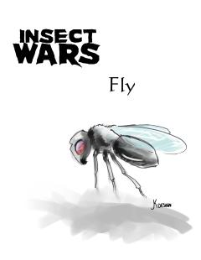
Fly
Hit Points: | 300
Speed: | 4.5
Visibility: | 9
Attack: | 10 – 20
Defense: | 1
Spawn Time: | 3 seconds
Special Ability: | Avoid Traps
Group: | Yes
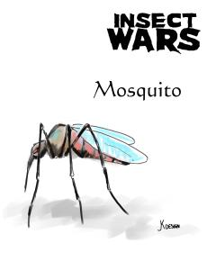
Mosquito
Hit Points: | 300
Speed: | 4.5
Visibility: | 9
Attack: | 10 – 20
Defense: | 1
Spawn Time: | 3 seconds
Special Ability: | Avoid Traps
Group: | Yes

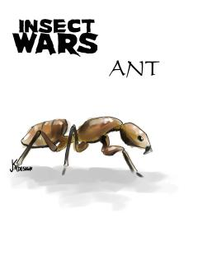
Ant
Hit Points: | 400
Speed: | 3.5
Visibility: | 6
Attack: | 30 – 40
Defense: | 2
Spawn Time: | 3 sec
Special Ability: | Attack in Group
Group: | Yes
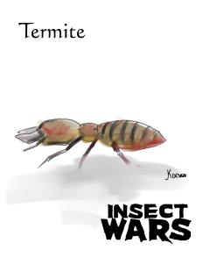
Termite
Hit Points: | 400
Speed: | 3.5
Visibility: | 6
Attack: | 30 – 40
Defense: | 2
Spawn Time: | 3 sec
Special Ability: | Attack in Group
Group: | Yes

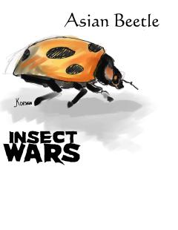
Asian Beetle
Hit Points: | 400
Speed: | 3
Visibility: | 4
Attack: | 10
Defense: | 1
Spawn Time: | 6 sec
Special Ability: | Defense Aura & AvoidTraps
Group: | No
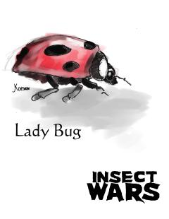
Lady Bug
Hit Points: | 400
Speed: | 3
Visibility: | 4
Attack: | 10
Defense: | 1
Spawn Time: | 6 sec
Special Ability: | Defense Aura &  Avoid Traps
Group: | No

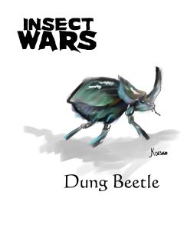
Dung Beetle
Hit Points: | 500
Speed: | 2.5
Visibility: | 5
Attack: | 50
Defense: | 5
Spawn Time: | 5 sec
Special Ability: | Lay Trap
Group: | No
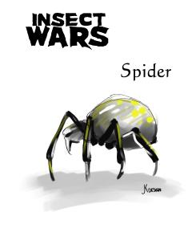
Spider
Hit Points: | 500
Speed: | 2.5
Visibility: | 5
Attack: | 50
Defense: | 5
Spawn Time: | 5 sec
Special Ability: | Lay Trap
Group: | No

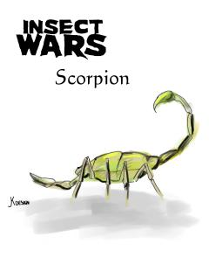
Scorpion
Hit Points: | 700
Speed: | 1
Visibility: | 5
Attack: | 40 – 50
Defense: | 9
Spawn Time: | 6 sec
Special Ability: | High Armor
Group: | No
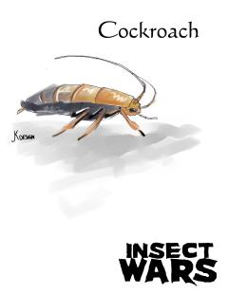
Cockroach
Hit Points: | 700
Speed: | 1
Visibility: | 5
Attack: | 40 – 50
Defense: | 9
Spawn Time: | 6 sec
Special Ability: | High Armor
Group: | No

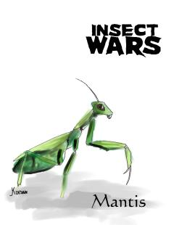
Mantis
Hit Points: | 700
Speed: | 2
Visibility: | 4 – 5
Attack: | 90 – 100
Defense: | 4
Spawn Time: | 7 sec
Special Ability: | High Attack
Group: | No
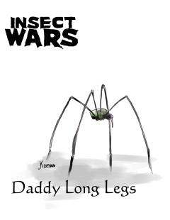
Daddy Long Legs
Hit Points: | 700
Speed: | 2
Visibility: | 4 – 5
Attack: | 90 – 100
Defense: | 4
Spawn Time: | 7 sec
Special Ability: | High Attack
Group: | No

Data dictionary

Models - Units

The units have different variables associated with them. One of those is where the actual 3D model is located. Others include
baseDamage - amount of damage it does
attackDelay – how quickly it attacks
damagePlus – a damage modifier
armor – how well it is protected against damage
moveSpeed – how quickly the insect moves
range – the range at which it can inflict damage
maxDamage – the amount of damage it can take before death
vision – the maximum range that it can see enemy units
spawnTime – how quickly it can be sent back onto the field after death
unitCost – how much it costs to buy this unit at the unit select screen
boundingBox – the scale of the unit’s bounding box
isMelee – is this unit hand to hand or ranged?

Models – Bases
shapeFile – the path to the actual model
maxDamage – the amount of damage it can take before death
boundingBox – the scale of the unit’s bounding box

GUI Variables
$main::total<insect> – this denotes the number of that insect the player has selected to be inserted into the level

Diagrams

Class Diagram

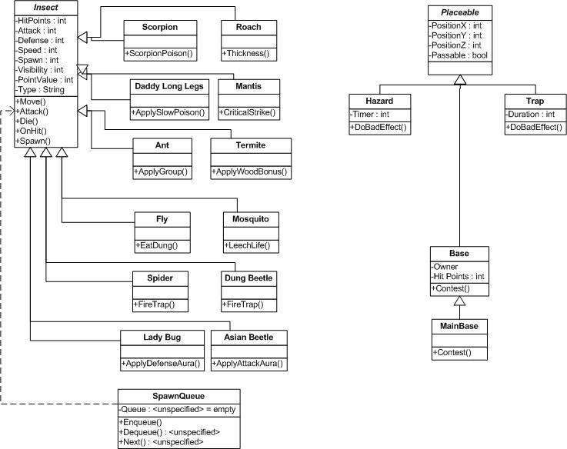

Use Case

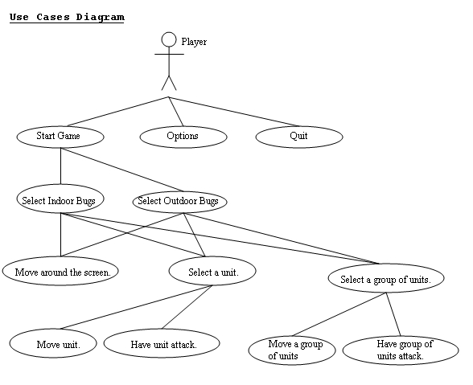

Sequence

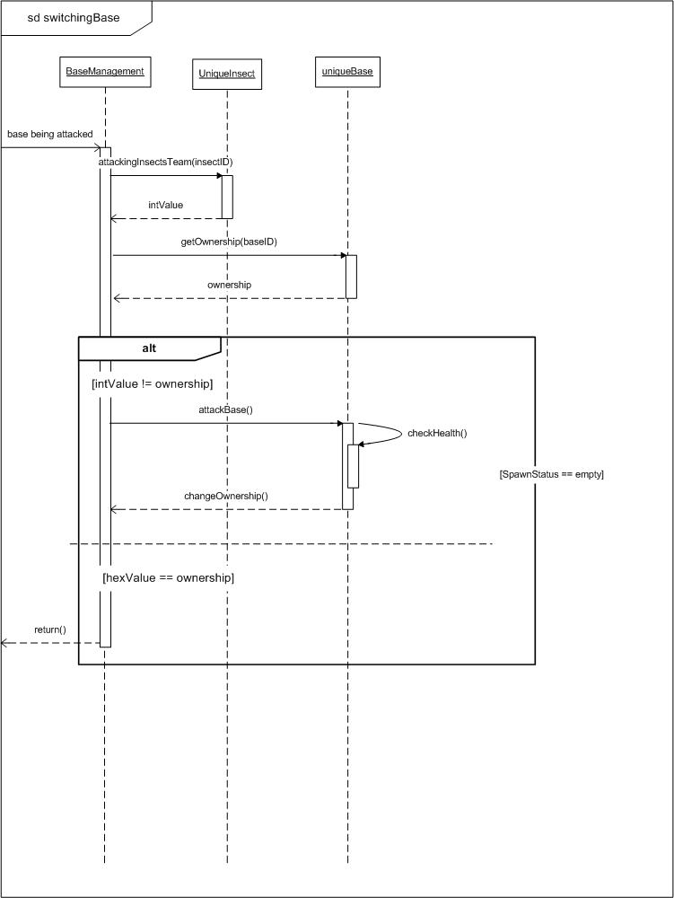
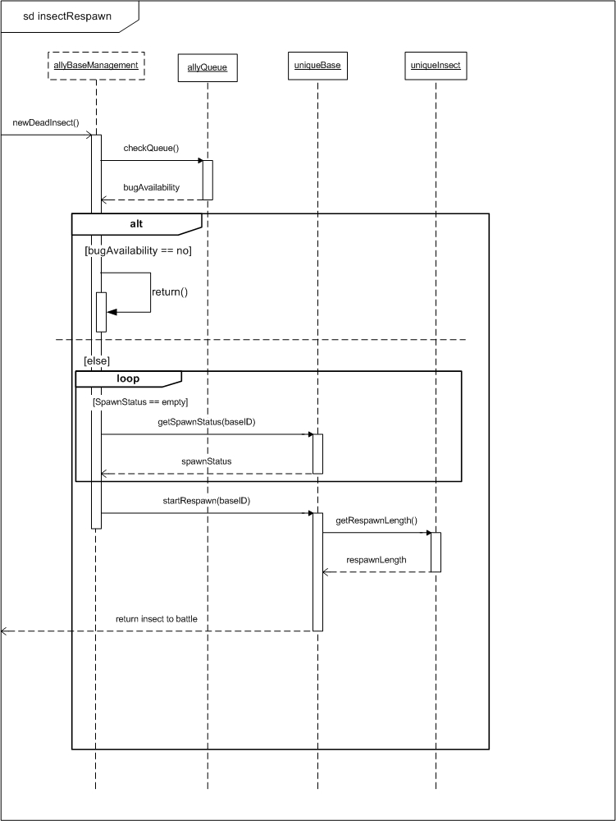

Collaboration

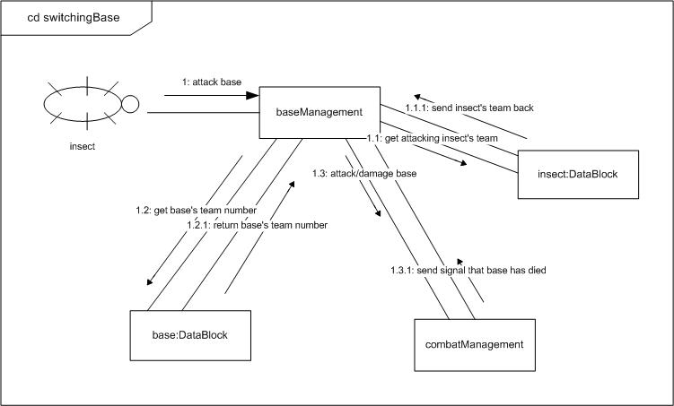

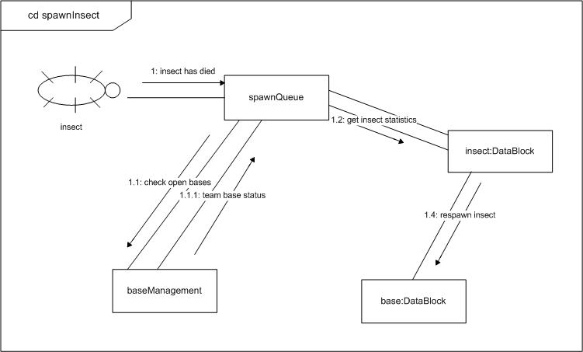
State
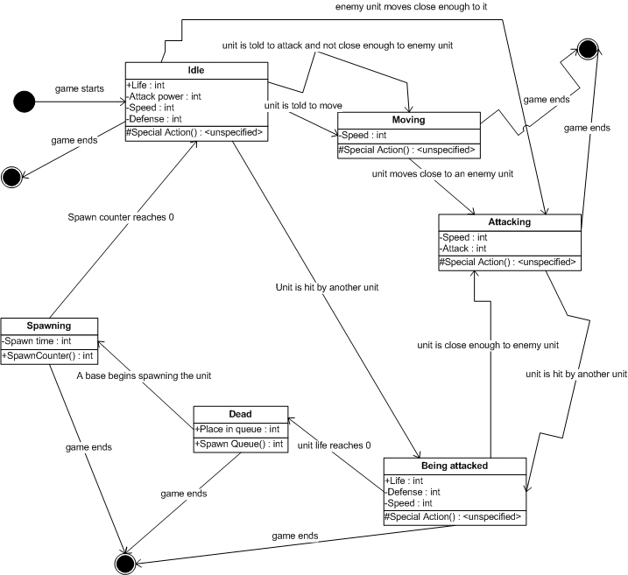

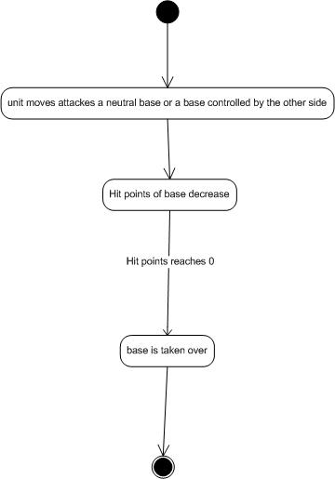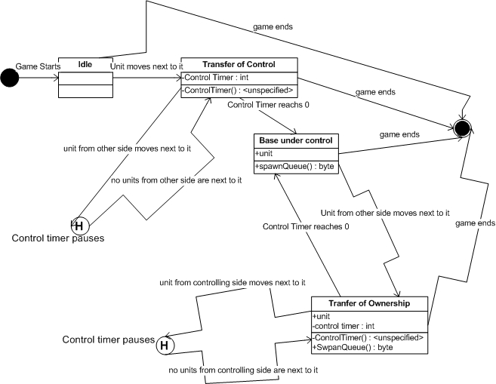

Activity
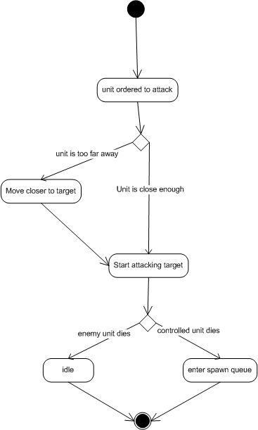

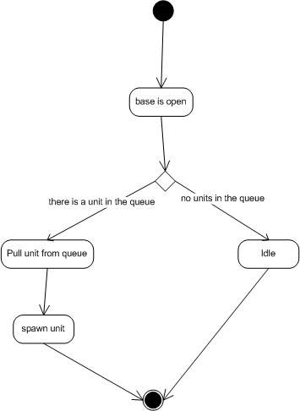
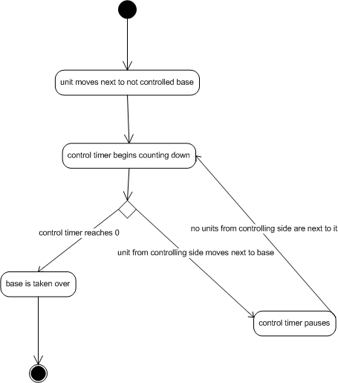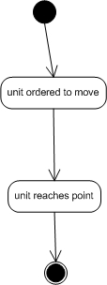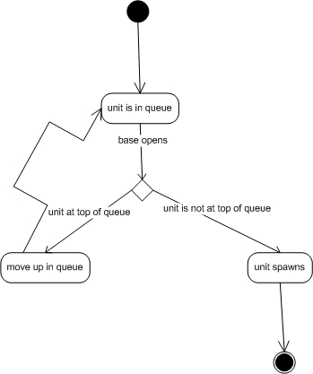

Component
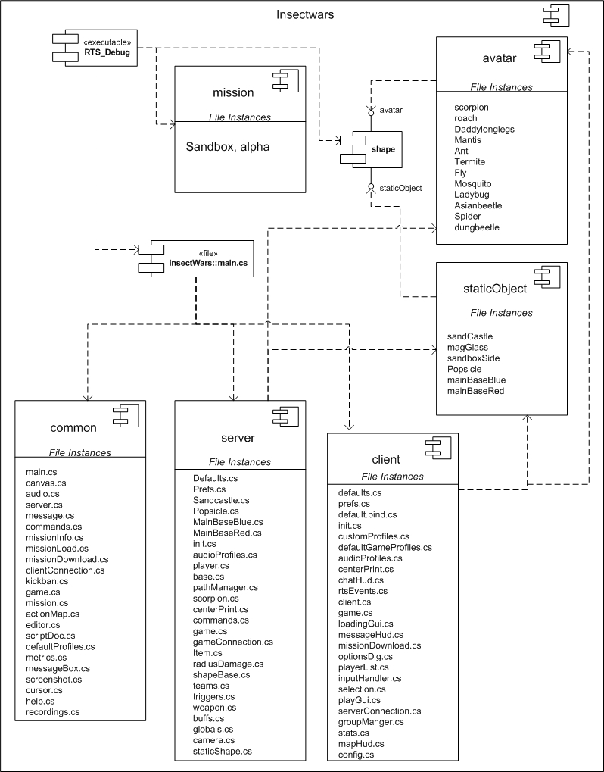

Deployment
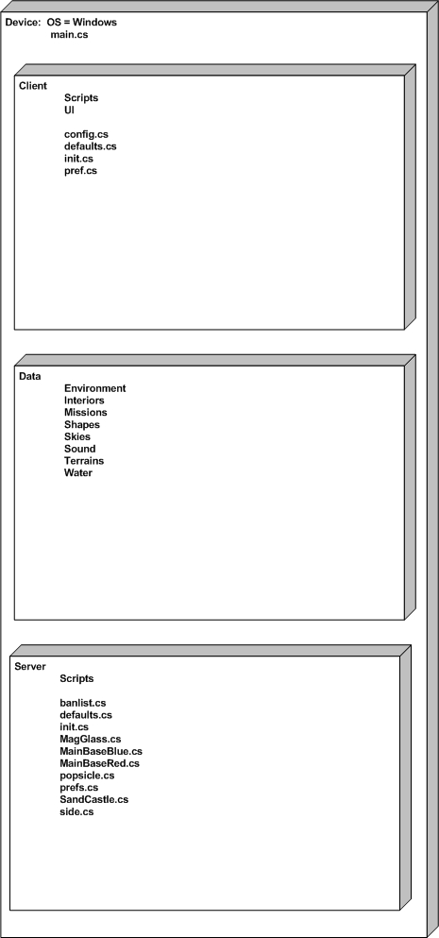

Test Plans

Strategy
Testing of Insect Wars falls into two major categories – continuous and dedicated testing. Continuous testing is performed at all times with the assistance of the team's version control server. Dedicated testing occurs prior to a release of the project or after major features have been integrated.

Continuous testing includes unit and integration testing. These tests are performed by individual team members as they complete the units or portions of units assigned to them. After each change, the game is launched and basic functionality is ensured, as well as the functionality of the new addition or change. When the change is completed and working properly on the team member's local instance, they then update/merge their code using any updates done to the shared repository. Integration testing is performed during this stage as the team member verifies that changes made do not conflict with new features added by the other team members. Once these tests are completed, the team member is allowed to commit their changes to the repository.

Dedicated testing is done at major milestones/changes or prior to a release of the game. Every portion of the software is tested to ensure no problems were missed during continuous testing. Complete play-throughs of the game are performed to ensure no problems prevent successful completion of the game. In addition to this, group discussion reveals 'stress points' of the game scripts and engine. These exceptionally complex or essential aspects of the game are reviewed for any possible issues.

Results
Menu Tests:

Test: Does the correct bug selection screen appear?
Result: Yes

Test: Are the correct points on the bug selection screen given to the player?
Result: Yes

Test: Do the bugs cost the correct amount?
Result: Yes

Test: Does the correct stage load?
Result: Yes

Test: Can you start a game without selecting one bug?
Result: No

Game Tests:

Test: Do the correct bugs load into the level?
Result: Yes

Test: Does the game end when a main base is destroyed?
Result: Yes

Test: Does a neutral base re-spawn on the correct side?
Result: Error: First, it goes to the enemy side, but then it goes back to neutral, and then to your side.

Test: Do the bugs re-spawn on the correct sides?
Result:

Test: Do the correct bugs re-spawn?
Result: Yes

Test: Do the bugs attack bugs on the other side when they move close to them?
Result: Yes

Test: Do bugs spawn at the secondary bases after they have been taken over?
Result: Error: Enemy bugs spawn, but not player bugs.

Test: Is there a warning only when your bugs are under attack?
Result: Yes

Test: Can a player give commands on the mini map?
Result: Yes

Test: Does the command buttons only appear when the player bugs are selected?
Result: Yes

Test: Does the correct number of bugs appear for the computer side?
Result: Yes

Test: Does the computer attack the player?
Result: Yes

Schedule
April12 – Beta Release
April 19 – Have starting of in-game GUI; have all animations working; appropriate spawning algorithm in place; AI controlled bugs able to attack when being attacked.
April 22 – GUI and menus finished; save function implemented; basement level in place and able to accept bugs; AI controlled bugs able to walk towards a target; base-control is properly working.
April 29 – Gold Release, everything finished!

Post Mortem – Chris Lesnieski

What went right?
- The art work made by the students at CCS is incredible as are the animations. I highly doubt we would have been able to create game assets even half as good as these models were.

What went wrong?
- We devoted more time to collisions than we should have. The game works without collisions but tactics are lost as insects can walk right through objects as there are no collisions. This time could have been used on more complex AI.
- The RTS starter kit did not have helpful documentation. Doing supposedly simple things such as adding sounds, units, or objects cost us valuable time that could have been spent focusing on the actual game play.
- Communication was weak with CCS. While we tended to rely on e-mail for quick communication, this was usually not the case with CCS. They did not check their e-mail on a regular basis nor post on the forums. In their defense, we did not make posts as often as we should have on the forums. Because of this, we were not able to get the assets that we needed.

Lessons learned/process improvement suggestions:
- Set up a central SVN repository as early as possible. This will help keep the team on the same page code-wise and script-wise without dealing with swapping .zip files across the team.
- More cohesion, less coupling between roles within the team. For example, assign one person to deal with all the documentation, one person to be the team lead, one person to deal with sounds, the other with the GUI/menus, etc. This will help create specialization and get people more familiar with their sections.
- Set up a solid and reliable communication model. Make sure all team members have everyone else’s e-mail addresses and phone numbers. Try to have both teams meet at least once a week in person. Relegate one person to also run communication between the teams, which should consist of weekly or biweekly e-mails stating a couple different things:
  - What have you accomplished since the last e-mail?
  - Are there any problems keeping you from advancing?
  - What are the goals of your tasks?

Post Mortem – Mike Choppa

What went right?
- Collaboration with CCS was timely.
- Importing models went extremely well.
- Gui creation was easy to do.

What went wrong?
- Collision wasn't implemented
- Triggers weren't implemented
- Too many scripters had to fix the engine because the above two were not implemented

Lessons Learned/Process Improvements Suggestions?
- Better team collaboration and documentation would've helped to keep everyone on the same page. Although trips to CCS were helpful, several of the CCS students weren't very helpful, nor did they respond to their email.
- Time must be included in a schedule to learn a new software tool such as Torque.

Post Mortem – Nick Mezza

What went right?
- Development has reached a point where the game is playable. There are many things which we would like to improve upon, but Insect Wars provides a basic RTS experience as is.

What went wrong?
- Because of initial inexperience with version control, and lack of software to assist, several times we overwrote each other's changes to code. This resulted in loss of productivity.

Lessons Learned?
- The project should have begun with strong version control software. Until we had a versioning system in place, development proceeded very slowly.
- COTS are not always the right answer for development. Significant research should be performed before starting production. The Torque RTS Starter Kit is incomplete and lacking in any coherent documentation. It should not have been used as a development framework.

Post Mortem – Scott Tluczek

What went right?
- The teaming up with CCS was actually a good move. It allowed us to focus more on the code half of the project and not the graphics.
- Using the Torque Engine also helped us jump right into the game and not worry about some of things.

What went wrong?
- CCS didn’t always send us everything we needed, but that’s just like having a lab partner who doesn’t do all of his work.
- The Torque RTS starter kit did not have everything that we needed, thus, trying to add those things created lots of problems and really ate up way too much time.

Lessons Learned/process improvement suggestions:
- When using an engine, make sure you understand what that engine is good at doing. Torque is good at first-person games with driving elements. While you can turn it into a RTS game, it’s really hard. Just like you can make Doom 3 into a pinball game, it’s not a good idea to do so.
- Tortoise SVN is a great tool to use to pass data between team members and was invaluable.
- Make sure you’re in constant communication with CCS if you team up with them in the future. Some do need prompting to get you some necessary art.
- Remember, keep your game simple. Insect Wars is a very simple game, so even through we had problems, we managed to get it mostly done.

Post Mortem – Nick Zakhar

What went right:
- First I have to say that our team was great. Everyone did a fantastic job, especially considering the problems we had with Torque and the RTS-SK. Working with CCS was also great. Getting actual art done by actual artists is very nice. I highly recommend continuing to work with CCS in future instances of this class.
- We where able to get our insects and models in the game without much trouble. And we got our units and bases animated, though with some difficulty. We also were finally able to get sounds into the game, though it was at the last minute. I am also satisfied with the AI that we managed to get implemented. Though I really want to improve the AI, I just need more time and knowledge of Torque and the RTS-SK.
- The bases spawn points work well, the unit selection also works great. The unit respawn queue is also implemented and working.

What went wrong:
- 5 words… Real-Time-Strategy Starter Kit. It does some great things. But is also does some very very stupid things. Or it lacks some very obvious things. Namely collision, and AI controls. Torque itself has some great collision, and the aiplayer object has some good AI controls. Both of these are lacking in the RTS-SK. So we had to start from scratch and try to implement collision and AI. Implementing collision was a nightmare. Implementing the AI was tricky, but didn’t end being impossibly hard.
- For future reference, Torque does FPS, and racing/vehicle games really well. That was what the engine was created for after all. It lacks a great deal of control for RTS games.
- We were also unable to get flying units implemented, though I THINK I know how to get it implemented now. It’ll just take some time, and some plugging through Torque code.
- No unit special abilities where implemented. Though once again we figured out how at the last minute.
- Finally the traps and hazards were not implemented. And once again we figured out how to implement it at the last minute. It is just going to take some time, and work to get everything implemented.

Lesions learned/process improvement suggestions:
- Don’t relay on the RTS-SK! It’s missing some key features! Don’t spend so much time trying to implement collision when you don’t understand Torque enough, and when time is a at a premium. I spent way too much time beating a dead horse and trying to get collision implemented completely, when I should have been working on other things.

- Torque is also not made for RTS games. The RTS-SK is a start, but it needs some work on the Garage Games side.
- We also needed some better Torque recourses/documentation. I highly suggest getting that Torque book for the next instance of this class.
- So, for next time, here are my suggestions. First, great class. Get the Torque book and make it required text for next winter. Suggest to the class that a FPS or vehicle game would be easiest to do. A first/third person prospective RPG might not be too bad either.

Finally, I should still be around next winter, and would gladly offer my services to anyone in the class for help and advice. And even if I’m not around next winter, feel free to give out my email address. I’ll gladly help.

Team Evaluations – Chris Lesnieski

Nick Mezza (5/5) – Nick was responsible for getting the animations fully working, which he did sometime between the beta and the final release. Because of an error on the CCS side, one of the play animations actually caused the game to crash. Nick successfully debugged this error, notified CCS (which then corrected the problem), and then reinserted animations. He also was responsible for adjusting the insect’s attributes such as health, attack power, speed, insect costs, and range.

Nick Zakhar (5/5) – Nick had one of the most difficult jobs of anyone on the team. Getting some semblance of AI into the game as well as struggling with creating collision within the game where it did not exist before. Because these were large tasks we did not ask much else of him code-wise. The AI came into being perhaps a week before the final release of the game and it works to satisfaction. He was also responsible for the use-cases and the deployment diagram.

Scott Tluzcek (5/5) – Scott was a solid and hard worker all-around. After the CCS team member finished his menu renderings a week or two late, Scott quickly integrated them into the game without any errors or much delay. He is a very astute game player which helps the team immensely in testing and quality assurance. His documentation was also very solid.

Mike Choppa (4/5) – Mike was assigned with various tasks including sounds, environments, game manual, and lead communicator with CCS. Our communication tended to be on the weak side with CCS. More e-mails, posts on the forums, and even phone calls would have been made for a better experience. The sounds also weren’t worked on as soon as they should been but they have been implemented. Due to technical problems, we weren’t able to implement any other levels.

Chris Lesnieski (3/5) – I was chosen to be the team lead for the project and felt that I did not do a good enough job of managing. In previous projects, when tasks were assigned, all people involved were able to finish their parts on time and without any reminders. In this project, not all tasks were started as soon as they were assigned. I felt I did not communicate well enough with the team. On the technical side of things, I did contribute in terms of getting the spawn queue working as well as dumping in various insects to the game, and doing minor modifications to other parts of the code.

Team Evaluations – Mike Choppa

Chris Lesnieski – (4.5/5) Chris did a fine job throughout the semester. However, if there was any feedback that I could offer would be that his leadership role was just a tad passive. More assertion and a finite schedule would’ve been preferred. However, he did a fine job nonetheless.

Nick Mezza – (5/5) Nick did a great job keeping up the FTP, SVN, and forums. Updates with these systems were done at a reasonable time; all the while he still managed to get his scripting assignments completed.

Scott Tluczek – (5/5) The first release Scott wanted to help on everything, which was good, but we needed to focus his energy. We managed to do so, and all of the GUI work came out really sharp. Great work, Scott!

Nicholas Zakhar – (5/5) Nick was the only one who even attempted to muck up with the engine. He also did a great job figuring out how to implement things such as collision and triggers successfully. Even though the collision that was originally implemented will be removed, he still found a way, using torque script, to do everything that we need to do with triggers in a different way.

Michael Choppa – (4/5) I always think that if I give myself a 5, then there is no reason for me to improve because I’ve reached the highest marking. However, I like to think that there is still something I can improve on. I’d like to improve on my note taking skills, and collaborating skills. Analyzing the best way to communicate with the other team would’ve been helpful, since we know it isn’t by electronic means.

Team Evaluations – Nick Mezza

For the final product for Insect Wars, I rate my team members as follows:

Chris Lesnieski - 10 out of 10. He worked non-stop on very essential parts of the game, and coordinated the team well.

Nick Zakhar -10 out of 10. He did an excellent job on the AI code and continued to work and improve it until the end.

Mike Choppa - 8 out of 10. He got sounds working, along with some other features. However, he did not complete the second level.

Scott Tluzek - 9 out of 10. He did an great job on initial bug spawning, and menus.

Nick Mezza - 8 out of 10. I completed the tasks assigned to me and performed the game balance testing and tweaked as necessary. I also completed the animations. However, these were done late in the project, and I could not help significantly with the other team member's tasks.

Team Evaluations – Scott Tluczek

Scott Tluczek – Score: 5/5 Reason: For getting all the bugs to spawn at the beginning of the, and for finishing up all the menus.

Mick Choppa – Score: 5/5 Reason: For finishing up the sandbox level and miscellaneous work.

Nick Mezza – Score: 5/5 Reason: For fixing up the stats of the bugs and miscellaneous work.

Chris Lesnieski – Score: 5/5 Reason: For getting the base spawning done.

Nick Zakhar – Score: 5/5 Reason: For creating some great AI that can win.

Team Evaluations – Nick Zakhar

Michael Choppa – 5/5

Chris Lesnieski - 5/5

Nick Mezza – 5/5

Scott Tluczek – 5/5

Nicholas Zakhar – 5/5

This has been a great group. Everyone has done a great job the entire semester. I have no complaints about anyone.

I have a couple problems with CCS, though that could just be some miscommunications and the fact that we are at two different campuses. However, even these problems were small, and for the most part working with CCS was great.

