Design Document for:
Tournament of Heroes

Written by:
Aaron Curley
Marcus Gilbert
Evan Musu
Anthony Kline
Robert Pasco

Game Design and Implementation II
Dr. Bruce R. Maxim

Version: 012

February 10, 2008

Table of Contents
Table of Contents II
Revision History IV
1. Game Overview 1
1.1. Story Abstract 1
1.2. Appearance 1
1.3. Target Audience 1
1.4. Game Play 1
1.5. Development Specification 2
1.6. Production Team Description 3
1.6.1. UMD Team Member Roles 3
1.6.2. CCS Team Member Roles 3
1.7. Production Tools 3
1.7.1. Programming Design Tools 3
1.7.2. Graphics Design Tools 3
2. Game Specification 4
2.1. What is it like to play the game? 4
2.2. Interface Description 4
2.2.1. Menu Interface 4
2.2.2. In-game HUD 5
2.3. Storyline Summary 6
2.4. Character Bible 7
2.5. Storyboard 7
2.6. Game Flowchart 8
3. Level Design - Tournament of Heroes 9
3.1. Notes 9
3.2. Location 9
3.2.1. Geographic Location 9
3.2.2. Time of Day 9
3.2.3. Current Weather 9
3.2.4. Architecture or Terrain Style 9
3.2.5. Visual Reference 10
3.3. Player 11
3.3.1. Player Start Location 11
3.3.2. Player Inventory 11
3.3.3. Briefing/Starting Information 12
3.3.4. Reasons for Being There 12
3.4. Objectives 12
3.4.1. Main/Primary Objectives 12
3.4.2. Secondary Objectives 12
3.4.3. Bonus Objectives 13
3.4.4. Hidden Objectives 13
3.5. Challenge Highlights 13
3.5.1. Combat Encounters 13
3.5.2. Stealth Encounters 13
3.5.3. Conversations 13
3.6. Wow Factor 13
3.6.1. The Travel Powers 13
3.6.2. The Visual Style 13
3.6.3. The Primary Weapons 13
3.6.4. The Tall Skyscraper 13
3.7. Map Description 14
3.7.1. Center Skyscraper 14
3.7.2. Clock tower, Church, Super Market, and Television Station 14
3.7.3. Water Puddles 14
3.8. Assets and Requirements 14
3.8.1. Models 14
3.8.2. Textures 14
3.8.3. Sounds 14
3.8.4. Lighting 15
3.8.5. Effects 15
3.9. Sketches and Additional Reference Material 16
3.9.1. Fire Escape 16
3.9.2. Bus Stop 17
3.9.3. Fire Hydrant 18
3.9.4. Water Fountain 19
3.9.5. Garbage Can 20
3.9.6. Car 21
3.9.7. Street Light 22
3.9.8. Traffic Light 22
3.9.9. Players 23

Revision History

Version | Date | Revision Author | Details
001 | 1/25/08 | Aaron Curley | First section draft.
002 | 1/30/08 | Evan Musu | Level Design Portion
003 | 1/31/08 | Aaron Curley | Formatting corrections.
004 | 2/4/08 | Marcus Gilbert
005 | 2/4/08 | Anthony Kline | ToC section 2 updated, product specification (section 4) added.
006 | 2/5/08 | Aaron Curley | Corrections to sections by other team members:  → Rewrite of UI section.  → Rewrite of production team description.  → Rewrite of production tools.  Introduction of concept art from CCS.  Introduction of map illustrations.  Correction to formatting of section 3.  Merging/reorganization of sections.
007 | 2/6/08 | Unknown | Unknown
008 | 2/6/08 | Marcus Gilbert | Char bible updates and ui mockup added
009 | 2/7/08 | Aaron Curley | Miscellaneous fixes.
010 | 2/8/08 | Aaron Curley | Revisions made to match decisions made at the meeting on 2/8. Decisions made by Aaron, Evan, Marcus, Anthony, and Kristen. Section 3 still requires update.
011 | 2/9/08 | Evan Musu | Updated section 3 to be in sync with the rest of the document and ideas updated on Friday of 2/08/08
012 | 2/10/08 | Aaron Curley | Minor modifications before submission.  → Corrected version number and date on title page.

Game Overview

Story Abstract
Humankind has been slowly gaining the use of psychokinetic abilities. Though most humans were wise enough to avoid advancing these powers to the point where they could cause serious harm, some humans did not. These humans settled in a city where the use of such abilities was still allowed. Unfortunately, absolute power corrupts absolutely, and as a few elect people developed “superpower” abilities (abilities surpassing any others), these people began to fight among themselves for total dominance over the city and the surrounding areas. To contain the threat for which they have no defense, the rest of humanity erected an impenetrable dome around the city, permanently quarantining the city and its inhabitants.

Appearance
Tournament of Heroes is a first-person-shooter (FPS) in an urban environment on Earth. The environment will be sunny, bright, and colorful, but within reason for how earth’s cities might look in the future. The game will have a comic-book appearance in nature, especially relating to player attacks and superpowers; all attacks and powers will have an “overdone” look, to fulfill the “ridiculous” aspect of a comic story.

Outskirts of the level will be suburbs of the city centered in the middle of the level. Some city buildings will be able to be entered by players, and these buildings will have an office-building look. The buildings, streets, and the rest of the environment will have a futuristically clean look. Some buildings and objects will have a “damaged” look.

Target Audience
Tournament of Heroes is targeted for teens due to animated violence and death. However, as stated previously, the game will have a comic-book style of combat; therefore, the game will not contain excessive gore or violence.

Game Play
Tournament of Heroes is a multiplayer first-person-shooter (FPS) game based off of the Unreal Tournament 2004 game engine. Each player will choose a character. Upon entering the game, players will select from the various choices of superpowers and then control that single character in the game. Players will be able to join one of the two teams competing for dominance in the city. These teams will then cooperate in an effort to control the map and deal the most damage to the other team. As such, the game will use the Team Deathmatch mode in Unreal Tournament 2004. However, the game will resemble other modes of play such as Onslaught in that the central spawnpoint is able to be captured, and only the owner team may spawn there.

Upon spawning, players have 15 seconds of invincibility to prevent the occurrence of “spawn camping” the spawnpoints. However, if an invincible player uses eitherhis primary or secondary power, the state invincibility is immediately ended.

Each player will be able to choose three superpowers. Only one may be chosen for each category. The categories of superpowers and their possible choices are listed below:
- Travel Power
  - Fly – Floating/navigation in mid-air.
  - Jump – Extremely high jump (approximately one and a half stories high).
  - Run – Extreme speed.
  - Invisibility – Temporary invisibility for a few seconds. Attacking immediately disables invisibility.
- Primary Power
  - Fire
  - Energy
  - Ice
  - Electricity
  - Strength
- Secondary Power
  - Melee Attack – Melee attack weapon; only one animation.
  - Regenerate – Heals yourself and team members around you.
  - Shield – Allows you to project a large “energy wall” in front of you and your teammates.
  - Stasis Field – Freezes the enemy for a few seconds (enemy is invincible while frozen).

All abilities will have a “cool down” requirement where the player must wait a period of time for the ability to “recharge” after using it. All abilities have limited durations. Because only a single ability from each category may be chosen, team players are encouraged to work together to combine their powers in joint attacks.

Primary attacks have two or three “sub-attacks” (functions). For instance, the fire power has a very powerful fire blast attack but also allows a mini-torch attack that can be used more often than the very powerful fire blast. Unlike primary powers, secondary powers and travel powers have a single function only.

Development Specification
Tournament of Heroes will be implemented as an Unreal Tournament 2004 total conversion mod. The system requirements for Unreal Tournament 2004 are as follows:
- Pentium III or AMD Athlon 1.0 GHz processor (Pentium® or AMD 1.2GHz or greater recommended)
- 128MB RAM (256MB RAM or greater recommended)
- 6.0GB HDD space REQUIRED (Increased from 5.5 to ensure space for MOD files).
- 8X CD-ROM or DVD
- Windows® compatible sound card
- 32 MB video card required (64 MB NVIDIA or ATI hardware T&L card recommended)
- DirectX® version 9.0b (included on game disc)
- Internet play requires a 33.6 kbps or faster modem (broadband recommended)

Tournament of Heroes should and shall NOT modify any of the default Unreal Tournament 2004 files. As a total conversion mod, all files specific to Tournament of Heroes shall be stored in a separate mod directory. This will make it a simple process to uninstall the game without damaging the Unreal Tournament installation.

To install and play Tournament of Heroes, it is necessary to have Unreal Tournament 2004 installed and configured correctly.

Production Team Description

UMD Team Member Roles
The UMD members of the team will do the programming and most of the level design in UnrealEd for Tournament of Heroes. Team member names and their roles are listed below:
- Aaron Curley – Lead programmer; project coordinator; infrastructure.
- Marcus Gilbert – Programmer; QA;
- Evan Musu – Level designer/editor; QA.
- Anthony Kline – Programmer; QA.
- Robert Pasco – Unknown; may be dropping the class.

CCS Team Member Roles
The CCS members of the team have the following roles:
- Michael Drain – Props development.
- Bobby Pittman – Props development.
- Derek Salagan – Environments (any aspects not creatable by UnrealEd); level editor.
- Kristen Chamberlain – Character creation.

Production Tools

Programming Design Tools
The following is a list of the anticipated design tools required on this project:
- Unreal Tournament 2004 – The UT2004 game engine and related tools.
  - UnrealEd – For producing the game’s level(s), structures, and environmental elements such as lighting.
  - UCC – To compile modified scripts.
- SVN Server – For hosting the SVN repository.
- Tortoise SVN – The client software that will be used by team members to access the SVN repository.
- Google Groups – To manage email and information distribution.
- Text editing software – A program such as Notepad++ or ConTEXT to assist with script editing.

Graphics Design Tools
Graphical elements not included as defaults Unreal Tournament 2004 assets such as character skins and building and object skins will be created using the Maya 3D content creation tool.

Game Specification

What is it like to play the game?
The game is a spinoff of a basic team-oriented first person shooter. The player should feel that they are literally taking control of a “super hero.” Players should feel that they are very powerful; much more powerful than a normal human being. The gameplay should feel face paced, yet players should not die so quickly that strategy is not involved. With all of the loud explosions, colorful characters, and bright lights the player should feel that he is in the middle of an epic battle of immense power.

Interface Description

Menu Interface
Much of the menu interface will be the same as the default menu UI for Unreal Tournament 2004. However, as Tournament of Heroes is a total conversion mod, the title screen of the game will be redesigned. A mock-up of the title screen is shown below:
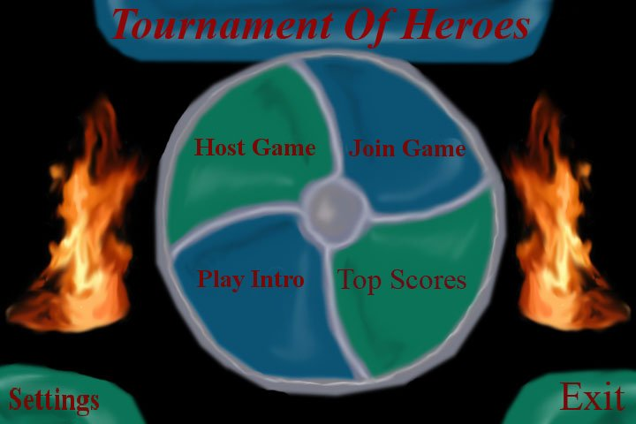

- Host Game – Opens the standard interface in Unreal Tournament 2004 for hosting a game.
- Join Game – Opens the standard interface in Unreal Tournament 2004 for joining a game.
- Play Intro – Plays/replays the intro sequence for the game.
- Top Scores – Displays the top scores that have been reached (subject to change).
- Settings – Displays the standard Unreal Tournament 2004 settings page.
- Exit – Exits Tournament of Heroes.

In-game HUD
The in-game HUD will be a very basic interface with only the necessary information being shown. At the bottom of your screen, you will see the weapon choices that are available to your character (ice attack, shield, melee attack, etc) with the “cooldowns” being shown (cooldowns are countdown timers that show when you may use your ability again). One corner of the screen will have your current health and another corner will have your current team ranking. There may also be a radar screen which shows the positions of your team members and the enemy (not decided yet).

Some possible designs for the UI:
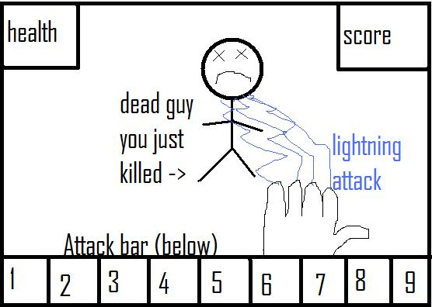
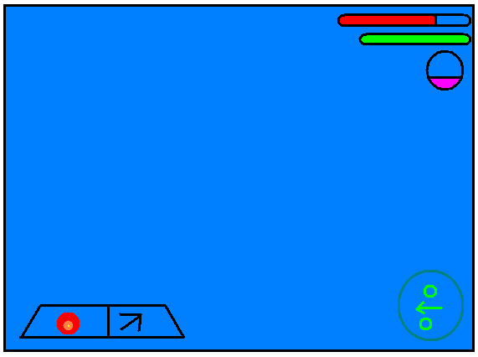

Storyline Summary
Through the passage of time over hundreds of years, humankind slowly developed its psychokinetic abilities. These powers were fairly weak and useless at first, but as their powers grew, most humans realized that their newfound abilities had the potential to do serious harm to others. They therefore decided that they should outlaw any use of such abilities, abilities that could easily lead to massive wars and destruction.

Most of the population saw wisdom in such thinking, but a few did not agree. These few established themselves in the city of Psychotropolis. This became the only city where the use of psychokinetic abilities was still allowed. Over time, some elect few continued to train and use their abilities. They developed powers that far surpassed anything the vast majority of humanity had ever experienced.

The situation in the city has degenerated into utter chaos. In the struggle for power between the few elite super-powerful humans, war has broken out in the city and the surrounding areas as people compete for total domination over the city. Unable to defend itself from such superpowers, the rest of humanity constructed an impenetrable dome and placed it around the city, permanently quarantining the city and its inhabitants. Trapped inside, factions now compete for the little territory that is left, struggling to maintain dominance over the other factions.

Character Bible
- Super Heroes – Gifted humans who have developed the ability to manipulate the environment and its elements in some way. Everyone has a different ability to some extent. Some are very gifted and have many powers, some are simple and useless. It can take years of training to master your powers.

- Citizens – Ordinary people who do not have super powers. Some don’t mind the super heroes, some hate them, some are neutral and some even try to replicate their powers through technology.

- Barmaid Bertha – A normal citizen who servers anyone who comes into her bar, human or super hero. Everyone loves her, if anything or anyone were to harm here there would be hundreds of people avenging her.

- Captain Destruction – Psychotic leader of Psychotropolis. Bent on leading the people of Psychotropolis to a better tomorrow by taking over the world at some point in time. Most power of all the “super heroes”

- Sergeant Johnson – Leader of the American army. He was the person responsible for ordering the dome to be placed over the top of Psychotropolis. He feels the world will be a much better place once all super heroes have been disposed of.

Storyboard
The idea is to have some subtitles pulled from the storyline to show what is occurring, ideally we would have narration.
- Scene 1: Shows the rise of the superhumans, and how they are testing out their powers
- Scene 2: The dissenters go off and form their own city, will focus on how the city looks like a utopia at first.
- Scene 3: The city is now in ruins, various inhabitants fighting over territories like gangs
- Scene 4: The dome created by the rest of the world is shown being dropped onto the city
- Scene 5: Pan out from a fight in the city past the dome and show the title “Tournament of Heroes”.

Game Flowchart
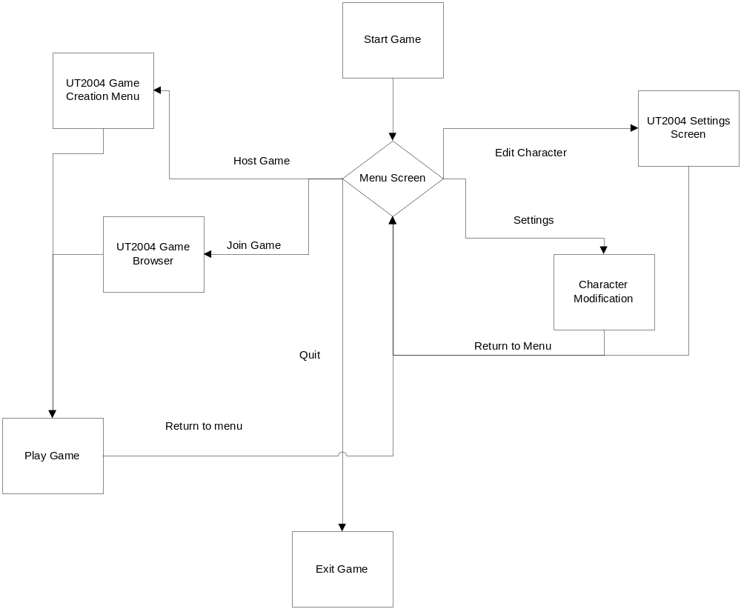

Level Design - Tournament of Heroes

Notes
Add notes and concept edits here, if this is to be a “living document” on a server. Make sure each edit has the name and time marked, for instance:
01/30/08 – First draft by Evan Musu.
01/31/08 – Formatting corrections by Aaron Curley
02/05/08 – Introduction of concept art from CCS.
02/08/08 – Addition of “official” level map drawing done by Kristen.
02/09/08 – Several sections in section 3 updated to be current with ideas modified and created on Friday of 02/08/08.

Location

Geographic Location
The location is a suburbanized city area that has a war-torn appeal to the cityscape. There will be a glass dome which fits over the city to encase the heroes to do battle.

Time of Day
The time of day will be during high noon with bright sunlight outside.

Current Weather
The outside weather has no affect to the conditions inside the glass dome. The weather inside the dome will be clear and dry while the outside in could be rainy and foggy.

Architecture or Terrain Style
There will be a large skyscraper in the middle of the map. The skyscraper will be shiny and new-looking with little age. The players will have the ability to go inside the building and travel though office cubicles. There will be an elevator and two fire-escapes which can lead you to the specific levels of the building. Both the fire-escapes and elevator can lead you to the top of the building.

The area around the skyscraper will consist of cityscapes and suburbanized areas. Half the map will be suburbanized and half will be cityscapes. Each team will spawn in a quadrant in the cityscape area or the suburbanized area, or on top of the skyscraper if they control that area. The spawn location of the players will be a supermarket, a church, a clock tower, and a television station. The cityscape areas will two of the largely detailed buildings (the clock tower a TV station). The suburbanized area will have two largely detailed buildings (the church and the super market). Each one of these building could have a critical item to gain power over the other team. The suburbanized area will include homes and a park. The cityscape area will have smaller corporate buildings. Smaller non-useable objects will include: cars, roads, fire hydrant, street lamp, street signals, etc.

Visual Reference
An overhead view of the level is included below. Buildings in purple are enterable. Grey squares depict buildings that cannot be entered.
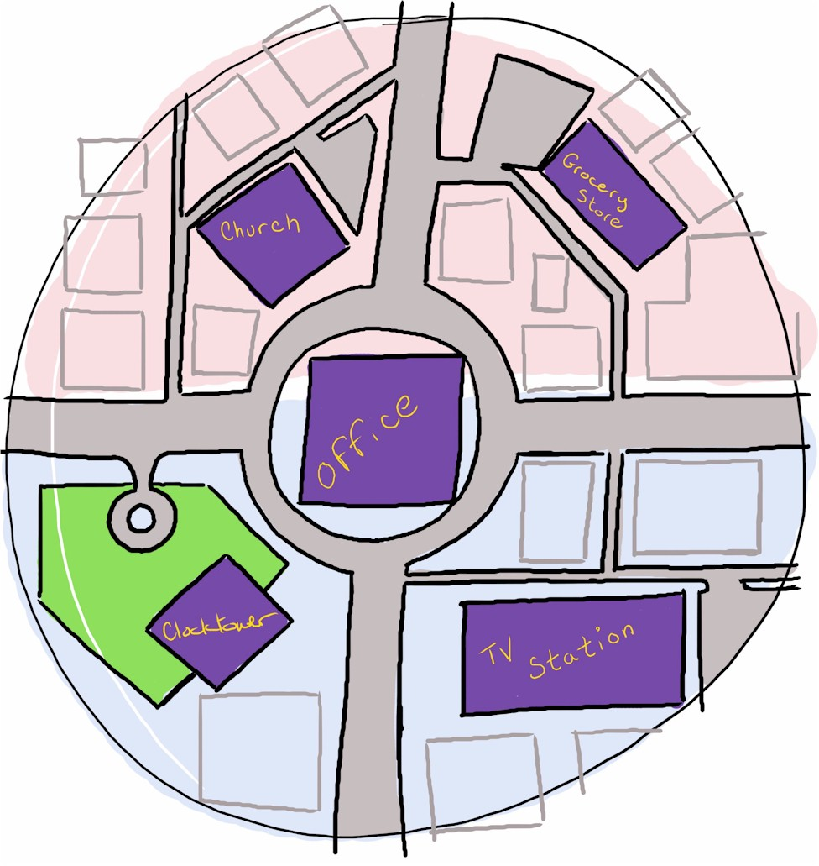

An early 3D design of the level is depicted below. See the overhead map given above for more up-to-date information.
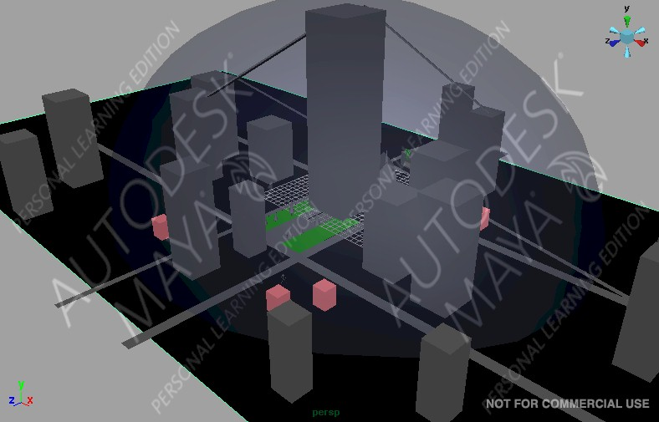

Player

Player Start Location
The player will start in homes which surround the suburbanized city. In these homes there will be areas where the player has the ability to switch his/her primary and secondary weapons.

Player Inventory
The player’s primary weapons are projectile weapon. The player has the ability to change primary weapons during a game match. The primary weapons are:
- Fire – A ball of fire. Projected straight (gravity does not affect its course in direction). Fire can be projected at a moderate rate and has a moderate damage effect.
- Energy – A slow but large burst of energy. Projected straight (gravity does not affect its course in direction). Energy can be projected at a slow rate but has a high damage effect.
- Ice – Sharp arrow like projectile. Projected with a downward arc (gravity affects the arc of the ice arrows). Ice can be projected fast but has weak damage effect and can freeze the player.
- Electricity – A netted web of electricity. Projected straight (gravity does not affect its course in direction). When electricity is in contact with water the water becomes electrically charged. Electricity can be projected moderate rate and has weak damage by itself or high damage rate when combined with water.
- Strength – Gives player the ability to hit an opponent and throw him or her across the map. When opponent falls damage is taken on him based on the height of the fall.

The player’s secondary weapons are either a non-projectile attack, or an ability to help the player condition in the game. The secondary weapons are:
- Melee Attack – A short weapon like knife.
- Regenerate – Ability to restore the player’s health. This power has a regeneration rate.
- Shield – Allows you to project a large “energy wall” in front of you and your teammates.
- Stasis Field – Freezes the enemy for a few seconds (enemy is invincible while frozen).

The player has travel power to choose from too and has that power type for the whole match. The travel powers are:
- Fly – Fly around map for a certain amount of time.
- Jump – Jump three times higher than normal player.
- Run - Super speed.
- Invisibility – Makes the player invisible for a short period of time. Player will appear when he or she attacks.

There will also be health recharge stations where players can stand around them and recharge their health.

Briefing/Starting Information
The opening cinematic will describe the initial events which lead to the tournament of heroes. It will also show key locations on the map, and describe how to control the player and the player’s abilities. There will be a huge television screen inside the bubble which tells the story to the players as they fight each other.

Reasons for Being There
A super human race has evolved in the world. This race is the character the players will control. They decided to build a city but end of fighting over it. Non-super humans decide to seclude these super humans from the rest of the world by covering the super human world with a dome. Now the super humans fight for survival in Tournament of Heroes.

Objectives

Main/Primary Objectives
To get as many kills as possible during one game match. The player with the highest amount of kills wins the match.

Secondary Objectives
Controlling the skyscraper will give the team the upper-hand by controlling a critical area in the game. It the central spot in the game, and when a team controls this spot it is the only areas where they can spawn.

Bonus Objectives
None.

Hidden Objectives
None.

Challenge Highlights

Combat Encounters
The Players will be fighting against each other in an open area. The player will be able to fire ice, fire, and electric projectiles towards their opponents.

Stealth Encounters
The player can act stealthy but killing a player still ends in the same result of a kill. A stealthy encounter that could take place is : An opponent is standing in a water puddle and you the player take care of him by shooting electrical charge by the water killing him.

Conversations
The opening cinematic will introduces the controls, the events that took place to start the tournament, and show the key locations for the player.

Wow Factor

The Travel Powers
Each player has special travel powers which grants them access for new ways to tackle a obstacles.

The Visual Style
The game looks like a comic book. Like with “POW” balloons when a player get hit. A similar visual style to compare to is the game XIII.

The Primary Weapons
Each power has its pros and cons, and selecting the right one is geared towards the player’s preferences.

The Tall Skyscraper
The tall skyscraper is the center piece and will look gigantic compared to the surrounding suburbanized and cityscape areas. There will be areas inside the building to travel and the ability to travel to the top of the building. The fire-escape and elevator will be the main means of getting to each floor in the office building. The top of the skyscraper is a control point. When a team controls the skyscraper, they will only spawn in that location and have the best area for shooting off incoming enemies.

3.6.5 The last 30 seconds of each match
Missiles will be shot down which will create chaos for the last 30 seconds. The missiles are being shot down by the non-super humans who finally decided to kill of the super humans. Will the super humans survive? Who knows?

Map Description

Center Skyscraper
The skyscraper is the center-piece of the level. It has floors filled with office furniture and cubicles. The player can access these areas either by fire-escapes or an elevator. These office areas will give the player of the feeling of being in a maze. The fire-escapes and elevator can also go to the top of the building which gives the player who can fly a good advantage over other opponents.

Clock tower, Church, Super Market, and Television Station
Each of these building will be areas were the players will spawn. Each building has it pros and cons for combating on the map. The clock tower is tall for sniping players off with their powers. The super market is a close combat area where a melee weapon might be a good choice. The church will have a good sniping position, and the television station will be large for players to take cover from other players.

Water Puddles
Shallow puddles of water which when combined with electricity takes damage to whom ever is standing in the vicinity of the water puddle. This damage rate is high compared to other damage in the word.

Assets and Requirements
List here anything that you know the level will require in terms of external assets

Models
1) Basic Female and Male character models.
2) Worn down cars and vehicles (Non-Usable).
3) Place for health recharge (maybe a fountain).
4) Complex structures pieces (like awnings, doors, computers, shelves, etc.) for the skyscraper, church, supermarket, TV station, and clock tower.

Textures
1) Multiple textures for male character model.
2) Multiple textures for female character model.
3) Textures for offices cubicles.
4) Textures for Streets
5) Textures for homes and skyscraper outside
6) Textures for sky and ground
7) Textures for skyscraper

Sounds
- Sounds for the primary weapons, secondary weapons, and travel powers.
- Sounds for the male and female like grunts and moans for damage.
- Sounds for the doors opening and closing.
- Sounds for picking up items.
- Music during game play.

Lighting
1) The sunlight actor.
2) Some light actors for indoor areas.

Effects
- Effects for the primary and secondary weapons.
- Effects for the travel powers.

Sketches and Additional Reference Material
This section contains concept art and screenshots of 3D models that have been received from the artists at CCS.

Fire Escape
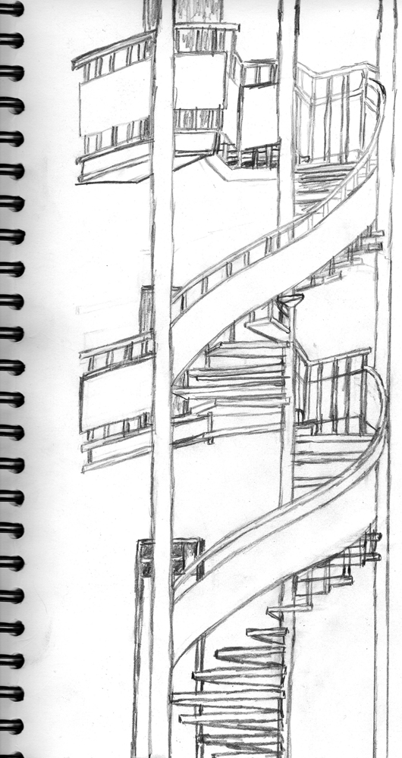

Bus Stop
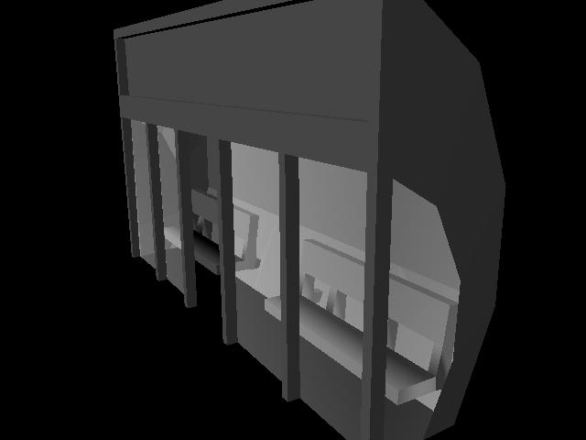

Fire Hydrant
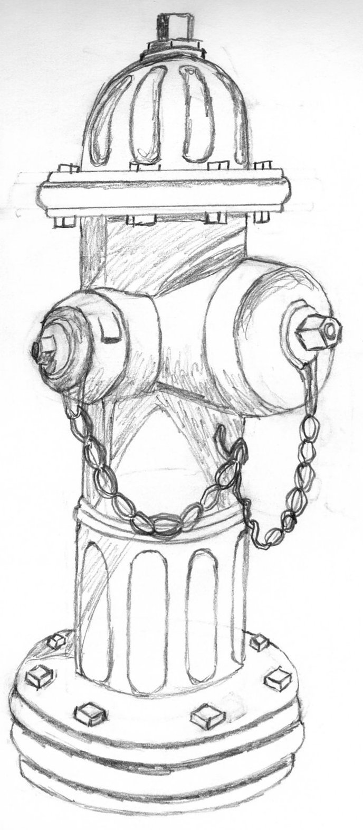

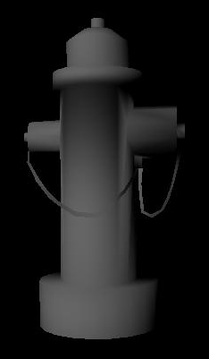

Water Fountain
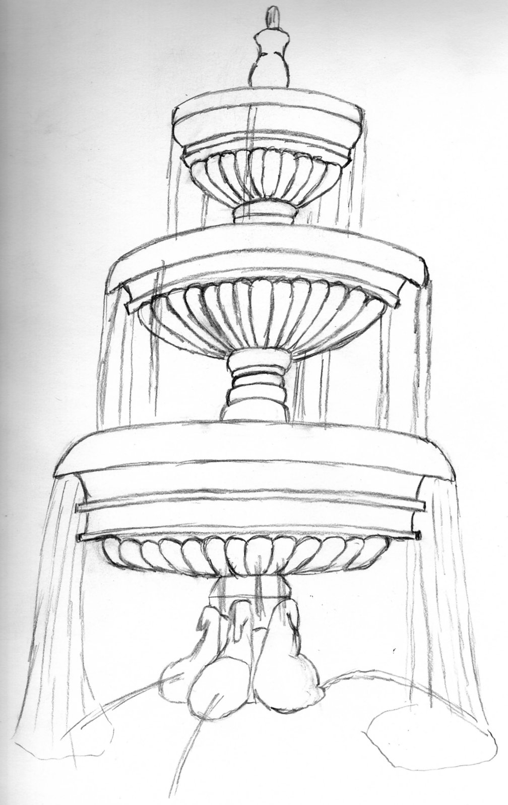

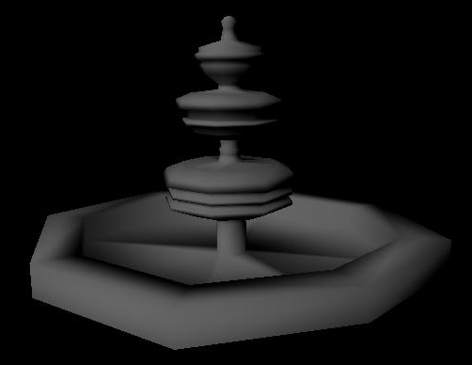

Garbage Can
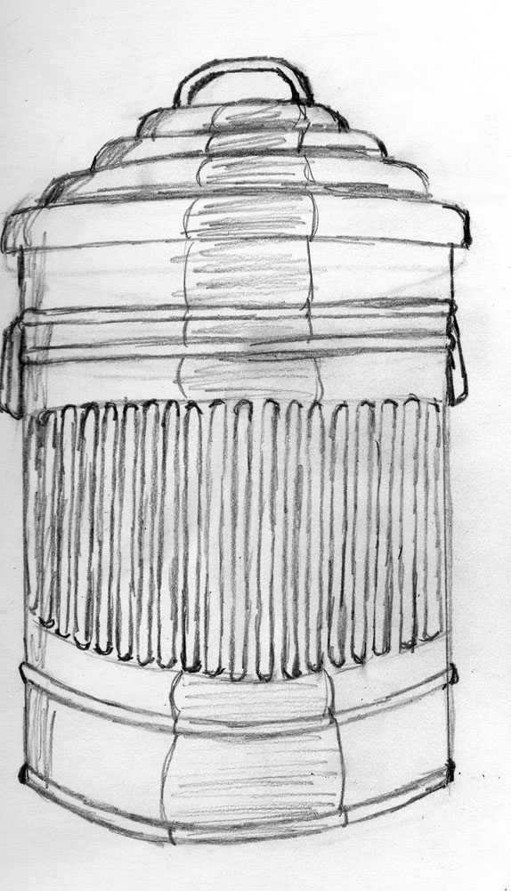

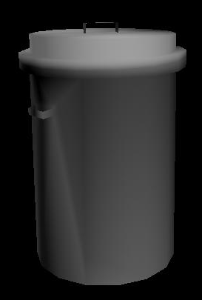

Car
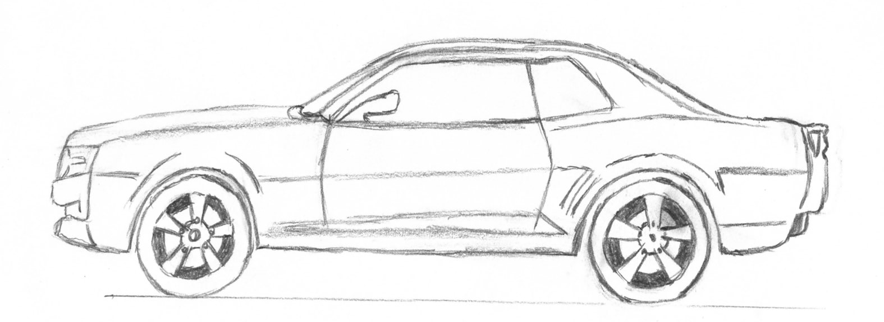

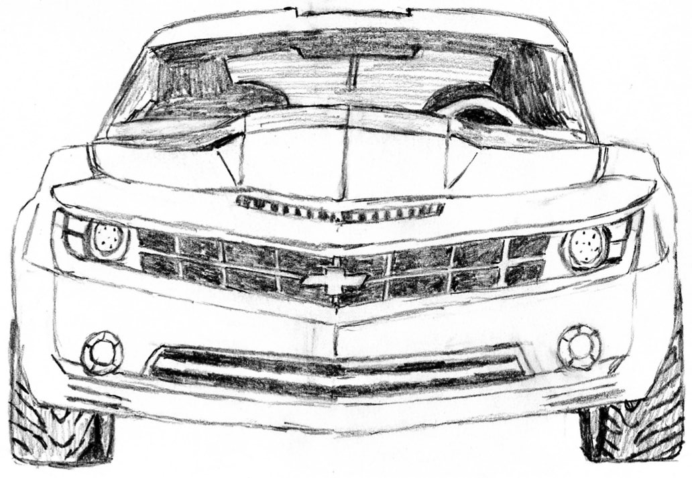

Street Light
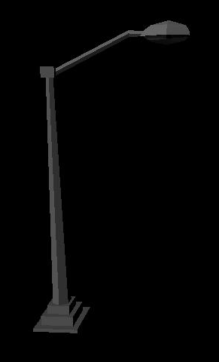

Traffic Light
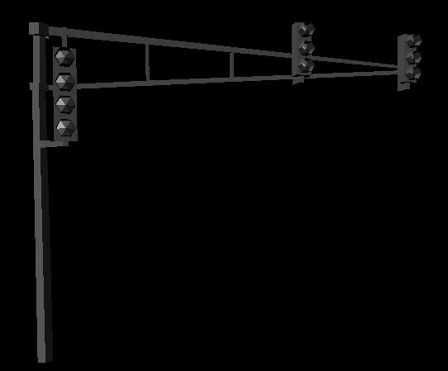

Players


