Jorden Lowe
Peter Wilkins
Mark Leich
Alan Batsford

UML Diagrams

Class

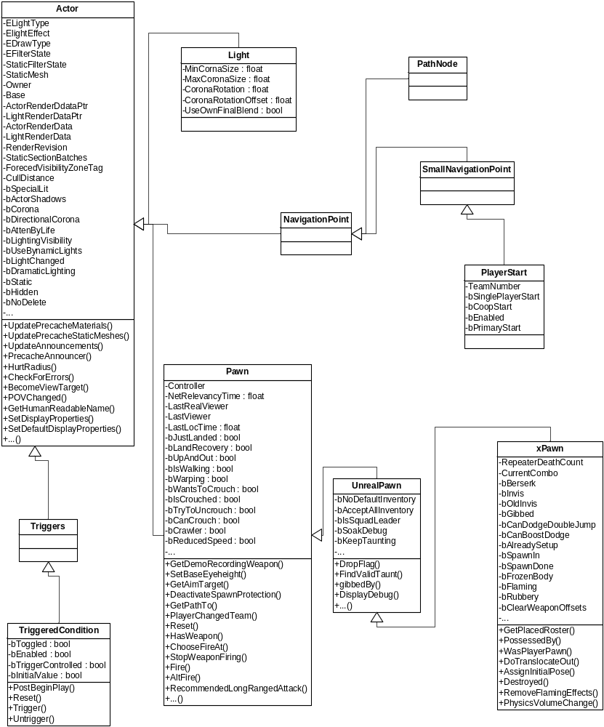

Use Case

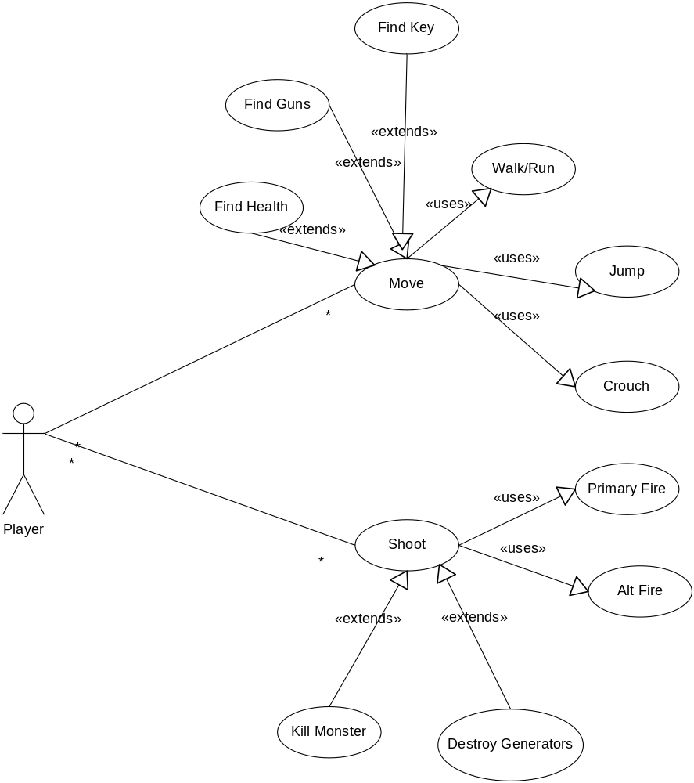

Sequence

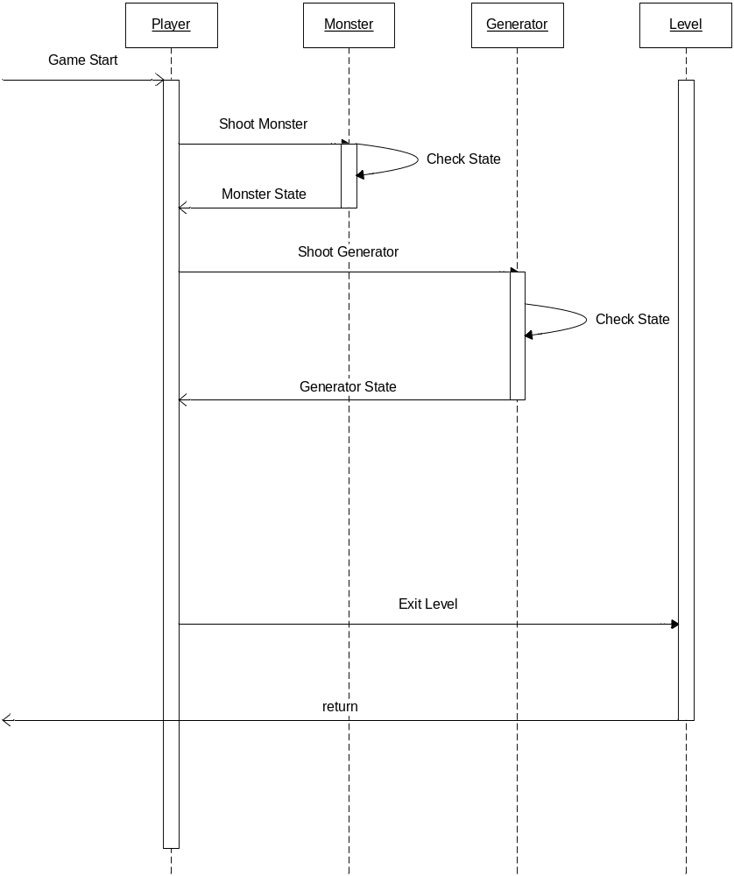

Collaboration

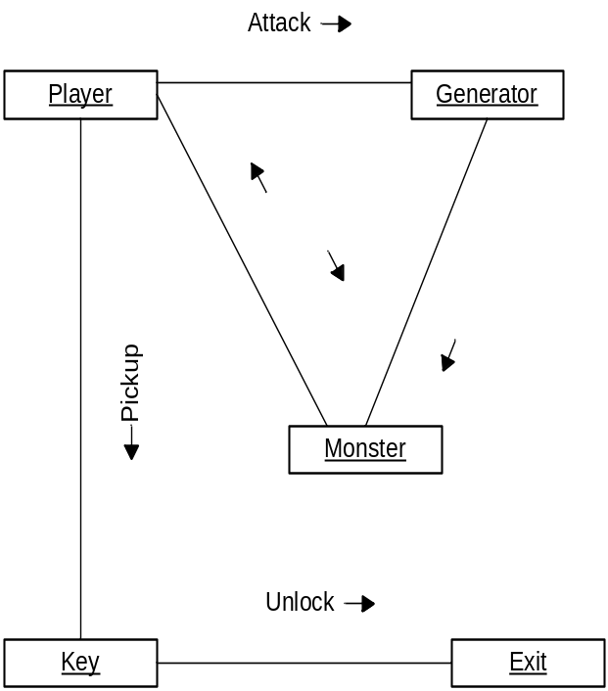

State
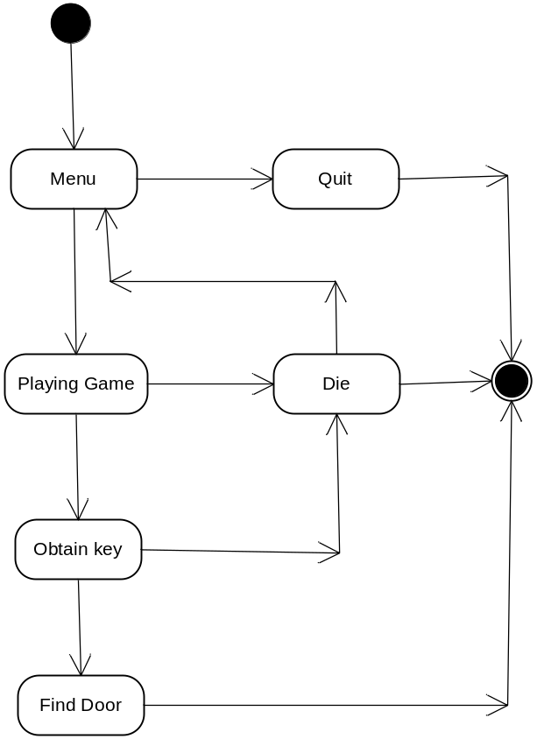

Activity
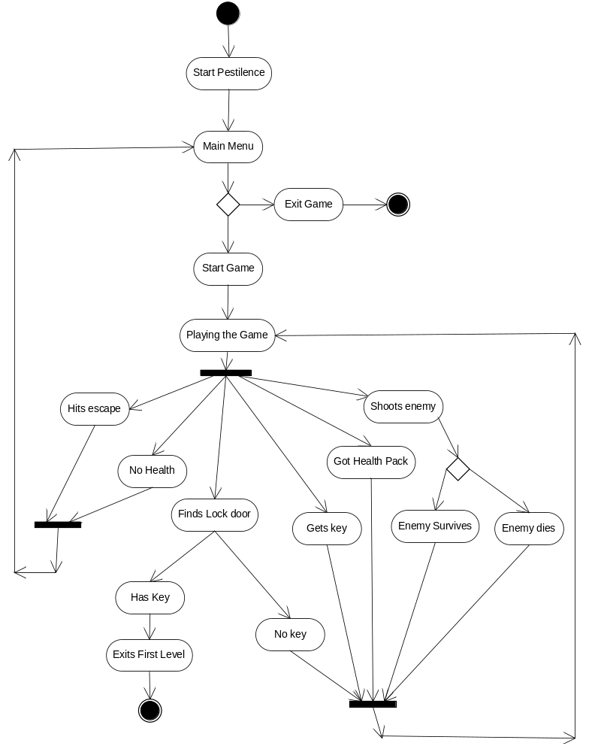

Component
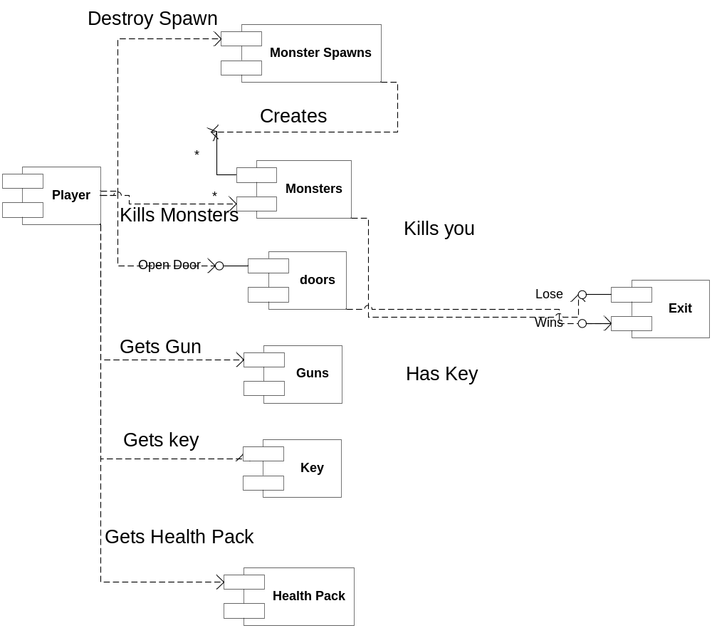
·

Deployment
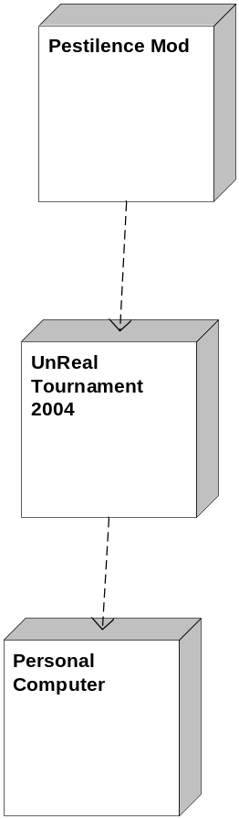

Pestilence User Manual

Contents:

Introduction:

Story……………………………………………………………………… 1.1

Minimum Requirements ………………………………………………… 2.1

Controls: …………………………………………………………………………. 2.2

Weapons: ………………………………………………………………………… 3.1

Gameplay: ………………………………………………………………………… 3.2

Monster Generators……………………………………………………… 3.3

Access Keys……………………………………………………………… 3.4

Power Ups………………………………………………………………… 3.5

Credits: …………………………………………………………………………… 5.1

Introduction

1.1 Story:

In an orbital outpost station above the planet Pluto a growing human colony is beginning to prosper on the fringe of humanity’s solar system. Space travel is possible at this time, but humanity has yet to reach beyond its solar system. This orbital outpost serves primarily as a research vessel for many different space technologies such as: advanced space craft design, developing technology so as to make life in space and in the colonies more suitable for human life, as well as serving as a launching platform for test flights beyond the solar system and as a dock and for ships needing refueling on their way back into the core of the solar system. This outpost and colony mark the advancing fringe of humanity, being so far from the core systems of Earth and Mars. Humanity has yet to encounter any other forms of intelligent life in the universe.

During a sweep of nearby space by the orbital station researchers a signature is detected of some unknown artificial structure on a meteor (the disease container) and it is retrieve it. Upon examination they determine this to be truly of alien origins and contact the Core government with their find. Upon the vessel is encoded some type of message which the scientists are unable to decipher. The order is given from CORE to open the vessel and investigate. The vessel is opened by the orbital scientists while under watch from CORE representatives as well as leading scientists. Upon being opened a few small scraps of alien-tissue are found. Seven days later all contact from the space station is lost and the bridge between the colony and the station is deactivated from the station’s end due to the fact that someone on the station commenced a complete quarantine lock down. Alarmed by the unusual timing of this communications blackout and seemingly self imposed quarantine of the station a military/biohazard vessel is sent to dock with the station and determine what has happened….

2.1 System Requirements:

Operating System: Windows 98/Me/2000/XP/Linux
Processor: Pentium III 1.0 GHz or AMD Athlon 1.0 GHz or faster.
(1.2 GHz or faster recommended)
Memory: 128 MB RAM minimum (256 MB recommended)
Hard Disk Space: 5.5 GB free
CD-ROM Drive: 8X Speed (DVD-ROM drive required for DVD Special Edition).
Video: 32 MB Windows 98/Me/2000/XP-compatible video card.
(64 MB GeForce 2 or ATI Radeon card recommended)
Sound: Windows 98/Me/2000/XP-compatible sound card.
DirectX: DirectX version 9.0b (included) or higher.
Modem: 33.6Kbps modem for LAN/Internet play
(Broadband Internet connection highly recommended)

2.2 Controls:

Move Forward …………………………………………………………………… W
Move Backward………………………………………………………………… S
Strafe Left ……………………………………………………………………… A
Strafe Right ……………………………………………………………………… D
Jump …………………………………………………………………………… Space
Walk ………………………………………………………………………… Unassigned
Crouch …………………………………………………………………………… C
Fire ……………………………………………………………………………… Mouse 1
Alt-Fire ………………………………………………………………………… Mouse 2
Use ……………………………………………………………………………… E

3.1 Weapons:

You will have a main weapon with two firing modes at their disposal. The main firing mode will be an unlimited shot weapon. You will never have to worry about scavenging for ammo.

The second firing mode should be reserved for emergency situations only. When triggered all enemies within your view will be decimated. Unlike main fire, alternate fire will have limited charges. Over time the weapon will replenish itself and you will be able to use the super weapon again.

3.2 Gameplay:

Your main objective in each area is to simply reach the end. There are a plethora of obstacles to overcome along the way.

3.3 Monster Generators:
Throughout the station are biological generators that create an infinite stream of ruthless monsters. Unless the generator is destroyed the monsters will continue to appear and attack you relentlessly. The station’s automatic quarantine defenses will remain in place until all threats are eliminated. Meaning destroying these generators will be vital to your success.

3.4 Access Keys:
Besides passages locked form quarantine, there will be security restrictions to overcome as well. You should always be on the lookout for keys that may open doors in their way.

3.5 Power Ups:
To help aid you in your mission, various power ups will be located throughout the map.
-Limited Invisibility: You will become undetectable by monsters around you for a short period of time.
-Timed Power Boost: The fire power of your main weapon will be doubled while the effect is active.
-Speed Boost: Running speed increased for short duration.
-Health Packs: Replenish health lost from combat.

If your health reaches 0 while in combat, your character will die and you’ll be forced to resume from your last checkpoint.

5.1 Credits:

Art Lead and Concept Artist: Level Design and Functionality:
Lance Red Pete Wilkins

Concept Artist: Enemy AI and Script:
Phil Spehar Jorden Lowe

Character Modeler: Weapon Design and Functionality:
Frank Dzidowski Mark Leich

Environment Modeler: Unreal Script Programming:
Brady Stetson Alan Batsford

