

Jonathan Schmoll
CIS490a Assignment 1
Computer Game Review
18 May 1999

Everquest is the newest contender in the gaming world’s most recent craze: massively multiplayer online games. A genre thought to have been redefined by Ultima Online, Everquest goes years beyond it in terms of sheer beauty, immersion, and fun. Featuring an above average 3D engine, with a slew of eye-popping special effects, and a gameworld so huge it would take many hours to walk across it, along with the ability to play with over 1,000 people at once, Everquest is nothing short of an experience.
Developer: Verant
Publisher: 989 Studios
Genre: Role-playing
Price: $44.99 (+ $9.89/mo)
Minimum Requirements:
Win 98, Pentium 166, 32MB RAM, 500MB HD space, Direct3D or Glide compliant video card, 28.8k Internet connection
Recommended Hardware:
Pentium II 233+, 64MB RAM
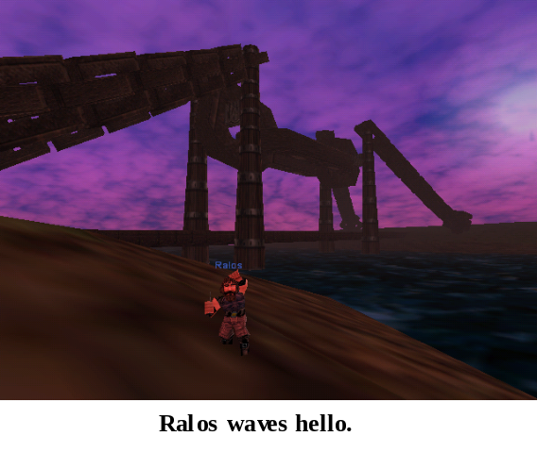 The story of Everquest begins before you ever log on to a server. The gameworld is backed by a well thought-out history, with stories of creation, wars between deities, and old hardships of the land’s inhabitants. All of which become evident as you begin to play. Norrath feels like a place that has been there long before you. Some people don’t like you; some like you before you even talk to them. Both purely because you serve a certain deity. This kind of back-story is necessary to flesh-out the gameworld, because there really is no ongoing story to speak of, aside from the one you make for yourself.
This brings us to the player’s role in Everquest. A large variety of character variations are available to choose from, and chances are there will be something for you. Race choices include Humans, Barbarians, Erudites, Half Elves, High Elves, Wood Elves, Dark Elves, Trolls, Ogres, Dwarves, Halflings, and Gnomes. These can all be paired up with 14 different class types, from warriors to wizards to rogues. Each race and class combination have been balanced well, to keep any one combo from lessening the variety of Norrath’s inhabitants. Everquest seems to keep to the general hack-n-slash formula when it comes to raising the level of your character, but what keeps this exciting is that you are always fighting bigger, badder creatures in new locations. Sometimes seeing new things in this game will truly make you go, “wow.” The first time I saw a hill giant towering 50 feet above me, I remember standing in awe. That is, until he crushed me with one blow.
Installation of the game is a snap. Put the CD in once and the auto-installation comes up automatically. After you install the game, the CD is not needed anymore to play it. A little tip: unless you just have to see it, don’t install the game’s intro movie. It’s extremely cheesy, and it will take up about 120MB on your hard drive. After the game is installed, you need only to connect to the Internet though your ISP. Once connected, you simply click on the icon and away you go. A patch screen comes up first, and will automatically download any updates that have been released since you last played. Once the game loads, you click on ‘new account’, enter your information, select your method of monthly payment, and you’re all set.
Now it’s time to create a character. Character generation is handled very nicely in Everquest, making it hard to get confused. Each race/class combo has fixed statistics, with a number of points available to distribute as the player sees fit. After you set your stats and choose a deity, the game will tell you the probable difficulty you will have in playing that character. The only complaint I have about the character generation is the lack of variety for the appearance of your character. There are only a small number of faces from which to choose, and your clothing style is predetermined by your race. The fact that a larger variety wasn’t present seems like laziness to me.
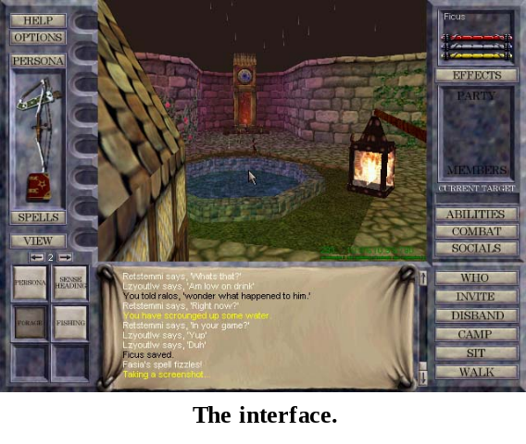 The user interface is very smooth. While it may seem almost daunting for the first five minutes of play, the interface only looks very complex because of the large amount of information that is displayed to you. This is hardly the case once you realize what all the information pertains to. All other pertinent info, along with necessary game functions and inventory items are never more than one or two clicks away and can be accessed quickly, which is extremely important when the hurt is coming down on you. There are six banks of hot keys to keep your most important actions close at hand, and even these are programmable to some extent. All other information is handled via an IRC style chat window. Communication with other players is easy, and chat commands will be familiar to anyone who has ever played on a MUD before. There are three different ways to view the interface screen as well. The first is the default style, in which information encompasses the actual game screen (ala Ultima Underworld). The second is a variation on the first, with the background of the surrounding information boxes being virtually invisible, thus enlarging the playing screen. The third is all game view, with no interface being visible at all (along with no chat window, etc.).
The gameplay in Everquest is not like the normal Quake style shoot-em-up. The combat takes place in a sort of psuedo-realtime, with each combatant taking a swing at set intervals depending on their speed and the weapon they are using, while remaining free to move about (although this does not aid in dodging blows). Again, this is very similar to MUDs in style. There are also a number of different ways the player can view the game window, be it from a first person perspective, or a number of third person perspectives with movable cameras.
Player killing (PKing) was a big issue in Ultima Online. Who wants to be killed by a bunch of ‘d00dz’ when you just want to explore? Everquest does not have this problem at all, with a unique take on the PK issue. If you want to be a PK, then you set your PK switch to ‘on’ with a mini-quest. After that, you may kill other players at will, but only those that are also PKers. With out the PK switch on, you cannot harm other players.
The monster artificial intelligence in Everquest is a mixed bag. It has some very good points, marred by some very cheap quirks. Monsters will run when they are near death, call out to others for help, and hunt you down throughout a zone if you run away. However, they will also hit you through walls, walk through walls to escape from you or attack you, or disappear as you are chasing them down to kill them. A line-of-sight and some better collision detection would be nice.
Players gain levels (and thus become more powerful) by killing monsters, which give varying degrees of experience and loot. Dying also becomes a harrowing experience at higher levels, as the higher you are, the more experience you lose from being killed. Grouping with other characters is a big part of Everquest, allowing you to fight bigger monsters and thus gain experience faster (besides being just plain more fun).
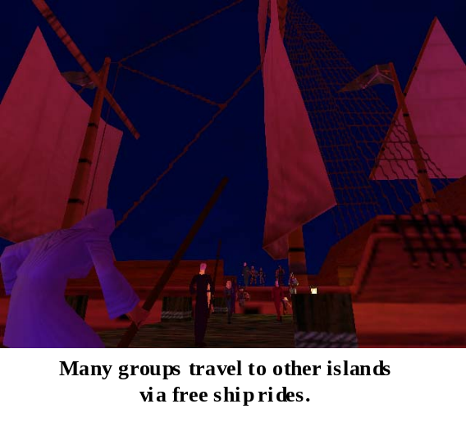 Graphically, the game is above average. The 3D graphics may not push the envelope like Half-Life or Unreal, but this slight shortcoming is defeated with some amazing landscape architecture. Players can look forward to beautiful sunsets, breathtaking vistas, dark forests, deserts, oceans, and more. Norrath is divided into ‘zones’ to cut down on the size of each area, but don’t be fooled. Some zones are downright huge, and may take you 15 or 20 minutes to walk straight across them.
The sound effects are decent, especially with the noises the monsters make. However, there is only one sound effect for casting all spells, and it is an annoying sound at that. The music in the game is annoying as well, but all music and sound effects levels can be adjusted or turned off entirely.
The manual that comes with the game is down right awful. Whoever was in charge of it should be fired immediately. It contains no useful information except for the back-story, and if you are looking for any information whatsoever concerning character races or classes, then don’t look here. The official website is the same: all hype, no real information. I have found three very useful sites with scores of statistics, guides, and the like at eq.stratics.com, www.eqvault.com, and www.eq-online.com.
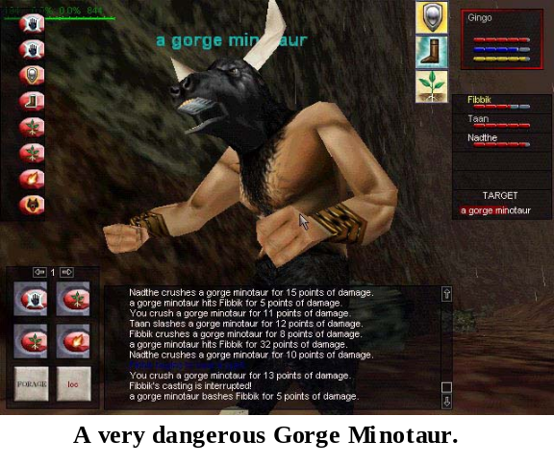 Everquest does have its share of bugs. In the first few weeks of its release, it was plagued with server crashes. On the second weekend after it was released all servers remained down for the entire weekend. Gamers were so angry that Verant was forced to give away two weeks free. Thankfully, for the past month or so, server problems have been almost non-existent. There are a few graphical glitches, broken quests, and some promised features that just don’t work. This is another case of a game that was released just a bit too early. You’d think that publishers would have learned by now.
Load times between zones are annoying, and there are also a few game related problems. Guards that are supposed to protect you sometimes stand around like fools as you are cut down in front of them. It can also be annoying when you are in combat and some other creature, walking up behind you, will kill you in one or two hits, not even allowing you to run.
Its problems aside, Everquest is extremely fun and addicting. The social interaction in the game is wonderful. There is a great feeling when someone you don’t even know walks up and saves you from certain death, and then strikes up a conversation with you while healing your wounds. Hearing people talk over the chat system can be downright hilarious as they argue over certain game aspects or make jokes about game characters. People even talk ‘out of character’ and ramble on about the new Star Wars movie. All very enjoyable, and what’s even better, is that you can join in yourself. Or if you don’t want to listen to it, just turn that aspect of the chat system off. Grouping with friends, or even just people you meet in the game is quite fun, and the experience is new each time.
While the target audience may be males ages 18-40, Everquest has something to offer both genders, due to its lack of gore and reliance on social interaction. Women may have a little trouble getting past the learning curve and supposed ‘geek factor’.
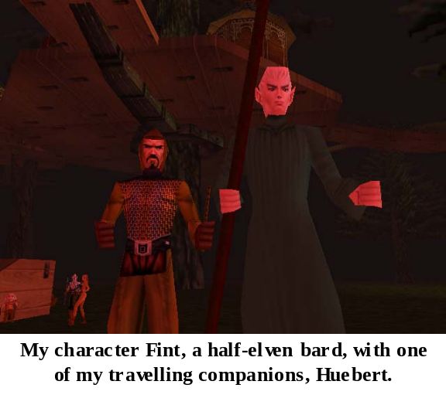 There is a real feeling of immersion and immensity in the gameworld. It can be frightening to walk across an area when you know everything there can kill you with ease, but because there is such beautiful variety in the landscape, you just can’t help but want to see what’s around the next mountain. I recently took a trip from the relative safety of the city I was staying in to travel to a desert oasis where I had never been, to buy some armor from a player, which he had made himself. It was a good experience.
One of the most impressive aspects of Everquest is that the game, while supporting such a large amount of players simultaneously, runs seamlessly with a 28.8k internet connection. There is usually no noticeable lag. Try playing Quake at 28.8k and have fun watching the slide show as you are killed repeatedly.
Everquest blows away Ultima Online in every way, and it comes highly recommended. If the premise of a huge fantasy world with thousands of real players sounds even remotely interesting to you, then buy this game. It’s extremely beautiful, surprisingly deep, and a whole lot of fun. There is not a better game of its kind out there.

