Ken Nelson
CIS 490A Computer Game Design and Implementation
Game Review – Half-Life

May 18, 1999

The game that I chose to review is called Half-Life. It is a 3D game from a first person perspective. It is priced at around $45.00 to $50.00. It was developed by Valve and is distributed by Sierra. The minimum requirements are a Pentium 133, 24 megabytes of RAM, an SVGA 16-bit video card, a 2x CD-ROM, 400 megabytes of hard disk space, and a sound card. The actual hardware required is some form of 3D accelerated video card. It does not have to be the best video card, but without hardware rendering, the game’s graphics look absolutely terrible. Aside from that I would suggest at least 32 megabytes of RAM instead of 24, a faster CD-ROM (for a faster install), and a Pentium II 200 or better.

The basic story behind Half-Life is that you, Gordon Freeman, are a scientist who is involved in a top-secret experiment that goes awry. Less than a minute after the experiment begins the scientific laboratory that you are in becomes a twisted collage of dead scientists, destroyed buildings, and last but not least, evil little aliens. Your goal becomes painfully obvious, get out fast, and get out alive.

The installation of the game is quite painless, you insert the CD, click on “Install Half-Life” and you are on your way. There were no problems installing the game, however an upgrade patch that I downloaded from Sierra’s web-site caused the video in the game to blow up every so often. This however was fixed once I downloaded and installed the newest drivers for my video card.

User interface is done very well, simply because the user can choose whatever keys he/she pleases to control their movement. Controlling your character then becomes a matter of personal preference. As far as the actual movement of your character goes, I found this to be easiest using “mouse-look” which allows you to use your mouse for moving your head around and aiming your weapon, and use the keyboard for character movement. Movement is very smooth and responsive, and of course, you can adjust mouse sensitivity for your personal liking. The menus are pretty straight forward, main options are listed then from there sub-options are listed.

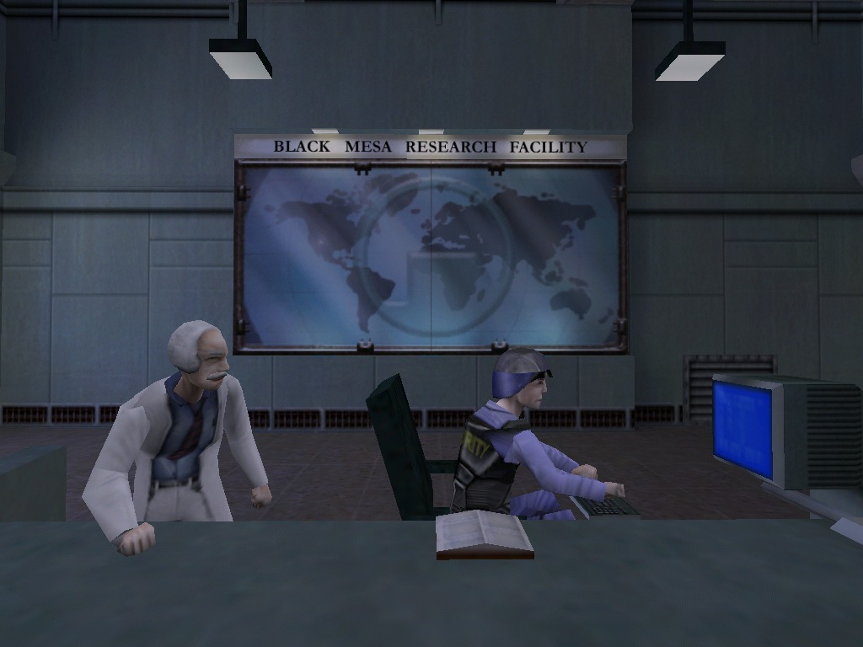
The graphics for the game are truly awesome, (assuming you have a good video card). There are plenty of textures to go around in this game so that not every level looks identical, (i.e. Quake). On top of that, the levels were designed realistically, (not including the last few levels) in that the levels themselves look like places you may have been to before. The game’s engine is based off of the Quake II engine and therefore has no dynamic lighting, but considering this, you really do not miss it. The level designers and engine programmers used a few nice tricks to create the illusion of dynamic lighting.

The sound for the game is great as well as it supports 3D sound, which helps an awful lot while you are standing in a dark hallway and you can actually hear what direction an enemy is coming at you from. What is also great about the sound is that the programmers did a really good job implementing digital voice. Instead of reading about the story as you go along on little notepads or in cut-scenes, your character actually interacts with other characters in order to understand the story better. Music in this game is not the best music ever produced, but it does help set the mood. I personally find music in some games distracting and so I turned it off.

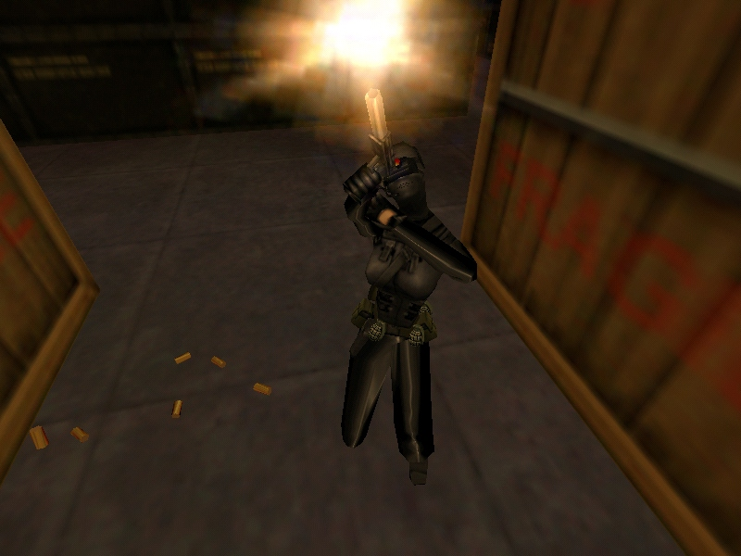
The AI for this game was done really well. The Non Player Character (NPC) movement and “mind” surprised me more than a few times. In particular the “assassins” stand out in my mind. I first encountered an assassin as he shot me in the head… twice. Once I reloaded my game and approached the assassins again, I heard an eerie sounding foot movement, which was of course the assassins running around, finding a nice spot to hit me from, and killing me… once again. What was so interesting about it was that they did not simply run in and shoot me, they instead would run in, shoot me, then run back out before I could get a good shot off, (after about 15 minutes of this I finally managed to kill them). However, as good as the AI was, this was the only place in the game that there was a significant bug, (aside from the cockroaches that crawl around randomly). I noticed more than once that an NPC would literally get caught on a wall or caught on nothing at all. This made it very easy to pick them off once they had no means of getting away.

I really enjoyed this game. The story was well written the character interaction was great, the graphics and sound were some of the best I have seen for 3D games. On top of that the game was simply a lot of fun to play. Just when I thought I might be getting bored a new twist was thrown in, a new bad guy to fight, a new weapon to use. It kept my undivided interest for at least a couple of weeks. Not to mention that the game is multi-player capable which extends the life of the game into months instead of weeks. I have spent countless hours online or on a network blasting away at my friends with my crossbow or my gluon gun.

In the multi-player game your goal changes. The new goal is to kill all of your opponents as often as possible as quickly as possible, without losing your own life. Therefore the score simply becomes a ratio of kills to deaths. The higher the kills the better, the lower the deaths the better. While playing the multi-player game you can check your opponents score as well as your own, to determine who to stay away from, and who to go after.

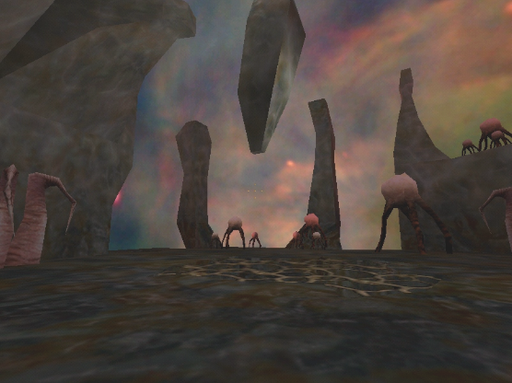The one and only thing I did not find fun about the game was the last few levels in the single player game. The reason I loved the earlier levels was because of the realistic landscapes and buildings. However, once you get to the last few you are teleported to an alien world and it just began to get way too strange. So strange in fact that, (and I hate to admit this), I never even finished the game because it quickly became boring upon arriving on the alien world.

Comparing Half_Life to Quake II, (which the Half-Life engine is based off of), it is no contest. Half-Life’s levels are far more realistic and colorful than the constant pea green color of Quake II. In comparison to Unreal, (which has a much better game engine due to dynamic lighting effects), Half-Life is still a much better game. Even though Unreal had amazing lighting effects, the overall game lacked the ability to draw a player in, as there was no character interaction and the levels were confusing or dull.

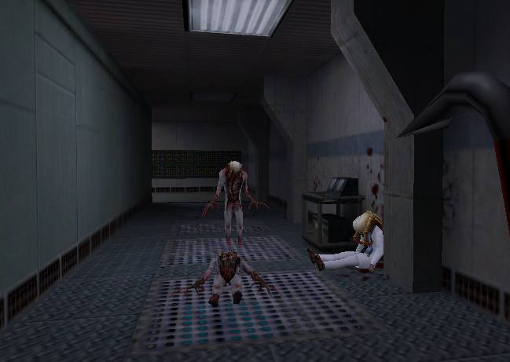The appropriate audience for Half-Life is most likely for males ages 12 and above. There is a lot of blood and gore which draws the younger crowd into it, but beyond that the game story and interactivity create a fun game for adults too. However, it has a lot of very violent content and would probably not hold a female audience captive for more than a few minutes. I would not suggest the game for children under 12. Some kids might be able to stomach the gore and violence without having horrid nightmares, but my guess would be that most would not be so lucky.

Overall Half-Life is a great game. The graphics are clear, the sound is crisp, and the levels are very well designed. Not to mention the game is very addicting to play. It is definitely worth purchasing a copy. The cost of the game is well worth the dozens of hours (hundreds if you include multi-player) that you remain entertained for. It is by far one of the better games currently released. The only improvements I would suggest would be fixing the AI (so NPC’s do not get caught on walls), and implementing dynamic lighting effects. These aside the game is a lot of fun, and I would suggest buying it to anyone.

