CIS 490A - Assignment #1 David Mehi

Basic Information

Game Title
Alpha Centauri

Company and Author
Sid Meier and Brian Reynolds, Firaxis Company

Type of Game
Turn based Strategy/Empire Building Sim

Price
$49.99

Minimum stated hardware requirements
Windows 95/98
Pentium 133
16megs RAM

Actual hardware requirements
Windows 95/98
Pentium 233
64 megs RAM

Game Summary

Quick Overview
Alpha Centauri presents the next evolution in strategy games, with the most addictive, compelling game play yet. Explore the alien planet that is your new home and uncover its myriad mysteries. Discover over 75 extraordinary technologies. Build over 60 base upgrades and large scales secret projects for your empire. Conquer your enemies with a war machine that you design from over 32,000 possible unit types.

Story Line
In the not so distant future, mankind is on the brink of extinction. Due to the reckless squandering of Earth's resources, the planet has become almost uninhabitable. To ensure the survival of the species, Earth sends a colony ship to the distant star Alpha Centauri. The grueling journey lasts almost 57 years and the ship repeatedly falls into disrepair. Tempers flair in the close environment and the crew and passengers splinter into factions, each with their own philosophies and political agendas. When the colonists finally reach the planet that will serve as their new home, seven separate factions exist. Each takes a seed ship down to the surface of the planet to claim their territory and begin their new societies.



It turns out that life on the new planet is going to be much like the life man knew on Earth - exploring new territories, setting up colonies, discovering new technology, and using diplomacy and war to deal with the other societies. There are five different ways of beating the game, one being total domination.

Player's Role
As the leader of one of the Earth factions, you must build colonies, gather resources and
micro-manage your growing society. You must research new technologies and develop weapons to defend your colonists and their way of life. Also, the environment itself is hostile and you must be wary of "Mind Worms", the only indigenous life on the planet. In addition to a strong military, you'll need diplomatic skills to know when to ally with other factions to face a greater threat. Win conditions can be set for diplomatic, economic or good old military conquest.

Installation
The installation is the same as other programs and games for a Windows based system. The game has an installation wizard, and will walk you through the installation process. Unique installation options and scaleable technology optimize performance for all machines, from laptops and low end Pentiums to the latest top-shelf hardware.

User Interface
Alpha Centauri has an excellent user interface. The interface offers 3d buttons, and a clear explanation of the controls at hand.

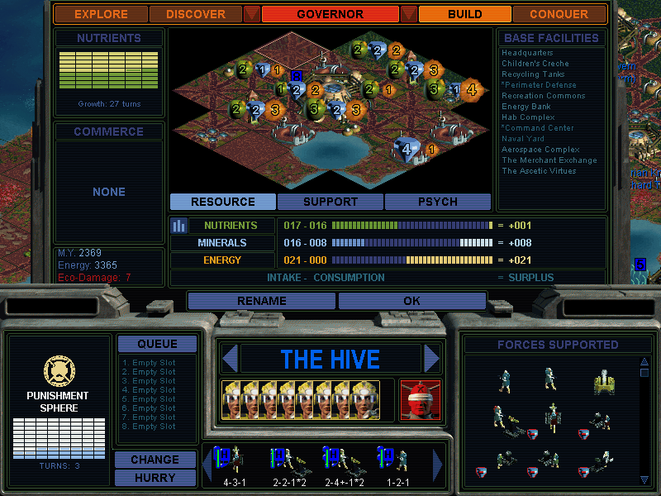

Game Play
Game play is the familiar exploration/discovery/building/conquest model. You'll establish cities, explore the area around it, and build both military and research infrastructures.

Scoring
I'm not really sure how the scoring works. I don't have the manual, so I can't say for sure. However, score is kept throughout the game.

Artwork
The artwork of Alpha Centauri is superb. The 3d landscape of the game is very descriptive. The cities, military units, and opponents are shown in surprisingly clear detail. Screen shots of new buildings built, new military units constructed, and pictures of the rising city are very nice 3d rendered pictures.

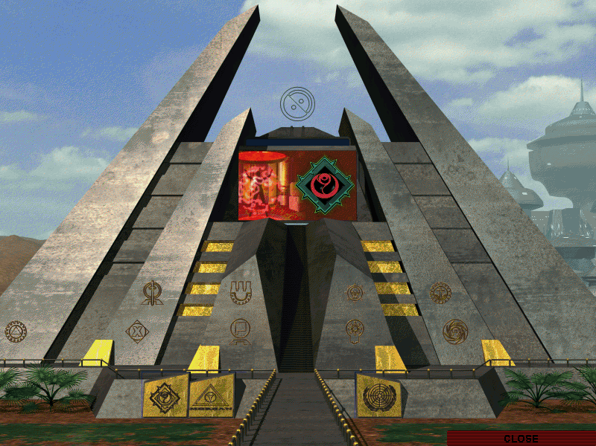

Sound and Music
Alpha Centauri has just the right amount of sound and music. Music is not played during the game. However, it is played for short periods of time throughout. There are many different kinds of sounds effects that increase the enjoyment of the game. Many of the effects are played during times of battle, interaction with opponents, and discovering new technologies.

Special Features
Multi-player feature. Play against human opponents over the Internet, LAN, modem or serial port. Includes a voice chat program. The game is infinitely replayable. A random 3D world generator, unlimited strategies, five paths to victory, six levels of difficulty, seven unique factions, fully featured map/game editor, and a whole host of customizable options ensure unlimited game play.

Manual
Includes a 250 page manual that explains the background of the game, all the features and factions, and gives strategy tips. I have not seen the manual though.

Bugs
I'm sure there are many bugs, but I have not run into any obvious or distracting ones.

Game Review

There are many things about Alpha Centauri that make it fun. The main one is the enjoyment of being in control of a whole civilization. Having the control to decide what gets built when, gaining knowledge and building military equipment to take over the world. The complexity and depth of the game increases the challenge as well.

Another thing that makes Alpha Centauri very fun to play is the superb Artificial Intelligence. The other factions are very competitive and can be quite challenging. Of course there are several different difficulty levels that you can choose from. The other factions develop military, create cities, build and attack as if a human was controlling it. The excellent user interface and 3d terrain map make the game pleasing to the eye. The sound and music effects please the ears also.

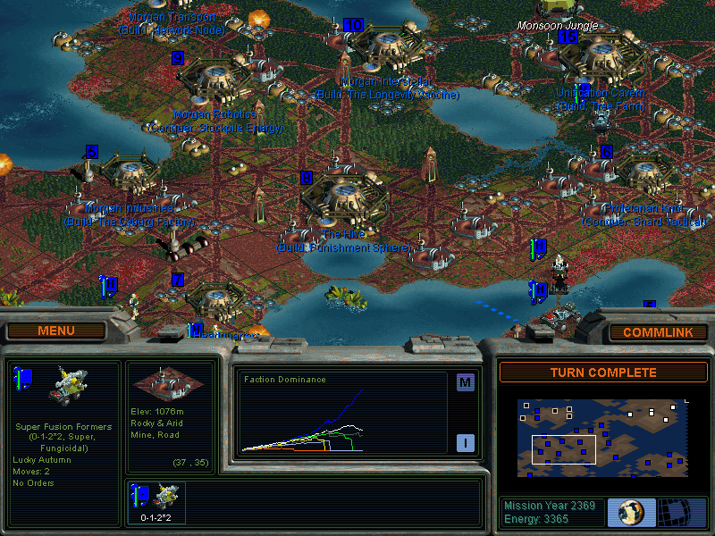

I can only think of one thing that is bad about the game, it's too addictive. The first time I ever played it, I installed it and started to play it at midnight. After picking up the game quite well and defeating many of my opponents, I decided to quite and continue the next morning. When I looked at the clock, it was 7 a.m.! I couldn't believe I spent 7 hours straight on it!

Alpha Centauri can be compared to Civilization I and II. Actually, Alpha Centauri is better than Civilization because it has increased and improved in every area. I would say the appropriate audience is 16 and up. However, I'm sure there are many under that age who are playing it. I say 16 because someone younger may not have the patience to play it for a long time. It is one of those games that can appeal to both men and women as well. You can choose a military reign, or a peaceful one. There are many different ways to play the game and win.

I didn't really recognize any design mistakes. I thought the game was very well designed.

Summary
The main strengths of the game would be the playability and the control over a civilization, the excellent and challenging AI, and the superb sound and graphics. The weakness is being too addictive. Alpha Centauri is definitely worth purchasing. Since it is such a deep and complex game, the manual will definitely explain a lot that would not be known if you got the game through some other means. I can't think of any ways it could be improved, but I'm sure Sid Meier will find a way in Alpha Centauri II.

