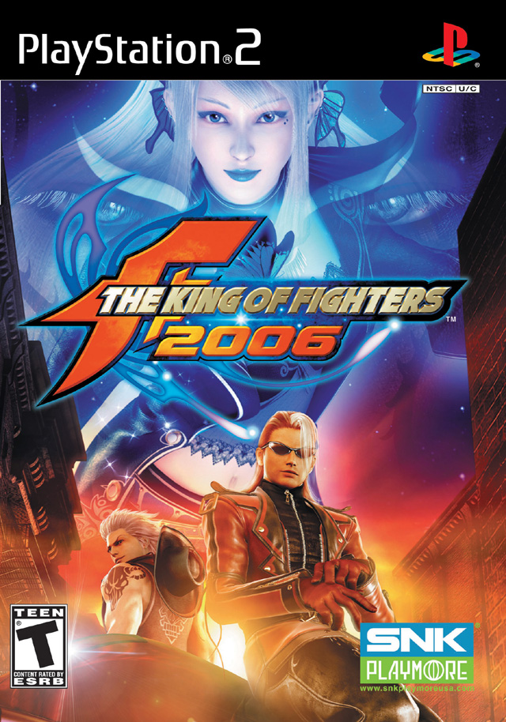

Game Review

Published and Developed by: SNK Playmore
For the PS2 Entertainment System

Basic Information

King of Fighters 06 is actually the second installment of the Maximum Impact series. It was developed by SNK Playmore and is now out for the Playstation 2 Entertainment System. The retail price for this game is 29.99. This year installment promises 38 different playable characters, mini games and a new counter strike system which helps improve game play. The only thing that is required is a PS2 a controller and a memory card (optional).

Quick Overview

Storyline
KOF 06 takes place after the events in the first Maximum Impact. Each fighter (with the exception of some bonus characters) has a unique storyline based on his or her personality. Basically you’re picking a character, and fight 6-10 different characters to win the game. You also get special cut scenes in versus mode when certain characters are selected. The cut scenes also depend on the type of stage that you select.

SNK also introduce some new and old characters into the game. Fans of KOF will be thrilled to see Billy Kane, and Kula Diamond back and in 3D. There are other SNK greats that fans will be dying to get their hands. Sadly not all of the SNK favorites made it in. Fighters such as Andy Bogard, and King will have to wait until next year.

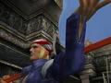
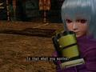


Just a few of the many new and returning characters.

One problem with the game story mode is that when you beat the final boss for most characters, you get a short little dialog (none in some cases) and the closing credits. The dialog doesn’t add towards the character personality or what they are fighting for. However characters like Terry, Mai, and the newly added characters so special cut scenes before the battle.

User Interface
The User Interface is pretty straight forward. There is four playable modes (story, practice, mission, and versus) as well as a profile mode (profiles are viewable once the player win with the character in story mode), and of course the option menu. Even though the menus are pretty straight forward, it doesn’t look as if SNK really tried to make the menus look good.

As for actual match screen it’s pretty straight forward. Energy bars, number of wins, and impact meters are located on the left and right top corners, and special gauges are located on the bottom part of the screen.

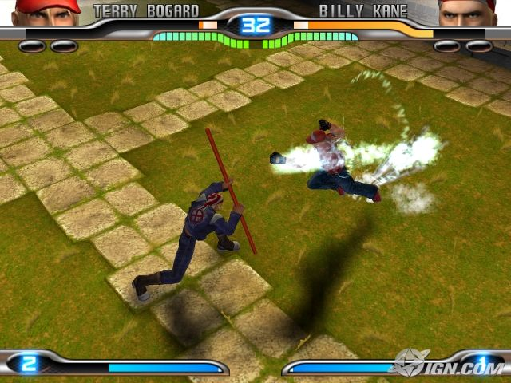

Fighting screen

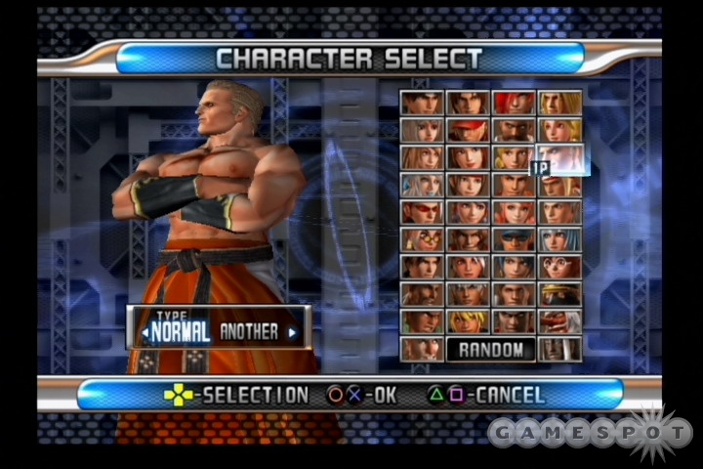
Character Select Screen

Gameplay
If you played one KOF game in your life you have played them all. KOF 06 offers the same fast paced fighting that the previous title did. The game allows the user to enter different types of combos (stylish moves), special moves, and of course the uber powerful super special move which is all unique to the character they are using. SNK also adds a new aspect to the game called Sabaki (counterstrike, evading, etc), the problem with this is that Sabaki has been in every fighting game since the PS1, N64 days. SNK also claims that they added “rising attack” and “side stepping” but these features were also in the previous title.

There is a big issue and that’s balance. The problem is that there is always 6 or 7 fighters stronger than yours. Plus the game also has combos where once you get hit you if executed properly you may never have the chance to fight back. (Especially while fighting the final boss.)

As for the CPU, the CPU tactics actually differ from opponent to opponent. If the CPU is using a long range fighter that does nothing but shoot fireballs it would do that (i.e Athena, Migeon), where as a grappler (i.e. Clark, Ralf) would fight you head on and perform many throws in succession.

If you are a die hard KOF fan you will be slightly disappointed due to the fact that SNK don’t have a striker system (The ability to use multiple fighters in a match up) like in the past 2D games, but KOF 06 does have a three on three fighting mode.

Scoring
Scoring does not have an impact on what you will unlock or how the game progress, but it is used to show off to your friends to see how well you did in story, survival and other modes. Scoring also depends on what mode you are playing in. If you’re playing in one of the extra missions, you are ranked based on how fast you complete the missions, where as story mode ranks you by moves used, combos, time, and difficulty.

Artwork
As for the artwork, some of the characters looks great, but others looks like they were rushed into the game. The stages themselves fits the game but looking at other fighting games, the graphics and artwork seems to be lacking.

Special moves however are very flashy and looks real good in the course of the game. Even though SNK is still fairly new in the 3D visuals department, this game is still very decent.

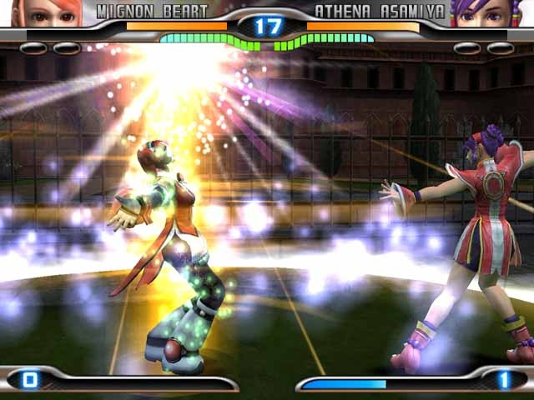

Flashy

Special Features
This is where KOF is worth your money. The game features 100 different missions easy missions to choose from. (You will have to unlock hard missions) There are even extra missions on top of that, which is similar to the Street fighter 2 extra missions (Beat up the car for example). Completing a mission will unlock a color scheme for your character, unlock a stage, or even unlock a character, depending on your progress in story mode. Also for those fans who enjoy listening to the original Japanese dialog,, players can switch from English to Japanese for voice overs.

A downside is that this game does not have online play. That will decrease the number of hours you will put into the game, but you still will be playing this for a long time and if you invite some friends over, you’ll get more out of the game.

Manual
The manual is pretty straight forward, commands are no longer in the manual like in previous games, but who needs it when you can just press select and go to the command menu.

Bugs
The causal gamer will most likely not see any bugs, there very little bugs that does not affect overall game play. Arena flaws is noticeable however. If you perform a combo that launch a player into the air they would hit an invisible wall instead of flying over a gate.

It also looks like SNK was going to input some type of instant replay feature into the game but SNK left an incomplete version that shows a paused screenshot of your match.. This wouldn’t be noticeable if SNK didn’t leave a Slow down and play button on the camera menu.

Game Review
As for the game itself, KOF 06 is game that any person could pick up and play. There is times that novice players will begin to try and “mash” their way to victory, but because the AI differs from character to character, button mashing is not guaranteed to work every time.

There are many different characters to try out. Compared to other fighting games out there right now, this one has a pretty solid roster that can compete. The missions and mini games that comes with the game also adds to the game to add a challenge.

That’s a lot of Fighters

Lack of story is one problem, story mode could be expanded especially since SNK has over 10 years of story yet this game doesn’t use it. Story seems to focus on characters that were introduced in the last KOF game.

Lack of online play might be a problem for some people to other who doesn’t have a broadband connection this won’t be a big deal. Even though the game has 38 characters fighters, a lot of the original characters were left out. These are characters who kept the KOF series going up till now.

If you compare it to other fighting games some might say that this game doesn’t stack up. Compared to games like Tekken 5, Soul Caliber 3, and Mortal Kombat, it doesn’t. If you are a fan of the 2D fighters this game is a great one to pick up.

There isn’t blood in the game, however this game does have animated violence and language. This game is more suitable for gamers in their teens (above 14).

There aren’t real huge design problems in the game. Some times you will experience hitting invisible walls when doing aerial combos or side-stepping and still getting hit but other than that if there are design mistakes it doesn’t effect game play.

Summary
Mainstream fighting fans probably will see this game as a rental but if you are a fan of the series, or if you’re new to the fighting genre, this game will keep you busy for a while. The huge roster, and 100+ missions are an added bonus, yet the game is missing online play. For 29.99 this game is defiantly worth the price.

Even though this game has 38 different characters, SNK needs to bring more of the original characters back into the mix. Story mode could be improved and online play is a must. Balance issues can be fixed pretty easily and the graphics will probably have a huge overhaul to suit the next-gen consoles.

Another thing that could make this game better is for SNK to go back to it’s roots. 3 on 3 team fighting is what made the KOF series different from other fighting games. It’s nice to see 3 on 3 as an option, but being able to use multiple fighters in a match, or switching character midway into a fight is what made the series great.

