CIS 487 Assignment #2 Game Review
By Pat Handy

Basic Information

- Game Title:
Gladuis

- Company and Author:
Lucas Arts ©

- Type of Game:
Turn based RPG strategy with a swing meter.

- Price:
Was $40 now $20.

- Hardware Requirements:
This game is available on three major consoles: PS2, XBOX, and Nintendo Game Cube

- Actual Hardware:
PS2

Game Summary

- Quick Overview: A medival turn based game with a swing meter. It is a giant RPG with skill points that can be used to aquire new fighting skills and gold that can be used to aquire new items to raise attributes and affiinity. Affinity is like magic, it is earned in battle when attacking. Each hit earns a certain amount of affinity based on your characters affinity.

- Story Line: The great war between good and evil is over. A great Valkary banished evil from the land. Now, battles take place in the Arenas to appease the four affinity gods of water, wind, earth, and fire. Schools now compete in the games to become imperial champions. You follow Munio as he uncovers his father’s mysterious murder. He also discovers that evil is on the rise and as you travel over four different lands you must defeat evil to become the Grand Champions.

- Players Role: You choose to be either Munio (Male) or Ursula (Female), a leader of your school and gladiator in the games. You have full control of your school during combat and have the ability to recruit others to join your school. You have the ability to outfit your gladiators with different weapons and armor to increase attributes and affinity. You also have the ability to dispel all but the main characters from your school. You get to decide how to use the skill points when your character raises a level. There are several different skills and you will never learn them all so you must choose wisely. Each unit also has unique abilities so no two units should learn the exact same skills. There are 5 basic classes of warriors light, medium, heavy, arcane, and support. Arcane and support are weak in combat up close, but can cause damage from a distance. If all others things are equal a light warrior will defeat a heavy warrior, a medium will defeat a light warrior, and a heavy warrior will defeat a medium warrior. There are bonus’s for attacking from the rear or side as well as a height bonus. These strategies should be considered during battle.

- Installation: NA this is a console app.

- User Interface: Durring combat a swing meter like the one that is found in a golf game is used for each attack. This keeps the combat from getting stale. A critical attack is scored when the player successfully presses the button when the swing indicator or arrow is in the smaller red area of the swing bar. A swing bar consists of a giant yellow area that is a normal hit, followed by a small red area for a critical hit, and then blue which will be a miss. For multiple attacks there is a greater number of red bars on the swing meter.
Example Swing bar
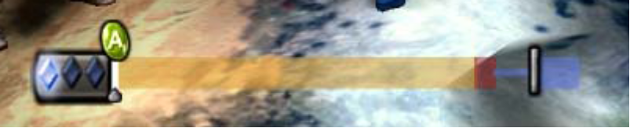

- You can also do a series of moves that either move or attack, empower self, use affinity, or transform your character into something else.
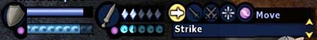

- Game Play: The combat is like chess where each gladiator has a turn. There are certain moves that require less time till that gladiators next turn and there are some moves that will cause more time till the gladiator gets their next turn. 1 activation point is earned per turn. Skills like combo attacks burn activation points, but each successful hit adds affinity points. Affinity points can be used with special affinity attacks that give a bonus damage related to that affinity either Earth, Wind, Water, or Fire. You can take however long you would like between turns and it is more of a strategy game than anything else. You are allowed one movement and one strike in a single turn, although if you move you will not be able to use a combo attack.

- Scoring: Some battles have a time limit and the team with the most points at the end win that battle. The team may have to score the most damage or spend the most time at the top of a structure, or destroy the other teams statue.

- Artwork: The graphics are amazing. The gladiators attack, dodge, and die realistically. When not attacking they each look left and right as if they were really engaged in battle. The surrounding arenas are well detailed and allow you to take advantage of the terrain. Some of the spells dazzle you with the effects of fire and explosion.

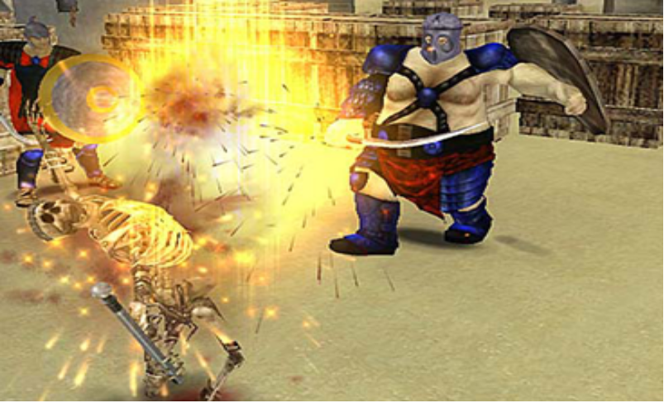

- Sound and music: The special effects sounds are great. You can really tell a hit from a miss because you hear the crisp sound of metal on metal or the groan of an opponent. As the opponents near death they will blurt out random sayings like “Death approaches.” The background music is a little dreary but not so overpowering that the song is in your head for hours. It’s like a piece of classical music that you can listen to without noticing. The music does change during critical points of the battle which seems to mount the suspense.

- Special Features: There is a player vs player mode, but unless the other player knows what they are doing they won’t be as challenging as the computer.

- Manual: There is a 120 page manual with the gist of how to play the game, but during loading Uslys, the teams elder displays bits of advice that educate you in random FAQs while you are waiting for the battles to load.

- Bugs: I did find a bug that can be used to your advantage during the timed scoring match. If you transform a gladiator into a Bear or any other animal, time will run down while the graphics are loading which takes extra time off of the clock.

Game Review

I really enjoyed this game which is why I choose it for the review. It was very challenging at times and it required a great number of strategies to beat certain levels. There were some battles that I could not finish, but you can still advance. You do not have to defeat every battle in the game just enough to open that tournament in that arena. You also needed to take use of the many different classes of gladiators. It is good to be very well balanced, otherwise there will be battles that are impossible to win. Although the combat could seem a little monotonous it doesn’t get stale because the use of the swing meter. The AI seemed pretty advanced and the opponents didn’t do anything like always attack, they seemed to gang up on certain players to get the bonus for attacking from the side.
One of the things I didn’t like was how long it took for some of the battles. One battle took about 30 minutes to complete and I ended up losing and having to try the battle again. The animation between attacks is entertaining, but there is no way to skip it. Another thing is how immensely huge the game is. It takes days to finish.
It fares better than most strategy games in it’s genre, because it seems to combine stunning visual effects, hand eye coordination, and combat strategy into one package.
Anyone is able to play this game from 14 years old and up. If the swing meter is too difficult you can set the game to hit for you and your critical hits will be randomized. There isn’t any lude comments or adult content and you can even make the main character a female and follow her slightly different journey through Gladius.

Summary

Overall I was impressed with this game. It has a perfect blend of strategy, RPG, and storyline. The AI is advanced enough to keep you challenged, while the visual effects give your eyes enough candy that it may rot your teeth. The swing meter keeps combat interesting and makes your concentrate on each attack. The meter varies from weapon to weapon so you will not get a critical attack every time. Earning skill points and gaining different attack skills keep you addicted to battles. You gain more powerfull with each level and your skills continue to reak havock on your enemies. The game is worth purchasing and I would recommend it to anyone. It could be improved by allowing some skips in the opponents turns or giving you the ability to increase the speed at which the computer takes it’s turns.

