CIS 487
Dr. Maxim
Fall 2006

Assignment 2—Game Review

Roger Davis

Civilization IV

Fixaxis Games

General
Civilization IV (Civ4) is a turn-based strategy game in its fourth (obviously) incarnation. The premise is that the player assumes the role of the leader of a specific civilization (e.g. Otto von Bismarck of the Germany, or George Washington of America), and attempts to build a glorious civilization. The player is in charge of practically everything: the location of new cities, what the cities build, the technology your nation pursues, trade agreements, waging war, and much more.

The game was bought from a retailer for around $40.

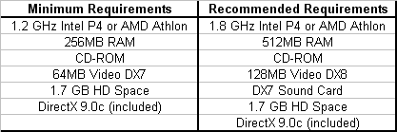

(Note that the game is not graphics intensive, but memory intensive. Therefore, a system using the low-end video card and having a fast processor and large memory will generally perform better than one with a blistering video card and minimum memory and CPU.)

Summary
As was stated previously, Civ4 is a turn-based strategy game. In effect, it is a very complex board game played on a computer. While the tendencies of a player can somewhat limit its re-playability, technically speaking the permutations during the course of a game are nearly infinite. (More on this in the Review section).

Regular games (that is, games that do not involve scenarios, or accelerated start-up) begin in 4000 B.C. The player has two or three “units”, and besides the area immediately around the player, the map (literally, the world) is completely black. One of these starting units will always be a “settler”, a unit that can build a city.

Players will develop their own strategy for early play, perhaps focusing on warfare, perhaps on city development. The course of action is completely dependent on the individual.
As is the case with many sequels, it is difficult to comment on what’s good or bad about one without referring to their predecessor(s). Whether it’s movies, books, or computer games, critical discussion always leads to comparison.

In this reviewer’s opinion, the user interface in Civ4 surpasses those that came before it. First, there is extensive information included on the primary screen, shown below:

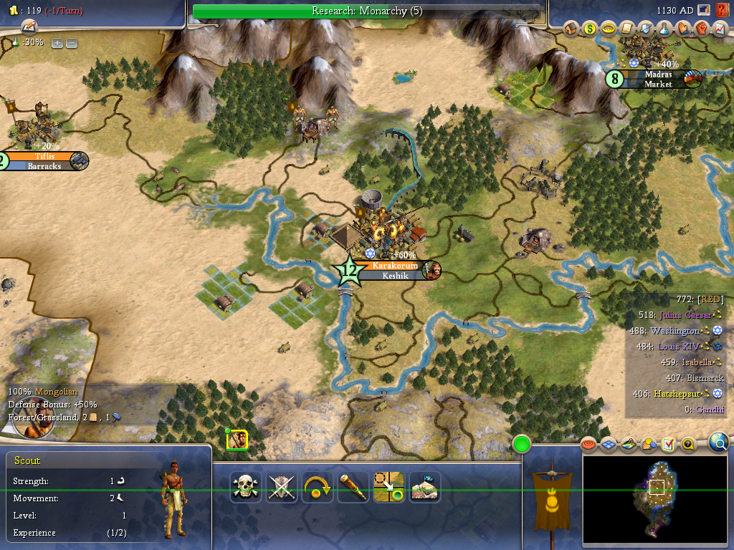

The local area map dominates the middle of the screen. The extreme portions of the screen contain information about your empire (how much gold you possess, the technology you’re studying currently, the year, the current unit(s) you’re to move and its (their) statistics.

Also present is (very) general information about rival civilizations. Namely, their scores, state religions (if any), and their willingness (and ability) to trade with you. Hovering over their leader name with the mouse shows you the break-down of their disposition toward you, as well as short-cuts to declare war or initiate diplomatic relations.

The user interface also provides numerous mouse-click shortcuts for keyboard commands. The current unit’s shortcuts are at the bottom-middle, and advisor short-cuts are at the top-right. (These call up various screens providing further information.)

At the bottom-right is the all-important “mini-map”, showing the world (as you know it) in miniature. The player can click within this box to move the main map to that area. Above the “mini-map” are buttons which limit/filter the information displayed on the main map. For example, you would click the resources button to cause large, caption-like icons to display and point to various special resources on the main map.

Finally, it should be mentioned that the player can adjust the tax rates by clicking small plus/minus icons on the top-left.

Game play in Civ4 is leisurely, because the game is turn-based. If the player wants to move two chariots, take a two-hour break, and come back to complete his/her turn it’s perfectly okay. Generally, non-combat units move around the screen doing their jobs. (Settlers build cities, workers move about, improving the land for greater production, missionaries spread religion, etc.) Combat units function differently. Unlike previous versions of Civilization, the players military units can occupy the same map space as another civilization’s units—even cities!

If no treaties exist between the player and another civilization, the player cannot enter their territory (an Open-Boarder treaty is required). In lands not controlled by anyone, if the player attempts to occupy a square with a unit from another civilization (and the two are not at war), he can.

Similar to the previous version of the Civilization series, there exist “Zones of Control”—shaded regions on the map that are considered within the nation’s “cultural borders”.

Like many other games of its ilk, to attack another nations units or cities the player simply moves into the square they occupy. To capture a city or square, the player must eliminate all enemy units occupying the city or square.

The ability to successfully attack/defend depends mainly on the unit’s Strength. (A Spearman has a Strength of 3, a Modern Armor a strength of 40.) Defenders receive bonuses based on terrain and city defenses. Units on offense and defense can also receive bonuses based on whom they’re attacking/defending. For example, Spearman are +100% vs. mounted units (Horsemen, Cavalry, etc.). An added feature exists that was not present in previous versions of Civ.

Units are awarded Experience Points based upon their combat performance. When they get to “level-up”, there are a variety of special performance enhancements the player can choose to give them. Combat enhancements increase the unit’s strength fractionally. City Garrison increases the unit’s city defense capabilities. Blitz lets a unit attack multiple times in a turn. There are many others.

Scoring in Civ4 has to do with your civilizations overall performance, as well as the path to victory that the player’s nation takes. The longest end-game involves conquering the world, that is, the player is the last surviving. The player can also win the game by building and launching a successful colonizing space ship to Alpha Centauri. (Cultural and diplomatic victories are also possible.) Always, the number of happy citizens in your civilization is a big factor. The value of your technological discoveries, the number of civilizations you’ve conquered, and your cultural score are reflected in the final score.

The “Great Person” is another new feature to the series. As your cities grow in culture and power, the player can be awarded a great person—scientist, engineer, artist, or prophet—that has its own special (and very powerful) abilities. From discovering technology in one turn, to completing a Wonder of the World with extraordinary speed—great people can have immense impact on the course of the game.

The artwork in the game is good. Being tile-based, fascinating animations and life-like portrayals are not necessary. The tile scenery is fair—sometimes it can be hard to determine which squares actually contain roads, for example, unless the grid feature is on. The unit art is good. Most units have a couple of different animation sequences.

The sound effects for the game are good. A very clever special feature is that moving around the map with the cursor triggers different sound effects. For example, if the player moves toward a War Elephant on the screen, the sound effect for a trumpeting elephant can be heard. Additionally, the distance from the center of the screen to the elephant will affect the volume of the sound effect.

The game manual is good. While there is a lot to explain, a few topics seem to only be hinted at or poorly explained.

Review
Civ4 is a very good game that will allow for many, many hours of play. What’s most fun about strategy war games (to this reviewer) is trying to plot successful attacks on multiple fronts. Taking three cities from a single enemy in one turn simply must demoralize the computer! Seriously, though, the fun is in the planning (and timing) of a devastating combined attack. Civ4 allows just this kind of gaming. Also, the addition of the special abilities and hit points makes Civ4 even more diverse.

During longer games, once the player has many cities in his/her control, the micro-management of cities and certain units (Workers, mainly) can become tedious. Unfortunately, the AI for the automatons that can control a city’s production, or a workers decisions often perform contrary to a typical human player’s decisions.

Also, there exists the cheating computer syndrome. Occurring frequently, a player will be in the process of building a Great Wonder. The turn before the player will build it, a computer player finishes it. Also, playing at a higher skill level doesn’t cause the computer player to use more clever tactics (or even to change their tactics to something less obvious), but simply causes a greater fudging of the random numbers, and bumps in computer build charts.

It is understandable that the latter situation exists. Game AI is one of the most difficult things to employ. Luckily, there are numerous multi-player venues that one can explore.

The Civilization series is a genre to itself, and Civ4 is the best, yet. The best change being the Experience Points and Special Abilities for units.

The game rating says that it’s appropriate for everyone ten and up. This is an adequate limit, because there is no sexual content, and no visual gore. The most evident indication that anything “adult” is happening are the units’ battle sound effects.

Summary
Overall, this game is so fun because of its diversity. Only a player’s stubborn attitude can limit the possibilities during game play.

The tedium involved in complete world domination may be the game’s biggest weakness. (While there are other ways to win, the highest score a player can achieve is almost always through complete conquest.)

Unless you’re someone who despises turn-based strategy, Civ4 is definitely worth purchasing.

