CIS 487 Assignment 2:
Formal Evaluation of a Computer Game

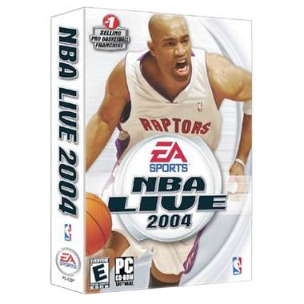

Steven Myslinski
Due: October 5th 2005

Basic Information

Game Title: NBA Live 2004

Company and Author: Electronic Arts Inc.

Type of game: Basketball

Price: $39.99 for PC

Minimum stated hardware requirements:

- Windows XP, Windows ME, Windows 2000, Windows 98
- 600 MHz or faster Intel Pentium III or AMD Athlon processor
- 128 MB or more RAM
- 16x CD/DVD-ROM drive
- 1.5 GB free hard disk space plus space for saved games (additional space required for Windows swap-file, DirectX 9.0a, and Macromedia Flash Player)
- 32 MB Direct3D capable video card using the NVIDIA GeForce FX, NVIDIA GeForce4, NVIDIA GeForce3, NVIDIA GeForce2, NVIDIA GeForce 256, ATI Radeon 9000 series, ATI Radeon 8500, ATI Radeon 7500, ATI Radeon 7200, SiS 315/400, or Matrox Parhelia chipset with DirectX 9.0a compatible driver
- DirectX 9.0a compatible sound card
- Keyboard, Mouse

Recommended Hardware Requirements:

- Windows XP, Windows ME, Windows 2000, Windows 98
- 1000 MHz or faster Intel Pentium III or AMD Athlon processor
- 256 MB or more RAM
- 16x CD/DVD-ROM drive
- 1.5 GB free hard disk space plus space for saved games (additional space required for Windows swap-file, DirectX 9.0a, and Macromedia Flash Player)
- 64 MB Direct3D capable video card using the NVIDIA GeForce FX, NVIDIA GeForce4, NVIDIA GeForce3, NVIDIA GeForce2, NVIDIA GeForce 256, ATI Radeon 9000 series, ATI Radeon 8500, ATI Radeon 7500, ATI Radeon 7200, SiS 315/400, or Matrox Parhelia chipset with DirectX 9.0a compatible driver
- DirectX 9.0a compatible sound card
- Keyboard, Mouse

Game Summary

Quick Overview:
The game has all the professional NBA teams and players that a user can play with. The user can choose to participate in practice, single games, season games and playoff games. Also there’s an option for the user to create their own players to their specific wants. There is a Dynasty mode that allows you to create a team and play them every year and the owner must manage the players and team. The last mode is the Manager mode in which you simply manage the team but don’t actually play games.

Player’s Role:
The player’s role is to control the players of the basketball team in order to win each game. In different scenarios of the game the player must make decisions on how a player is created or how a team is ran.

Installation:
To install NBA LIVE 2004:
- Start the Windows operating system.
- Close all open programs and background tasks, including virus scanners.
- Insert the NBA LIVE 2004 Disc 1 into your CD-ROM/DVD-ROM drive. The Autorun menu appears.
- Click install
- Enter the code fond in the white box on the lower left of the back of the CD case. Then click Next.
- You may be prompted to install or upgrade to DirectX 9.0a. After installing DirectX 9.0a, you may have to restart your computer.
- The User Type screen appears. Select Typical User or Advanced User. Then click Next.
- For Advanced Users only: Choose the destination folder in which you want NBA LIVE 2004. Then click Next.
- Register your copy of NBA LIVE 2004 with EA SPORTS. You are ineligible for technical support until you register your game. To register your game click Register Now. Fill out all required information in each form, and then click Next.
10. Select whether or not you wish to install the EA SPORTS Online components
11. NBA LIVE 2004 is copied to your hard drive.
12. When the NBA LIVE 2004 file transfer is complete, the game starts automatically.

User Interface:
The user interface in this game consists of a monitor to view the game and a game controller to manipulate the players and game menus.

There are many game controllers on the market for PC’s but I used the NYKO TECHNOLOGIES 80650 Airflow Ex Pc Game Controller when I tested out this game. This controller is like a Playstation 2 controller in that it has dual analog sticks four main buttons by the right thumb and four buttons along the top, two on the left and two on the right, near the index fingers.

The game interface has game menus that will allow the player to navigate to all the options of game play that the game has to offer. When playing the game players are allowed to change camera view so that they can view the court how ever they are comfortable.

Game Play:
The game play is similar to previous installments of the game, but EA has made improvements in player handling and graphics. There are new moves that you can use to fake out your opponents and more vicious dunks that make for an incredible finish for a drive to the basket. It should be easy for even beginning gamers to learn how the controls for this game work. The AI has different difficulty settings that allow a player to grow and master each level as they learn more.

The different game play options in NBA LIVE 2004 are practice, 1 vs. 1, season, playoffs, dynasty mode, and internet play.

Practice: Single player on the court. This mode allows player to become familiar with controls and practice moves, shots and dunks.

1 vs. 1: Two players on the court. This mode allows a user to play a game versus only one other player.

Season: This mode lets the user choose a team and play an entire season with that team all the way through the regular season and playoffs and finals if the player qualifies.

Playoffs: This mode allows a player to skip over the regular season with a team and start the playoffs right away.

Dynasty Mode: This mode allows a user to control an entire team as the manager. A user can trade, sign free agents, have team work outs to develop player ability and sign rookies in a draft. The user can play as many seasons as they want and also can switch franchises if the offer comes up.

Internet Play: This mode allows a user to play against other users all across the internet.

With all these modes, there are many different ways that you can get into the game and play some basketball.

Scoring:
The game follows NBA Official rules. Goals made behind the three point line are three points and goals made inside the three point line are two points. Also free throws are worth one point each.

Artwork:
The artwork for this game is incredible. The players are life-like and have facial expressions. The player movements are modeled after actual players and are very fluent in their motion. Here are some screen shots.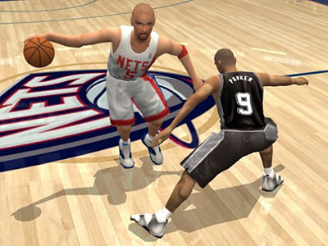
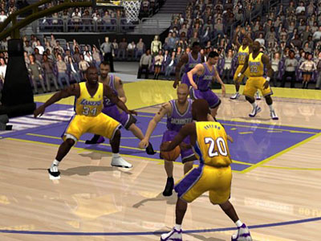

Sound and Music:
NBA LIVE 2004 actually has a soundtrack. There are many songs that were included in all the menu pages and videos throughout the game. Also the sound of the court and the ambiance surrounding a basketball game were all captured. Cheers of the crowd, the color commentary, swish of the net and the squeek of the shoes against the floor are all captured beautifully in this game. The sounds help draw the user into the game and immerse them in the excitement.

Special Features:
Marv Albert teams up with on air partner Mike Fratello to bring the most real play by play available. The analog sticks with the built in fakes and dekes give the player the most realistic action they can get out of a computer basketball game. Also there is the online play and the Dynasty mode.

Manuals:
The game comes with two different manuals. One is the installation manual that also contains trouble shooting tips. The other is the game manual that has all the controls and different options. This manual you will need to pay attention to in order to learn how to play.

Bugs:
I’ve played this game for over a year and haven’t found any bugs to report yet.

Game Review
What is good about the game? Why?
The game is entertaining and provides realistic play for its users. The replay value on this game is excellent because you can always find something new to do and the players can evolve in Dynasty mode. Also, teams can change as well providing changing characteristics for each team making them more different to play against.

What is bad about the game? Why?
The only thing that I don’t enjoy about the game is the inability to play for free on the internet.

How does it compare to similar games in the same genre?
It is better than most of its competitors in my opinion.

Why is it better or worse than similar games on the market?
I think that it has easier handling and more realistic game play than most basketball games on the market.

What is the appropriate audience for this game?
This game is appropriate for users of ages 8 to however old. The only reason that I have a low end age of 8 is because any younger and they might not be able to keep up with the game.

Are there any design mistakes present?
I didn’t notice any design mistakes. The menus weren’t confusing and the game play ran smoothly.

Summary

Overall Strengths and Weaknesses:

Strengths:

- Smooth and exciting game play
- Excellent graphics
- Great soundtrack
- Easy to follow menus
- Online game play
- Great replay value

Weaknesses:

- Rookies in dynasty mode aren’t very good
- Can create own player but can’t create own team
- Have to pay for the online gaming

Is the game worth purchasing?
Yes. I enjoyed this game a lot and would expect everyone else that likes basketball to as well. Its easy game play and great graphics make it fun to play over and over.

How could it be improved?
They could add features like the dunk contest and three point contest to the All-Star game that they have in the season and dynasty mode.

