Computer Game
Evaluation

Colin McRae Rally 2005

Prepared by:
Robert Rak

CIS 487
Fall 2005
Prof. Bruce Maxim

Date: 10/3/2005



The University of Michigan – Dearborn

Table of Contents

1.0 Basic Information 1
1.1 Game Title 1
1.2 Developer and Publisher 1
1.3 Type of game 1
1.4 Release date: 1
1.5 Platforms 1
1.6 Price 1
1.7 Minimum requirements 1
1.8 Recommended requirements 2
1.9 Compatibility issues 2
1.10 Review machine specifications 2
2.0 Game summary 3
2.1 Quick overview 3
2.2 Player’s role 3
2.3 Installation 3
2.4 User interface 4
2.5 Game play 5
2.6 Scoring 6
2.7 Artwork 6
2.8 Sound and music 7
2.9 Special features 8
2.10 Manual 8
2.11 Bugs 8
3.0 Game review 9
3.1 Good things about the game 9
3.2 Bad things about the game 9
3.3 Comparison to other games in genre 10
3.4 Game audience 10
3.5 Design mistakes / problems 10
4.0 Summary 11
4.1 Overall strengths 11
4.2 Overall weaknesses 11
4.3 Is the game worth purchasing? 11
4.4 Possible improvements 11

1.0 Basic Information

1.1 Game Title

Colin McRae Rally 2005

1.2 Developer and Publisher

Codemasters

1.3 Type of game

Racing / Rally

1.4 Release date:

- United States: October 28, 2004
- Europe: September 30, 2004

1.5 Platforms

PC, Xbox, PlayStation 2, and Nokia N-Gage

1.6 Price

At the release time the PC – DVD version of the game had a suggested retail price of $19.99. Currently the game is no longer being sold by the publisher and the only way to purchase this game is to shop at on-line stores like Amazon.com. The average price at those on-line stores is around $30.

1.7 Minimum requirements

- Windows 98/ME/2000/XP operating system
- DirectX 9c
- Pentium III or Athlon processor at 1 GHz
- 256 MB of RAM
- 2x DVD-ROM drive
- Supported 64 MB Graphics Card (ATI Radeon 8xxx and above, nVidia GeForce3 and above)
- DirectX 9 Compatible Sound Card
- 3.5 GB of free hard drive space

1.8 Recommended requirements

- Pentium III / 4 or Athlon processor at 2 GHz
- 512 MB of RAM
- Graphics Card: ATi Radeon 9xxx and above, nVidia GeForce4 and above
- Sound Card: Creative Sound Blaster Audigy 2

1.9 Compatibility issues

This game is not compatible with all integrated sound / graphics solutions. It is also not compatible with nVidia GeForce 4 MX graphics cards or nForce on-board graphics solutions.

1.10 Review machine specifications

- Windows XP SP2
- DirectX 9c
- Intel Pentium 4 2.66 GHz processor
- 1 GB of RAM
- 16x DVD-ROM drive
- Graphics Card: ATI Radeon 9700 Pro with 128 MB memory
- Sound Card: Creative Sound Blaster Audigy 2

2.0 Game summary

2.1 Quick overview

As the title of the game suggests Colin McRae Rally 2005 is a racing game. It is the fifth and the newest edition of the series and contains significant new features in comparison to the previous version. The most important one is the ability to play on-line in a multiplayer environment with up to 8 players in
a game. Another improvement in comparison to the earlier edition is the new “Career” mode, in which the player starts out in the lowest rally league and has to go through over 20 various rally events in order to become a true champion. Of course the new edition of the series contains updates to the graphics and physics engines, which among others include more interactive environment and updated damage engine sensitive even to small paint work scratches. Colin McRae Rally 2005 is a true rally game as it provides players with access to over 30 cars and over 300 different stages located in 8 countries all over the world. This variety of playing modes, cars, and stages guarantees endless amount of play time.

2.2 Player’s role

In every aspect of the game the player’s role is the same, to achieve the quickest stage time with the least amount of damage to the car. The second objective is very important in this game as the car can be damaged quite easily and in many different ways. Car damage is especially important while playing in the Championship and Career modes where the player sometimes must complete a few stages before he has access to service area and the option to repair the car.

2.3 Installation

The installation procedure is very simple, however a bit lengthy. After inserting the game DVD into the drive, the setup program starts automatically. Following the prompts, the user can select the desired installation language, choose the destination location, and decide whether to place the game icon on the desktop. After these initial steps game files are being copied from the DVD to the hard drive. This process takes the most amount of time as almost 3.5 GB of data, divided into many small files, needs to be copied to the destination folder. After the copying process, the user is presented with an option to install Game Spy Arcade software, which allows finding on-line games and opponents for Colin McRae Rally 2005. The installation process on the review machine took 15 minutes.

2.4 User interface

The user interface in the game can be divided into two separate parts. The first part consists of the in-game navigation system used for selecting desired gaming modes and setting game options. All of the actions in this part of the user interface can be accomplished with the use of the keyboard and just
a few main keys like Enter and arrow keys, which makes the navigation system quite intuitive and easy to learn. Figure 1 shows the typical example of the navigation interface. The second part of the user interface is the racing interface present during the individual rally stages. The overall layout of this interface is clear and easy to understand. Figure 2 presents the components of the racing interface.

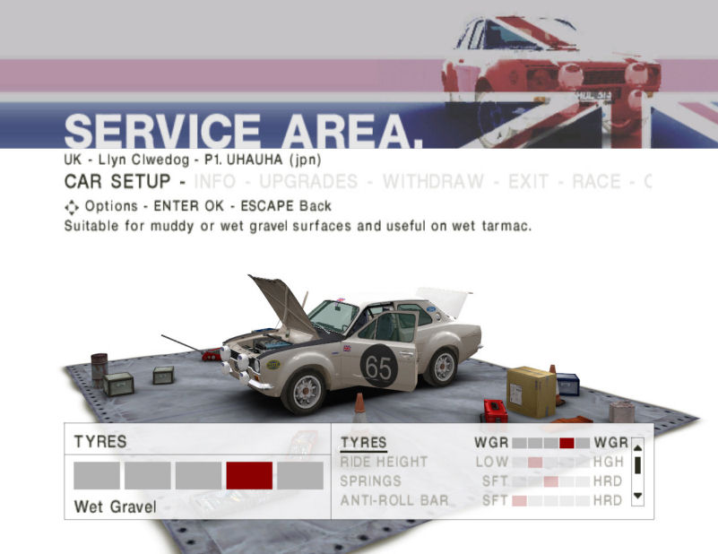
Figure 1
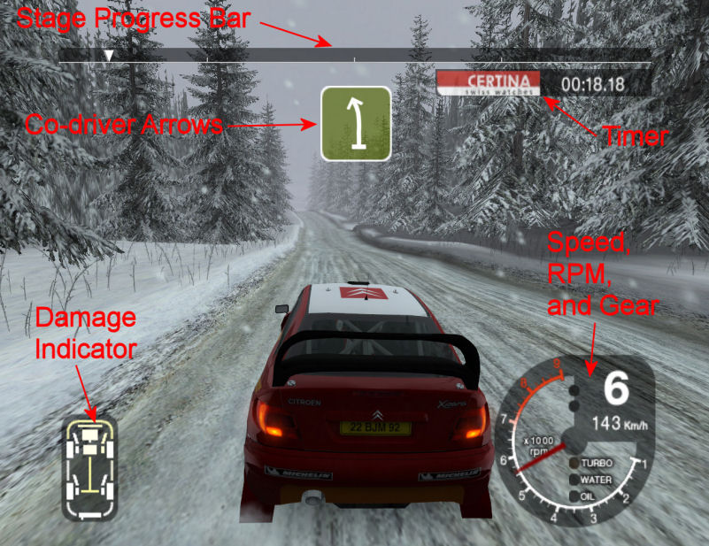
Figure 2

2.5 Game play

The players have four different play modes available for them: Challenges, Championship, Career, and on-line. In the first mode users can race in individual stage or entire rally and they can do so in single or multi player mode. In the Championship mode, the player takes the role of Colin McRae and races in a championship rally to win the title. In the Career option, as mentioned earlier, the player starts out in the lowest rally league and has to make his way through many events in order to win the championship title. One other very important thing that needs to be mentioned about the game play is that Colin McRae Rally 2005 is not an arcade game. It is a true rally simulation with all the real time physics and sophisticated damage engine. These features make the game a bit hard to play at first as the user needs to learn various rules and behaviors of the rally cars. The players can choose between different camera views during the stage. The available options are: bumper, hood, in-car, and behind the car view.

2.6 Scoring

The scoring in the game is not that evident, however it is present. The most noticeable form of scoring is the time of the stage, where players try to achieve quickest times. The game keeps track of the best times achieved overall in all individual stages and they can be viewed in the High Scores section. Another type of scoring is present in the Career play mode. There, the player receives a given amount of driver point depending on the place he achieved after finishing a given rally event. These points are used later on to unlock other rally events.

2.7 Artwork

At the time of release the artwork and graphics of the game were at
a high level. Due to constant progress in the graphics area the artwork has deteriorated somewhat but is still at a good level to provide enjoyable visual experience. The graphics used for the landscape of individual stages are not very sophisticated. The objects are made from basic geometric shapes to limit the needed rendering power. This in fact is very useful in a racing game as the players do not pay too much attention to the surroundings during fast action of rally racing. On the other hand the graphics of the cars, which is vastly more important, is very high. This situation is also achieved thanks to the advanced damage engine. The cars can be scratched, have broken windows, or even dented or missing parts of the bodywork.

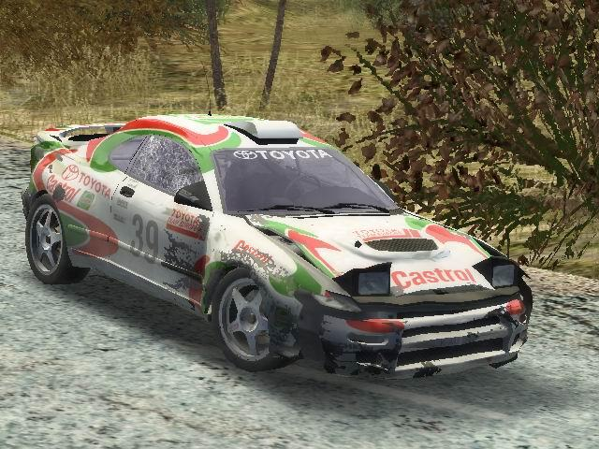
Figure 3
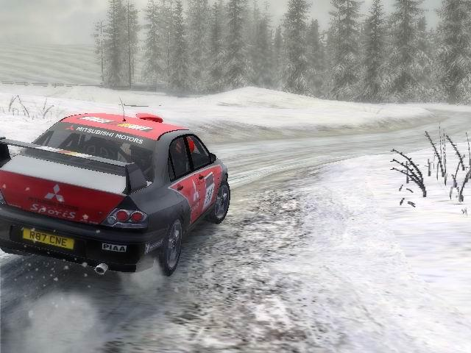
Figure 4

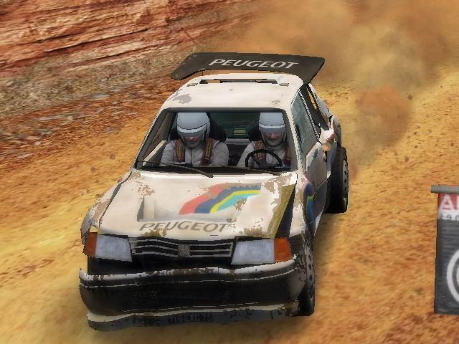
Figure 5

2.8 Sound and music

There is no music in the game. This is mostly because, as mentioned earlier, Colin McRae Rally 2005 is not an arcade game and the music in any form would be just distracting the players during game play in which they have to be completely concentrated. However there are plenty of sounds in the game and they are of high quality. The game supports Creative’s EAX 4.0 technology, which provides sophisticated environmental effects and makes the gaming experience more realistic. Each of the over 30 cars in the game has its own unique set of sounds, which makes the driving experience more interesting. In addition to the above features the game offers co-driver sounds in a few different languages broadening this way the possible audience.

2.9 Special features

The main special feature of the game is the possibility of unlocking car upgrades, like better suspension or gearbox, or even whole new rally cars. The user can achieve this in two different ways. In the first way the new cars and upgrades are unlocked automatically after the player wins a specific event or stage. The other way to unlock these cars and upgrades is to enter special codes in the game menu.

2.10 Manual

The manual is not really needed for this game as players can quickly learn how to play the game and they will understand most of the options. However, to fully understand and take advantage of the available options players should read the manual closely. It provides detailed descriptions about options, which are not very easy to comprehend at first like for example all of the choices available in the car setup screen. Another important thing that users should read in the manual is the explanation of the terms used by the co-driver in describing the directions during the stage. Overall the user’s manual is well organized and contains good descriptions of the game components.

2.11 Bugs

Since the release one update has been made for Colin McRae Rally 2005, which solved few problems in the game. There were two main problems with the game. The first one was connected with the issue where no texture would be present on the grass in some places of the track and the grass would just be white. This problem has been solved in the patch; however it did not cause too many inconveniences in the first place. The second problem, on the other hand, was more serious, to the point that the game was very hard to play. The problem was connected with the sun effects in the game, which were so intense that they some times just made everything on the screen white making it virtually impossible for the player to drive the car. This problem was also corrected by reducing the sun effects and providing a special command line switch to turn off these effects if there was such a need.

3.0 Game review

3.1 Good things about the game

Colin McRae Rally 2005 has many advantages. The most important one is connected with the wide variety of available rally cars and stages in the game. Together with all the different play modes, this variety provides a lot of game time for players. Also the special features in the form of car upgrades and additional new cars that can be unlocked throughout the game are a big plus for Colin McRae Rally 2005. In addition, the sound effects that utilize the EAX 4.0 technology and good graphics make the game very enjoyable to play. Another interesting and good feature of the game is the replay system. The game records all events and the drive that occurred during a given stage and the player after finishing the stage can replay it entirely in order for example to see what mistakes he made. However, the most important feature of Colin McRae Rally 2005 is the level of realism to which the developers have recreated the car’s behavior on the road. Along with realistic behavior, the developers have also recreated quite accurately the damage that can occur to the car in a crash. These features make the game more interesting and require the user to think while driving in order not to damage the car. They are also advantageous to players, which have some real life driving experience as they can easily predict how the rally car will behave in certain situations.

3.2 Bad things about the game

Although Colin McRae Rally 2005 is a very good racing game, it also has some disadvantages. One of these drawbacks is surprisingly connected with the amount of realism present in the game. Some players might find the game too hard, as they might have problems with keeping the car damage at low levels. This problem would be most apparent while playing in the Career mode where the option to repair the car is available only every few stages. Another drawback of the game is the fact that at the beginning a lot of cars and stages, which are available in the game, are locked and users must either acquire codes to unlock them or go through the entire Career play mode to achieve the same result. This issue could discourage some of the players, which would like to quickly try out all of the different cars and stages present in the game. A different type of disadvantage is connected with the low interaction of some of the objects in the environment of the game. Sometimes an object like for example a small bush, which in real life could be run over by a car without any significant problems, is treated in the game the same as a tree. When a player hits such a small bush the car is damaged as it would hit a tree and such situations should not take place.

3.3 Comparison to other games in genre

There are two types of racing games: realistic and arcade. As mentioned earlier, Colin McRae Rally 2005 is a realistic racing game and is completely different from arcade games like for example some of the Need for Speed series games. Racing arcade games concentrate mostly on achieving the fastest time on a stage or lap and do not require too many skills from the player. In those kinds of games the cars in most cases cannot be damaged and thus the user does not have to worry about his driving style and capabilities. However, in realistic racing games this factor is very critical and these kinds of games require a lot more skills from the players. In comparison to other rally games, Colin McRae Rally 2005 turns out to be a very good game with clear advantages. Games like Xpand Rally or Richard Burns Rally although have good graphics and sound effects lack in the level of realism present in Colin McRae game. This is most easily seen in the damage engine, which is far less advanced in those two other games.

3.4 Game audience

This game contains no violence or strong language and that is why it has an ESRB rating of Everyone. Basing on the description of this rating it means that this game is suitable for persons ages 6 and above. However, basing on the difficulty and my own experience with this game, I would have to say that it should be intended for persons at least 10 years of age or older. Another issue in describing the appropriate audience for this game is to decide for what group of players it is intended. As mentioned in the earlier sections this game would be an ideal choice for people who like realistic racing games. On the other hand players who like arcade racing games or casual game players this game might prove to be challenging or difficult.

3.5 Design mistakes / problems

The main design mistake made by the developers is the lengthy startup process of the game. It is caused mainly by many logos and intros, which are displayed during the startup process. As they may be interesting when the user launches the game for the first time, after a while they become more and more annoying. Although they can be omitted by pressing the Enter key a few times, this solution is also inconvenient.

4.0 Summary

4.1 Overall strengths

- Large variety of rally cars (over 30 in total)
- Large number of stages (over 300)
- Good graphics and sound effects
- Special features (unlocking car updates)
- Replay system
- Physics and damage engines

4.2 Overall weaknesses

- Many options are locked at the beginning of game
- Game is challenging because of the degree of realism
- Low interaction of some environment objects
- Lengthy startup process

4.3 Is the game worth purchasing?

People who like to play realistic racing games should definitely buy this game as it is considered to be one of the best rally games of all times. On the other hand, people who like pure arcade fun games should think before buying this game if they are willing to spend some time in developing the needed skills to fully enjoy Colin McRae Rally 2005.

4.4 Possible improvements

The main area for improvement in this game is connected with the level of interaction between the cars and the environment. As mentioned earlier the game exhibits some problems in this aspect and it would be a good idea for developers to incorporate some changes into the game in order to raise the level of interaction.

