Nicholas Mezza
n_mezza@yahoo.com
CIS 487 – Game Design and Implementation
Dr. Bruce Maxim

Carnage Heart

Title: Carnage Heart
Publisher: Sony Computer Entertainment of America (SCEA)
Developer: Artdink
Release Date: January 31, 1997 (US), Also released in Japan (December 8, 1995) and Europe (May 5, 1997)
Game Type: Strategy
Price: Lowest about $20 used
$39.99 MSRP
ESRB Rating: K-A (Kids to Adults) – Equivalent to today's E rating

Hardware Requirements:
- Any Playstation model up to PSOne. Full compatibility with Playstation 2 unknown.
- 1 Standard Controller
- Color TV

Actual Hardware Requirements:
- Memory Card with at least 5 blocks free for each savefile. The game cannot realistically be finished in one sitting. Note that while I do not have the original packaging, information I've found indicates the game is listed to require only 3 blocks, which is not true (Possibly a last minute design change).

Demonstration Machine:
Pentium 4 3.2Ghz HT, 512 MB RAM, Geforce Go! 5200 64MB VRAM using ePSXe 1.6 Playstation emulation software and Pete's OpenGL 1.76 GPU plugin.

Overview:
Carnage Heart is a strategy game like no other. You control groups of 'Mech' style robots on a map, similar to many other turn-based strategy games. You build your units, and defend your bases, like many other turn-based strategy games. However, you also get to research parts for and design your robotic armies. This is as much detail as the blurb on the packaging gives. What it doesn't tell you is that by 'design', it means to choose parts, as expected, but also allows you to program the AI of your robots.
Manual Excerpt: By 2073, war has evolved. The battle for domination is now a game fought on the moons of Jupiter by warrior mechs armed with deadly firepower. You control an army of cyber gladiators. More importantly, you design them, deal for parts, set up assembly lines and devise battle plans. When the game begins, whoever has created the most diabolical strategies and deadliest mechs wins!

Storyline:
Manual Excerpt: In 2031, the remaining governments of the world looked to the stars for the answer. Led by the United States, several countries opted for expanding into space to gather the much needed resources that could end the worldwide crisis. The U.S. Space Mining division began operations on the moon and soon many other countries joined suit.
With so many interests intensified on the lunar surface, misunderstandings were inevitable. In June of 2032, a mining dispute between France and Brazil arose over an area of the moon known as Oceanus Procellarum (Ocean of Storms). This dispute led to a small-scale skirmish that quickly developed into a full-blown war. It looked as if the war would last for many years until France unleashed, for the first time ever, a "heavy armor unmanned robot," (now known as an Over Kill Engine or OKE). This new type of weapon proved to be highly effective and soon after it was deployed, Brazil surrendered.
The World Federation, a reformed United Nations, monitored the situation closely and quickly created a new bureau, the Space Mining Resource Probe Association (SMRPA). Peace was regained by assuring all countries involved that mining operations would be regulated to be safe and fair. With this agreement, a new order came to the world.
Twenty-Eight years later, in 2059, the human race, which had already exhausted the resources of the moon and Mars, was forced to locate new sources of minerals. Feedback from mining probes sent to Jupiter showed that three of its moons, Callisto, Europa and Ganymede offered abundant mining opportunities.
The super-powers of the world stepped up their espionage activities in order to obtain mining rights first. Upon increased SMRPA surveillance of these activities, they discovered several unscrupulous acts being carried out were not those of a nation, but of a single corporate group. The object of the SMRPA's scrutiny is the Drakken Group, the leading force of the capitalist sector. The Drakken Group is a huge conglomerate comprised of a few hundred of the world's largest corporations. Its net assets exceed $8.9 trillion. The Drakken group has contributed greatly over the years to space resource development, capital, and research. In return, they now demand their fair share of new contracts from the SMRPA.
Without the proper constraints, an inevitable event occurred. In trying to enforce the Mining Rights Policy, a World Federation ship fired upon a Drakken-owned space cargo ship. Although this action was necessary to prevent Drakken from gaining an unfair advantage in the market, the incident was deemed unnecessarily harsh by the public. Fanning the flames of the issue were the Drakken-based media teams using a controversial photograph of the incident provided by NASA.
To the average citizen, the photo represented proof of the overbearing nature of the SMRPA tactics. It was also a troubling glimpse of future events. The dispatch of a multinational force by the World Federation to Jupiter was made public by Drakken journalists. The situation degenerated further.
In September of 2073, in accordance with the Treaty of Belmia, the World Federation found their only remaining course of resolution was to officially declare war on the Drakken Group. The Drakken conglomerate acknowledged this declaration and a war the likes of which had never been seen before broke out between the super-power nations of the World Federation and the enormous corporate conglomerate Drakken.

Player's Role:
The player serves as the commander of World Federation armies on a battle map. He also researches and designs new OKE's and their AI. He does not have any control over combat. There is also a Vs. Mode, where two player's saves are loaded. Once the player chooses OKE designs to compete, there is no user interaction. The mode finishes when only one OKE or team is standing.

User Interface:
Through most of the game, the player performs actions through menus.
This is the unit command menu (see picture). On screen currently is an adviser giving you a quick idea as to what the current screen is for. Also on screen is a list of units and their status. The map on the right shows their current position on the battlefield. In the background is a 3D representation of the strategy map, though it is not free roamable.
Also notice the top bar, which is present on every menu. It shows what menu you are currently on, the what turn in the game it is, and shows your remaining money.
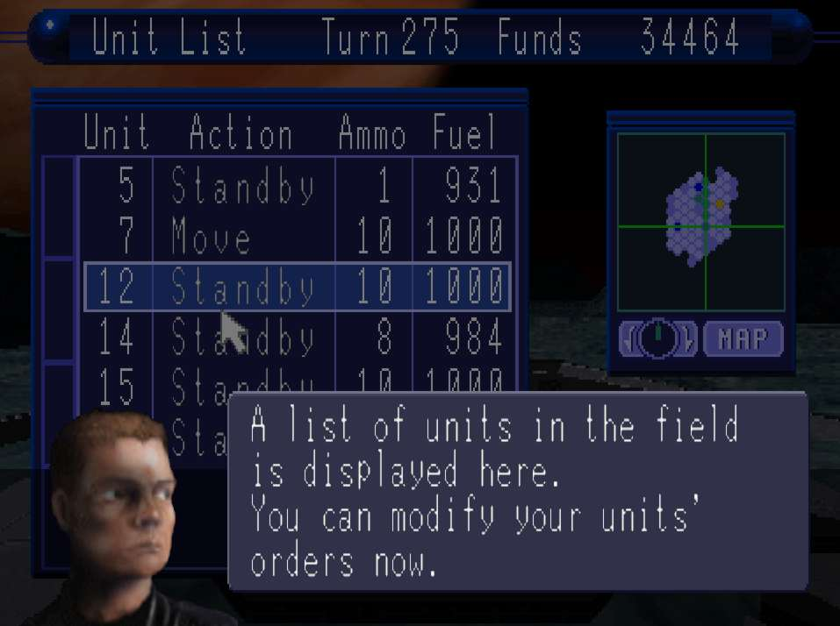
The only live action in this game is during combat sequences. While the player does not control OKE's during combat (unless a cheat code was entered), there is information on the battle screen. During testing mode (before finalizing your design for production), more information is displayed, such as a map of your software/CPU design. On it, the path of current execution is highlighted to show how your OKE is reacting.
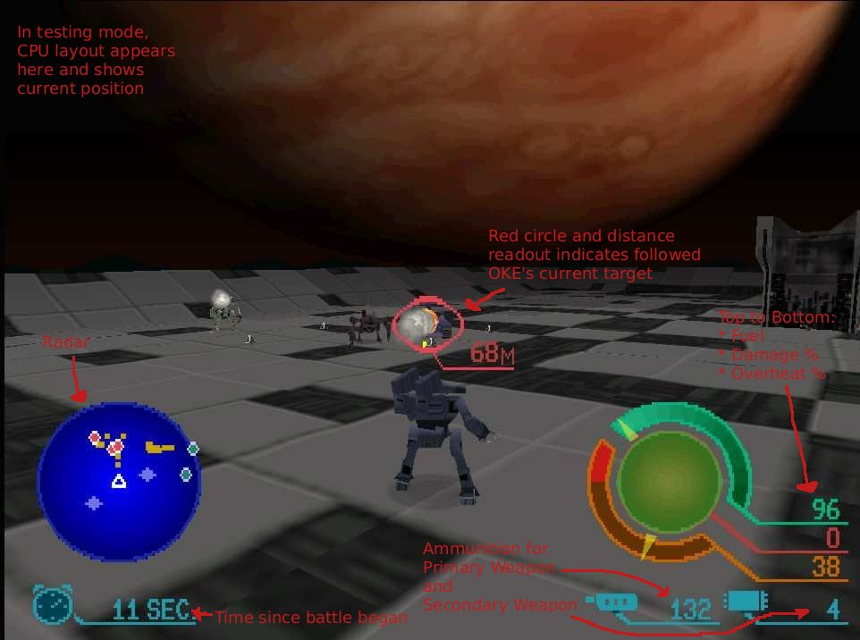

Game Play:
Campaign mode (New Game) is single player only. The opposing side, Drakken, is always controlled by the computer. Each campaign has a difficulty, the easiest being 'Practice', where you start with a large sum of money and there is only one level to complete. Each campaign is harder than the last, and you start with less money, the enemy is more ruthless and adaptive, and there are more levels to complete.
The campaign starts with the player controlling a single base, in which are garrisoned a couple early units with stock (read: poor) AI's and very low end parts. Luckily, your enemy is not sophisticated at this point either.
There are several things you can do at this point (see next image). Tactics allows you to command your units, build new units using your bases, or upgrade their production capacity. Design allows you to create new unit designs using part blueprints you have purchased, and to create the software for your new designs. This is where you will most likely spend most of your time. Negotiation is where you pay to research and purchase new part blueprints and OKE body designs. When you complete giving orders and designing new units, you end the turn and play advances.
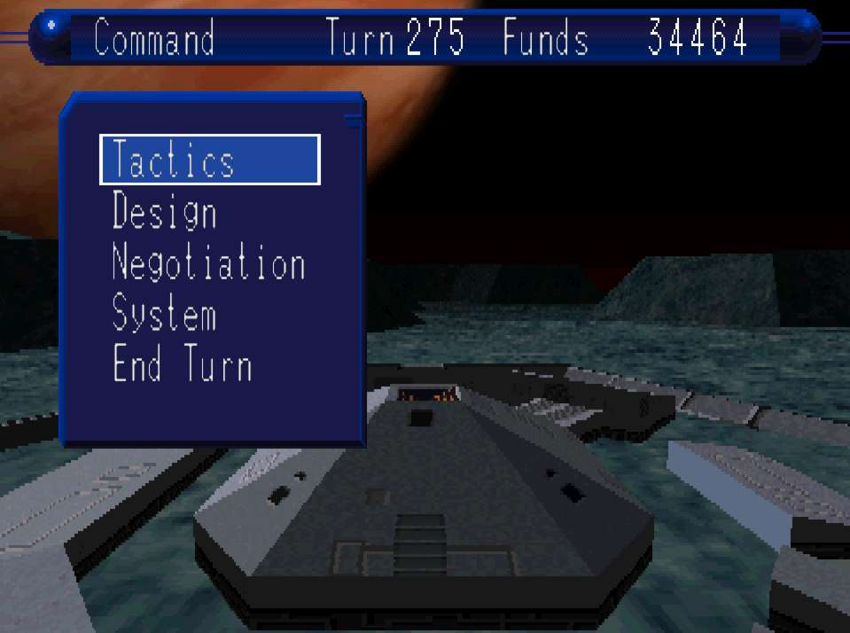
When units meet on the battlefield, a combat session begins. Here, the design of your OKE's comes into play. OKE's react during battle depending on how their software was coded, so poorly written software can easily result in defeat. If either side completely destroys the other within a time limit, then the defeated unit is destroyed and the remaining unit moves into whatever space was contested.
Each level continues until all bases are captured.

Scoring:
There are no visible score during the game. However, at the end of a campaign level, your command efficiency is calculated. This compares your losses to the enemy's, and how much money and time you used to win.

Artwork:
At the time of its original Japanese release (late 1995), Carnage Heart's graphics were slightly sub-par. Texture detail was poor, as can be noticed in the screenshots. Objects other than weapons and the OKE's themselves are very blocky, made up of only a few polygons. Most colors used in the game are very drab, making visuals equally so.
Most of the attention to graphics shows during combat. Here, weapon effects and OKE models make up for other shortcomings, being acceptable for the technology used. All in all, this game certainly shows you don't need well polished graphics for an enjoyable game.

Sound and Music:
Music in Carnage Heart is nothing special. There are 5 synthesized music tracks for use in the menu system, and 2 CD music tracks (though very dull and the same tune) for battles. While fitting, the music can be very repetitive and annoying.
Sound effects are somewhat poor. However, while the quality is not great, the collection of sounds is complete. Menus make appropriate sounds while navigating through them, and battles contain explosion, impact, weapon fire, and OKE movement sounds.

Special Features:
Carnage Heart's depth shows when you factor in the design modes. Once you research and purchase some of the many weapon and part blueprints, you can create a large variety of OKE hardware designs. There are 2 leg, 4 leg, tank, and flying OKE's (3 body designs for each), all with their own advantages and disadvantages.
The deepest part of the game is certainly the AI software design. Depending on the CPU part attached to an OKE, you will have several hundred slots to place 'chips'. There are 40 chip types, ranging from actions such as 'move forward' or 'jump', to logical chips such as 'If enemy within X meters'. You must arrange these chips on a grid such that execution follows a path along adjoining chips. (see picture)
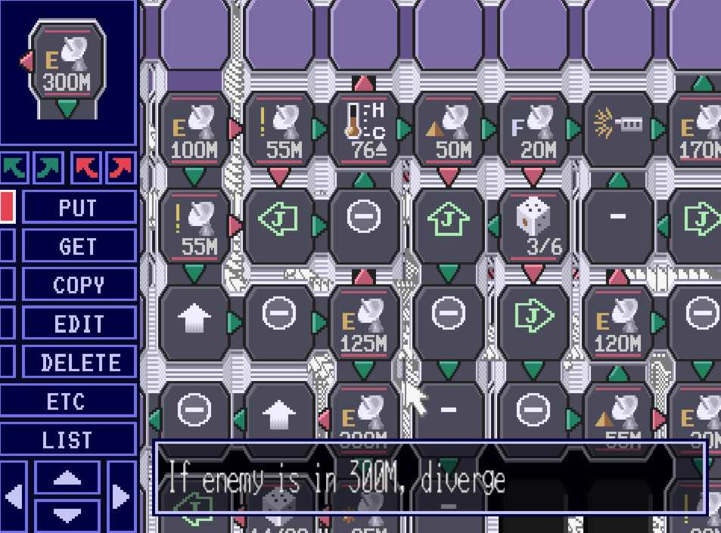
Most game time will be spent programming, or else you will be quickly eliminated in the more difficult campaigns. The more difficult the campaign, the faster the computer player will change its tactics and AI to better combat your units.
For example, I learned this the hard way with a very defensive AI design. I was dominating the battlefield, taking very few losses. The enemy caught on to my AI strategy and resorted to using tank OKE's, which can cover the field with withering arrays of fire. My very defensive AI was defeated easily, as while it could dodge most if not all of the enemy fire, it eventually ran out of fuel - leaving it helpless. The few shots my OKE's could get off were not enough to destroy the heavily armored tank OKE's.

Manual:
The game ships with a 'regular' 30 page manual, detailing controls, storyline, and the objectives of the game. It also ships with a 60 page guidebook primarily detailing the programming of software. In addition to all this, the game includes a second CD containing voice-guided video tutorials.
I do not possess any of this documentation, though I did in the past. I cannot comment on the quality of artwork, etc, in the manuals. I do know that the manuals were detailed enough to cover all game topics and the functions of software chips.

Bugs & Cheats:
By pressing the select button twelve times in the battle pause menu, you can enable a leftover debug mode where you can control the currently viewed OKE. Control is difficult and not documented, and so unless your AI programming is very poor, battles are best left to the computer.
I've yet to discover any obvious glitches/bugs in the game.

Game Review

What is good about the game?
- Truly unique game play
- Customizable Units
- Versus mode for 2 player competition

Carnage Heart, at first glance, appears to be just another strategy game. Then you notice the unit customization. Somewhat distinguishing, but not unique. Then you start coding an AI and realize no other game comes close. No matter how skilled or lucky a general you are, if you cant create an efficient AI, you'll never be able to win.
While the customization of hardware on an OKE is not the most varied, different parts behave differently and require different programming and other strategic considerations. Rarely do strategy games allow true customization of units. Rarer still is when the customization seriously comes into play and is not just aesthetic.
The game also extends its replayability greatly with the addition of the 2 player versus mode. In it, players can compete with their OKE designs and see who programmed the best AI.

What is bad about the game?
- Drab graphics
- Campaign levels may end prematurely, due to inexplicable funding loss
- No true two player campaign
- No “Sandbox” mode

While graphics are not necessary to make this a great game, battles would be that much more fun to watch if textures were not so drab.
A real issue with gameplay is the occasional inexplicable loss of funding, dooming your efforts to win. Even when winning, funding can suddenly be cut. If you do not have a sizable reserve of funds or are not close to occupying everything on the map, there is little remaining chance to win. On the other hand, this can also happen to the computer player, though I have never seen this happen when they were winning.
Also, there is no true two player mode in the game. The only way to compete is to fight OKE designs in a tournament. I certainly wouldn't want to wait for another player to write an AI, but I would like to play out a game on a strategic map.
If you're really into the programming part of this game, you'll probably also want to have a free form mode where you can have all the hardware you want. This is absent from the game. For example, without successfully playing many hours, you cannot use the flying OKE bodies. Being able to code the ultimate AI also requires a high speed, high capacity cpu (larger cpus can hold around 400 chips as opposed to about 100). Low speed CPUs can take a full second to perform one cycle, so accuracy of response with high capacity low speed cpus is next to impossible. High speed, high capacity CPUs are expensive and not available until later turns.

How does it compare with similar games in the same genre?
While the strategy mode is somewhat more simplistic than other strategy games. It is simple yet still enjoyable. The true attraction of this game is the ability to program your units.

Why is it better or worse than other games?
Although the strategy involved is not the most advanced around, it is enough to make this a fun game to play. You focus on what you want to see, your OKEs fighting it out.
Even though you don't have any control over battles, seeing your AI react as you intended is much more fulfilling than just controlling a robot.

What is the appropriate audience for this game?
The game's rating says “Kids to Adults” (everyone), but I doubt many children or young teens would have the patience to learn and apply the time and effort this game takes. However, there is no reason that younger children could not play the game, other than for the general concept of war.
A major problem with this game's marketing is right on the packaging. Without reading reviews for this game, there is no indication that so much effort goes into customizing your OKEs. The packaging of the game hints at customizing your designs and sending them into battle. But all the preview pictures show fighting and 3D models.
This is also the reason that many private reviewers give this game a poor score. Rather than rate it for what the game is, the game was rated as 'terrible' since they were expecting a fast paced action game.

Are there any design mistakes present?
As mentioned as a serious problem, the sudden unexplainable loss of funding (while uncommon), seems to be a design mistake. It introduces what seems to be a totally random chance of failure.
Also, the issues with packaging do not affect the game itself, but its success on the market. If it was marketed to the proper audience, it may not have ended up a “sleeper hit”.

Summary

Overall strengths and weaknesses:
Carnage Heart is simply unique in the detailed customization of units it offers. Only rarely does a game allow programming your creations, and as far as I have seen these are all simplistic customizations, or the games themselves are simplistic. Carnage Heart is neither, and would still be an acceptable game even without its unique features.
While it is a fun and unique game, its own unique quality is its downfall. Not many people will play a game requiring you to program to do well. Many people do not have the time or patience to do this. When I did have time, I spent over 8 hours in one instance creating a complex AI.
Overall, this is a great game with a great design. But due to its niche market (at least in the United States – Japan has seen three re-releases), it cannot be a very successful title.

Is the game worth purchasing?
Yes, though the game can be difficult to find. Only those with programming interests should choose this game over others.

How could it be improved?
For the game to be truly replayable, there needs to be a mutliplayer strategy mode, or a randomized campaign.
The game could also be given better graphics or at least a more detailed or colorful texture set.

