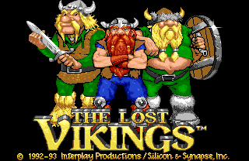

Basic Information:

Created by: blizzard
Published by: Interplay
Genre: Platform/Puzzle/adventure
Price: about $50
Appropriate audience: 8 and up, due to some puzzle complexities.
Hardware requirements: SNES, Sega Genesis, Gameboy Advance, or emulation.

Quick Overview:

The Lost Vikings is a combination puzzle/platform/adventure game. Each level represents a specific period in time, ranging from prehistoric to the futuristic. Location varies from ancient Egypt to strange factories and Goofy settings. In fact, it’s the humorous additions to the game that kept me playing it, often just to see what would happen next.

Story:

The story starts with our three Vikings going on for a hunt. Each Viking has a special quality that sets him apart from the others. Eric the swift is the fastest of the three. He can jump, and bash down walls with his tough helmet. Baleog the fierce is the strongest. He is an expert with the sword and bow. Olaf the stout can block anything with his should (well, almost anything), and can hold the shield above his head to hang glide.

Everything goes well with the hunt, and plenty of meat is brought home. However, a few moments later a spaceship flies overhead and transports the three aboard, where the evil Tomator plans to hold them as part of his universal zoo. The three Vikings race through time in order to get back home.

Player’s Role:

The player must switch between the three vikings and use their powers to get to the end of each level. Each Viking possesses a special power or ability that enables it to solve certain pieces of the level puzzles. The levels become increasingly harder, and the vikings must work together in order to make it to the end. One player can play all three vikings, are two players can split control between the three.

User Interface:

All vikings have three orbs of health, which are displayed at the top of the screen, which is far off out of the way of the action. The items each Viking holds is also at the top, near their respective portrait. Anytime a Viking is switched to, the portrait will flash momentarily to alert the player to with Viking he now controls. There is no additional menus or pause screens.

Game Play:

The game is played as the traditional 2d side-scrolling action game would be. Yet getting from the beginning of the level is not as easy as killing all the monsters in the way.

When the action picks up, then switch over to Baleog and dive in with sword and bow. Baleog’s bow can also trigger distant switches. Make sure Olaf gives him protection with his shield, or raise his shield up for a step Eric can jump on. You can even use the raised shield to hang glide. When platforms are too high to simply walk on, you must switch to Eric to get to those hard to reach places, often times to get a powerup or hit a switch to move on to the rest of the level. His running helmet charge is used to defeat certain enemies, or to bust down some walls.

The Lost Vikings is very much like playing different types of games, all rolled into one. Depending on which Viking you control, you are probably doing something different. However, you must play each Viking on each level in order to advance. All three vikings must make it to the end of the level, or the game will not progress. The player may pick a favorite Viking, but that Viking only gets so far. Eric cannot safely glide down pits, Olaf cannot defeat enemies, and neither Baleog nor Olaf can jump.

Some levels have extra items that can be used to help progress through the level. Bombs are used to aid in the puzzle solving by blowing up certain walls or floors that are destructible and awkward for Eric to run into with his helmet. Smart bombs can be used to destroy all monsters on the screen. Food restores health to a particular Viking. All of these powerups can assist in the completion of a level, and some of them are even necessary.

Scoring:

There isn’t formal score. Just get to the next level, and eventually past the last level to win.

Artwork:

The artwork is pretty good for it’s element, though the realism doesn’t exist. The characters are drawn to be more comical than real, such as Eric seeing stars after hitting something with his charge. Each Viking has a large head, and a short body, which is more apparent on Baleog. In some levels there are bubbles that the vikings must ride on to float to a higher part of the level. These bubbles are very unrealistic and cheesy looking, and ironicly won’t pop when Olaf fits on one, or Baleog shoots one with an arrow.

Each world travel is portrayed to the best that can be expected on the SNES, and the enemies vary with appearance as well as tactics used to defeat them.

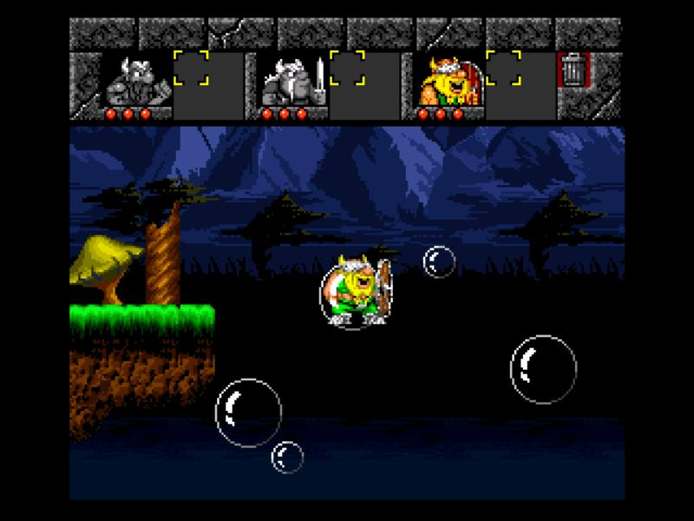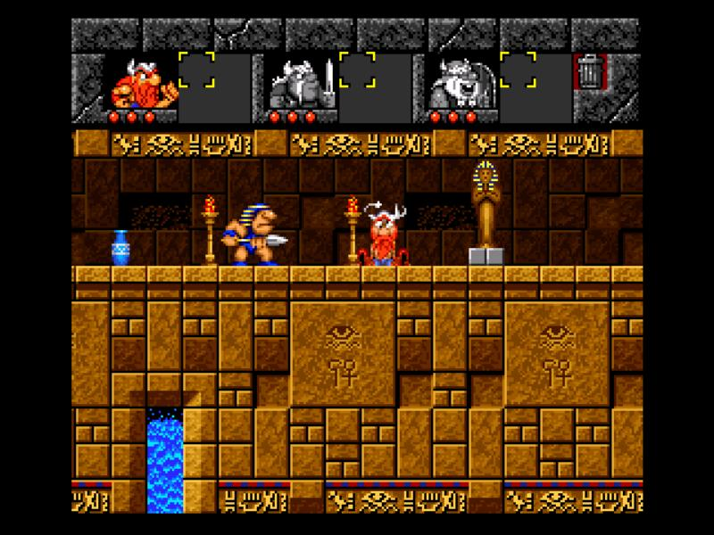
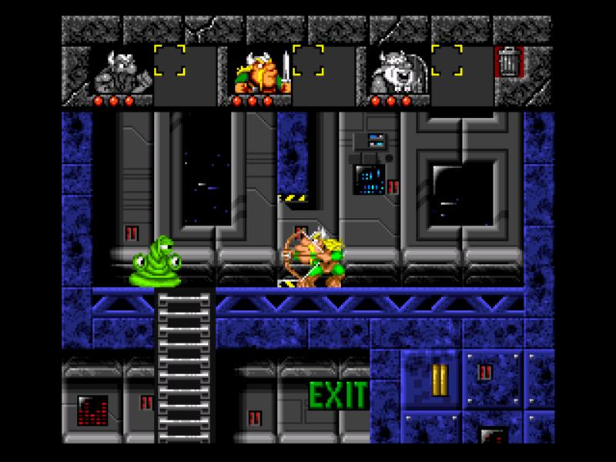

Sound and Music:

The music is an upbeat techno sound, often times fitting the timeframe that the vikings are currently in. The famous Egyptian tune is used in the Egyptian level, with a bit of an quicker beat added to it. The prehistoric era features lots of drums in the background.

The sounds promote the nonrealistic part of the game. The bow twang and such is fine, but there’s an explosive sound when an enemy is struck and destroyed. I enjoy the cuckoo bird sounds that accompany Eric’s charge into an object. Very well done on that one.

As the levels progress, more sounds are introduced, such as the sound of the magnet going off, a spring being jumped on, and so forth. These sounds aren’t incredibly good nor bad, but fully support the comical view of the game. The magnet sound is used, in my opinion, to let the player know that it is active. In such case it serves its purpose well.

If a sound is not expected, then it is there to alert the player that something happened, or to add humor. The loud belch heard when a Viking eats food adds to the comical nature of the game, as well as letting the player know that the food was consumed.

Special Features:

This game is pretty funny. After each level, the vikings will partake in dialog, which can sometimes be in reference to a movie, or just a funny bickering between the three. Oftentimes I feel like completing a level just to see what they will say next.

Manual:

The manual is very informative, but definitely is not required to play this game. There are several hint blocks scattered throughout the game that will let you know basics about playing the game, as well as things you may need to know to complete the level. The manual itself was an attempt to throw a comical spin on the instructions. The controls and special abilities of each Viking is hidden in a bio about them near the back of the book. In order to find out what each Viking could do, you had to skim the bio, which poked fun at each specific Viking.

Bugs:

There weren’t too many noticeable bugs that hindered game play, though there are a few, and no design mistakes that I could find.

Baleog cannot shoot at anything that is off the screen, nor can anything off the screen shoot at you. That means if there’s a switch at one end of the level, you must run a Viking over there, then switch to Baleog, fire his bow, and switch back so the camera pans with the arrow to the other Viking. However, this bug is actually used as part of solving puzzles.

Another oddity is if a Viking is standing on Olaf’s shield, and Olaf is on a vertically moving platform, the other Viking will fall through the shield onto the platform holding Olaf.

What is fun about this game?

The fun factor about this game is threefold. First, there’s the puzzle element about the game. Next is the platform/ action part of the game. The last bit that supports the fun in this game is the humor. All three elements make this an extremely fun game.

What isn’t fun about the game?

One thing that can become a bit disgruntling is when one of the vikings dies, you have to start the level over. The level is over only when all three vikings reach the end of it. There are times when two of the vikings are sitting at the exit, and the third one dies on the way. At this time, all the work done with the other two is wasted, and the level must be restarted.

Compared to similar games of the same genre?

This game doesn’t fall under one particular genre. It’s difficult to think of another game similar to this style of game play. Other puzzle games are not necessarily adventure/platform games, and vice versa. Even if all three are present in another game, there’s still the humor that will set the Lost Vikings apart from them.

Summary:

The Lost Vikings is a great game with a mixture of puzzles, adventure, action, and platforms, as well as a little humor. If you can get your hands on it, I recommend giving this one a try. This game may be better improved if it included more characters to choose from, or perhaps had more items with special effects.

