CIS 487 ASSIGNMENT 2 -FALL 2005

GAME EVALUATION

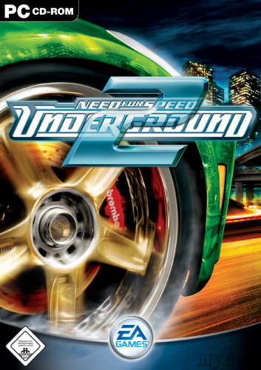

LUCIAN BLEBEA

BASIC INFORMATION:

GAME TITLE: Need for Speed Underground 2
COMPANY: EA GAMES
PLATFORM: PC
AUTHOR: EA Blackbox -Canada
TYPE: Racing
PRICE: originally $39.99, now $29.99
RELEASE DATE: NOVEMBER 15, 2004
RATING: E FOR EVERYONE

Minimum PC System Requirements
Operating System: Windows 98, Windows Me, Windows 2000, Windows XP
CPU: 933 MHz or better
System Memory: 256MB RAM or higher
Hard Drive Space: 2GB or more
Video card: 32MB Nvidia GeForce2, ATi Radeon 8500, DirectX 9.0-compatible
Sound Card: DirectX 9.0-compatible sound card
Disk Drive: 8X or faster CD/DVD drive
Other: Internet service required to access online features

actual PC System Requirements
Operating System:Windows XP
CPU: Pentium 4 or similar AMD processor
System Memory: 512MB RAM or higher
Hard Drive Space: 2GB or more
Video card: Nvidia GeForce5950 or better, ATi Radeon 9800 or better
Sound Card: Sound Blaster® Audigy® series
Disk Drive: 24X or faster CD drive
Other: Broadband required for Internet/LAN features

GAME SUMMARY

QUICK OVERVIEW
Do you like driving at high speeds, sliding trough corners, or just cruising in your own completely customized show quality car? If your answer is yes, then Underground 2 can deliver that exhilaration and more without having you to worry about any car repair costs or law enforcement. In this game you will be driving many cars trough Bayview city, with over 125 miles of open road. You will find street races where you can race just any other customized car in the street, circuit races, drag races and drifting.

STORY LINE
Underground 2 is a sequel to Underground 1, so it starts where the first game ended. You start the game arriving at the airport of Bayview city, where you have to get to Rachel’s garage, where Rachel (voice of Brooke Burke) introduces you to the city, to types of racing in the city, to some racers and mechanics. First you buy yourself a new car from a selection of about 5 cars. As the game progresses you will buy more cars, and upgrade them as you wish. Sponsors are going to show up and offer you money to race some particular races for them. You will make racing rivals, and compete in all types of races: sprint, circuit, drag, drift and street-x. There are also unique performance parts that you can unlock, which will give you a small advantage against the other racers. Certain magazine and DVD publishers will also pay you money to be featured on the front page. After having five sponsors the story ends with a final 7-lap race against one of your most skilled rivals, Caleb. After you beat him, there are no more scheduled races to do, except explore the city some more.

PLAYER’S ROLE
You play a male character that is focused around racing and upgrading his car. He devotes all of his time to racing other racers. As the game progresses, he wins many races and makes plenty of money that he spends on some more cars and accessories.

INSTALLATION
Installation of Underground 2 is easy and straight forward. This game comes with two CDs. After inserting CD1 in the disk drive, the Autorun menu appears. Follow the on screen instructions to complete the installation. Furthermore you need to use CD1 to play the game. The installation takes up 1.7 Gb. I also recommend that you download the patch available for the game to get rid of some bugs that were discovered so far.

GAMEPLAY
This game features forty plus hours of driving under CAREER mode, in which the player buys cars and upgrades the performance and looks, races them to make money for future upgrades and beats his competition, thus completing the career mode. The player will experience races such as circuit, sprint, drag, StreetX, URL (similar to the LeMans), closed circuit drifting and of course the most challenging, downhill drifting. Career difficulty can be easy, medium, and hard. Under QUICK RACE the player can select any unlocked car and any unlocked track and just race and practice. Under the CUSTOMIZE CAR mode the player can customize any car with different parts and also hook up the car to a dyno to measure performance. While doing dyno runs, the player can adjust suspension, transmission, the ECU, the turbo, braking and the nitrous oxide. The last mode is the Multiplayer mode, in which the player can either play over the LAN, or Online. You need an internet connection to play online.

USER INTERFACE
The user interface of this game is the same as the one of Underground 1, very similar to other racing games. The default key configuration is very simple and easy to memorize. Use the arrow keys for movement, SPACE is handbrake, shift up is left SHIFT, shift down is left CTRL, nitrous boost is left ALT, change camera view is C, look back B, enter shops ENTER, hydraulics use J and H, world map M, and to use SMS you use TAB. This configuration can be changed to accommodate anybody who plays the game. On the screen you see the car in the middle, SMS in the top left, the map in the bottom left, your money in the bank at the top right, and your speedometer and boost gauge at the bottom right. The speedometer also shows you which gear you are in. On the map, the orange triangles are other racers, the blue, green, red, purple dots are shops you can go into to modify your car. The mouse is also needed to click “join” a race and to be used in the menu screens. See below a screenshot of the user interface.

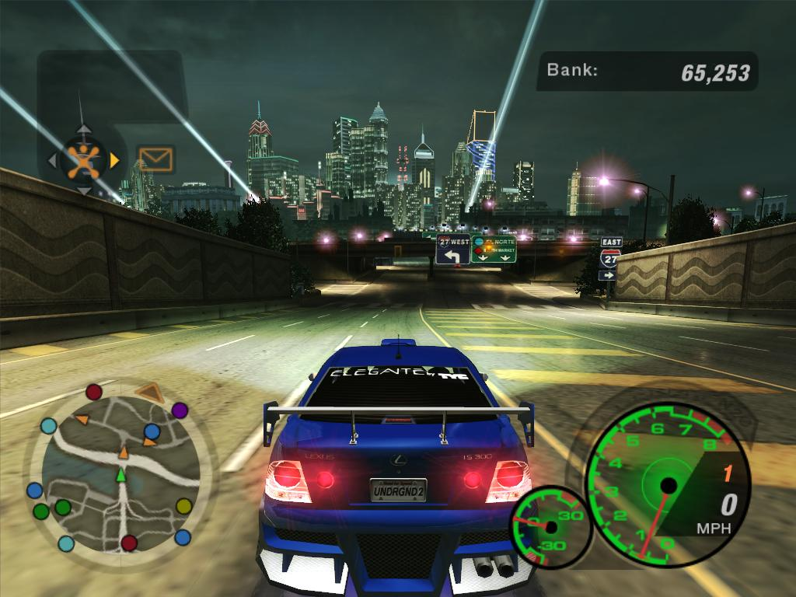
A screenshot of the user interface.

SCORING
Although scoring is not a main goal of the game, there are two parts of the game in which you get a score. During drifting the player gets a score depending on how well he or she drifts around corners and other cars. This score is based on speed and drift angle. The higher those factors the higher your score. Another time the player gets a score is after customizing a car, the more modifications and performance upgrades the higher the score. To get a perfect score, the player needs to upgrade all parts of the car.

ARTWORK
The artwork of this game is incredible. All cars look very realistic and the graphics are remarkably sharp. The city is very big and very detailed. All buildings look realistic, lighting is also important in this game since every race takes place at night. Street signs and traffic lights are also operational, so the other cars in the game are respecting traffic laws. The latest graphics technology was used in creating this game, so it is also recommended that your computer is powerful enough to run the game at full graphics detail.

SOUND AND MUSIC
The sound is also amazing. Each car’s engine makes a distinct sound. Tires screech, turbos whistle, hydraulics hiss, nitrous sprays, and gear shifting are very well done and sound very realistic. It is best experienced on a surround sound speaker set. The music includes 27 songs of rap, rock, punk and techno targeted toward a wider audience who likes distinct music. The player can set which songs to play when the player desires, which is very convenient and eliminates any music genre issues.

SPECIAL FEATURES
The player can customize cars with over seventy billion car combinations. There is over 125 miles of road to explore. LAN/ Online play, replays, and SUV’s and spinner wheels are new features that Underground 1 did not have.

MANUAL
The manual is kept short and very informative. It includes system requirements, installation notes, key configurations, an introduction, a summary of each mode of the game and technical support. Underground 1 has a similar manual, so most people that have played the first game do not need to read the manual.

BUGS
I did not discover any bugs. But other people did, so EA Games released 2 patches, version 1.2 being the latest, which solves many bugs, one of which is that an internet connection is no longer required to play the LAN mode.

GAME REVIEW

WHAT IS GOOD ABOUT THE GAME?
- It’s fun to explore the city and drive around the different parts of the city, trough freeways and narrow roads in the hills.
- It’s fun to customize your car and to see your friends’ cars and their skills under multiplayer mode
- Most of the performance parts to customize your ride are available aftermarket parts for real cars.
- You can get to different places without following the GPS directions
- Real road signs that can actually direct you to where you want to go.
- Great graphics and sound
- It keeps the player in a good mood, if you lose a race you can restart, and not lose any money.
- AI of the game is great, your opponents will try to push you around to make you crash.

WHAT IS BAD ABOUT THE GAME?
- No damage after crashing, even though it does show your crash in slow motion which is nice to look at unless you are trying to win and don’t have time for slow motion clips
- SMS gets annoying, after each race you get a new SMS message
- Only 30 cars compared to other racing games that have over 500 cars
- Cutscenes are 2D instead of videos like in Underground1

COMPARISON TO SIMILAR GAMES
Compared to Underground 1, it is more realistic, there aren’t any crazy jumps in the streets, and the cars look and sound better. Compared to Burnout 3, the driving simulation is more realistic. Compared to Juiced, Underground 2 is still a superior game in terms of graphics quality, game story and experience.

BETTER OR WORSE THAN SIMILAR GAMES?
Even after a year, Underground 2 is still better than the new games that were released after it. What makes it better is the graphics quality and the closeness to reality simulation.

AUDIENCE
This game is rated E for Everyone. This game is for kids, teens, and adults, most of them who are car enthusiasts who enjoy racing simulation or real racing. This game, out of many other racing games, is the one that brings you closest to the real racing.

DESIGN MISTAKES
There aren’t many design mistakes. One that I did notice is that there are no drivers in any of the cars. Your opponent cars are empty and just drive themselves.

SUMMARY

OVERALL STRENGTHS AND WEAKNESSES
This game has many strengths including great visual graphic detail. It puts you in the driver’s seat of very fast cars. The realness of the cars and environment puts this game above similar games. The only weakness that I want to mention is the lack of damage on cars, which was a design choice on their behalf, but many of us expected this game to be even more realistic.

IS THE GAME WORTH BUYING?
Yes, the gaming experience is well worth the price. Now, after having played it for a year, this game still attracts me to play it again, especially in multiplayer mode.

HOW COULD IT BE IMPROVED?
It could be improved with the addition of more cars, more driving environments and a better story.

