Bryan Suarez
9/29/03
CIS 487

Game Evaluation Project

Basic Information

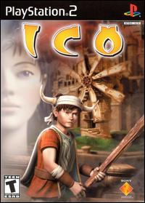
Title: Ico
Developer: Sony Computer Entertainment Inc. (Japan)
Publisher: Sony Computer Entertainment America Inc.
Type of Game: Adventure/Puzzle
List Price: $37.99
Max Players: 1
Hardware Required: Playstation 2 Console, Dual Shock Controller, Memory Card (Requires 360k)
Release Date: 09/30/01
ESRB Rating: Teen

Game Summary

Quick Overview

Exiled to a mysterious castle, you must navigate yourself and a strange, magical princess to safety. By deciphering unique puzzles and fighting off bizarre enemies, you can find your way to freedom as the story of the ancient castle unfolds.

Ico was released in September of 2001 to a great deal of anticipation because of its unique artistic vision. Ico then went on to receive great critical acclaim because of its groundbreaking visuals and creative game play.

Storyline
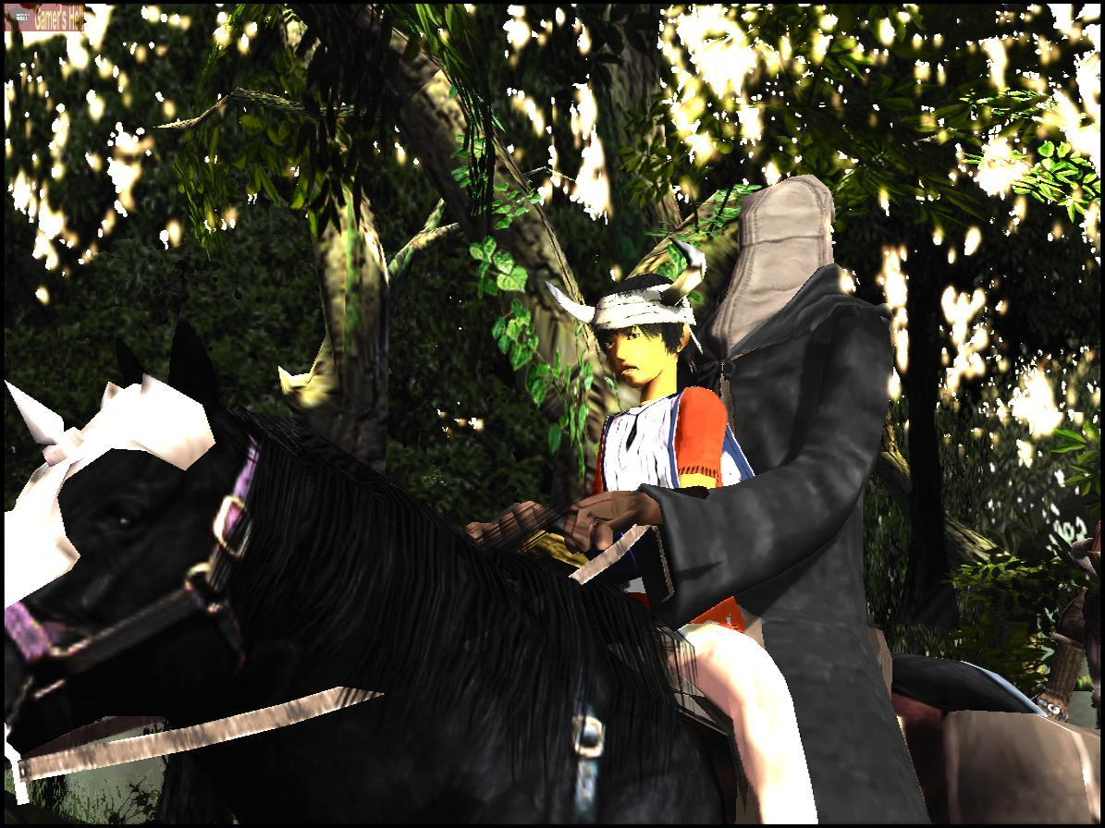
In a strange, magical world, every few years a child is born with a bizarre deformity: large horns protruding from the sides of their heads. Because of the world’s fear of these horned children, they are exiled from villages at an early age. The story begins with Ico, one of these children.

Ico is taken, against his will, and imprisoned in an ancient castle where these children have been sealed away for generations. When an earthquake strikes at the castle, Ico is set free from his cell to try and find his way out of the castle.

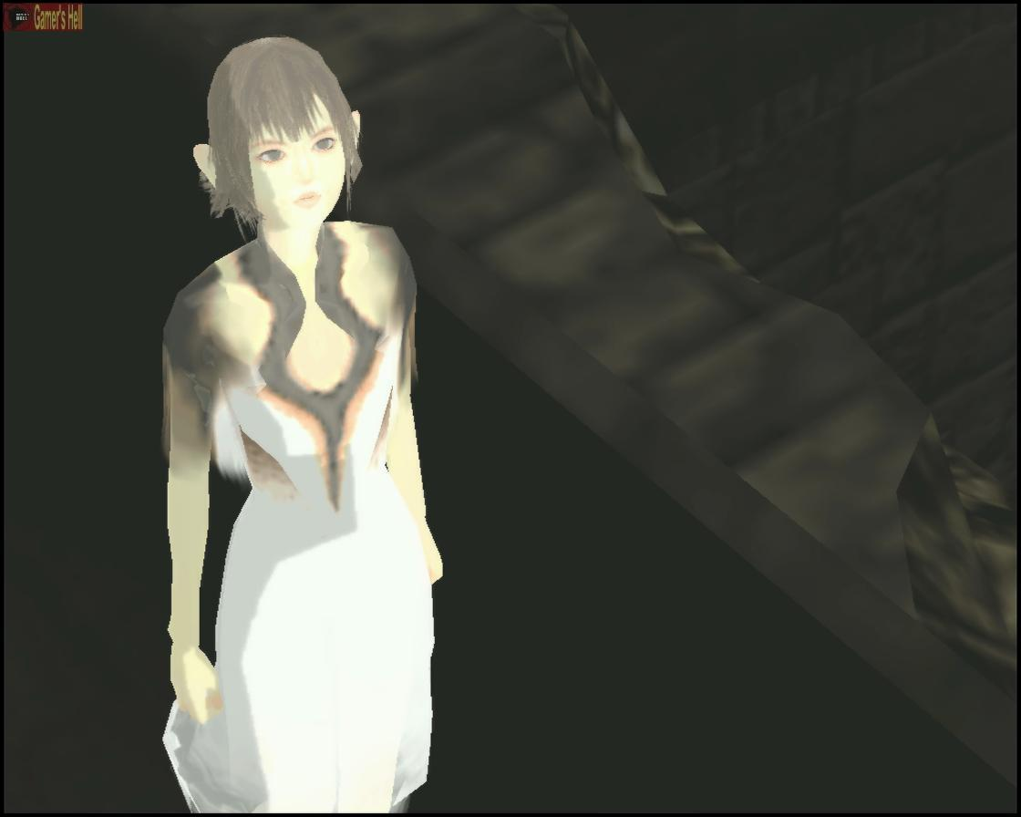
Ico then meets Yorda, a princess that has also been enslaved in the castle. After rescuing Yorda, Ico finds that Yorda is foreign to Ico in that she speaks a completely different language. While they cannot communicate, Ico finds that Yorda holds some kind of strange key to the castle for she can open sealed doors and move platforms with magic.

Since Yorda is weakened, her and Ico must work together to escape the castle. They cooperate to solve the puzzles that the castle’s ancient technology present. Once it is realized that the princess has escaped, evil spirits are sent after her and Ico to return her to captivity. Ico must do what he can to prevent this from happening for him and Yorda to reach freedom.

Player’s Role

The player plays as Ico, the imprisoned child. They must navigate through the ancient castle to take himself and princess Yorda to safety.

Installation

Since this is a console game for the Playstation 2, this is no real installation of the game. The player is allowed to set basic options at the beginning of the game which may be saved such as Controls, Sound options, and controller vibration.

User Interface
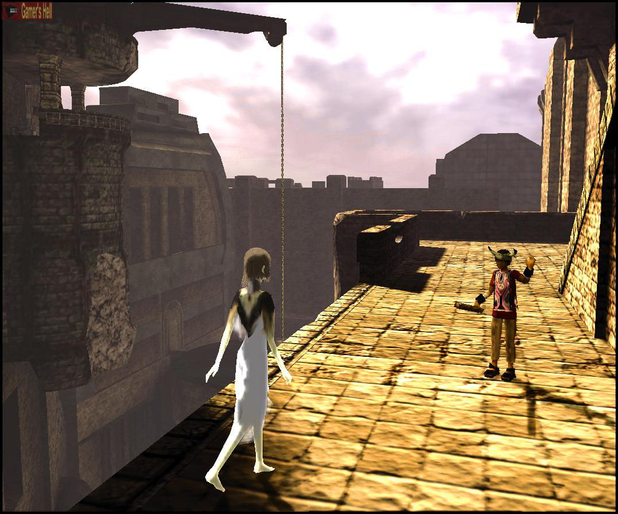
Ico is set up from a third-person perspective where the player moves Ico around in three-dimensional rooms in the castle. Analogs are used for control of Ico and camera movement for a feeling of free control over the character.

Other controls include jumping, attacking, and generic action on objects (pulling switches, pushing obstacles). There are also controls to guide Yorda, the princess, from room to room. The user may call to Yorda or grab Yorda’s hand to guide her with the push of a button.
There are no on-screen displays in Ico, no health bars, no point counter. The screen you view is completely bare. I anticipate this is to draw the user in to the involving atmospheric nature of the game.

Game Play
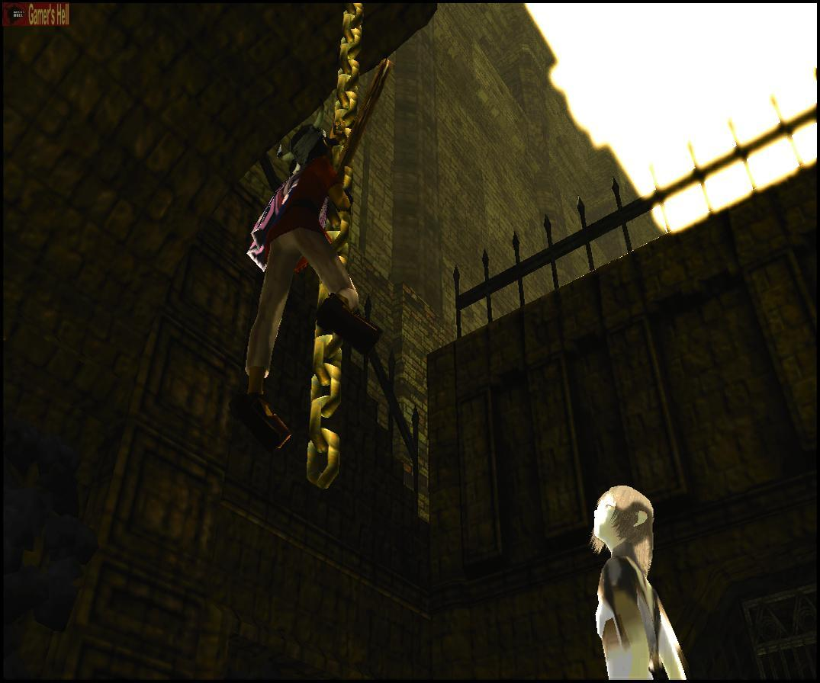
The game play in Ico primarily involves moving, jumping, climbing, and interacting with objects to get through different rooms in the castle. Ico must occasionally attack enemies and find a safe way to guide the princess through puzzles as well. This adds an extra dimension to the average puzzle game because the player must play while not thinking of just themselves but as to how they will guide Yorda through this as well.

Game play is extremely smooth in Ico with very intuitive movements. If it appears that an object can be manipulated, it probably is. Along the way, Ico will pick up new weapons with both practical purposes in a variety of puzzles and effectiveness in fighting the spirits that come to take Yorda away.

Yorda provides some new elements of game play in that she is a unique AI program which tries to appear as a living, confused girl that follows you around. The player must keep track of her because she may tend to explore on her own. The player must remember to call to her and show her the path which she must take.

Enemies will frequently attack to attempt to return Yorda to her prison. The player must be conscious of this being able to happen because they cannot stray too far away from Yorda for fear that she may be attacked.

Overall, Ico just feels different to play. While frustrating at times to see your way through a difficult puzzle, Ico will give you a gaming experience the likes of which you probably haven’t seen before.

Scoring

There is no real scoring in Ico. There are no health bars. There is no measure of how many lives the player has. Everything in the game seems to point toward making the game feel like playing a movie where you actually are Ico, not playing a game about Ico.

Artwork

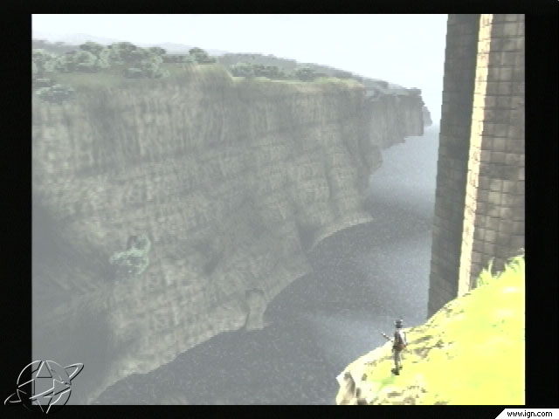
This is where Ico truly excels above other games in its genre. Ico has been considered one of the first games that actually contain artistic importance in its own right. Hence, this made people look at Ico as more than just a game but as a complete work in itself.

Everything is rendered in elaborate detail. From castle walls to simple water surfaces, all textures look incredibly realistic. The concept work is also jaw dropping. The castle appears to almost have a modern technology to it wherein detailed systems of gears and pulleys operate everything inside this castle without any assistance. Gigantic windmills power the castle’s functions above and large waterfalls power systems beneath the castle. At times the game almost feels like you are playing in a strange painting. At times one can even find themselves simply looking around and exploring the castle visually instead of playing the game.

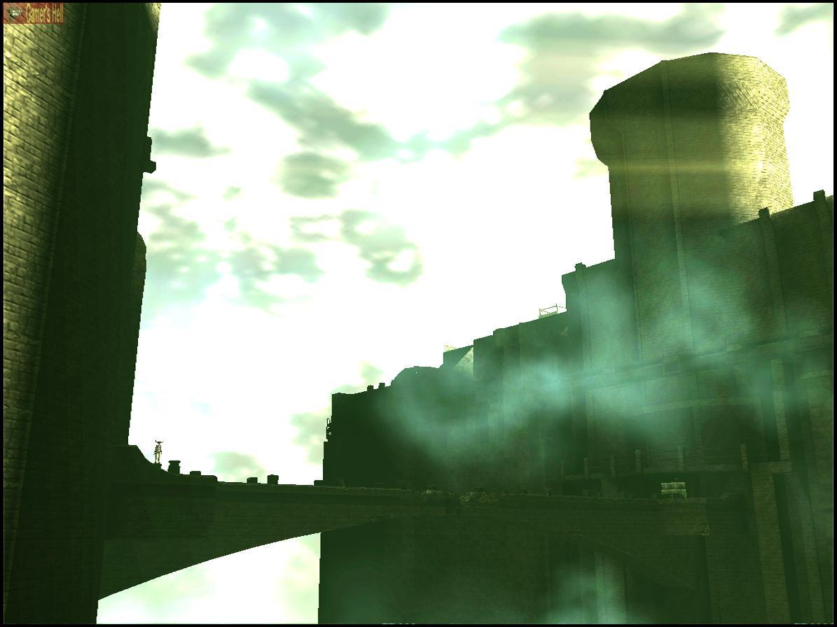
A great deal of lighting and shading effects are also used to promote the cinematic nature of Ico. There is always a positioned sun in the game which can always be seen outside and can be found poking through different windows. This adds a level of realism because things that are in direct line of the sun are often difficult to make out because of the brightness. Contrasting this, there is a haze or myst over may of the interior rooms where a user may have to carefully look to make sure monsters are not lurking around a corner.

Sound + Music

Ico makes a very interesting choice of usage of music. There is none. Well at lease in game that is. Besides a mellow keyboard driven song at the main menu and a ballad at the end, there really is no in game music. At first, one might think this was a way to cut around the budget but after a while one can see the benefit. If you were stranded walking around an empty dungeon, you wouldn’t hear gigantic orchestra hits and dramatic strings wherever you went. You would hear things like the wind through the walls of the castle and the burning of torches on the wall. This is just what you hear. The sound effects in this game are completely realistic and add to the atmospheric feeling that Ico provides.

Special Features

There are no real special features to Ico like a new technology used or unique mode that you can put the game in. The uniqueness in this game is due in large part to its basic game elements as stated above.

Manual

The manual is nicely laid out with a design including images of the castle in the game. It gives certain elements of the story to the player and gives a solid overview of how to play and general strategies that should be followed to play successfully when starting. This is most likely to avoid initial frustration with the game.

Bugs

There wasn’t much in the way of bugs that I caught in this game. There is always one main problem with any game that has a free floating that camera that the user is allowed to control. This is that the camera will often not show up where the player may optimally want it to be or the camera may cause glitches to appear when it is moved to awkward positions. Ico however kept these types of camera errors to a bare minimum when reviewed.

Game Review

What is good (fun) about the game?

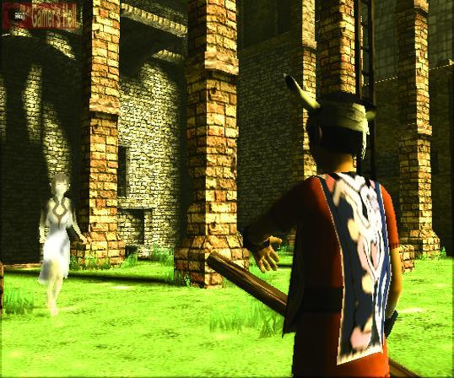
The most fun thing about Ico, in my opinion is its ability to draw you into the world this story is in. The artwork, concepts, sounds, and game plays all make you feel like you are trying to escape this castle with Ico.

I liked that there was no health bar or point system. The only way to really die is to fall from too high a height or to lose princess Yorda to the evil spirits in the castle. This may seem like it would make the game too simple but I thought that it made it much more engaging.

The puzzles are also very well done. They are challenging, yet very intuitive. You won’t see anything like Myst’s puzzles where you have to look up combination codes for things and write down different keypad combinations. The puzzles in Ico require problem solving to come up with a solution to a room. I found myself spending 20 minutes trying to decipher certain puzzles and then wondering how I didn’t figure them out immediately when I find out what the solution is. Not only must you think of an actual solution to escape from a room but you must also explore what the technology in this castle can do and how it can benefit you.

There is a real feeling of accomplishment when completing puzzles, knowing that you are one step closer to escaping the castle.

What is bad (not fun) about this game?

There wasn’t much I didn’t like about Ico, but if I had to choose I would say that a few of the puzzles became extremely frustrating after trying to solve them for a while. I could see some people thinking that some of the puzzles are too hard and pushing them away.
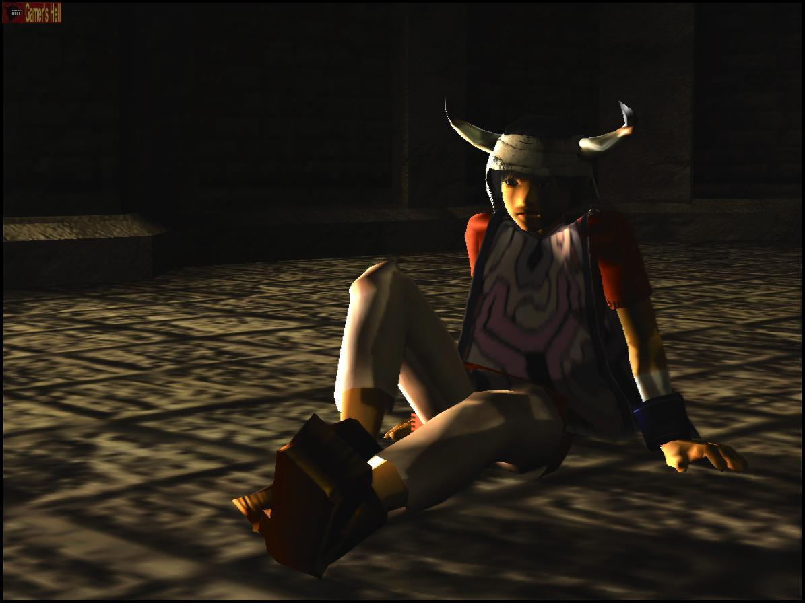
The game is also relatively slowly paced. If someone doesn’t have patience to get deep into a game, this aspect to the game would also turn them off.

Also, Yorda’s AI does get a little irritating sometime when you will have something in mind for her to do to escape a room but she just won’t cooperate. Sometimes it takes a few more times to call her than it should.

All in all, these are inconsequential to the game experience that can be had playing Ico.

How does it compare?

Well, this is a little hard to answer. Ico is so unique that there aren’t many games like it in the market. One could make a case that it is similar to games like Myst and 7th Guest where you have to escape a strange place by solving puzzles. But the game play is completely different because you actually feel like you are walking around and interacting with these worlds.

One could also compare this game to the early Delphine Software games released for Super Nintendo / Genesis / PC. These are games like Out of This World and Flashback where the game play and story lead to more of a cinematic adventure game.

I see Ico as a combination of these types of games with vast improvements. While Ico may not be in direct competition with any other game that may be similar, I hope its uniqueness will inspire other games.

Appropriate Audience

The appropriate audience that I would say for this game is at least 15 because the puzzles may be too difficult or confusing for younger children and some of the content contains realistic violence. The game could also seem scary to younger children because of its use of haunting visuals and sound effects.

As far as later ages enjoying this game, I would anyone with a small amount of patience for a slow, engaging story could enjoy the cinematic experience of this game. I don’t think there really is a “too old” for this game. Anyone who took the time with the game could learn to enjoy it.

Puzzle fans and adventure fans alike should be very pleased with this game as it has impressive elements of both.

Design Mistakes

I really don’t think there were hardly any actual mistakes in the design of this game.
As mentioned earlier, the camera glitches and moves unfavorably, but this is always to be expected in this type of game.

Also, Yorda’s movement gets to be strange at times which can be distracting but the AI program is already very impressive. While not perfect, it could use a small amount of work.

Summary

Strengths + Weaknesses

In conclusion, there are a great deal more strengths to Ico than weaknesses.

Strengths

-Engaging story is something original.

-Artwork is some of the most impressive you’ll see.

- Realistic sound adds depth to game.
- Puzzles are challenging and not repetitive.
- Fun to beat up evil spirits with a stick.

Weaknesses

-Complicated puzzles are often frustrating

-Slow pacing requires patience.

-AI for Yorda is sometimes confusing.

All in all, Ico is a very good game.

Is it Worth Purchasing?

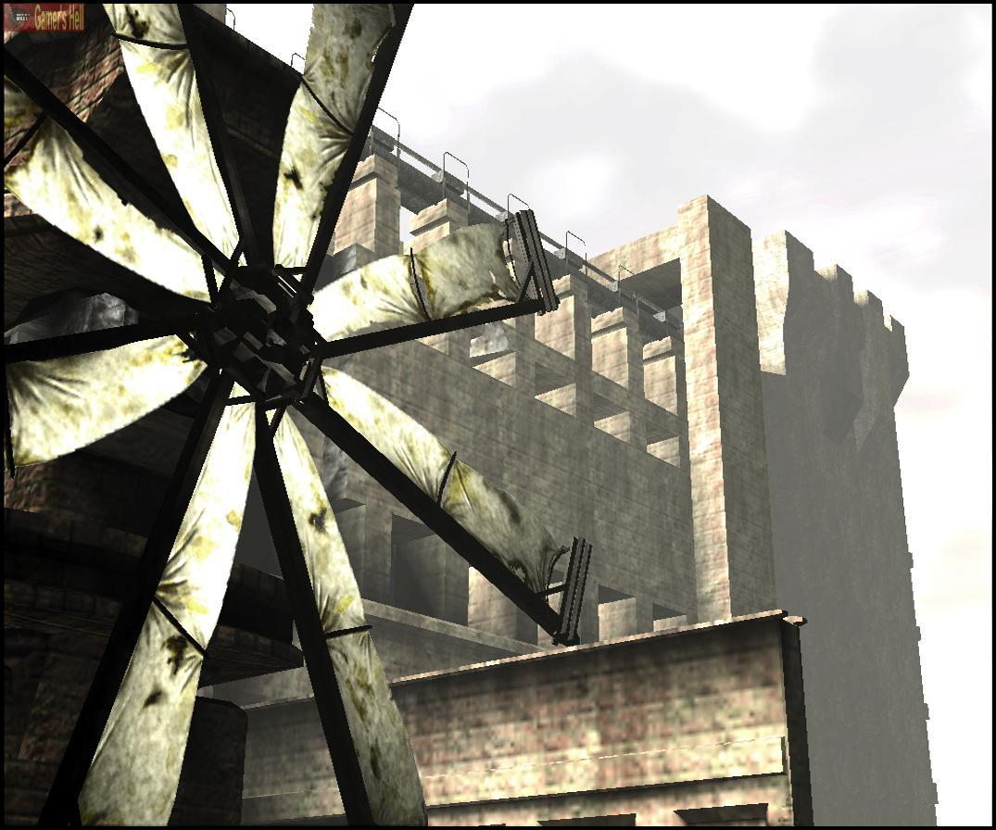
Ico has become a cult favorite in the past couple years with many people that think it is a great game and very important to gaming because of its artistic visuals and some people who think its boring and brush it aside. This is fine because Ico really isn’t a game for everyone. I do believe, however, Ico is something people should experience once at least because of its uniqueness.

All said in done, yes, I would say that Ico is worth purchasing. While the puzzles stay the same and the enemies remain in the same places each time you play the game, it’s story is one that can be returned to over and over and still provide a rewarding game play experience.

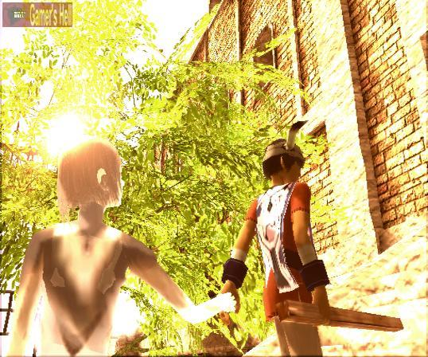
If you’re still unsure if Ico is right for you, I would highly recommend that game players and those interested in what they’ve read above at very least rent Ico to experience something new. See why Ico has become such a critical favorite in the gaming world.

How could it be improved?

Ico could be improved by making the game longer. The game is currently about 12-15 hours the first time that you play through and only 5 or 6 when you play again (because you have a better idea of how to solve the puzzles. A runtime closer to 20 may have allowed more depth to the game.

The action sequences could have been varied a little more. The action of seems like it comes second hand to the puzzles. This seems if the fights were almost thrown in after the fact. This does not mean that they are not fun. They just seem rather insignificant.

Things to unlock for beating the game in different ways would have been nice as well. For example, you unlock hidden areas of the castle the faster you beat certain puzzles, or something like that.

All in all Ico is a great game and I hop to see some of these suggestions acknowledged when Ico II comes out in 2004/2005.

