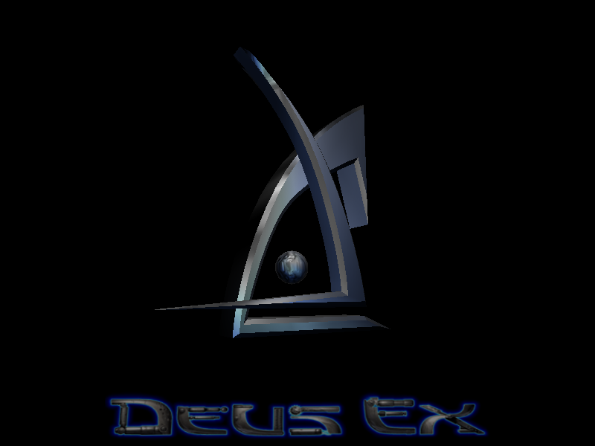

Deus Ex Game Review

By: Todd Pugh

The story of Deus Ex begins with a plague, called the Gray Death, ravaging the world. There is rumored to be an unconfirmed cure, known as Ambrosia. Conspiracy theorists claim that the governments of the world are hording for wealth and powerful of the world. Riots have begun in many large cities, demanding that something be done about the Gray Death. Recently, there a shipment of Ambrosia was delivered to New York City on its way to Washington, where it was hijacked by a terrorists group.
You are Paul Denton, the newest field agent for UNATCO. You are a new type of agent, capable of upgrading your body using, what is known as, Nano-Technology. You have been sent to New York to subdue the riots, eliminate the terrorist threat, and recover the shipment of Ambrosia.

The Basics
- Company: Edios
- Author: Ion Storm
- Release Year: 2000
- Type of Game: First Person Shooter, with parts of Adventure thrown in
- Price: $19.99
- Minimum Requirements  - 300 MHz Pentium II or equivalent  - Windows 95/98  - 64 MB RAM  - DirectX 7.0a compliant 3D accelerated video card  - DirectX 7.0a compliant sound card  - 4X CD-ROM drive  - 150 MB hard drive space, plus space for saved games | - Recommended Requirements  - AMD Athlon or Intel Pentium III processor  - 128 MB RAM  - 3D accelerator with 16 MB VRAM  - 8X CD-ROM Drive  750 MB hard drive space, plus space for saved games

Game Summary

Quick Overview:

In Deus Ex, you walk around cities or installations where you interact with people and objects, trying to complete objectives. Now to be a bit more specific, you can interact with any person in the game in some way or another. You can actually have conversations with specific characters, where they will say something, you pick a response from a list of responses, and so on. You solve puzzles, like opening doors, trying to figure out who is actually good or bad, find a specific item, find specific information, and so on. You do this by finding information through talking to people, hacking computer, finding secret documents, finding keys, picking locks, and other tasks of this nature.
All the while, you are fighting terrorist groups, secret societies, state of the art robots, and people who are more than the seem. There are a tremendous amount of items which you can pick up and use, not all of which will help you. But, you are forced to choose what you want to keep, and what is not as important, because you have a limited inventory space. As you go along you earn skill points, which can be used to learn new skills. Skills allow you to do things such as hack computers, pick locks, use a specific weapon better, override electronic devices, swim faster, and use health packs more efficiently. You, also, come across body augmentations, which you can install on your body. Augmentation abilities range from jumping higher and lifting incredibly heavy objects, to becoming invisible and launching and using a robotic drone from your body.

Installation:
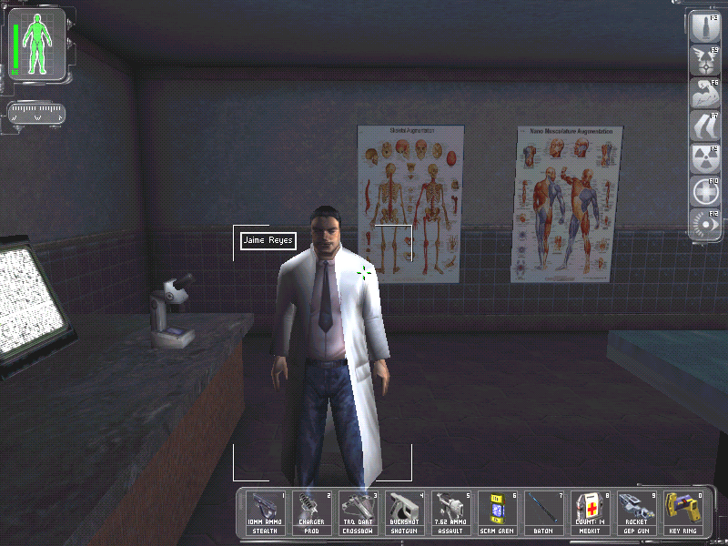
Installing the game is fairly simple. All you need to do is put the game CD in your CD-Rom drive and when the Deus Ex screen comes up push the installation button and follow the directions given to you.

User Interface:
Above is a screen shot showing the user interface. In the upper left corner is health meter. Your health meter is shown as a picture of your body, when a part of your body is green it is at full health when it is black it is at 0 health. Next to the body is a green bar, which shows your bio-energy, which is used to power your augmentations. Below these is a compass, which shows the direction you are facing. Along the right side of the screen is the list of your current augmentations and what F-key they are mapped to. Along the bottom of your screen is a list of the number keys from 1 to 0, with a picture of what inventory item you currently have mapped to that key.

Game Play:
The game play is a little different than most First Person Shooters. You do walk around the environment in first person mode and you do shoot things. The difference is that killing everything in sight may not actually always be the best solution. There is more than one solution to most problems you encounter in the game. Most times when you have to attack an installation there is more than one way to attack it. You can choose to walk in the front door with guns blazing and destroy everything in sight, or you can sneak in the back door and take out only those you threaten to keep you from completing your objectives. Not only is completing objectives important, but in what way you complete and objective, or possibly not completing an objective at all will change how certain characters in the game react to you. Your actions in the game can actually change the story of the game.
Scoring:
There is no true “score” in the game. The way to tell if you are doing well in the game is by how many skill points you have received and by how many augmentations you have. You gain skill points by completing certain objectives, which range from exploring a certain area you did not have to enter, to completing the main objective. Augmentations are found throughout the game. Some augmentations can even be found in more than one place.
Artwork, Sounds, and Music:
I found the artwork to be quite exceptional, especially for a 3-year-old game. The people look and act in realistic ways. The cityscapes are mostly based off of real locations, and actually look like those locations. The sound effects where appropriate. If you smashed a mirror you would hear it. If you shot a gun it made an appropriate noise for that specific gun. The music was great. Each city had its own music, and the music would change if something significant happened, like you were being attacked.
Special Features:
- Non-Linear Story Line
- Multiplayer Mode
- Interactive Enviroment
- Artifical Intelligence that reacted to your past actions
- Evolving Story
Manual:
The manual was short and concise. It did a good job of explaining how to use each interface in the game and how to perform each action. They did not use the manual as a means of telling you the story, which I appreciated.
Bugs:
The version of the game that I purchased did not contain any bugs. The game had been out for several years and the bugs had already been removed from retail copies of the game.

Review
Good Points:  - Evolving story line  - Non-Linear Story  - Number of Useable Items  - It Used Real Life Locations  - Multipule Playstyles  - Realistic Problems with Realistic Solutions  - “Bosses” are Not Unbeatable  - Interaction with Characters | Bad points  - Forced into Certain Story Arcs  - Limited Inventory Size  - Multiplayer  - Too Easy to Kill “Bossed”  - If you die, you have to load your last saved game
I found Deus Ex to be better than most other First Person Shooters. It’s Evolving story line kept you interested in moving forward in the game. The non-linear story line and multipule playstyles allowed you to almost create your own game specified to how you wanted to play, but at times you were give no choice and had to progress in a certain way. In most games the puzzles are basically find the correct colored key to match the colored door. In Deus Ex when you came to a locked door you could bypass the lock if you had the sufficent equipment and skills to do so, or you could find the code or specific key you needed for that specific door, or possibly destroy the door. It was nice that you were never stuck on any enemy for an extremely long period of time. Every enemy could be destroyed or at least temporarily incapacitated with just one attack if you had the correct equipment. But, this was at times disappointing that you could kill a tremendous opponent in one unexciting shot. One of the most frustrating points of the game was that if you died you would just have to use your last saved game, which may have been as far back as several levels if you had forgotten to save. So, when you died, you had to redo all of you latest progress. Overall, I found this to be one of the greatest games I have ever purchased. The only way I saw to improve it was in the multiplayer, which looked exactly like every other death match game. It was more than worth the $19.99 I paid. It is a game that I think anyone above the age of 15 could enjoy.

