CIS 587 Fall 2002 Assignment 2

Game Analysis and Review

9-23-02

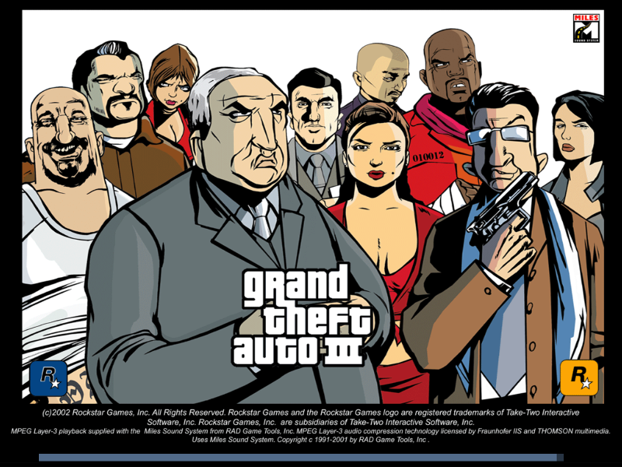

Analyzed by
Patrick Kenny
pkenny@soartech.com
For Dr. Bruce R. Maxim (CIS 587)

Game analyzed:
Grand Theft Auto III (GTAIII)

Basic Game Information

Game Title: Grand Theft Auto III (GTA III)
Publisher: Take-Two
Developer: DMA, Rockstar Games
Category: Action
ESRB Rating: M
Maximum Players: 1
Price: $49.99
Platform: PlayStation 2 and PC

Minimum Hardware Requirements
CPU PIII 500, 128MB RAM, 700MB HD, 16MB 3D Card

Actual Hardware Used:
Intel Pentium 3 500Mhz, 256Meg Ram, GeForce 2 GTS 32MB 3D Card
1.16 GB HD with 161MB MP3’s
16x DVD/CD

Game Summary

Quick overview:
You are framed for a robbery, backstabbed by your friend, you escape and become a freelance and work you way up in “the business”
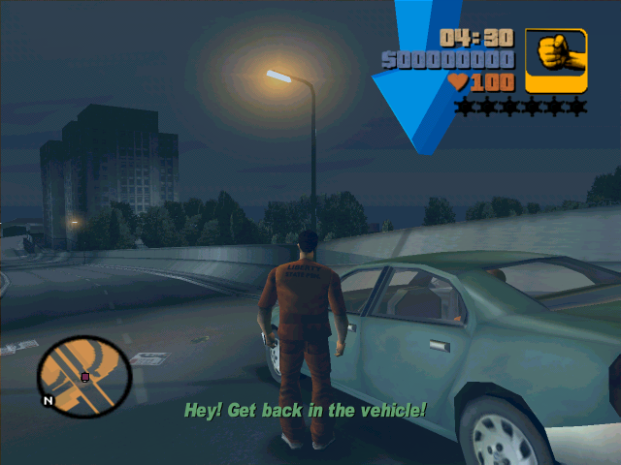
Grand Theft Auto 3, released on the 23rd of October, 2001, was one of the most looked forward to games in history. You play as the role of a criminal, doing jobs for money, and just trying to stay alive. You can do missions, or try to kill the feds, but whatever your options are, YOU do whatever you want in Liberty City.

Story Line

GTA3 starts out as you working for a small time gang. You are all robbing a bank and, the alarm trips and everyone scrambles to the cars, as you watch holding your shotgun. As you start to leave you follow your girl friend, but turns out you can't trust anyone. You get shot by her and are left for dead. Your caught and thrown into a jail wagon car. You escape and go to a hideout, where you work out of taking odd jobs from bosses in the city.
You are a criminal. You are wanted dead. You have no friends, no family, and you can trust nobody. It is up to you, to do favors for the local thugs and gangs, to earn respect, to earn money. Some mobs want you dead, others will risk anything for you. You are either hated or loved in Liberty City.

Players Role and Game Play
Your role is very free and open, you can just explore the world and stay out of trouble, or you can take on missions and sometimes take on the cops and National Guard.
You work your way around the city taking jobs from the mob bosses such as Luigi, Maria, El Burro, Donald Love, or 10 others. Each mission pays money and can involve stealing cars to assassinate certain other bosses or just giving someone a ride. Overall there are 100 missions to be attempted. There are also sub missions that can be attempted such as:

- Rampages – Certain icons and trucks are placed through the city, when these are run over, they trigger specific sub missions, such as destroying 10 cars in 2 minutes with a rocket launcher, or killing 20 mafia in 1:30 with an Uzi. Each one gives you an increasing about of money when completed.
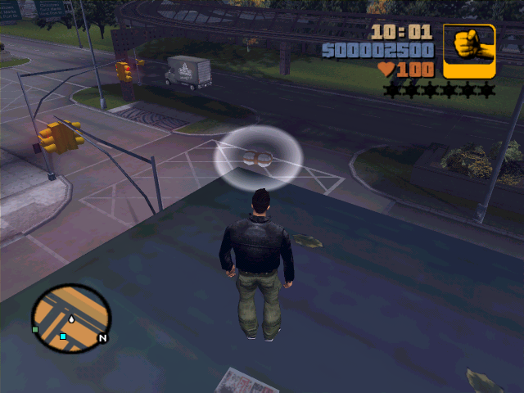
- Finding Hidden Packages – There are 100 packages located throughout the city, each package is worth $1000, but after each set of 10 packages are found, then a special weapon item is placed at your hideout, such as generades or an M-16. You get the rocket launcher when all 100 packages are found.

- Firefighter – A sub mission when you run around the city putting out fires in a fire truck, if you put out 10 fires in each island, then you get a flame thrower at the hideout.

- Ambulance – When you enter an ambulance you can activate the mission to save people by running around the city picking them up and dropping them off at the hospital, your reward for 80 saves is a health at the hideout.
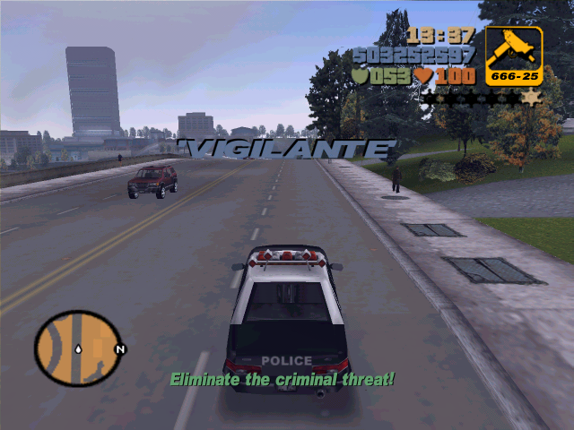
- Taxi Driver – The taxi driver mission allows you to drive around in a taxi picking up people and drop them off for money before the time runs out.

- Vigilante Police missions – In these missions you chase after criminals and kill them or run them off the road, after 25 mission you get a police bribe at the hideout.
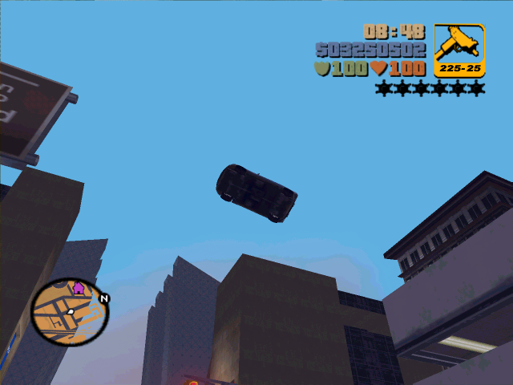
- Unique jumps – There are multiple ramps located throughout the city, some will give you money for jumping over them, some are harder and are called unique, when you jump these you get a large amount of money. These usually involve jumping over water or bridges.

Or you can just ride around the city, carjacking, creating random destruction, fly a plane, drive a boat, steal cars for people, or if your lucky steal a tank and go on a rampage blowing up cars and running over people and lampposts.

Installation:
Easy and simple, insert CD and choose location to play the game and enter the game code on the CD. There were no patches for the PC version of the game. A few keys had to be re-configured from the standard default. There is an option to add your own MP3 files to be played on the car radios in the game and those had to be added to the MP3 directory in the installed folder. There is a way to re-texture the player, but it was too much of a hassle to change the artwork.

User Interface
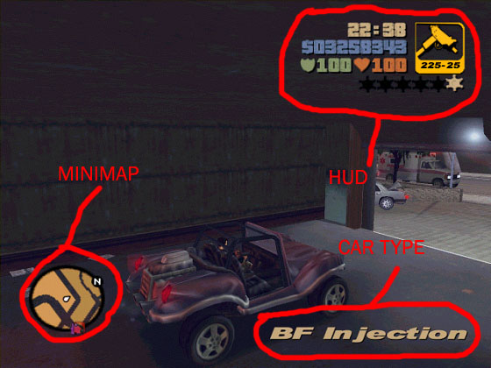
The main game user interface is easy and simple to use and understand and doesn’t get in the way of the gameplay. There are three main areas in the game screen, the Minimap, the HUD (Heads up Display) and the car/location name. The bottom left contains the Minimap, and is a top down view of the current location and a few blocks away. Overlayed on the map will be boss houses, hideouts and current mission objectives. In the top is the HUD, how much money the player has earned, the amount of shield and health of the player, the time of day, the weapon currently being used, with ammo left and the wanted level in stars.
As the stars go up, more and more police, FBI, SWAT and eventually National Guard with tanks and army men will come to hunt you down when you max out with six stars.
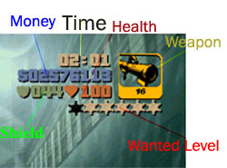
Also overlaid on the game screen are information about missions, time remaining for a mission, or specific data needed for a current objective.

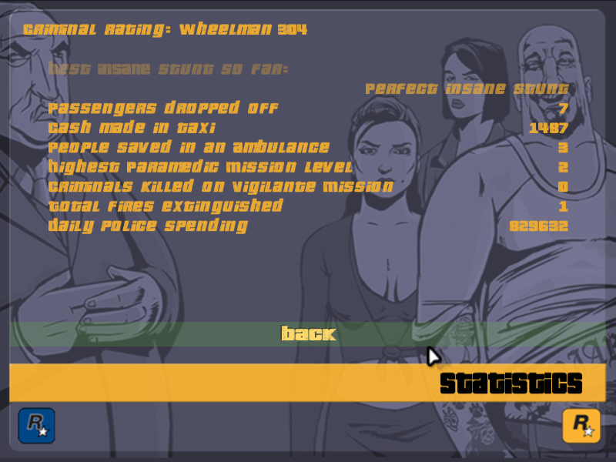
The out of game menus contain screens to change the video, audio, controls, load games and display the statistics the player has accumulated throughout the game. Entertaining statistics such as your criminal rating, cars exploded, insane jumps completed, people wasted, kg’s of explosives used and daily police spending amongst others.
The game starts with an opening clip that combines titles reminisant of a Kojack or Streets of San Francisco TV show and music that sets up the mood of the game.
During the game whenever a mission is attempted, a cut screen is shown with a small clip of characters or scenes setting up the mission and adding to the story.

Scoring
There is no real scoring, you attempt missions from the bosses in the game, which earns you wealth and weapons, statistics are also keep for all of missions and actions performed. Your wealth in Dollars is shown in the upper right of the game screen. Your statistics are accessed from the main menu within the game, as seen in the picture.

Artwork
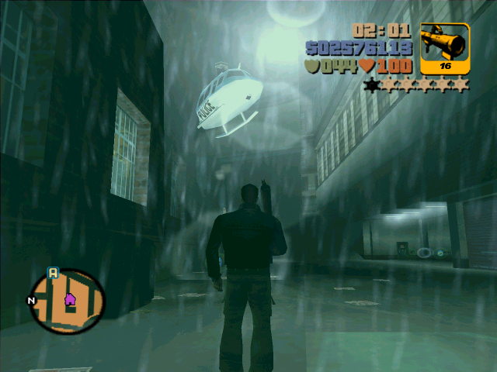
The artwork in the game is very well done and has options to adjust the settings for lower end PC’s. Everything in the world is modeled in 3D. The game has time of day and weather that changes, which affects the textures of the 3D models.
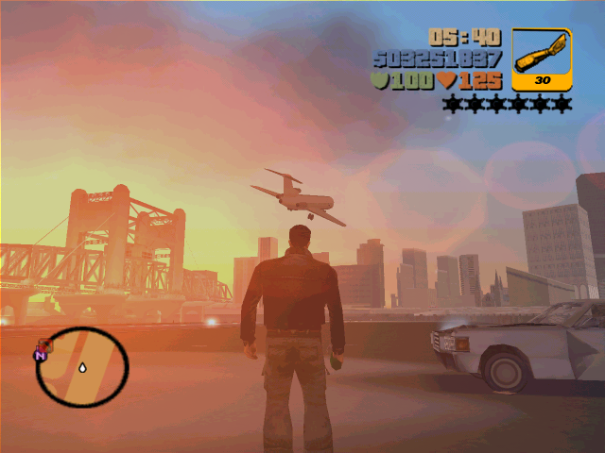
The artwork in the world is made to fit a 90’s style world. The game itself is a virtual world with three islands that introduce new models and areas with new textures. For example the first island that the player starts on contains several boroughs a shipyard doc and an overhead rail that travels throughout the district. The artwork reflects the area with more subdued colors to create a harder, more worn-out look and feel, while the second island is a business area that contains a downtown area and a sports stadium; the last island contains an airport and a dam amongst other numerous buildings. An underground subway connects all three islands. What turns this into an incredible feat for this game is the fact that you can drive from one island to another, you can sit ontop a mountain and watch the sunrise or the stand at the airport and watch an airplane fly over the rest of the city. This is accomplished through an incredible use of LOD (Level of Detail) for the models and objects in the world. Each of the objects in the game are finely detailed and textured, shadows are cast from streetlights and characters are dressed to fit the mood of the city. Special effects of explosions, gun fire, police lights and sirens and rain splashing in puddles is realistic. Mission objectives are clearly marked on the map and with special effects of large arrows or circle halos of where to place the car.
Character animations are numerous and interact with the player as they walk by.
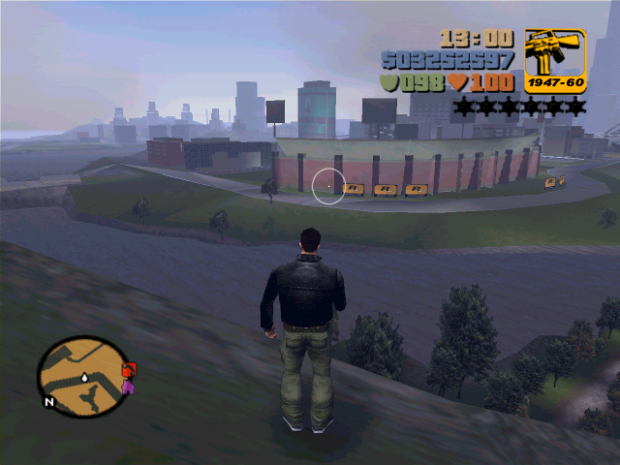
Another feature of the game is the ability to have cinematic cameras when the game is played. Through it is a bit hard to play from this vantage point, it makes it interesting and creative to watch. Also when the player attempts unique jumps the game automatically goes into a cinematic slow-motion mode to make the player feel like they a re in a movie.

Sound and Music
The music of the game is provided through the radio in the cars. There are 9 stations that the player can listen to everything from Reggae to talk to techno, and there is the special feature to add your own mp3 and switch to that radio that plays those.
The sounds in the game are numerous and enjoyable to listen to, everything in the game has a set of ambience attached to it. An M-16 sounds like it should, and car explosions fit when a car blows up. Almost all of the objects in the game contain some form of sound effect. Rain make noise, birds are chirping when the sun rises. There is the constant background noise of a city humm, airplanes and subways add to the realism.
When the player gets into trouble and the police take chase, they have their sirens blasting, helicopter blades are making noise, and they call over loudspeakers for you to come out. People talk, curse, yell and scream, especially when they are lit on fire from a flamethrower. The voice acting production values were excellent and fit the characters in the game world. The only sound missing would be a larger back blast from a tank or rocket launcher. Cut scenes, and the intro credits set the mood and emotion of the game to follow.

Special Features
The game has the ability to play MP3s of choice on the radios of all the cars by choosing the MP3 radio station. The MP3’s must be stored in a directory called ‘mp3’ in the main installation directory. There is a way to change the character skin of the player with a paint program.

Manual
Basic game manual, 2 pages and a readme file in the installation directory. Since the game was so popular, there have been many official and fan sites set up to help players with hints, help and a general understanding of all the many different things that can be done in the game.

Bugs
There were a few bugs that I have noticed. It is possible to freeze up the game, jump your car, in any insane stunt jump, and when you land, keep turning the car, the camera will lock onto the vehicle from a far, the only control you have will be over the vehicle turning and speed. Now if you happen to run into something and catch the car on fire, you will not be able to escape, the car will blow up and you will get wasted, but you will be stuck in the car, the camera will still be from a-far. This only happened to me once, while I was just playing around. There are some serious game/graphic slowdown problems. It is possible to get all of the police and national guard after you, you hide behind a wall so they can’t get you, it becomes impossible to throw generades or molitive cocktails as the frame rate drops to around 5 frames/sec. Also anything over 1024x768 16 bit textures really slowed down my system and another one I tried it on that was running a 900Mhz, 256Meg ram and a Geforce 3 card.
The game also did crash on me once when I had a majority of the police and national guard after me and I just stole one of the tanks, after 20 tries, I was going back to my hide out when the game crashed, needless to say I didn’t like that and went to bed, but the addiction was already in place and I returned the next day to resume and capture the tank!

Game Review and Analysis

The game industry has been moving more towards open-ended free-form game play where the player can make up their own story in a pre-constructed environment. One game that has done this successfully and innovatively is Grand Theft Auto III. This is the third version of this game and has amassed a large following of game players over the years from both the PC and console gamers. The first version of the game was played with a top down perspective and, though it was a good game for it’s time, people tired of it after awhile. When GTAIII game out, they had converted it into a truly amazing interactive 3D world, where the game play has come to life. GTA III was developed first on the PlayStation 2 then ported to the PC.
This game is hard to characterize, as it is actually several games in one. It borrows ideas from simulation, role-playing, action and shooter games, but without the extreme depth of each. What the game does do is provide a realistic world that hooks the player into coming back, day after day to explore and enjoy.

Interactive Game World
GTAIII has developed an extremely rich and interactive game world for the player to enjoy and live in. The game world, called Liberty City, is divided up into three islands, Portland, Staunton Island and Shoreside Vale. You could actually spend several hours just driving around, it is recommended to find out where things are located, before even attempting the first mission. One of the more enjoyable aspects of the game is just driving around. Each island is accessible and opened after completing the missions on the current island.

Game Interactions
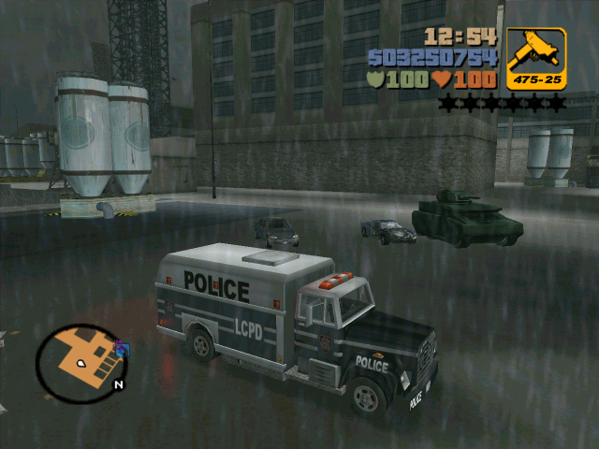
The game world is truly dynamic and there are multiple actions going on all the time to make the world feel alive, these are:
Weather –The game contains time of day, so you can see the sunrise and the moon fall. At night, street lights come on, fog rolls in, cars turn on their lights at night and hookers come out.
Cars – Cars are always driving around, honking, turning their lights on when night falls and the police are always there to chase you, or know you off the road if you get out of line.
People – People are present all over the city, in the red light district there will be gangs, in the downtown area, there will be bisuness people. The interactions and character animations bring the people to life, they yell at you and scream when a car is jacked. Characters interact with each other and the player they drive cars and get into fights.

Objects – There are many other objects that bring the city to life, lampposts with lights, stoplights with flashing walk – don’t walk signs. Paper and leaves blowing around, exhaust from cars and smoke from fires or blown engines. When cars get damage or run into something pieces go flying in every direction. Fire hydrants explode with water when the play happens to run over them.

Physics
The physics in the engine is very well done, cars and object have weight, bigger cars and trucks drive more slowly and slam into other cars with more force. When cars skid around they act like they should. Going off of jumps can be a challenge, but it is realistic. The only complaint would be that car damage and car pieces tend to break off on small hits.

What is good and fun about the game, Why?
GTA III is an extremely fun game for several reasons. Just being able to roam around the streets and watch the world happen can be enjoyable. Figuring out what kinds of interactions characters, objects and cars can have or do will keep anyone entertained for hours.
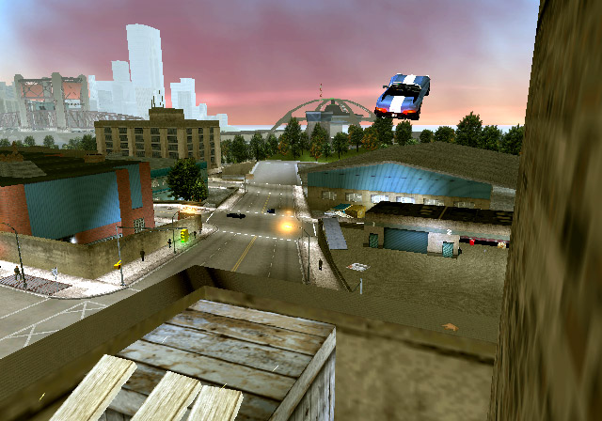
Since the world is very open-ended the player can take their time and go at their own pace, missions are like a slot machine. When you want one just go to a boss and ask for one. There is no penalty for not completing a mission. Along with the main missions there are many side quests and missions that will keep everyone occupied. Simple quests like searching for hidden packages and rampages to blow up cars exist. There are many many objects in the world that you can take a car to jump over, some are simple and some require more precision. Lastly just roaming around the world and causing destruction make the game enjoyable. But there is a catch to this fun and that is the wanted level, if there is too much destruction then the police, SWAT and eventually Nation Guard will chase you down, but these chases and trying to get police bribes to reduce your wanted level are one of the most enjoyable tension filled parts of the game.

There are many missions in the game, and they don’t have to be solved with one particular method, many people have develop creative problem solving to finish a mission or steal certain cars that we not meant to be taken. The variety of missions keeps the game from becoming dull and predictive. The virtual world is huge and expansive and allows the player the freedom to go anywhere and the LOD technology keeps the game running smoothly.

What is bad (not fun) about the game and Why?
Some of the missions can be a bit hard to complete and there is no saving during a mission, so a failure involves retrying the mission. The missions are not very big, which limits the types of mission that can be developed, this results in some of the missions being repetitive for different bosses. A lot of the missions are based on time and take several trials to finish them. It is very hard to not smash up a car, running into a rock or back of a car can cause more damage then one would think, and that is frustrating especially when you have a nice new car. Since there are steep system requirements, it is easy for the game to get bogged down when too many objects are on the screen.
It becomes a bit frustrating when you get wasted or busted and loose all your weapons and have to run back to the hideout to pick up the weapons, early in the game picking up weapons meant finding them in the game world as they did not appear at the hideout yet. Finding objects and items in the world becomes frustrating when you can’t remember where items were located.
There is no difficulty level in the game, play balance is done well, but the game missions do not increase in difficulty to much as the game progresses.

How does it compare to similar games in the same genre?
There really are not any games to compare against GTA III. No one has released a game like this in 3D with a working virtual world. There is a sequel coming out and another game called Mafia, that is similar. I think that this will inspire many clones.

Why is it better or worse than similar games?
This game is the first in a line of immerse 3D worlds that have a very open ended game world to play in and for that it is much better than similar games.

What is the appropriate audience for this game?
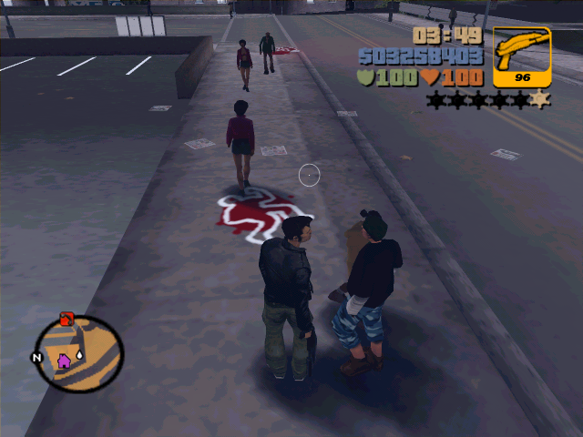
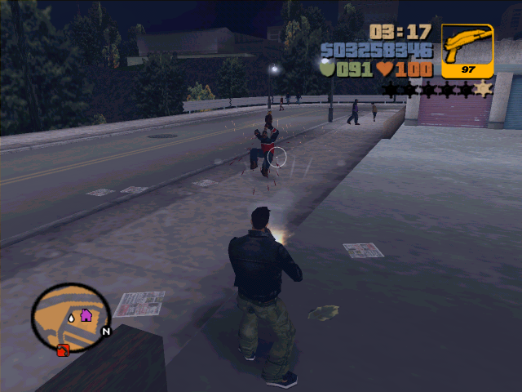
This game is intended for a mature audience, and rightly so. It is a game that contains lots of violence and has been under extreme controversy for it. What distinguishes this game from others is the fact that the violence is aimed against innocents that are not necessarily bad people, it’s easy to run over people or use the sniper rifle to pop the head off of a character, or use a bat to knock people to the ground, fists work just as well. My view on this is that this is just a game and does not promote violence or aggressive behavior, but should not be played by minors without parental permission, or for too long of a period.

Are any design mistakes present?
One of the major design mistakes that is present in the game is that this is mainly a port of the PlayStation 2 version of the same game. The graphics and artwork have been updated, but the play style has not, there are no key shortcuts to choose a weapon, and the missions are each quite short and linear and it is possible to get into a situation where if you don’t complete all the missions in a specific order then it might be extremely hard or impossible to complete the mission that were skipped over. The game has done a good job of keeping play balance, ease of use and difficultly down for the common user. It has a good design that has done a lot of stuff right and should be used as an example of how to design a game such as this.

Summary

Overall strengths and weaknesses
The overall strength of GTA III is in its open free-form game play and sub-missions that totally immerses the player into the virtual world that has been created. The game creates a world that appears to be living and breathing with time of day, characters that interact, radio stations on the radios, weather and mobs that are out to get you. Another strength is the sub game play of driving cars around and trying to jump them off of places they may not have been intended to go.

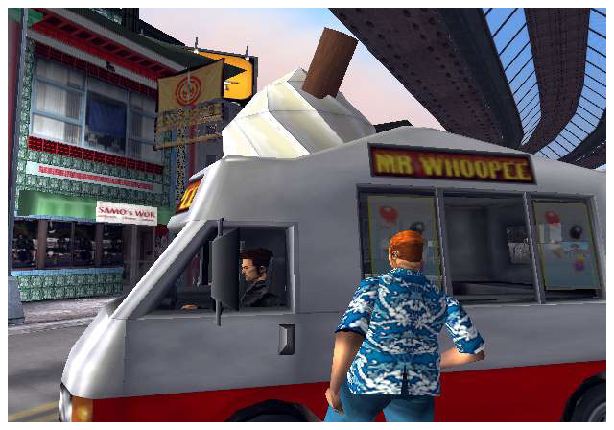
One of the main weaknesses is the ability to get lost easily and having to remember exactly where every police bribe and health are located as they do not show up on the map and there is no general city map that one can add annotations to. Another weakness is that the game really is a system hog and does get bogged down when there are a lot of actions occurring, thus the need to keep the screen resolution down. Since this was a console port, there were many features that could have been added that I am sure will be seen in the sequel.

Is the game worth purchasing?
This is a novel and innovative game worth purchasing just to experience a new form of game play that will keep you hooked and craving for more.

How could it be improved?
There are many ways a game like this could be improved, here are some ideas:
- A more dynamic world that can be changed based on the players actions.
- The ability to dynamically generate missions based on players actions and by other character’s actions.
- The addition of a multiplayer component.
- The ability to add mods and new car or character models or missions.
- Currently there are a limited number of characters in the game, most of them generic. The ability to have more special characters that effect the world would be interesting.
- Adding more of an RPG component where the player can gain skills or improve based on the actions the player performs.

