Game Review
Of

Piranha Byte’s


Christopher Furton
Computer Information Science 487
23 September 2002

Gothic - Insomnia

I only smoke weed when I need to,
And I need to make some tests, yo
I confess, I spent a night on anothers mattress,
Yes, yes, it was me, I play guilty,
And on the count of three I opened up the chest,
Make my way to the depth,
One candle stick inside, no lie
Not even bread, ham,
Then the guard above my head went bam!
I won't sleep, something's all over me,
Gothic, insomnia please release me,
And let me dream about Scavengers on the cliff,
Tearing off wolfs their teeth.
But there's no relief,
I'm wide awake with my mouse,
It's dark and I'm lonely,
Oh, if I could only get some sleep,
Speaker noises make my skin creep,
I need to get some sleep,
I can't get no sleep....

* Taken from Gothic FAQ Version 1.2
Basic Information

Game Title: Gothic
Company: Piranha Byte
Type of Game: Role Playing Game
Price: $39.99
Minimum Stated Requirements:
- Windows 98/200
- 128 MB RAM
- 16 MB Video Card
- Pentium 400 (and compatible)
- 1 GB HardDisk
- DirectX Soundcard (e.g. Sound Blaster)

Actual Requirements:
- Windows 98/2000 or higher
- 256 MB RAM
- 16 MB Video Card
- Pentium 400 (and compatible)
- 1 GB HardDisk
- DirectX soundcard (e.g. Sound Blaster)

Game Summary

Quick Overview:

Storyline:
In the land of Myrtana, the mining city of Khorinis was quickly falling apart. The thieves and criminals which worked the mines were fighting back and the King was loosing the magic ore produced from the mines. King Rothbar II called out to the mages of the Circle of Fire and the Circle of Water to erect a magical barrier around the city of Khorinis. This barrier would allow living creatures to enter but not leave the city. The mages developed a plan and combined their powers to create this giant dome, but the plan did not go as planned. The barrier was created, but the mages were trapped inside along with the criminals.
The criminals quickly learned that the mages were their only chance of escape, so a unity was formed. The mages studied the barrier trying to find weaknesses and the criminals mined the ore for the King in exchange for food. The mages of the Circle of Water, however, could not agree and left to start their own camp. The city of Khorinis now contained the Old Camp and the New Camp.
A short while later, a group of mages left the Old Camp heading for the swamps. They created a new camp founded on swampherb which could be smoked resulting in contact with the “gods.” This new camp flourished based on communication with their god, the Sleeper.

Player’s Role:
The player is the newest entry to Khorinis. Your first goal is to successfully join one of the three camps. This goal requires interaction with and betrayal of the other two camps. Once part of a camp, you must work towards the larger goal, destroying the barrier.

Installation:
Gothic is designed to run completely off a hard drive. Once installed, the CD is not required. A custom installation program is provided, however Direct X 7a must be installed prior to installing Gothic.

User Interface:
Gothic presents a fairly simple user interface that allows complete control of the game’s action without excessively complicated controls. Movement is easy with the option of using the mouse along with the keyboard. When engaged in combat with another character or creature, advanced movements are possible but only basic movements are required.
Inventory of each character is displayed on the screen in a manner which facilitates easy trading and view of items in possession (picture #1). This allows for a clutter free view of a character’s inventory making purchasing and trading of goods easy. Multiples of the same item are only displayed once in the inventory screen with small subscripts next them indicating quantity.
Saving and restoring the game can be accomplished by using the Main Menu (escape key). Multiple slots are provided with a screen shot and space for a long description of the game play. This allows for convenient saving and restoring with little ambiguity of game position.

Picture #1
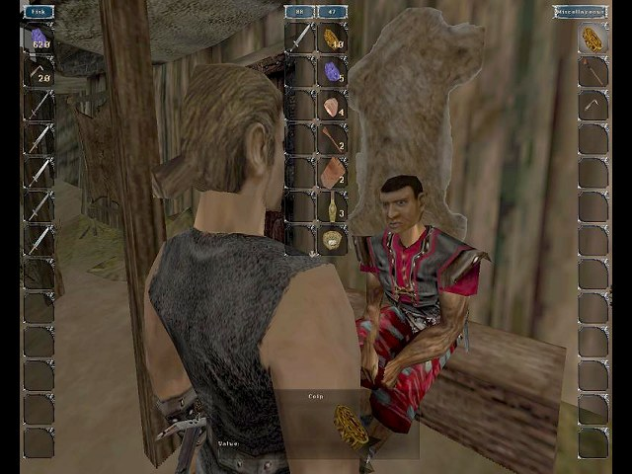 | This picture shows the trading of goods between the player and a merchant. The left column shows the weapons for sale, the right column shows the players inventory. The center two columns show what the player is giving to the merchant and what the player will receive. Each item has a set value and the amount of the trade is shown in the blue boxes on top of the center columns.

Game Play:
Gothic has a “go where you want” approach which gives the player the feeling of total control. Most locked chests and doors can be picked and buildings can be explored. This free environment provides characters which daily routines and activities. The time of day changes along with day and night time. Your character must also get sleep, whether it be in “his bed” or someone else’s bed, and must eat to maintain proper health.
The plot of the game has several different paths; all of them interact with each other. The player has the option of controlling which path to take; some are more difficult than others. The player can become a warrior, a ranger, or a mage. Playing Gothic more than once is possible because of the many different paths.

Scoring:
The main score in Gothic is calculated in experience points. When accomplishing tasks and missions, killing large beasts, or experimenting with something new (weed for example), experience points are gained. Once a new level is obtained, the player earns skill points. These skill points can be used to train in areas such as strength, dexterity, and mana.

Artwork:
Gothic’s art work is extremely detailed and precisely assembled. Gaps or flaws in the 3D appearance of the world are very few, almost non-existent. The creatures and characters are extremely detailed with excellent animation. See Appendix A for images of creatures and characters.

Sound and Music:
The sounds and music in Gothic are very appropriate and nicely support the game. Sound effects do not interfere with game play and do not take away from the main goals of the game. The music is dark and mysterious when in the forests or caves and lighter when in cities and other populated areas.

Special Features:
Gothic supports the use of cheat codes which are available in the Gothic FAQ. The cheat mode, called marvin mode, allows for invincibility, creation of game objects, and teleportation options. Alteration of .ini files allows for the increase of blood and gore and the addition of nudity to the game.

Manual:
Gothic comes with an installation manual that provides information about Direct X and some troubleshooting. It also comes with a small book providing little information about the storyline and creatures that are encountered. Most information is learned through game play, often times resulting in death of the character.

Bugs:
No bugs were discovered during my experience with the game. However, many bugs are noted in the Gothic FAQ. These bugs usually result in a change in the flow of the game, not a system crash. Unfortunately, some of these bugs can result in making the game unsolvable.

Game Review:

What is good (fun) about the game?
Gothic provides many hours of outstanding game play. Aspects of the game which are good include:
- “Free Roaming” environment
- Interaction with most objects in the game. Raw food can be cooked at ate, stew can be stirred, and weapons and potions can be created.
- When certain tasks become difficult or unsolvable, there are other tasks to work on. This keeps the players interest in the game and prevents the player from getting flustered and quitting.
- Creatures outside the cities are creatively devised. They include scavenger birds, wolves, giant orcs, and even over sized bees with poison stingers. Every new creature encountered as the game progresses gets more difficult to destroy.
- All characters carryout dialog with the player. This is accomplished through audio files, not through text.

What is bad (not fun) about the game?
Gothic is very well thought out and designed. However some parts take away from the enjoyment of the game. These include:
- Traveling from camp to camp can be tedious do to the long distance and slow pace of the lead character. A mode of transportation or a quicker way to get from camp to camp would reduce the amount of “wasted” game play.
- Gothic allows for killing of most characters. However, some characters seriously influence the flow of the game. This becomes irritating because it is unknown whether or not game flow has been affected. Piranha Bytes claims that characters vital to game accomplishment can not be killed until the game no longer relies on them.

How does it compare to similar games in the same genre?
Role Playing Games often time can be discouraging with long plot irrelevant tasks. Gothic is much better than most other RPGs due to thought and time put into carving the storyline. Gothic is a great RPG that corrects many problems seen in games like Ultima Ascension and Unreal. Gothic utilizes great graphics, which is lacking in games like Tomb Raider. Gothic is very smooth with great usage of available hardware.

What is the appropriate audience for this game?
Gothic is designed for a teen audience. The animated violence could be disturbing to young children, however, a violence setting is available through the .ini file. The American version of the game has been censored, removing the nudity. The german version has not been censored.

Summary:

Strengths and Weaknesses:
There are many strengths in Gothic. The detailed environment is the largest. Characters interact with each other, eat, sleep, and even fight among each other. The run rises and sets and different creatures are present in the forest at different times of the day. For example, walking through the forest at night is hazardous due to the packs of wolves.
There are some minor weaknesses in Gothic. Many tasks require travel throughout the realm which is slow and time consuming.

Is the game worth purchasing?
Gothic is definitely worth purchasing. The game designers made an excellent game which has been released in Germany and in the United States. Gothic is definitely a success and is worth the $39.99 price tag.

How could it be improved?
Gothic could be improved by releasing a patch to fix some of the known bugs listed in the Gothic FAQ. Although my game play did not reveal any major problems, some are known which can result in many hours of game play without the possibility to solve the game. This could be problematic to avid game players determined to complete the game.
Appendix A: Screen shots/Characters form the Gothic.

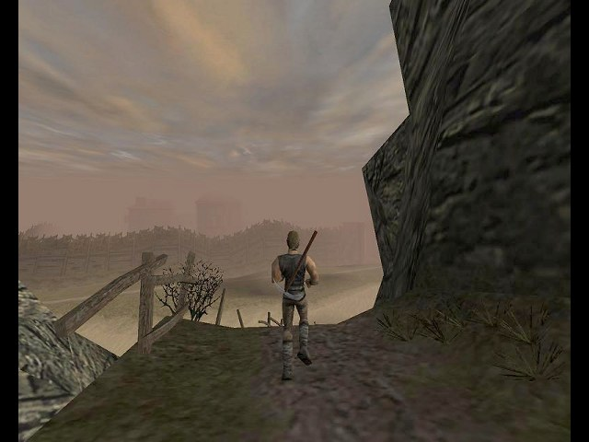 | 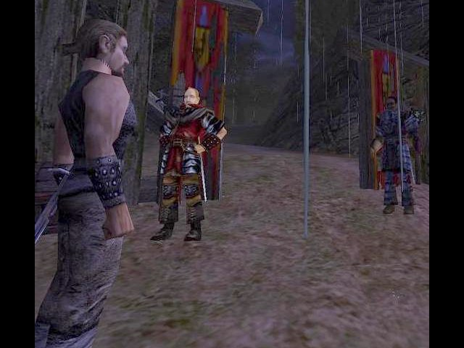
Path through the hillside. | Guards outside the mine in the rain.
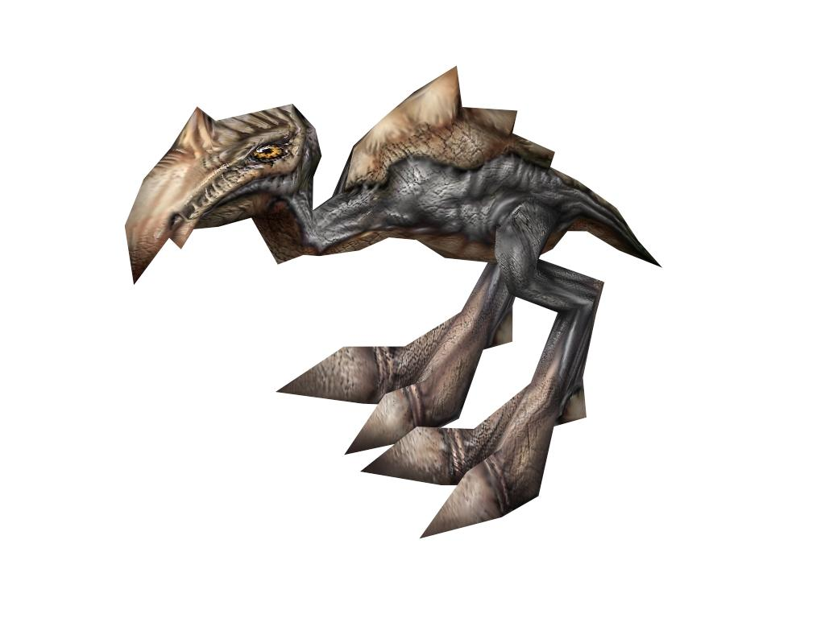 | 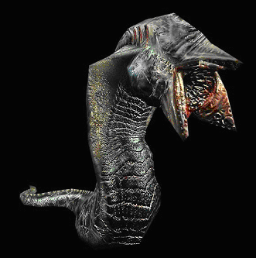
Scavenger Bird | Swamp Shark
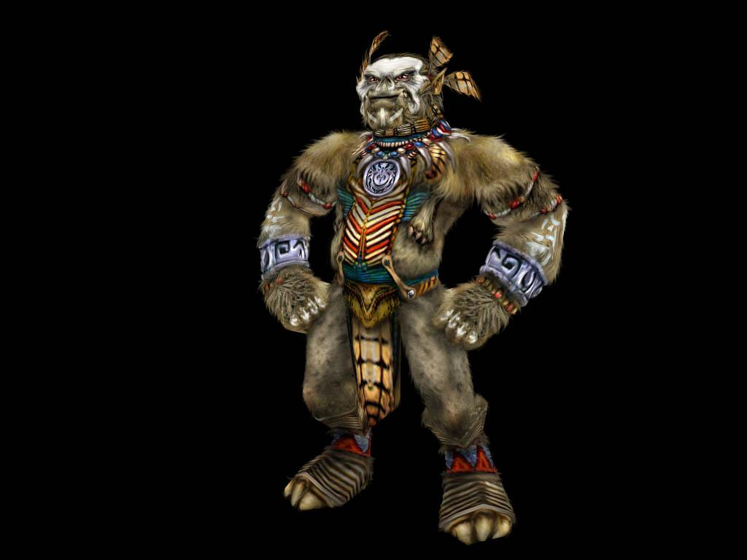 | 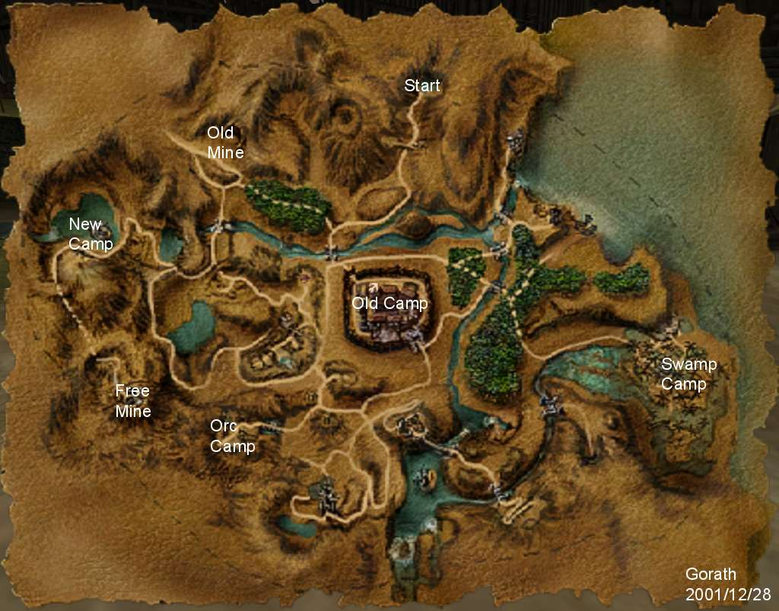
Orc Shamane | Map of the City of Khorinis

