Basic Information

Lego Racers

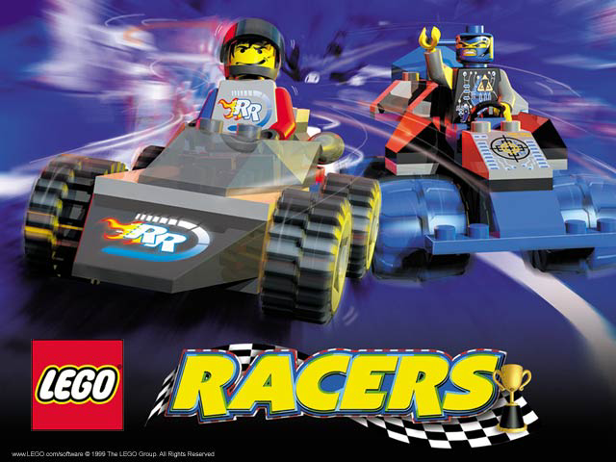

Company and Author | Lego Media, High Voltage Software
Game Type | Primary – Childrens Game (estimated ages 5-11).  Secondary – Arcade (Racing)
Price | $9.99 (Direct from Lego)
Minimum Hardware Requirements | Win 95/98 only (not compatible with Windows NT, OS/2, Linux or any Windows emulated operating systems.  100% DirectX 6.1 compatible system (DirectX 6.1 included on LEGO Racers CD)  Pentium 166 MHz (Pentium 200 MHz or faster recommended; also compatible with AMD-K6-2, AMD-K6-III and Cyrix MII processors)  32 MB RAM  4x speed or faster CD-ROM or DVD drive  210 MB uncompressed hard disk space  4 MB Direct3D compatible graphics accelerator card (PCI or AGP)  16-bit DirectSound compatible sound card  Mouse  Joystick/game pad recommended but not required
Actual / Recommended Hardware Requirements | No additional hardware requirements or recommendations provided by company.
Review System Configuration | 500 MHz Celeron processor  256 MB RAM  DX6 Sound Card, DirectSound support  VooDoo3 2000 graphics card, 16 MB RAM  Enough hard disk space for full install (402+ MB)

Game Summary
Quick Overview | Construct your own LEGO car and driver, then race against five other challengers on 12 tracks based on LEGO SYSTEM play themes. Once you've mastered them all, go head-to-head against Rocket Racer in the ultimate racing challenge! Play to win in this pulse-pounding test of skills and wheels.  Build your car from scratch, or start racing immediately with a ready-made model.  Create and customize your LEGO driver and license.  Rocket through 12 wild tracks across 4 LEGO worlds! Race against 5 popular LEGO characters or challenge a friend in split screen mode.
Story Line | The basic storyline for this game is that the player is a racer driver driving his uniquely created car in a series of racing circuits. Each circuit is hosted by a talented race driver, who challenges the player to 4 races. Doing well in a circuit unlocks the next circuit, leading to a racing showdown with the ultimate Lego Racer, Rocket Racer!
Player’s Role | Initially, the player has the role responsible for creating a driver and a car to drive. Once the player has created a driver and car, or opted to race with one of the preconstructed driver/car teams, he takes on the role of race car driver.
Installation | Win32 standard installation. Installation detects DirectX version currently installed and will offer to install version 6.1 if a lesser version is found on the machine.
User Interface | - Mouse used primarily for all construction activities.  - Keyboard or joystick may be used to control vehicle during races.  - Keys or buttons on joystick provide additional functions while driving (using special powerups, changing views, looking back, powersliding, acceleration/braking).  - Multilingual dialogue - 9 languages supported
Game Play | - Create/select driver and car first, then race.  - Select from different hairstyles, hats, helmuts, faces, mid-sections and legs to construct the desired driver “look”.  - Choose from a large variety of classic and specialized Lego blocks to construct the car for this racer.  - 4 modes of racing  - Circuit  - Single  - Versus (2 player head-to-head using same computer, split screen)  - Time Trial  - Circuits consist of 4 tracks, hosted by a “Boss” character.  - In order to advance to next circuit, player must place in top 3 for points earned in the circuit.  - 6 circuits (12 tracks, each track raced twice).  - Power ups are represented at floating blocks that racer drives through to collect. Power-ups can provide enhanced performance capabilities (rockets, shields against other drivers) or inhibit your opponents from progressing (cannon balls, grappling hooks, oil slicks, TNT).  - Tracks become more difficult to navigate in higher circuits due to random hazards and obstacles.
Scoring | - Points awarded to drivers based on finish position in each race of a circuit.  - After racing on all four tracks, if the player is in the top three for the circuit, he is awarded access to the next circuit.
Artwork | - Bright colors  - Fairly geometric  - Varied scenery  - Moving objects on each track are unique.  - Patterns on terrain are used to visually differentiate to the players.  - Consistent with Lego building block product.
Sound and Music | - Simple, repetitive music during construction.  - Basic motor sounds, action sounds when using power ups.  - Can hear other drivers as the approach.  - Other drivers make comments when “attacked” or observing an attack.
Special Features | - Driver construction very interactive; model gives you feedback regarding how well the selections go together.  - Different terrain and settings for every race, making each race a unique experience.  - Power ups for unique abilities (colored blocks).  - Special upgrade blocks that change and enhance the capabilities of the power ups. Collection of multiple upgrade blocks provides a cumulative upgrade to other collected power-ups..  - Multiple views when driving.  - Unique hazards on each track.
Manual / Instructions | Manual was not available for review of this game. But the game is simple enough that it can be thoroughly enjoyed without the use of a manual.
Bugs | - Graphic artifacts on screen when not using a 3d video accelerator.

Game Review
Things Gone Right | Driver Construction  Lots of options regarding costume/uniform styles, colors.  Male and female options  Interactive model gives feedback to choices  Car Construction  Large variety of standard and specialized Lego pieces available to build car with.  Full 3D rotation viewing to see car from all angles during construction.  Themed pieces are grouped together so to facilitate building of “era” vehicles (medieval, space, racing/performance).  Test track for taking car out for a spin (raceway and off road).  Racing  Cars are easy to control.  Racing is fast enough to be fun, but not too fast to be difficult to control car.  Varied scenery makes every race fun, even though each track is actually used in multiple circuits.  Driver voice add humor to the races (gentle tauntings).  Conflict between drivers is handled without blood or gore.  Different tracks have expected effects on cars (sand and grass slows cars down, pavement makes cars easier to control).  Terrain is very varied, making good use of elevations.  Cars can go airborne!  Powerslide feature!
Things Gone Wrong | Car Construction  Repetitive music played during driver and truck construction gets very boring.  Difficult to visualize final product while building car.  Cannot remove blocks from car once placed without completely starting over.  Purpose behind making a license is not apparent (does not contribute to game play).  Car construction has no impact on the performance of your car compared to other designs.  Racing  Higher level circuits and tracks get repetitive because the racer can’t progress past a particular track without a top 3 finish. Racer must start an entire circuit over if he doesn’t place in top 3 racers.
Comparison to similar games in same genre | Compared to racing simulations, Lego Racers gives the much more control over the visual design of their car. A player can design and build a car from the ground up. Where Lego Racers is lacking is in contributing to the performance characteristics of the car. All cars perform the same regardless of design. The only incentive to design a car differently is so that it looks different.  From an arcade perspective, this game resembles a clever version of Road Rash for young kids. Road Rash had some elements of simulations, where winnings could be applied to high performance motorcycles. Legoracers only rewards winning racers with the opportunity to progress to additional tracks. But the game play is similar in that the vehicles are simple and easy to control. The tracks make use of elevation, curves, different terrain. Drivers can collect items along the way to help them, as well as take advantage of other drivers (chains and clubs in Road Rash). But in Legoracers, no one gets hurt.
Appropriate audience for this game | Different parts of this game appeal to different age groups. Very young kids enjoy doing nothing but building drivers and taking prebuilt cars on the test track.  Young kids will enjoy constructing wild, imaginative cars and driving them on the tracks against the computer drivers or head-to-head with friends.  Adults will enjoy jumping in for a quick race or two using the prebuilt drivers and cars.  The game will appeal to a wide variety of age groups, providing a higher range of players than other games.
Obvious or subtle design mistakes | No easy way to “transport” created cars to other machines.  Multiplayer racing limited to 2 players at same computer using split screen (limits view of race track). Does not include computer controlled racers in head to head racing.  No internet racing options.  Layout of race tracks tend to be very similar from circuit to circuit.

Summary
Overall Strengths and Weaknesses | Appeals to wide demographic of players.  Good replay value (lots of tracks).  Multi-faceted game (construction, racing) – can play any one part or all.  Just plain fun to play!  Challenging, hard to come in first, but not too hard to do well in each race (rewarding).  Car construction is difficult, tedious.  Poorly implemented multiplayer gaming.
Worth Purchasing (Yes/No)? | Yes, for less than $10, how can you beat it!
Suggested Improvements | - Internet enabled multiplayer racing.  - Breakable cars, or at least pieces that fly off the cars when they are hit by other objects.  - Ability for car design to impact car performance.  - Ability to control the number of opponents in a race, along with the laps in a race.
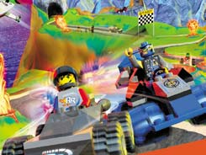 | 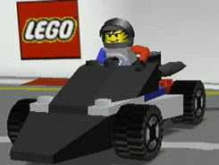
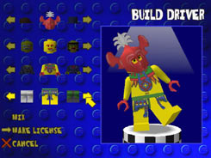 | 

