Table of Contents

Table of Contents 1
Introduction 2
Game Summary 2
Quick overview 2
Story line 2
Player's role 2
Installation 2
User Interface 3
Game Play 3
Scoring 3
Artwork 3
Sound and Music 4
Special features 4
Manual 4
Bugs 4
Game Review 4
What is good about the game? Why? 5
What is bad about the game? Why? 5
How does it compare with similar games in the same genre? 5
Why is it better or worse than similar games? 5
What is the appropriate audience for this game? 5
Are any design mistakes present? 5
Summary 6
Overall strengths and weaknesses 6
Is the game worth purchasing? 6
How could it be improved? 6
List of Figures 7

Introduction

The purpose of this document is to evaluate a computer game. This evaluation will be on the Spy Fox game, the Operation Ozone sequel. Here is the basic information for this game:
- Game title:
Spy Fox, “Operation Ozone”
- Company & Author:
Humongous Entertainment
- Type of game:
Kids adventure
- Price:
$29
- Minimum stated hardware requirements:
Windows: Pentium 133, Windows 95/98/2000/ME, 32MB RAM, 4X CD-ROM
Macintosh: 132 MHz PowerPC, System 7.5.5, 32MB RAM, 4X CD-ROM
- Actual hardware required:
Unable to test for actual minimum hardware required. The computer used was AMD Athlon 900 Mhz, Windows 98, 256 MB RAM, 40X DVD/CD-ROM

Game Summary

Quick overview
This game is an adventure game for children, ages 7+. The game is a typical James Bond story without the violence. It enables a child to assume the role of a spy trying to save the world from danger.

Story line
A mysterious object has appeared in orbit above the Earth. Poodles Galore, the Queen of cosmetics, has blasted an enormous aerosol (hairspray) space station into orbit and set it off. The constant blast of aerosol will deplete the entire ozone layer within a matter of hours, leaving the planet at the mercy of the ravaging sun. The World will have no choice but to buy Poodles' super sun block.
There is only one hero with the courage and wits to save the planet. It’s up to SPY Corps and their top agent. SPY Fox.

Player's role
The player assumes the role of a spy, which is top agent Spy Fox.

Installation
No installation is required. The user clicks on Play button to start the game. The autoplay feature of Window 98 starts up the game automatically. The child can click on “PLAY” immediately. The opening interface is shown under Opening Screen in List of Figures at the end of this document.

User Interface
User interface screens are all understandably designed for children. The Main Screen in List of figures below is an image of the main cartoon characters with simple animated menu options. There are only three command buttons related to the user: Play, Quit, and Help. The other command buttons are Demos, Humongous Website, Game Preview, Credits, and another Spy Fox episode demo.
The game starts when the user clicks on the Play button. The user is asked to register optionally. The Continue button takes the user to the next screen. All the screens after this point have no visible command buttons. The user must navigate with the mouse all around the screen to click on context sensitive objects. All those screens have two hidden menus at the bottom of the screen (see Hidden Popup Menus in List of figures). Those menus pop up when the mouse is moved to the lower right and left corners. The lower right corner has a watch when clicked on a menu pops up. This menu offers: Quit, Save & Load a game level, Play, or Fun. The Fun command offers the child a break by going into other easier simple games. See Watch Menu and Gadgets Menu in the List of Figure.

Game Play
Gadgets are the key to solving the spy game puzzle. Here is a description of them by the game publisher:
Professor Quack’s gadgets are essential to any SPY Corps operation. His ingenious creations all have special functions. You can find the gadgets in the vending machine in Mobile Command Center. Listen to Professor Quack’s explanations and, when a situation arises, you’ll know when to use the gadget. Soon you too will be thinking like a quack!
The game inventory bar is where you will find all the necessary SPY items, SPY watch and SPY gadgets. Move your cursor to the very bottom of your screen and you will see the inventory bar and SPY watch "pop" up. The inventory items and gadgets are kept in the inside pocket of SPY Fox’s white dinner jacket.

Another nifty creation from Professor Quack and it tells real time!
Click the Mobile Command Center button to communicate with Monkey Penny at any time. The player may also use all Talk Balloons on Monkey Penny by clicking them on the SPY Watch screen.
Click the Save button and your cursor will become a picture of whatever room you are in. Place the picture in the Save Game screen.
Click the Load button and you can play one of your saved games.
Click the Fun button to play the arcade game Radioactive Trash Collector!

Scoring
There is no score in this game. The user is rewarded at the end of the successful completion of all levels of the game by awarding him or her a diploma that can be printed and framed.

Artwork
The game is rich with images and animations with low video resolution. The artwork is intended for children, and not for the more demanding seasoned game users. The drawing quality is that seen in TV cartoons.

Sound and Music
A lot of time and effort was spent on sound. There are plenty of sounds and music played throughout the game. Hints that are needed by the user are provided using mostly audio feedback. For an example, if the user clicks on the wrong object, Spy Fox will give the user a clue by talking aloud. There is lots of aural communication between the different characters.

Special features
This game has the following:
- Gadgets that are essential to solving the puzzle. Gadgets and their use are explained by Professor Quack aurally during Spy Fox debriefing. The child (user) has to choose limited number of gadgets. The choice depends on the child judgment.
- Interactive animation
- Multiple game paths and mini-games in every corner
- 11 original SPY songs that can be played on the computer or audio CD player
- No installation required

Manual
The Manual is provided, but as far as a child is concerned, it is tossed in the garbage with the wrapper.

Bugs
No bugs were discovered.

Game Review
The Operation Ozone game, as in all two previous Spy Fox sequels, is rich in sounds, music, and interactive animation and provides hours of fun for a child or even an adult. In addition to pure fun, the game enables a child user to acquire deductive reasoning and problem solving skills. The user has to have patience and good memory recall to play the game. He or she has to pay attention to all clues throughout the game. The user (Spy Fox) must question characters in order to find clues, and as the game progresses so does the amount of information a character will provide
What is most impressive is the use of gadgets in the game. Initially the user is allowed to choose limited number of gadgets. The gadgets and their use are first explained to the user (Spy Fox) by Professor Quack at the start of the adventure. The user will remember those gadgets and what they can be used for and under what circumstances. Gadgets are used to solve a puzzle or overcome an obstacle to go to the next game level. The game enable the user to go back and get a different gadget in case the wrong one was chosen.
The user is not penalized for making wrong decisions. A game level can be saved at anytime and loaded later. Multiple levels can be saved for different users that can be loaded later.
Music, sound and animation can be turned off, if the user chooses. There are also sound card options but this is too advanced for the typical user (ages 7-10).

What is good about the game? Why?

- Playability The game is interesting enough to enable an eight-years old child to spend many hours without being bored to solve the different game levels.
- Originality Compared to its predecessors, new sound, music, and interactive animation with different interesting characters make the game interesting even if it is the 3rd in the sequel
- User Interface Simple interface that does have few command buttons to makes it easy for a child to interact with the game. Most feedbacks to the user are audible with hardly any text.

What is bad about the game? Why?

- Replayability The user loses interest after accomplishing the mission of saving earth. The user might play it twice after that but no more. The game becomes boring because the steps and outcomes are predictable.
- Complexity At times the user can get frustrated and discouraged because of the inability to get to the next level. This sequel included instruction on solving all of the different levels if the user opens the help menu but this may tempt the user to read the instruction at the slightest encounter of difficulty. Luckily, a child cares only about Play, Quit, and Save commands.

How does it compare with similar games in the same genre?

This game, with all its sequels, rate as one of the best of its genre.

Why is it better or worse than similar games?

Sound, music, and especially interactive animation make the game more exciting and interesting. Use of the spy gadgets is also a good factor that makes the game more interesting.

What is the appropriate audience for this game?

“Ages 7+” is appropriate for this game. Adults can find this game entertaining, even though it is designed for children. The first sequel was advertised for ages 5-10, but this was changed by the publisher to 7+. The game maker, wisely, must have realized that the game is too difficult for five and six year old users.

Are any design mistakes present?

No obvious design mistakes were found with this game.

Summary

Overall strengths and weaknesses

The strengths of the game are originality, playability, and user interface. The Spy Fox. Operation Ozone sequel, is an excellent game. The game is full of sound, music and interactive animation with different cartoon characters make the game fun to play. The game is not too easy that it can be conquered in a short time and not too difficult to frustrate a young user. The game user interface is designed with a child user in mind. The game teaches a child how to be patient and aware.

The weaknesses are the replayability and complexity for the age group advertised.

Is the game worth purchasing?

Yes. The game offered hours of entertainment that can sharpen a user’s skills

How could it be improved?

Adding more gadgets and game levels can help increase replayability. The replayability factor can increase the popularity of a game. Different game levels or different route taken when the user decided to replay the game after successfully finishing the initial game levels.

The game should make it easier for the user to pass a level, but only if it detects the user is spending too much time at one level which is an indicator of the user’s inability to go on to the next step. Providing solution to the game levels is not a good idea since the user, which is usually a child, can go into help and peek at the solution.

The options menu should be split for two different audiences: one for children, and the other for adults (players or parents). The simple options that a child need, background sound for an example, could be designed for the child, and the more advanced options, sound card buffer options for an example, be designed for the adult. The reason for giving a child access to sound options is that repetitive sound can become annoying when repeating a game level due to difficulty or simply just replaying the whole game again. See General Options in List of Figures

List of Figures

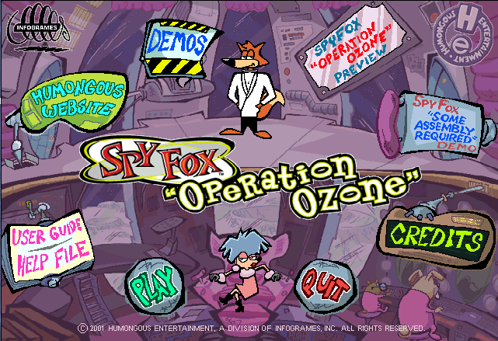
Opening Screen
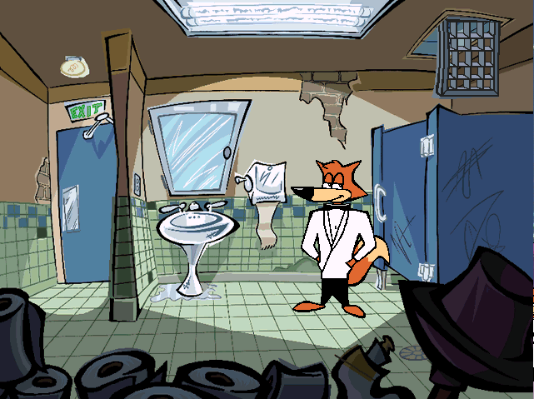
First Scene

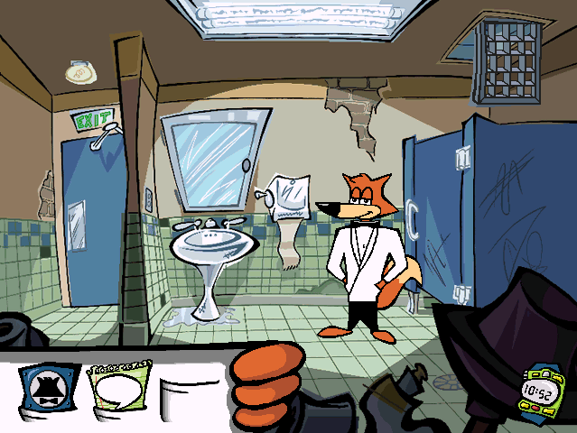
Hidden Popup Menus
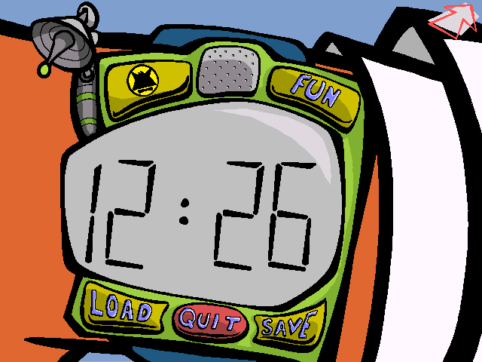
Watch Menu

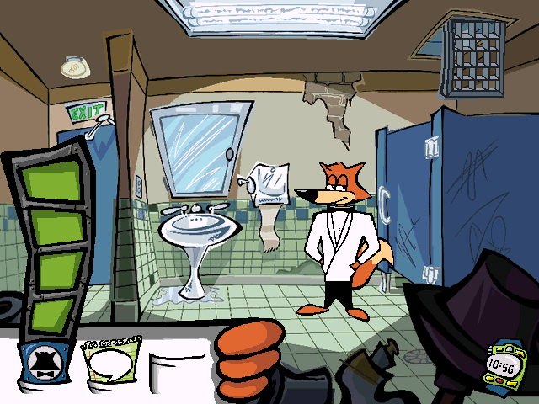
Gadgets Menu

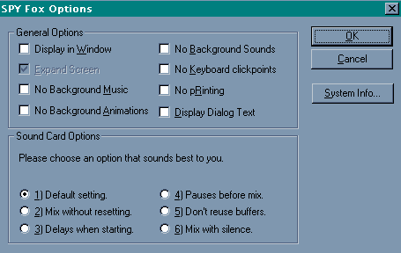
General Options

