CIS587 – Game Design & Implementation

Professor Maxim

Final Game Project

Specification and Design

Brion Scheidel

Executive Summary

Game Genre
Art Gallery Baby is a simple action game, with a bit of strategy.

Abstract of Game Story
Art Gallery Baby was developed in honor of my sister-in-law, who recently opened up an art gallery, and in honor of my 15-month-old daughter. The story is that you bring your baby with you into an art gallery, she gets loose and climbs up the shelves and starts knocking and throwing pieces of art off. You must catch the art pieces or pay for them when they hit the floor and break. When you run out of money or fail to catch the baby when she jumps off a shelf herself, the game is over.

Game Play and Appearance
Game play is extremely simple - use the mouse to move your character left and right to catch the art pieces and the baby before they hit the floor. Each art piece has a color-coded price tag affixed to it - Red = $1,000; Yellow = $500; Green = $100. You begin with $10,000. Your score is the number of walls you clear before running out of money (to pay for the ones you don't catch) or failing to catch the baby when she jumps off a shelf. After clearing one wall of shelves, the baby jumps off a shelf, wriggles out of your arms with even more energy and heads for the next wall of shelves (i.e., the next screen). Each successive screen contains more red-tagged items than the previous screen, and the baby moves faster and drops art pieces at a faster rate.
There is only one scene - one wall of the art gallery, covered with several shelves, each shelf containing several pieces of art. The player is on the floor facing the shelves, moving left and right to catch the art pieces and the baby. The baby crawls up and across shelves in random directions, knocking pieces off randomly.
Below the scene are the areas for displaying the player's progress - how much money is remaining, how many pieces have been caught, how many walls have been cleared.

Product Specification

Production Team Description
- Lead Developer: Brion Scheidel
- Programming: Brion Scheidel
- Game Art: Brion Scheidel
- Game Description and storyline: Brion Scheidel
- Quality Assurance and Game Testing: Brion & Donna Scheidel

Target Audience
The target audience is any game player who appreciates fine art and babies. It is appropriate for children and adults.

Game Play Time
The initial screen takes about 30 seconds to clear. Each screen after that will take progressively less time to clear as the speed of the baby and the thrown art pieces increases. Play-testing shows that an excellent player can clear around 8 screens, so total game play time will be around 4 minutes.

Production Tools
Images used for the player, the baby, and the art pieces were all down-loaded from various web sites. PaintShop Pro was used to prepare the images for use in the game. Background music was recorded from CD and edited using GoldWave. Sound effects were down-loaded from various web sites.

User Guide

How to Install the Game
Since the game is a Java2 applet, installation requirements depend on the flavor of internet web browser you are using. If using Netscape 6.0 or later or some other browser that supports Java2, then no special installation is required. If using Internet Explorer, you must install the Java2 plug-in. Once you have a browser configuration that supports Java2, simply point your web browser at the correct URL and the game runs in the browser. For internet-independent play, installation consists of unzipping the supplied zip file in the directory of your choice and then opening the ArtGalleryBaby.html file in your web browser.

How to Play the Game
Once the applet is fully loaded, you will see the first screen appear. The game is paused initially, and there are simple instructions shown on the screen ("click mouse to resume").
Click the mouse to un-pause the game. The baby will begin crawling around the shelves. Each time she encounters a piece of art, it will come flying down toward the floor. Move the mouse left and right to move the player to catch the art pieces before they hit the floor. When all the art pieces have been thrown off the shelves, the baby jumps off the shelves. Move the mouse left and right to move the player to catch the baby before she hits the floor.
The game is over when you run out of money (each art piece that hits the ground costs you the amount of money designated by the color of the price tag affixed to it) or when you fail to catch the baby before she hits the ground.

Game Specification

What is it Like to Play the Game?
As described above, the controls and objective of the game are quite simple. The player moves his character left and right across the screen to catch as many of the falling art pieces as possible. Some strategy will come into play, as the player will need to evaluate which pieces are more important to catch than other pieces (based on the color-coded price tag, how fast and in which direction each piece is falling, and where the player is located with respect to each piece). Remember, the baby is not simply knocking pieces off, which would result in all pieces falling straight down at the same rate (due to gravity), she is throwing the art pieces off, some with greater velocity than others. So pieces will be approaching the floor at different velocities and angles, adding to the challenge the player faces in trying to catch as many pieces as possible (especially the more expensive pieces) to make his/her money last as long as possible.
The background music, baby sound effects and art-breaking sound effects help make the game more interesting and fun.
To make the game more or less difficult, many parameters can be changed by modifying the contents of the ArtGalleryBaby.html file.

Interface Mockup
The game has no real user interface in terms of menus and dialogs. The game board consists of the following elements:
- Main game board: The shelved area taking up most of the screen. This is where the main game action takes place.
- Money remaining: The area showing the amount of money the player has remaining.
- Pieces caught: The area showing the count of how many pieces have been caught.
- Walls cleared: The area showing the count of how many walls have been cleared.
- Pause banner: A “paused” banner is displayed in the center of the screen when the player clicks the mouse button to pause the action.
- Game Over banner: A “game over” banner is displayed in the center of the screen when player runs out of money or fails to catch the baby.

Summary of Story Line
You are a hard-working software engineer with a beautiful, active, and precocious 15-month-old daughter. Your sister-in-law has recently opened up an art gallery, and you have stopped by with your daughter to pay her a visit and check the place out. In anticipation of getting some great deals on some fine art, you have brought $10,000 cash with you.
Unfortunately, your squirmy daughter is so excited to see all of the pretty pieces of art that she escapes from your arms and climbs up a wall of shelves with amazing speed and agility. Before you know it, she is throwing and knocking art pieces off the shelves, just having a blast. Realizing that the "you break it, you buy it" policy applies to family members as well as typical customers, you do your best to catch every piece. You can identify the cost of each piece by the color of the price tag affixed, so you are able to determine which pieces are more important to save than others. Once your daughter has finished up with one wall, she jumps down, counting on you to catch her. When you run out of money, your sister-in-law boots you out of the store. Or, if you fail to catch your daughter and she bumps her head on the floor, you must leave immediately and spend what remains of your cash on toys and candy to console her.

Storyboards

Start Game

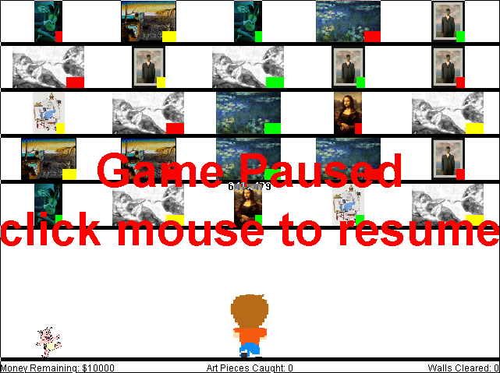

Middle of Game

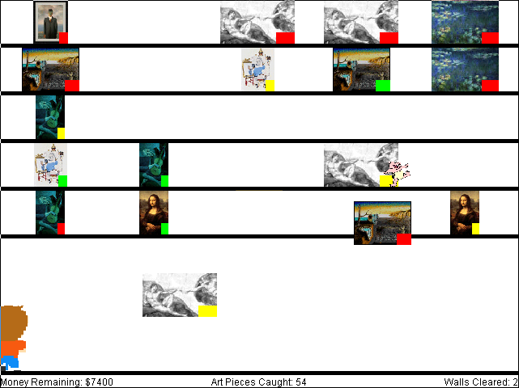

Game Over

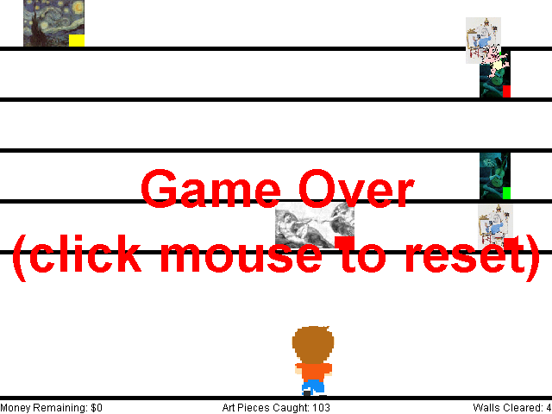

Character Bibles
The story line given above provides more than enough character development for a game of this nature.

Level or Scene Outlines
There is really only one scene, the wall of shelves holding the art pieces. After the wall is cleared and the baby caught, the scene clears and re-draws with a new wall of shelves full of art pieces.
Each new wall will feature more red-tagged (expensive) art pieces, the baby will move faster and more art pieces will be thrown down at higher velocities.

Design Specification

Implementation Details
ArtGalleryBaby.html contains the <APPLET> tag which runs the ArtGalleryBaby applet contained in ArtGalleryBaby.class (source file ArtGalleryBaby.java).
ArtGalleryBaby.java contains the code for a single class (ArtGalleryBaby) which extends the Applet class and implements the Runnable, MouseListener and MouseMotionListener interfaces.
By making the applet implement the Runnable interface, we give the applet its own thread in which to run. The run() method of the applet is called after the applet is initialized and started, and will not return until the applet exits. The contents of the run() method is an endless loop in which the off-screen image for the next frame is prepared and displayed, then the thread sleeps for a little bit to let the screen finish drawing and to give the player time to absorb what's changed before we move to the next frame.
The MouseListener interface methods are used to detect when the user has clicked the mouse to pause/un-pause the game.
The MouseMotionListener interface methods are used to detect when the user has moved the mouse so that the player's position can be moved accordingly.

Data Structures and Interface Definitions
The ArtGalleryBaby class contains several inner classes (really just structs) that represent the various types of data used by the game:
- ArtPiece - represents an art piece; contains a reference to the image that represents it, its initial shelf location, its current screen position, its dimensions, its delta-x and delta-y (for when it is moving), a reference to its price.
- Spot - represents a spot on a shelf for an art piece; contains a reference to the art piece that occupies it, its screen position.
- Player - represents the player; contains a reference to the image that represents it; its current screen position, its dimensions.
- Baby- represents the baby; contains a reference to the image that represents it; its current screen position, its dimensions, its speed, its direction.

Pseudocode for Algorithms
The general algorithm for the core logic of the game is:
- We pick a random target art piece from the Shelved list for the baby to go to next.
- Then we pick a random crawling direction that will take the baby closer to the target piece.
- Then we determine the next shelf/column along that direction which contains an art piece; that is the next art piece that will be hit. Or, if there are no art pieces between the baby and the shelf/column holding the target piece (along the selected direction), then the next shelf/column is simply the one holding the target piece.
- Whenever the baby reaches the next shelf/column, then it is time to:
  - Move the art piece occupying that shelf/column into the Falling list.
  - If current shelf/column == target shelf/column, then it is time to:
    - Select a new target art piece (or drop the baby from its current location if no more art pieces in the Shelved list).
  - Select a new random direction for the baby that will take it closer to the target piece.
  - Find the next piece the baby will encounter (or the target shelf/column if there is no piece along the selected direction).

The specific algorithms of interest are as follows:
- Start Initialization (init() method):
  - get param values from html
  - calculate array sizes, list sizes, shelf spot sizes, etc. based on param values
  - start loading art images, baby image, player image asynchronously
  - load audio clips
- Finish Initialization (finishInit() method):
  - resize art images to fit shelf spots
  - resize player and baby images
  - initialize wall
- Initialize Wall
  - for each shelf spot
    - calculate spot position
    - create new art piece for this spot
    - select random image for art piece
    - select random price for art piece (weighted selection so that the higher the level, the higher the odds that it will be the expensive price)
    - select random speed for art piece (weighted selection so that the higher the level, the higher the odds that it will be a higher speed)
    - select random destination X position for art piece
    - calculate delta-x, delta-y for art piece based on selected speed and destination X position
    - add art piece to shelved list
  - initialize player position to center on the floor
  - initialize baby position to random X on the floor, direction to UP, speed to mMinSpeed + 2*mWallCount
  - select random target art piece
  - find next shelf spot baby will encounter en-route to target art piece
- Main Loop (run() method):
  - while (true)
    - prepare off-screen image
    - paint off-screen image on screen
    - sleep
- Prepare Off-Screen Image (prepareImageBuffer() method):
  - if (not initialized yet)
    - if (all images not loaded yet)
      - draw "please wait" message
    - else
      - finish initialization
  - else
    - if (not paused)
      - if (shelved list is empty)
        - if (baby hit floor)
          - set game paused, game over
        - else if (baby hit player)
          - increment mWallCount
          - initialize wall
    - if (still not paused)
      - if (baby hit next shelf spot)
        - if (art piece in spot)
          - move art piece to falling list
        - if (art piece is target art piece)
          - if (shelved list is not empty)
            - select random target art piece
          - else
            - drop baby toward floor
        - if (baby target is not the floor)
          - pick random direction (UP, DOWN, LEFT, RIGHT) that will move baby closer to target art piece
          - determine the next shelf spot (either the next art piece the baby will encounter or the shelf/column that contains that target piece, whichever comes first)
      - adjust baby position (based on current direction and speed)
      - clear the screen
      - draw the shelves and the floor
      - draw the art pieces in the shelved list
      - for each art piece in falling list
        - if (hit floor)
          - remove from falling list
          - subtract price from remaining money
          - if (remaining money <= 0)
            - set game paused, game over
        - else if (hit player)
          - remove from falling list
          - increment caught count
        - if (game not over && piece still in falling list)
          - adjust art piece position (based on delta-x, delta-y)
      - draw the player
      - draw the baby
      - draw the status information
      - if (game paused)
        - if (game over)
          - draw "game over" message
        - else
          - draw "game paused" message

Development Environment
The game was developed using JBuilder 5 Personal, a free Java development IDE from Borland. The Java2 environment was JDK 1.3.0_02 (the one that comes built into JBuilder 5 Personal).

