Slime Castle
CIS 487
Brandon Manni & David Stephenoff
10-18-2016

Table of Contents
- 1. Executive Summary 2
  - Abstract of Game Story 2
- 2. Game Play Look and Feel 3
  - Appearance 3
  - Sound 3
  - Player Roles and Actions 3-4
  - Full Controls List 4
  - Strategies and Motivations 4
  - Level Summary and Story Progression 5
- 3. Development Specification 6
  - Hardware 6
  - Software 6
  - Algorithm Style 6

1. Executive Summary

Abstract of Game Story
Planet by planet the aliens have invaded, each one being slowly taken over and harvested for resources. As one of the elite, you have been deployed time and time again to scout out these uncharted worlds for their potential. You are skilled, and most of your kind's armed forces look up to you. Unfortunately, they do not see that you are not only one of those most forgetful in the entire platoon, but you are also quite clumsy. Some would say that you even trip over thin air. Luckily, you haven't had any "incidents" while deployed to an unfamiliar planet, so nobody ever hears about this awful crutch that you have. It's too bad your luck is about to run out.
While on a routine patrol through a nearby solar system, you notice something peculiar on one of the planets. As you go to inspect it, you trip over the anatomically small speck of dust floating in the air and fall down a seemingly endless hole in the ground. Able to survive the fall, you are in a confusingly perfect square of a room, with an even more confusing assortment of particularly angry looking fellows. The great news for you is that they don't seem to be moving at all! And you remembered to bring your super awesome belt that lets you shoot bullets in all four cardinal directions, which is even better news! Unfortunately, being forgetful as you usually are, you forgot your ammo reserves. As if some higher power deemed it necessary, you happen to have precisely as much ammo that's necessary to kill everyone in this dungeon. That is, only if you don't miss a single shot.
Throughout this dungeon you will face progressively more difficult puzzles, a multitude of these stationary enemies (Scary, I know), and even the awful repercussions of not paying your electric bill (I mean seriously, who the hell just doesn't pay? How can you live in the dark like this? WHAT ARE YOU THINGS?!). Can you make it through this unfortunate circumstance without calling for help and ruining your reputation? Can you conquer the adversity that might present itself as your progress through?

2. Game Play Look and Feel

Appearance
The game will be played from a top-down perspective, in a world completely devoid of all physics. Gravity will not take effect on you, nor the bullets you shoot (which is important, because at some points you will absolutely need to shoot from a distance). Your enemies will be placed in very specific locations and groups throughout the levels, with no noticeable pattern to how they are grouped or where they are placed. Each grouping of enemies will have an invisible origin, which is what the player is looking for.
The player is a small blueish alien with a glass helmet on (considering his balance, he should have gone with a better solution). Contrasted by the enemies, which are stationary green slimes in the shape of a square.
The levels will all look the same, as far as the background goes. The dungeon walls are stone, while the floors are a surprisingly nice hardwood finish. In the later levels, there will not only be enemies but portals as well, that add an extra layer of depth to the difficulty. These portals are very similar to cans of paint, each one of a different color (Turquoise, Green, Yellow, and Orange).
= Character that the player controls! He can move in any direction and shoot!
= Enemy that the player must eliminate. They group up so watch out!
= Bullet that the player can shoot. You can shoot 4 of these at a time!
= Wall that does nothing but block you from exiting the level!

Sound
Our game has several sounds that indicate different events happening on the screen. When you shoot your bullets, a loud and clear sound effect plays. When enemies are hit, a sound effect is played to let you know that you did actually hit it and your arrow didn’t just hit the wall. An arrow entering a portal plays a different sound than when exiting. There are rollover sounds when you go over menu buttons and there is a confirmation sound when you actually click a button.

Player Roles and Actions
Your role is the main character, the clumsy and forgetful little alien who has gotten himself into this predicament. On a mission to maintain your reputation throughout your species, you must navigate through these puzzles and preserve your precious ammunition. You will have access to anywhere within the level, which is a "box" of a room, so feel free to utilize the space you have. Movement is crisp and very controllable, and where your bullets are going will be extremely telegraphed so there is little learning curve.
Your actions are simple, and straightforward. Move the alien around the screen, within the boundaries of the dungeon room you are in. This will be done with the "standard" WASD keys, with no inversion on the movement. This means that ‘W’ will always make you move upwards, ‘A’ will always have you going left, and so on and so forth. Your other mechanic is going to be shooting the bullets, which will always come out in groups of four. They will each move in the four cardinal directions, and only collide with a single target. Your actions will have to be calculated, because all it takes is one miss and you will lose the level and have to start again.

Full Controls List
- Movement: WASD
- Shoot: Z
- Slow Movement: Left Shift
- Reset Level: R
- Menu: Escape

Strategies and Motivations
Since this poor, lost little alien is already having a bad time, we made sure to make the game have fairly simple strategies. There is a little wiggle room in case that darn speck of dust causes any tripping again, but there is really only one way to handle each grouping of four enemies. The which slimes are part of which group are not obvious, and it will take some thinking ahead of time to align yourself properly. Remember, you only get as many shots as it takes to clear the room, so a single miss will result in a loss. Your strategies, especially in the early levels, should be to scope out the enemies and their alignment. You are not timed, you are not expected to finish in the fastest time, you are only expected to clear the level. Take your time to see where they are placed, and how your shots will line up when you take them. Your shot placement will be very telegraphed, so it’s very simple to take your time to aim. Always keep in mind that you don’t always have to be equidistant from each of the four you are shooting at. Another notable fact is that nothing is hidden from you in each level. Everything is out in the open, and your view lets you properly plan these shots out.
As for your motivations, we are relying entirely on humanity’s innate sense of desire to finish puzzles. By giving the player smaller achievements such as completing a level, there is a sense of accomplishment that keeps them coming back for more. With the levels getting harder and harder as the game goes on, there’s even more satisfaction for completing the later levels. What helps keep the player motivated is that the game is extremely forgiving when you do fail, since you can quickly restart the same level and not have to worry about being set back too far. This is intended to keep the player from getting too frustrated, and just giving up.

Level Summary and Story Progression
Each level will be a square room. This means four walls that you cannot move through, which are the same four walls that enclose the enemies. The level is simple… Eliminate all enemies with the bullets provided to you. Of course, different levels will have different amounts of enemies and thus you will have different amounts of bullets, but the goal remains the same. The story progresses in the sense that once you conquer the perilous dungeon that you have fallen into, you are freed and nobody knows of your balancing incompetence. The rest of the story progression is left to the imagination of the player, which can heavily vary from player to player.
An example level below shows a procedurally generated level where the user always spawns in the center. One possible feature is a crosshair that follows the player and allows for more precise aim. This crosshair makes it easier to see if two enemies are actually on the same grid line, in case they look very close.
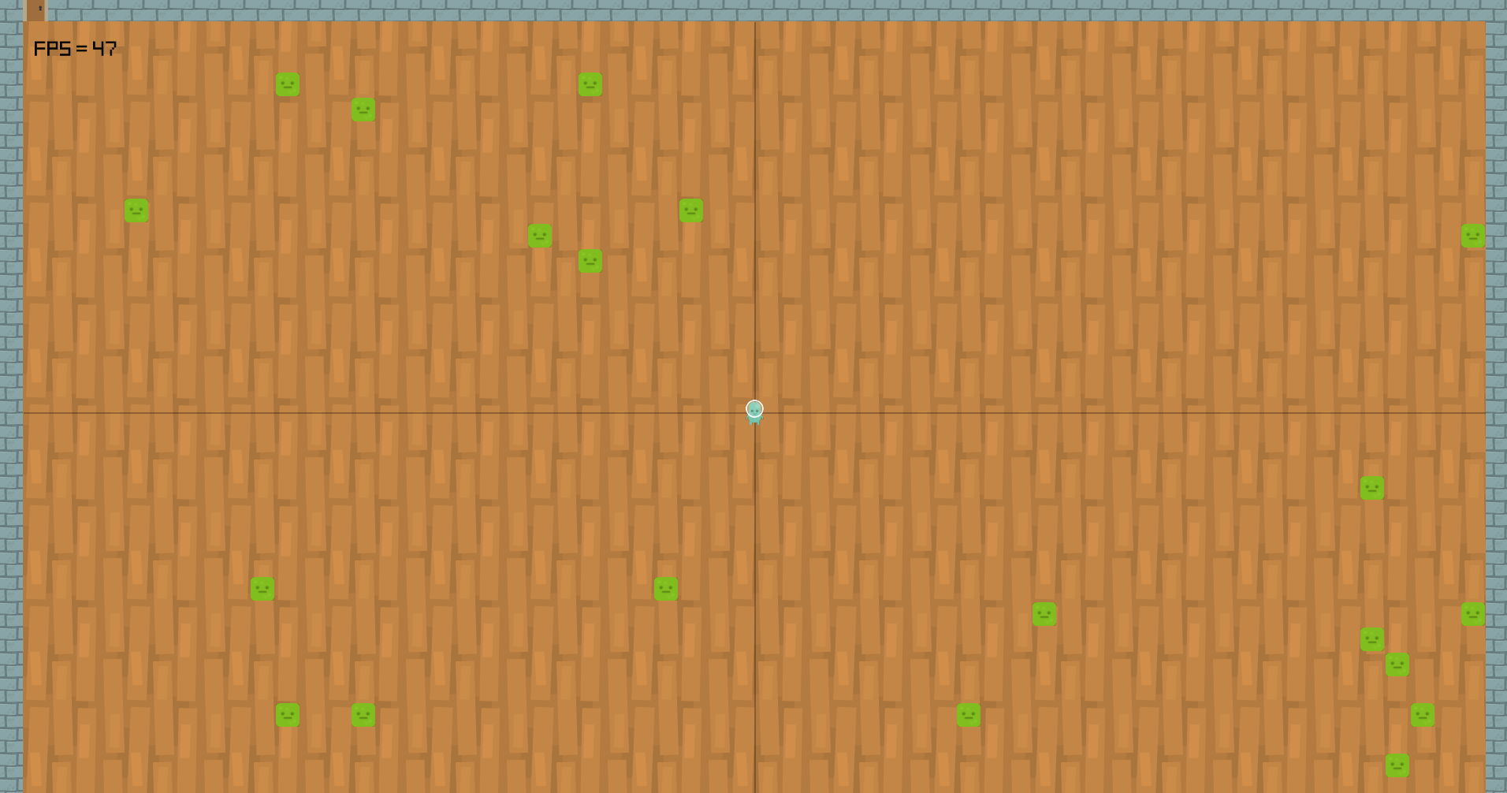

3. Development Specification

Hardware
We are developing this game on an assortment of hardware specifications, so we want to make sure that this will be accessible to everyone. This game will be capable of being run on any modern system.
- Video: Integrated with DirectX11 Support
- Memory: 100MB
- Storage: 50MB
- Peripherials: Keyboard, Mouse (Controller Recommended)

Software
Our development of this is also ranging in the software department, as we have macOS Sierra and Windows 10 as our development environments. This game will be capable of being run on any Windows 7 machine or higher, and any OSX machine or higher.
- Microsoft: Windows 7 or higher.
- Apple: Mac OSX or higher.

Algorithm Style
Our game is programmed using C#. Each object with its own interactions has its own scripts. The player movement is controlled by the keyboard or controller.

