2D Game Pitch Document

“Joe Jumper” 2D Platformer

Written by: Steven Gassner and Mohamed Nasrallah
CIS 487 - Computer Game Design & Implementation

Table of Contents
- Executive Summary………………………………………………………....2
  - Abstract of Game Story…………………………………………………………...2
- Game Play Look and Feel…………………………………………………...3
  - Appearance………………………………………………………………………..3
  - Player roles and Actions…………………………………………………………..4
  - Strategies and Motivations………………………………………………………...4
  - Level Summary/Story Progression………………………………………………..4
- Development Specification………………………………………………….5
  - Hardware…………………………………………………………………………..5
  - Software…………………………………………………………………………...5
  - Algorithm Style…………………………………………………………………....5

- Executive Summary
  - Abstract of Game Story
The game will be a two-dimensional platformer/puzzle game in which the goal is to reach the end of each stage through many placed obstacles. The obstacles will be in the form of spikes, fire, bottomless pits, and the puzzle like layout of the levels themselves. The player will be taken to the next level completing each level, or returned to the menu after beating the final level. The player will also have the option to return to the menu at any time by pressing the escape key. There will be three levels in total ranging in difficulty and layout. The main menu will display the title and instructions, and give players the option to play or quit the game.
- Game Play Look and Feel
  - Appearance
The player character’s design will feature that of a pixelated human like an 8-bit Mario. The goal will be a star sprite. The background will be a typical blue sky with a dirt/grass landscape. The background will scroll from right to left with wrap around and will be lit up. Spikes and fire sprites will also be used.

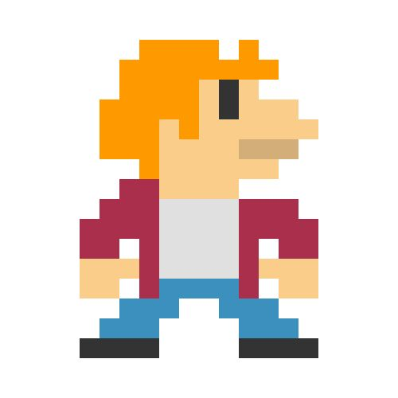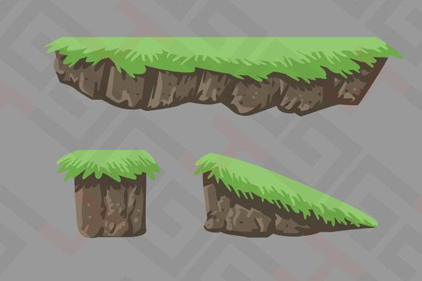

  - Player Roles and Actions
The player’s role is to figure out the puzzling layout of the level and jump from one platform to the other without running into any obstacles or getting stuck. The goal is achieved by reaching the star. The player will be able to move left or right and jump.

  - Strategies and Motivations
The motivation of the game lies within reaching the star to unlock further levels. One cannot jump from one level to the other without completing the previous level. They are sequential.

  - Level Summary/Story Progression
The game will not feature much of a story, but there will be level progression in the form of increasing difficulty. As stated previously, there will be three levels. The first will be easy, as it will function more of as a tutorial so the player will be introduced to the mechanics. The second stage will feature higher difficulty by introducing the obstacles listed above. The third stage will be the most challenging, as it will feature tougher obstacles, trickier platform locations, and even a dead end.

- Development Specification
  - Hardware
The game will be developed on hardware running Windows. Hardware input depends on the keyboard. Hardware is the same as the minimum it takes to run the OS. The game is not demanding.

  - Software
The game will be developed for Windows based systems using the Unity game engine. It will be executable through an exe, and works offline.

  - Algorithm Style
Due to the simplicity of the game, most of the scripts required can be found in the Unity webstore. Therefore, the coding of the game will not feature much of a unique algorithm style. Parts of scripts will be modified to suit the game’s needs, as this comes naturally to adjustments that fit the game style objective. Scripts that need to be written from scratch include moving to the next level after completing the previous level, scrolling the background, and restarting the level if the player touches a hazard or falls off the level.

