Nilbog

2D Game Pitch Document

Omar Elshaikh
Patrick Taghap
CIS 487

Version History
Version # | Date | Author | Description of Changes
1.0 | 10/18/2016 | Patrick Taghap | Document creation
1.1 | 10/18/2016 | Omar Elshaikh | Updated details for Development
1.2 | 10/18/2016 | Patrick Taghap | Added ToC, numbering
1.3 | 10/19/2016 | Omar Elshaikh | Updated title
1.4 | 10/21/2016 | Patrick Taghap | Peer review corrections
1.5 | 11/1/2016 | Patrick Taghap | Update features, corrections, final for grade

Table of Contents

Contents
1. Game Summary
2. Gameplay
2.1.1. Appearance
2.1.2. Music and Sound
2.1.3. Player Role
2.1.4. Motivations
2.1.5. Player Actions
2.1.6. Level Summary
2.1.7. Scoring (Rewards)
3. Development
3.1.1. Hardware
3.1.2. Software
3.1.3. Algorithm Style

- Game Summary
A goblin archer named Nilbog has been cursed by a wicked witch so that any arrows he fires will only be lethal on the way back to him. Nilbog needs to hone his skills with this new constraint and as a result, is shooting birds in his backyard to get a feel for what he is capable of with this curse.
He realizes his bow and arrow now work best when pointed straight up so he does not bother to tip it in either direction. What he needs to perfect now is his timing while being careful not to injure himself with his own falling arrow.
The birds fly at different heights, speeds, and with varied special abilities in order to survive. If Nilbog lets too many birds pass without being hit, he will consider himself a failure and retire.

- Gameplay

    - Appearance
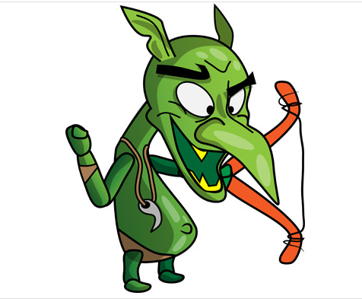
The game will have a cartoony lighthearted feel to it. It will be completely
2d with use of sprites for characters and background/foreground elements. The player controlled character will be a goblin archer made up of several sprites. There will be three different types of birds which resemble each other but differ in some way (speed,durability). Each bird sprite is composed of 3 sprites for a simple flying animation. The player stays on the ground which is just a grass platform. The birds fly in the sky with a light blue background and white clouds. All graphical assets will have been sourced from the Unity asset store.

The menu system will be simple with options to play the game and quit the game. In game, the player’s score is listed in the top left. Below it, the number of lives the player has left.
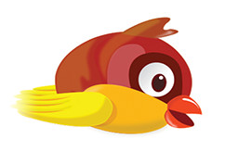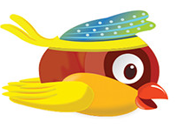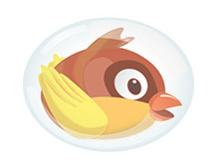

    - Music and Sound
The background music matches the art style in the sprites in that it is
lighthearted and somewhat comical. If the player strikes a bird, the bird emits a screech and falls off screen(no ground hit sound). If a bird reaches the other end of the screen, a laugh will play as it escapes. A special sound effect plays if the player manages to kill more than one bird with a single arrow.

    - Player Role
The player's role is to survive for as long as possible and collect as many points as they can before the game ends. Every bird that goes by deducts from the number of lives. Furthermore, the player can be hit by their own projectile (arrow) if they fail to move out of the way which will end the game instantly (to discourage arrow spamming).

    - Motivations
The motivation is to score higher than the previous high score. It can be rewarding to go through a game and hitting every bird possible. It could be the player's goal to beat their own personal high score or the overall high score achieved by other players. The game has a decent difficulty curve which is rewarding in a micro context.

    - Player Actions
A mouse is used to navigate the starting menu and loss menu. The player has limited actions. He/she can move left to right with the arrow keys. Pressing space bar shoots an arrow. The player cannot jump as this would not add any benefit to the game.

    - Level Summary
The level is fixed with a continuous increase in difficulty as time goes by. There are no discrete waves of enemies. The player can move side to side but cannot exceed the vertical bounds of the level. Birds spawn from either side of the level, at varying heights and exit from the opposite side. The player is fixed to a flat grassy ground.

    - Scoring (Rewards)
There are 3 different types of birds that will fly across the screen. A regular bird which flies at a normal speed and dies in one hit. A fast bird which flies much faster than the regular bird but still dies in one hit will award more points. The last is a shielded bird which takes 2 hits to take down and awards more points than the regular bird.

- Development
    - Hardware
The game can be played with just a keyboard on a windows machine with at least windows XP. Unity states the base requirements as follows:

- Graphics card: DX9 (shader model 3.0) or DX11 with feature level 9.3 capabilities.
- CPU: SSE2 instruction set support.

    - Software
- Windows XP or later

    - Algorithm Style

The birds will be generated randomly. At the start of the game, the chance to have a fast or shielded bird is very low, close to 0%. As the game goes on, the special birds will be spawned more often than a regular bird, until only special birds spawn. Furthermore, the number of birds spawned as a function of time will increase as the game goes on. For instance, at the start of the game only 1 bird will spawn every 3 seconds. Later on a bird may spawn every second.
The arrow’s trajectory will be determined by Unity’s built in physics engine which acts on rigid bodies. The arrow will be a rigid body that only gains a collider/trigger while its velocity is negative. If a bird and the arrow collide while the arrow is falling, the bird will take a hit and if it dies will fall off the screen.

