Building Brawl
Story
You are a man who lives in a city in a building with a sweet view of the river. Upon returning home from a vacation, you find that some jerk has begun construction on a building that is blocking your sweet view of the river! You head over to the new building to talk to this jerk.This is where the game begins.

The game is played by platforming your way to the top of this building to have a “talk” with the jerk. As you make your way up, you are confronted by construction workers, movers, businessmen, and body guards that are all trying to prevent you from getting past. As you play, the opposition becomes increasingly “hostile”...

You begin to learn about the secrets behind this building and the individual in charge of building it. Why is everyone so adamant about stopping you?

Setting
The game takes place in the near future somewhere in the United States. Some of the
level settings include a city street, office building, and construction site. The city the game takes place in is a fictional location called River City.

Player roles and actions
The player’s main role/goal is to get to the end of each floor of the building by traversing the platforms and avoiding the obstacles and enemies; ultimately leading to the final boss.

Player actions will include:
- Running
- Jumping
- Shooting
- Upgrading weapon
- Healing
- Selecting floor (level)

The player will damage enemies by firing a weapon at them.
The player will take damage by either touching enemies or being hit by the projectiles they throw/shoot at the player. A health bar will be present as part of the gameplay UI.

Controls
The player moves the character with the WASD keys on the keyboard. The space bar is used to jump. The left Mouse Button will fire your weapon. The mouse is used to navigate the menus.

Game Play Strategies and Motivations
The Strategies are similar to other 2D platforming games. You need to use a mixture of hitting the enemy and avoiding damage to successfully play the game.

Strategies
- Avoid the enemies
- Attack the enemies
- Collect health/weapon upgrades
Motivations
  - You hate this guy and his cronies.
  - You miss your river view.
  - Find out enemies are evil and now you must take action

Level summary/story progression
- Each floor of the building is a level
- There is a mini-boss at the end of some levels
- Each level completed unlocks the next floor/level
- Once all levels are completed, you fight the mega-boss at the end

Development Specification

Hardware

Development
- Windows PC

Target Hardware
- Windows PC
- OS: Windows 7, 8, and 10
- CPU: 1.5 GHz Dual-Core CPU
- Ram: 2gb (minimum for Windows 7)
- Video: On-board video card

Software
- Unity
- Visual Studio
- Photoshop
- Paint Tool SAI
- Google Drive
- Dropbox

Algorithm Style
- 2D game with 2D sprite based graphics.
- Health packs are dropped randomly by defeated enemies and placed throughout a level.
- Enemies will move towards the player and shoot projectiles at the player
- Health and weapon upgrades would be picked up at random spots in a level

Game Art

The game includes hand drawn levels and characters. We feel this makes the game
more unique.

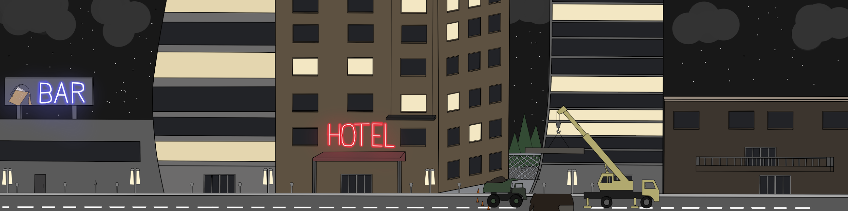
- Intro Level

- Character Sprite Sheet
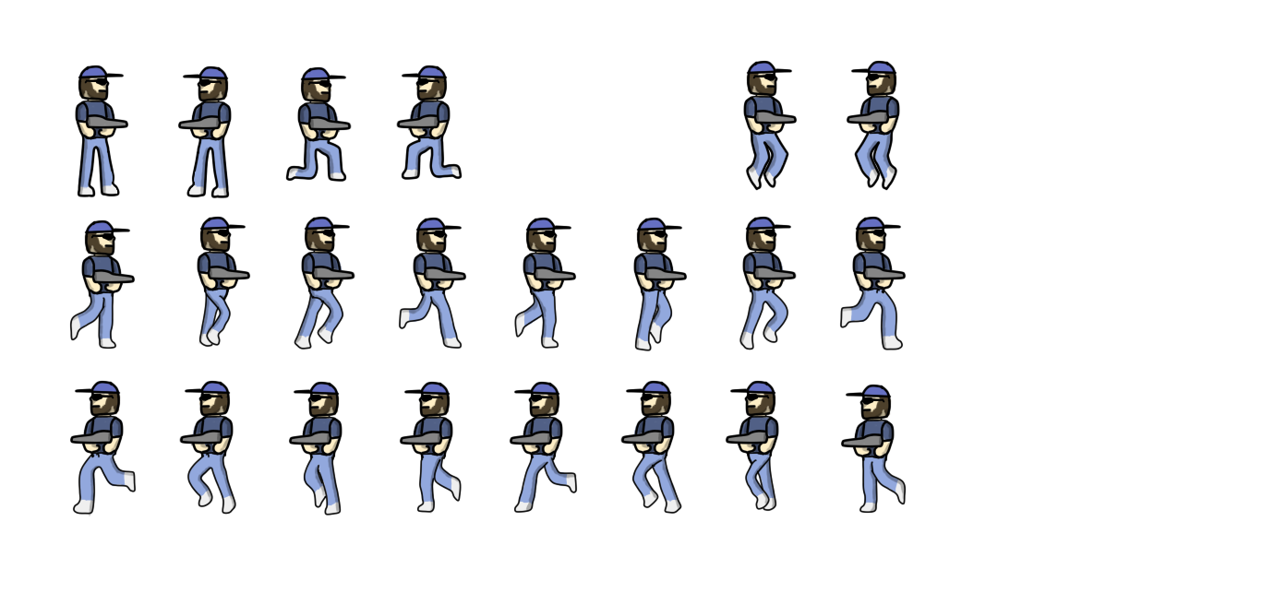
Sound
The game features bit-tune music as background music for each level as well as a boss
theme for the boss on level 3.
Sound Effects include:
- Player firing weapon
- Player firing upgraded weapon
- Player jumping
- Player taking damage
- Enemy taking damage
- Boss death

