Ben Walker
Samier Mukhashen

Henry’s Hectic Hustle Game Pitch Final
Executive Summary:
Abstract: You play as the astronaut Henry O’hulahan as he crash landed on a distant planet, Bledger. He was ejected from his ship and is now many miles away. You must make it back to your ship in time before your oxygen runs out. All the while being chased by a mysterious black haze and fighting aliens along the way. In order to make it back to his ship, Henry must make it through multiple levels that end at abandoned stations on the planet that happen to have oxygen tanks that will allow Henry to continue on his way to his crashed ship and safely return home.

Gameplay Look and Feel

- Appearance:
  - Environment: The ground will be a reddish color to simulate being on another planet. The player will jump on frozen clouds shown hovering above the ground. The background will be black space with stars.
  - Items: Powerups will be spread across the levels for the player to collect to help enhance their play. Power ups come in the form of space gems of varying colors. Health kits and oxygen tanks appear as boxes and cylinders respectively. Health Kits and Oxygen Tanks will be in hard to reach locations compared to power ups since they are far more valuable to the player.
  - User Interface: There will be a red number showing the number of hits remaining that Henry can still take. In the top right corner of the screen will be a timer that represents how much longer Henry has until he runs out of his oxygen supply. Henry’s kill count is recorded in the top left of the screen.
- Roles and Actions:
  - Hero: Henry is the main protagonist. He has the ability to jump around his foes as well as blast them with his blaster. His main goal is to move from platform to platform while killing or avoiding enemies in order to arrive at an abandoned station so he can refill his oxygen. He has three hearts of health which means he can take three hits from enemies. After taking a hit Henry will be pushed back to prevent him from getting stuck and taking multiple hits from an enemy. He must collect health kits in order to restore his hearts. When all three hearts or all of his oxygen is gone its game over. Upon death Henry will start back at the beginning of the level.
  - Items: There will be powerups in the form of space gems that help Henry along his way. The power ups include blue gems that slow down oxygen loss. Green gems double his jump height. Both power ups last 10 seconds. Henry can have multiple power ups activated at the same time. Health kits restore one of three hits. Oxygen tanks restore 10 seconds to the clock.
  - Enemies: Enemies will be aliens that patrol back and forth. Their only purpose is to be an obstacle for Henry; they do not want to see him getting home. If an enemy touches Henry then he will lose a hit. They take 1 hit to defeat.

- Strategies and Motivations:
  - Motivation: The oxygen supply left in Henry’s suit is what drives him forward. There is oxygen available on Henry’s ship and he can fly away from the haze using the ship once he reaches it. The abandoned stations serve as a breaking point for the player to rest up before tackling the next level. The black haze prevents the player from going back from where Henry has already been (previous levels). This is because Henry is in a hurry to get to his ship and does not understand the black haze.
  - Strategies: The two strategies will be to either kill enemies along the way in order to make maneuvering the level easier, or the player can forego killing enemies to save time, but they will have to dodge around them instead. Players can scavenge for health kits if they have been beaten on by enemies, but this will take precious time. Another strategy is to go off the main path in order to grab oxygen tanks that will add to the amount of time that Henry will have to complete the level.
- Level Summary and Story Progression:
  - Level Summary: Levels will be marked by Henry’s arrival to an abandoned station that happens to have one spare tank of air around and the black haze will not follow him into the station. These will be at the end of every level because this is the point that Henry will need to stop at if he wants to survive. The levels will continue on until Henry has reached his ship safely and has returned home.
  - Story Progression: At each station that Henry rests at we find out more about who he is and what he was doing near planet Bledger so far away from home. This will appear in the form of text on the screen that will be shown to the player.

Development Specification:

Hardware: PC that can run a Unity executable file. We do not currently plan on making our game available on other platforms, but it is a possibility since Unity can be good with creating executables that work on other platforms.

Software: Our game’s executable file. The graphics and actions will be basic enough that any computer that can run Unity should be able to run our game.

Algorithm Style: 2D Graphics with 2D Physics. There will be basic move and jump actions along with projectiles programmed for Henry. Power ups will affect either Henry’s gun or make him invincible. Henry will not be allowed to move back from where he came within a level; we opted for this over forced scrolling since we felt that the timer was motivation enough. Enemies will have AI to patrol an area.

Some Example Art:

Henry
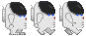
http://opengameart.org/content/astronaut-0
Alien Enemies
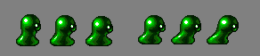 Normal

http://opengameart.org/content/the-blob-ultimate-smash-friends

Frozen Clouds
http://opengameart.org/content/2d-clouds

Medkit
http://opengameart.org/content/space-stuff

Ship
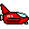http://opengameart.org/content/tiny-ship

Bullets

-Standard Shot
http://opengameart.org/content/bullets
Space Background
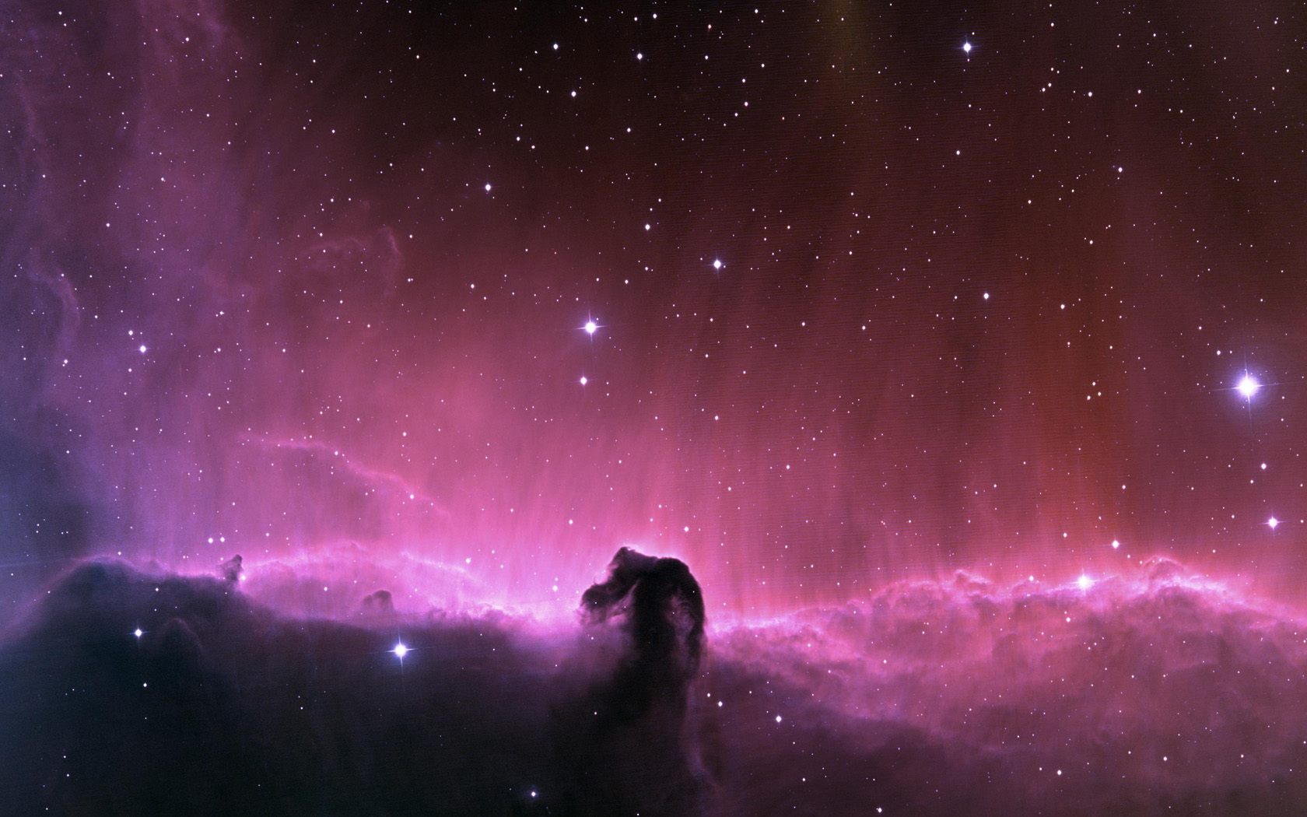
http://www.hd-wallpapersdownload.com/upload/bulk-upload/stock-photos-space-hd-wallpaper.jpg

Game Screen Final
