Jedi Training Grounds
Ryan McNichol
Robert Nimmo
CIS 487 - Game Design
2D Game Pitch

I. Executive Summary
- Game Story
The player character is an ambitious Jedi recruit with great potential, who has been noticed by several of the Jedi masters. They have tasked the nameless trainee with completing the Jedi training program, to develop and master his maneuverability and combat skills.
II. Game Play Look and Feel
- Appearance
The overall game is a 2D platformer in which all character entities are 2D sprites with minor animations. The player character is a mobile Jedi trainee with a lightsaber. The environment is the Jedi training grounds, in which each training course is composed of unique obstacles and challenges for the player to complete. The user interface consists of a stamina bar and the current level. The user’s stamina bar changes color based on how much stamina is left for use (Green, Yellow, Red). Throughout a training course, the player’s stamina replenishes over time so the player isn’t left stuck on a level after running out of stamina.
- Player Roles and Actions
The user plays as an unnamed Jedi trainee with the objective to complete various training courses. To complete a level, the trainee must reach the end point. The player can perform the following actions:
- Run left and right
- Jump vertically
- Slide down walls
- Jump laterally off of walls
Default key binds are arrow keys for JUMP, MOVE LEFT, MOVE RIGHT. To wall-jump, the player must be in contact with a wall and press the JUMP key to lunge laterally off the wall. To wall-slide, the user must be in contact with a wall, allowing the player character to latch onto the wall, and slide down at a decelerated pace.
- Strategies and Motivations
The primary puzzle in Jedi Training Grounds is to use stamina as efficiently as possible to complete the course. Consistent replenishing of stamina helps greatly to execute sequential wall jumps. The player will have to time and position themselves carefully in some levels to be able to maximize the distance their jump travels, in order to reach the exit to the level.
- Level Summary/Story Progression
The first several levels of Jedi Training Grounds are extremely simplistic and offer a gradual introduction to the game’s mechanics. They serve as a “tutorial” of sorts, without explicitly being labeled as such. Following levels increase in complexity, and by extension difficulty. The intent of level design is to mirror the state of the Jedi’s progress through the training program; while they may be difficult to solve, they have a clear puzzle aspect to them.

III. Development Specification
- Hardware
- CPU: Most if not all modern CPUs should be able to run Jedi Training Grounds
- Graphics card: DX9 (shader model 2.0) capabilities
- 200MB RAM
- Hard Drive Space: 100MB
- Software
- OS: Windows XP+
- Unity Engine
- Algorithm Style
To develop our game, we will have to make use of the physics and collision detection algorithms provided to us by Unity – namely the Collider2D and RigidBody2D objects. However, beyond the simple scope of gravity and collisions, the player will need additional physics calculations for wall-jumping and sliding down walls. These events will need scripts written to implement their intended interactions, as well as the depletion of stamina whilst performing them.

IV. Media
- Audio
Small sound effect files will be taken from the Unity Web Store for jumping, dying, successfully completing a level, and other atmospheric clips.
- Initial Sample Mock UI Screens
(note: sprites have not yet been chosen for the project)
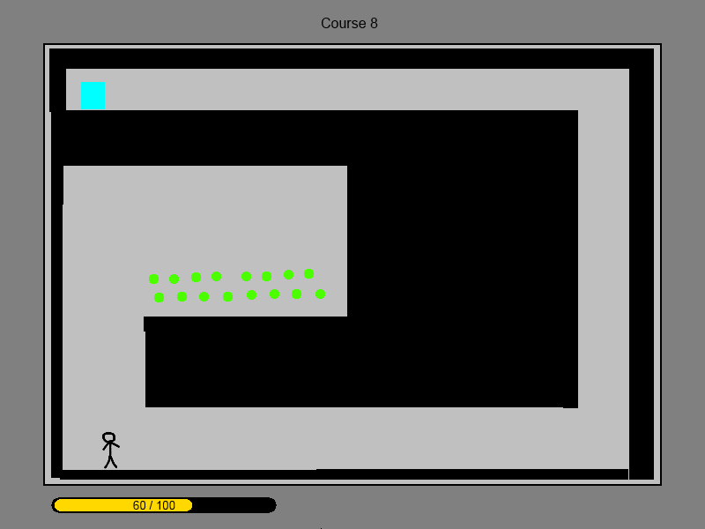

The screen above shows a sample level of our game.

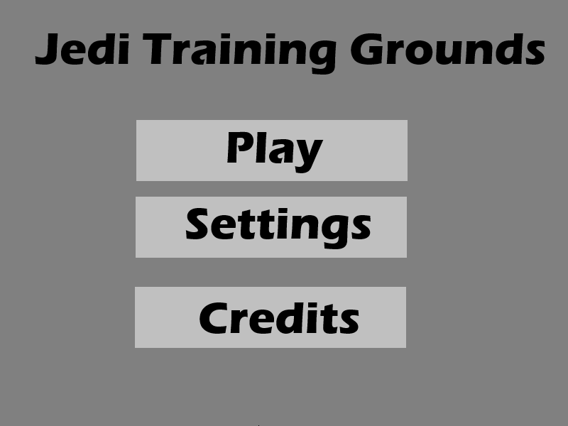

The screen above is our current plans for the intro screen, which will have “Play” - taking the player into the first level; “Settings” - where the player adjusts audio, video, and keyboard mapping settings; and finally the credits screen.

