Nullifier
CIS 487 2D Game Pitch
Hadi Nasser
&
Austin Horton
11/6/15

___________________________Table of Contents__________________________

Executive Summary...…….…………………………………….....Pg. 2
- Abstract of Game Story

Gameplay: look & feel…………………………………………....Pg. 3
- Appearance
- Player roles & actions
- Strategies & motivations
- Level Summary/Story progression

Development Specification………………………………...….... Pg. 8
- Hardware
- Software
- Algorithm Style

[Executive Summary]

Abstract of game story
The City of Bernshackle: a flourishing domain of markets, companies, and greenery. However, that pleasant living is threatened by an incoming epidemic!
It wasn’t long until the City Hall received word from the government that quarantining will be the imminent fate of the ever wonderful City of Bernshackle to prevent the menacing tiny creatures from expanding their dominance to neighboring cities…
Retired at the age of 37, you are famous for controlling a previous disease outbreak in the past. The city council summons you at once for an urgent meeting. At the meeting, you learn that viruses have started spreading out from a mysterious vortex unleashed in the trash area of the city, and you are given the task to eliminate all viruses roaming around. Once you accomplish that, Bernshackle would no longer be fated to quarantining by the government!
You are provided with microscopic binoculars (allowing you visibility of the tiny creatures), and a plasmatic killer net that you’ll use to capture and kill the viruses instantaneously. The city promises you an epic reward if you succeed to close the vortex, as Bernshackle would continue to be the flourishing city it once was after the quarantining is prevented.

~Good luck!

[Game Play Look and Feel]

Appearance
The player’s perspective is a 2D side-scroller view of the City of Bernshackle, where the player will be traversing the different parts of the map to accomplish their goal. The visual aspect is cartoony and simple, displaying a city background image throughout the levels of the game.
Since the game story reveals that the epidemic started from a trashy area of the city, the player will be traversing the map by jumping mostly on trash bins to capture the viruses with the plasmatic killer net given to them by the city council. The complexity and depth of the trash bins layout increases as the player makes successful progress to the next level of the game.
The score will be determined by the extra time left in the level. Basically, even though the game is single player, players can compete against each other by comparing who was able to capture all viruses in a level faster…thus making this game not only a type of survival game, but also a competitive, speed game.
The final level will involve an additional presence in the game: the vortex generating/releasing the viruses!

Gameplay Prototype
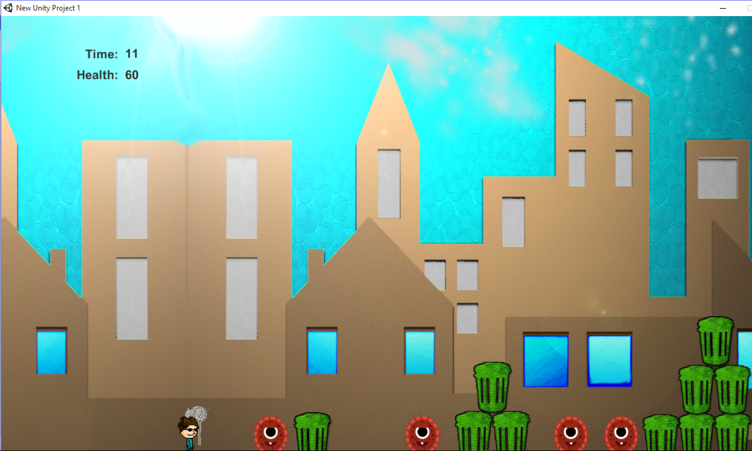
The opening screen displays a menu for starting the game, the game story, and gameplay instructions. Game-ending situations such as level completion or failure to save the city would result in ‘You win!’ or ‘Game Over! You lose!’ messages, respectively, along with score accumulated.
Start Screen
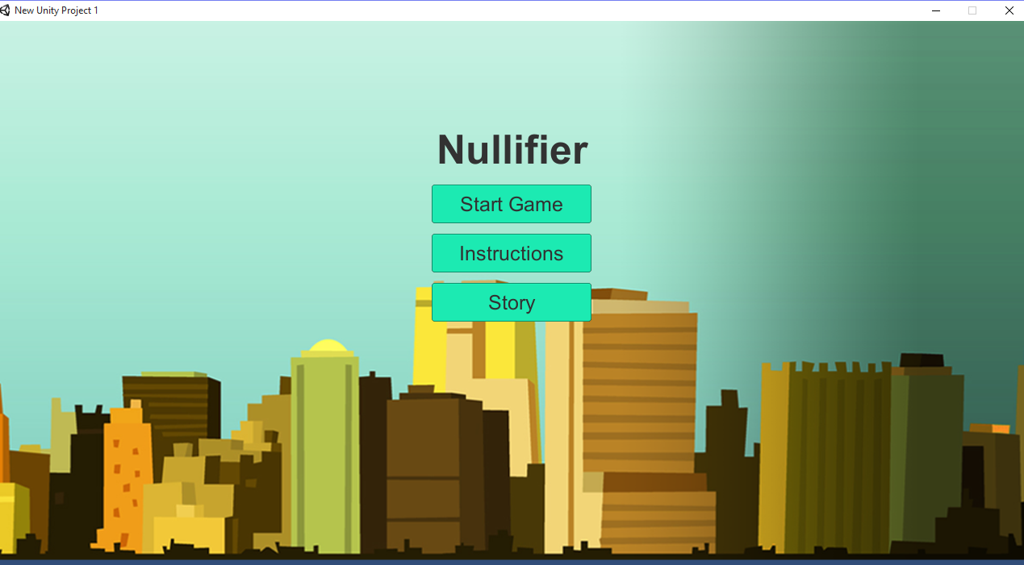
The animation involves:
- The player sprite’s movement
- Viruses sprite movements
- gameplay special effects
- countdown timer
- game state effects

Player roles and actions
- The player will be responsible for capturing the viruses with the plasmatic killer net that the player is given at the beginning of every game automatically. Once the player captures the virus with the net, it will be destroyed and gone.
- The player loses a level if they are touched by viruses a couple times. (-20 health points each touch out of 100)
- The player will lose the level if all of the viruses are not destroyed in the given time.

Strategies and motivations
- The player is motivated to move around the hideous trashy area of Bernshackle and destroy the viruses to protect the city from the threat.
- There will be a set time at the beginning of each level and the level must be completed in the limited time given.
- The movement of the viruses is random.
- The player is allowed to move anywhere that is accessible within reasonable view; meaning being able to jump on objects and move around on physical objects that are grounded on the map.
- The optimal strategy of the game is for the player to capture all of the viruses as quickly as possible without getting touched by them. This will allow the player to gain the maximum amount of points at the end of the level.

Game Ending Screen (game over!)
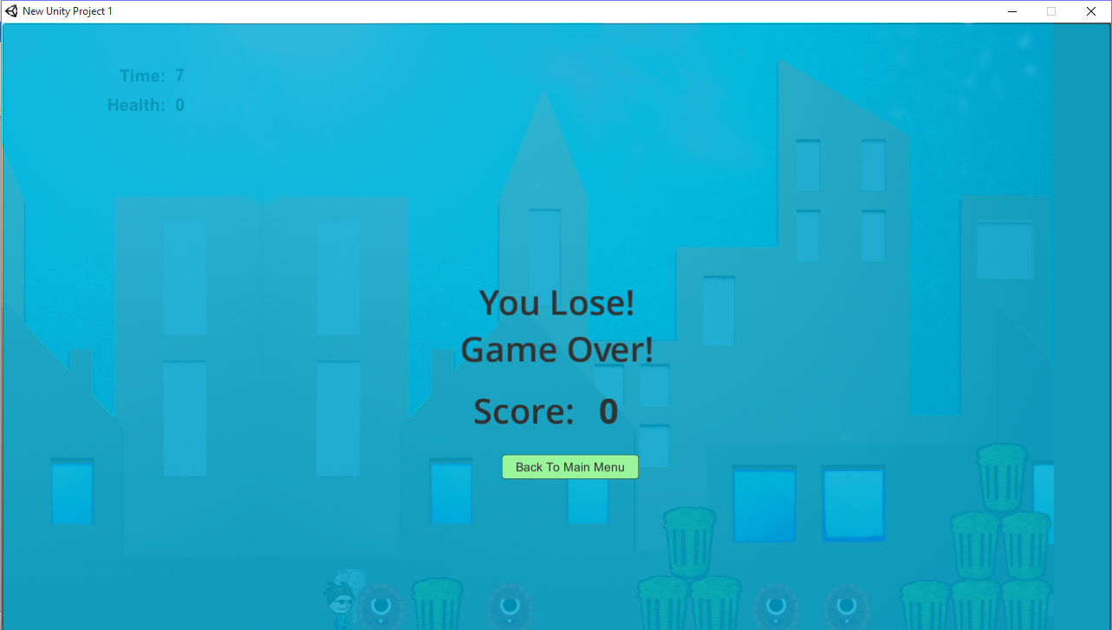
Level summary/story progression
- The game is survival based, so each level will get harder for the player to complete.
- Upon level advancement, the map will have a varying background along with different object placements. In addition, the player will face difficulty to complete the level with more viruses appearance.
- The game will end once all of the levels are completed and the player defeating the viruses on the final level, saving the city from the viruses, preventing the quarantining fate of the city by the government!
- Currently, the game features 3 levels.

[Development Specification]

Hardware
- Windows 7/8/10
- Good graphics card
- At least 30 MB of space
- At least 4 GB RAM
- Play the game in 1280x720 resolution windowed mode
Software
- The game is coded in C# using Unity as the game engine. It will be capable of running on any device that supports Unity (any platform practically).
- Sprites and rendering of animation done in Unity.
- Background pictures and some in-game objects (i.e. trash bins) rendered in Photoshop.
- Sound comes from free-to-use songs/music/sounds from freesound.org.
Algorithm style
Much of the gameplay algorithm is handled by built-in mechanisms found in Unity (e.g., sprite movement and speed, collision, etc.) as well as C# functions. The character sprite is able to move right or left, as well as upwards when trying to jump, and downwards when jumping down from above. Viruses will be randomly scattered around the levels’ map, and will be directed to move as such by a position random function.
The timer and score labels will be calculated by mathematical algorithm functions in C#, and objects (such as vortex and trash bins) will be manipulated by certain keyboard inputs.

