1v1 Me Bro
Abdullah Hadid
Andrew Kuelbs
CIS 487 Game Design
2D Game Pitch

Table of Contents
1.0 Executive Summary 3
1.1 Story 3
1.1.1 Elijah 3
1.1.2 Wes 3
1.1.3 Shyko 3
2.0 Game Play Look and Feel 4
2.1 Appearance 4
2.2 Player Roles and Actions 6
2.3 Strategies and Motivations 6
2.4 Level Summary/Story Progression 6
3.0 Development Specifications 7
3.1 Software 7
3.2 Hardware 7
3.2.1 Minimum System Requirements 7
3.2.2 Recommended System Requirements 7
4.0 Additional Game Features 8
4.1 Power Ups 8
4.2 Gun Types 8
4.3 Player Controls 9

Executive Summary
Story
After many years of playing all kinds of fps video games together, Elijah, Wes, and Shyko would always argue about who the best play was. They would get into long debates that would drag on for days about who the better player was. Each had their own unique playstyles and they melded well together. The three finally got fed up and decided to figure out who the best was once and for all. In 1v1 me bro you will play as one of the three friends and you can see who the best player is.
Elijah (Shotgun) – The man known for not needing many shots to take out all his enemies. Elijah is a cerebral assassin who is known for his skills with a shotgun. Many people say "Anyone can kill with a shotgun" and they are right, but no one can match Elijah when it comes to his accuracy. "Two Bullets? No Problem."
Wes (Pistol) – Anytime he gets in a duel, just make sure you aren't the one on the other side. He got his name from his skill with a pistol that rivals those of the cowboys. People would think with all his talent that he came straight from the old west. Anytime he walks into town, People whisper his name. "The Fastest Pistol in the West is Wes."
Shyko (Rifle) – Many people look at a rifle as the easy way to fight, but Shyko looks at it from the perspective that he has more bullets, so more enemies to kill. It only takes one properly placed shot from Shyko and his foes will fall to the floor, and with a clip the size of a rifle, many foes will be dropping. Faster fire rate doesn't mean as much when you have the aim and skills that no one can match. "More Enemies? More Bullets? Sounds Like Fun!"

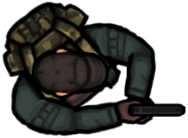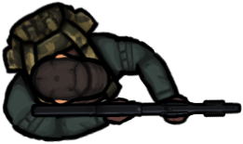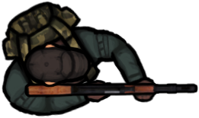

Game Play Look and Feel
Appearance
The game will start with a small dialogue between the players. Afterwards, the story of each player is shown, as well as their play style. The player is then taken to the an instructions screen, which shows the controls as well as the power-ups and their benefits. Once the player reads them over, they can click to go the character selection screen, where each player can select which character they would like to play. Once both players lock in their selection, the game counts down from 3 seconds. This gives the players the time to get ready and have their hands on the controls. Once the game starts, both players can start moving and shooting, as well as interact with the power-ups. Both players start with 5 health, they cannot have more than 5 health. If they interact with a health pack, they will gain 1 health, but no more than 5 total. If a player interacts with the boots, their speed gets increased slightly, these can be picked up multiple times to gain more speed. If a player interacts with the Nuke, it turns their next shot into a Nuke instead of normal bullets. The game screen will be split down the middle, giving both players their half to play. Each player cannot cross the half point. The power-ups spawn in the middle, giving both players the chance to pick them up. When a player gets hit by a bullet or the Nuke, they will lose health, once they reach 0, they will explode and a loser screen will pop up for 5 seconds. After the loser screen finishes, it will automatically take the player back to the character selection screen. An example picture is attached below in this document.

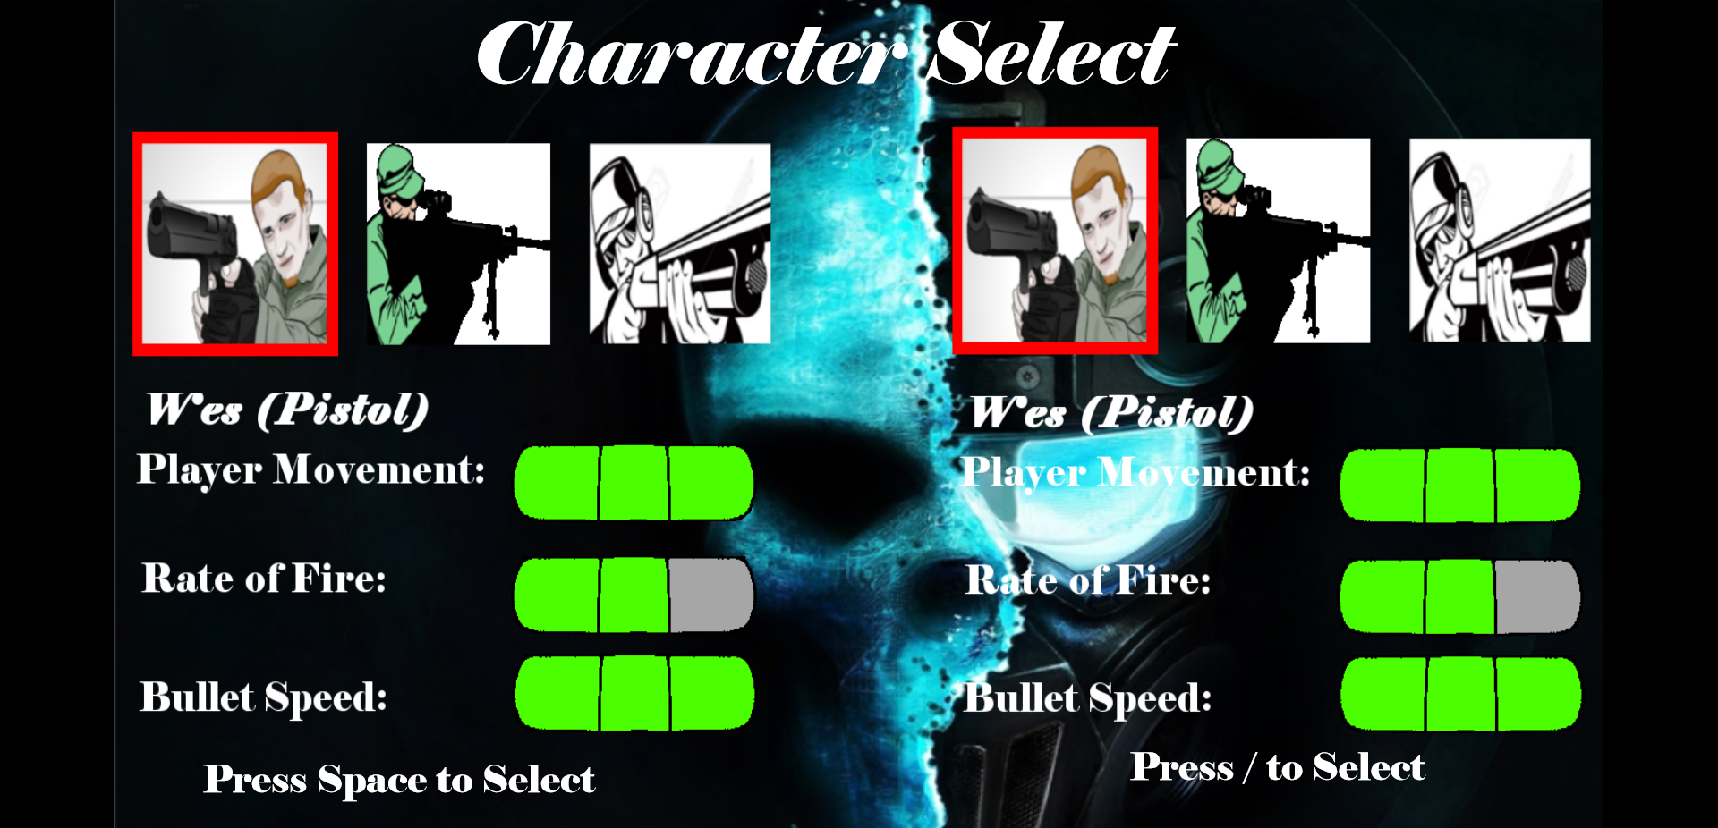
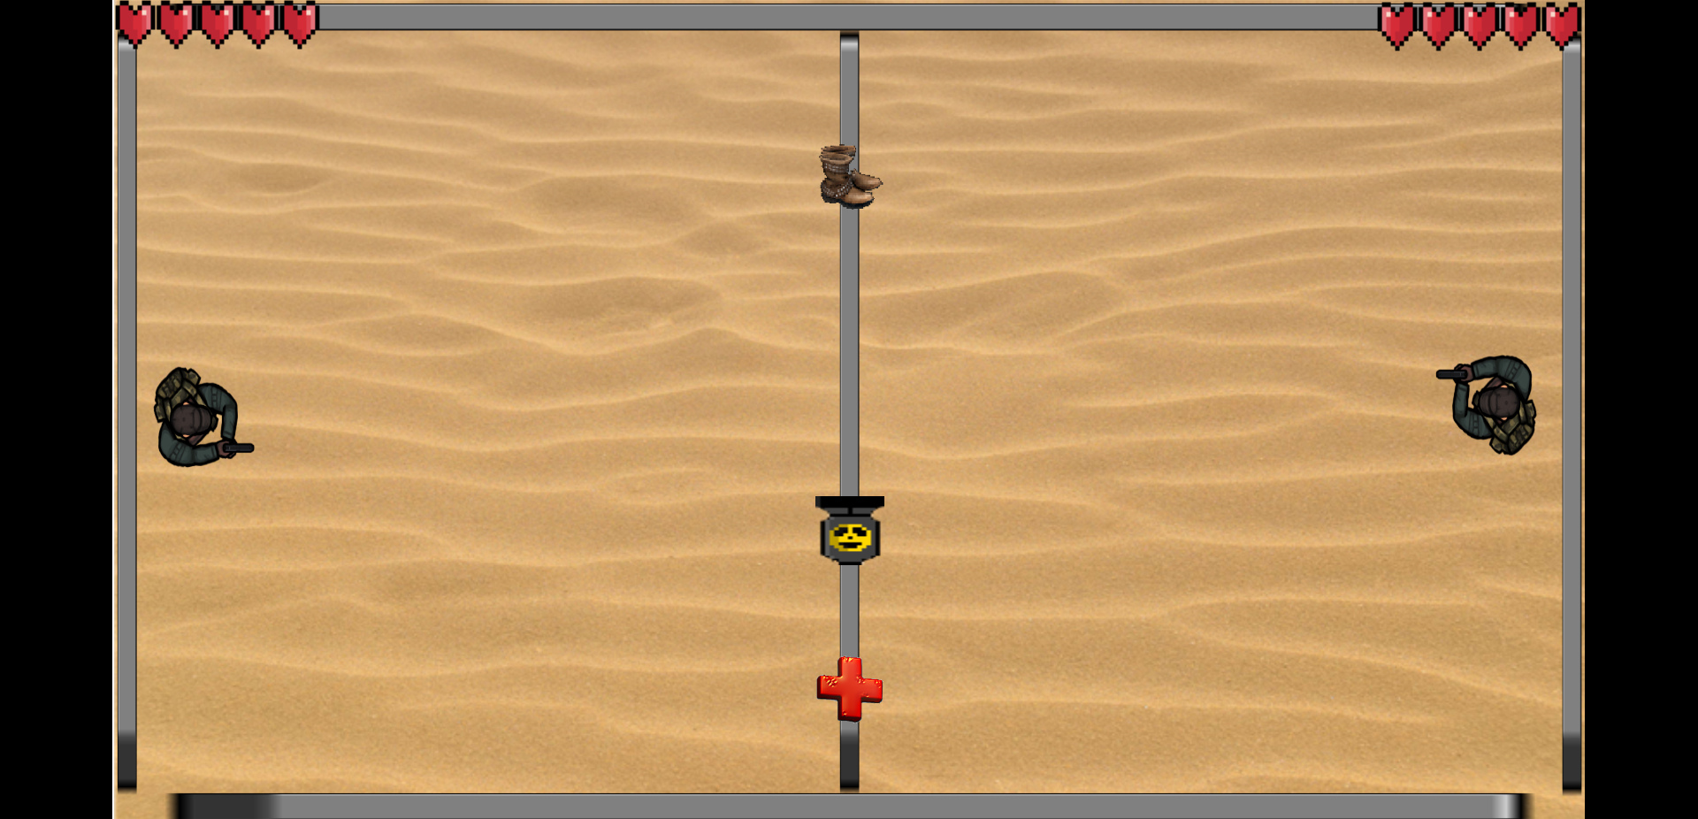

Player roles and actions
The role of the players on each side is to kill the other player. Each player will have 5 health points which they can regenerate by picking up health packs. Each player can move up, down, left, and right; as well as shoot their weapons. The player's cannot rotate themselves, meaning they can only shoot in a straight line. The players can interact with Power-ups that when picked up, they can give them different effects. The power-ups offered are health pack, boots, nuke. The power-ups will randomly appear throughout the game, but will always appear in the middle of the map. The players will have to risk moving toward the center to pick up the power-up because they will be closer to the enemy. Each player can choose their weapons before the game starts. The weapons give different move speed, bullet speed, rates of fire, and number of bullets that can be fired at a time. Each weapon deals 1 health damage to the enemy except for if a player is hit by all three shotgun shots, then two damage is dealt. Whereas, the nuke which deals 3 health damage if it hits a player.
Strategies and motivations
This game is made exactly to feel like playing dodgeball. The point of the game is to dodge bullets while knocking your opponent out of the game, in this case, killing them. Instead of balls, they will have guns. The strategy will be the same as dodgeball predict which direction your opponent will try to shoot you, or try to dodge your shots. The motivation is to prove to the other person that you are better, and that he/she is a big fat loser. Whether it's fighting to see who buys lunch, or who has to do chores, or a quick bet with your brother or friend for money, a quick match can quickly determine that for you.
Level summary/story progression
The players will be playing on a completely open map that won't have any defenses in which the players will be able to hide. This will allow for the ability to test each player's trust skill because there won’t be any lucky involved, nor will there be any defenses to hide behind. The player with the highest skill will prevail, showing who truly the best is.

Development Specification
Software
This game will be constructed using the construct 2 game engine.
Firefox web browser to run the game.
Hardware
Minimum System Requirements:
- Windows XP Service Pack 3 or newer
- 512 MB RAM
- 1 GHz Processor
- A HTML5 compatible browser
- The latest version of your graphics card drivers

Recommended System Requirements:
- Windows 7 or newer
- 2 GB RAM
- 2 GHz dual-core processor
A nVidia or AMD graphics card with latest drivers. We recommend you avoid any hardware using Intel graphics chips due to their poor performance, stability, and feature set.

Power Ups
 | Description | Effect | Duration
Health pack | The player who picks it up will gain 1 health back, up to the maximum of their health points. | +1 health | Full game
Boots | The player who picks it up will have increased movement speed in the game, giving them the ability to dodge better and set up better shots. | +25 Move speed | Full game, stackable
Nuke | The player who picks it up will have their next shot changed to a nuclear shot; they only get 1 shot, and will return to their previous guns afterwards. | Equippable weapon | 1 shot, stackable if taken more than 1.
Gun Type
 | Description | Effect | Damage | Rate of Fire
Pistol | The pistol is a weapon that gives the player the ability to move fast and fire quick shots at their opponent. | Fast bullet speed  Fast player movement | 1 damage | Medium(5 bullets max, larger bullet)
Rifle | The machine gun is a weapon that gives the player the ability to fire rapid shots, at the cost of their move speed. | Normal bullet speed  Medium movement | 1 damage | Fast(7 bullets max)
Shotgun | The shotgun is a weapon that gives the player the ability to fire 3 shots at once that are spread, at the cost of their rate of fire being slow. | Normal bullet  Medium Movement | 1 damage  If all 3 hit, 2 damage | Slow (3 shots of 3 bullets max)
Nuke | If the player picks up the power up for the nuke, the player's next shot will become a nuke. | Bullet size x10  1 shot only | 3 damage | Fastest
Player Controls
 | Movement | Shoot
Player 1 | W,A,S,D to move Up, left, down and right respectively. | Space bar to fire weapon
Player 2 | Arrow keys to move in direction of arrow respectively. | M button to shoot

