Assigned: 09-23-15
Date due: 10-21-15
Lauren Gaber
Chisom Osuji
CIS 487
2D Game Pitch Document
Executive Summary
You play as two kids in a haunted house who have been separated from their parents… and things have started to get weird. The perils are just getting a bit TOO REAL, and the scarers have started following you and your brother for so long, it just isn’t fun anymore. Its starting to creep you out. Why won’t they leave you alone?! And who is that shadowy figure you keep seeing out of the corner of your eye? You and your brother grab the only weapons you can find - a sword and shield from a broken set of knight's armour - and try to survive the last few rooms of this haunted house. But will you be able to survive it together, or will he just keep running off!?

Game Play Look and Feel
Appearance
For the appearance of this game, we’ve decided on going with a top down overview look that’s reminiscent of the classic Legend of Zelda video games. We want the player to see the whole map and all the objects on the map. The user interface will also appear on the screen with various different items such as hit points (HP), life count, stamina, and score. Dialog boxes will also appear when the character is engaging in conversation with the non-playable characters.
Regarding the character models, we went with using pixel sprites to display our on screen characters because it allows us to give more attention to the other aspects of our game rather than spending time designing and creating a character model.

Player Roles and Actions
For our game, we’re utilizing two characters to act as a unit to complete the level. The two characters have their own unique abilities that are essential in order to complete the level. Their abilities are listed below.
- Main Character 1 (Big Sis):
  - Roles:
    - You start out each level as the older sister by herself. She’s worried sick about her little brother, so being the responsible older sibling, she has to rescue save her little brother before moving on to the next level.
    - She’s known for being overprotective to her somewhat reckless little brother.
  - Actions:
    - Being the overprotective sister that she is, she comes equipped with a shield. She can use her shield to ram enemies which can defeat them; however, the ram doesn’t do that much damage since a shield isn’t normally an attacking weapon.
    - The older sister also has the ability to interact with the NPCs to progress the story along.
- Main Character 2 (Little Bro)
  - Roles:
    - The little and somewhat reckless little brother needs to be rescued every level. Hence, the player won’t begin the level with his abilities.
    - When he’s rescued, he provides the pair with more offensive capabilities than what the big sister originally starts with.
  - Actions:
    - Being the somewhat reckless guy that he is, the little brother is more offensive based. Because of that, he comes equipped with a sword. He gives the pair more attack power when rescued, so that enemies are defeated in less amount of hits as opposed to when the older sister is by herself.
Strategies and Motivations
Strategy:
- The strategy we want the player to employ is to play more conservative and stealthy during the rescue phase due to the sister’s inferior offensive capabilities. Try to avoid enemy encounters en route to rescuing your little brother. When you finally rescue your brother, however, you can more easily dispatch those pesky enemies that were giving you problems throughout the level.
- The scoring system also reflects this. Points are worth more when defeated when your brother is rescued, and bonus points are awarded depending on how fast you save your little brother. So in order to maximize your score, it’s best to have a strategy that demonstrates the above step.
Motivation:
- Our motivation to keep the player playing past the first level is to develop that sibling relationship. Hopefully the player can relate to a situation where someone in their family needed some kind of help and they were there to help them. Even if the player is an only child, maybe they can see themselves in the brother’s or sister’s position and wonder what it’s like to have a sibling.

Level Summary/Story Progression
- Level 1
  - Introduction to the Story (first arc):
    - Has an introduction to controls for story segments (alternatively, all controls can be referenced on a front menu page).
    - Background of story set up through light character dialog, player starts to get a feel for character personalities, the first signs of a conflict that will occur between the main characters start to appear (this is centered around the younger brother’s tendency to run off).
    - The characters’ personalities and attitudes are also revealed through interactions and comments with things they find and examine in their environment.
      - EX: The characters are able to examine the corpse of a scarer (enemy), so the player will know what they look like.
      - EX DIALOGUE: “It's spooky, I don’t like it...” “Wait… is this one actually dead?”
    - Introduction to the goal (getting out as fast as you can) is expressed as the chief desire of the main characters.
    - Big Bad’s shadow is seen briefly at the end of story segment. Older sister takes notice.
  - First Battle:
    - Has an introduction to controls for battle segments, and models the flow of the rest of the levels (alternatively, all controls can be referenced on a front menu page). FLOW:
      - Short Dialogue (where brother runs away) “Brother! Get back here! Stop messing around!”
      - First Enemy Wave (player navigates alone)
      - Brother Returns Dialogue (brother returns to side of player) “hey I’m back!””don’t run off like that! jeez”
      - Second Enemy Wave (characters defeat enemies together)
      - Level Completed Dialogue (and results listing) “At least they’re gone for now.”
    - A timer runs to keep track of how long it took you to complete the fight, and there is also something that keeps track of your HP and other stats. You have 10 HP on your own, but with your brother you have 15 HP. In general, the number of enemies on this level is easy, and they are slow.
    - At the end of the level in the results listing, you have the option to continue on in the story if you win or retry the battle portion of the level if you lose or win. The saving method is yet to be determined.
- Level 2
  - Rising Tension in Story (second arc):
    - In general, the haunted house gets scarier and more mentally exhausting for our protagonists. The younger brother gets more worried about their parents. The sister gets more and more paranoid. They see another flash of the Big Bad.
      - EX: The characters see the silhouette of the Big Bad, who hides in the shadows and speaks to them before the second level begins.
      - EX DIALOGUE: (shadowy figure, speaking lightly): “Poor lost children who’ve wandered into my unknown… fear not. You will not be lost for much longer now.” (kids whirl around): “Huh!? who said that?” “Show yourself!” (shadowy figure laughs and disappears).
    - The brother and sister fight about the brother running off and the sister not listening to the brother or bothering to understand him better (or some similar themed conflict).
  - Second Battle:
    - Follows flow set out in first battle (Short Dialogue, First Enemy Wave, Brother Returns Dialogue, Second Enemy Wave, Level Completed Dialogue). Characters are less confident in their victory after interacting with the Big Bad.
    - UI and results screen are the same. Enemies are either quicker or more aggressive, and more numerous.
- Level 3
  - Climax of Story (third arc):
    - In the last room, the younger brother’s worry mounts, and the sister is now obsessed with the shadowy figure they saw (the Big Bad) and fears for their lives. The brother keeps acting in a way the sister struggles to understand, and their relationship is more strained than before and the fighting continues.
    - The Big Bad is revealed, and they exchange words with our protagonists. The sister is freaked out, as they seem to be trying to lure the brother away from her side. The Big Bad leaves the room before the end of the sibling’s argument. Their fight ends with the brother running off one last time, into the same room where the Big Bad waits for them.
    - The older sister is shocked and distressed by her brother’s actions. She takes a deep breath, and rushes into battle for a two-fold purpose: to leave the haunted house for good and to get her brother back.
  - Third Battle (flow disruption):
    - The story bleeds into the protagonist’s last fight, and a new battle flow is introduced:
      - Short Dialogue (brother already gone) “... Brother? Brother where are you!?”
      - First Enemy Wave (player navigates alone)
      - Big Bad Returns Dialogue (brother still gone.) (Big Bad cackles sinisterly): “Oh my. You seem to have misplaced your brother. But I wouldn’t know anything about that.” (sister): “LIAR! Where is he!? I’ll destroy you if you hurt him!”
      - Boss Fight (player fights alone, more challenging, and there are three waves of attacks)
      - Finale (brother finally returns, and the Big Bad is not doing well) (sister, scowling at Big Bad’s crumpled figure): “I may not understand him that well, and sure he can be a brat. But if you touch my brother I’ll kick your ass… because he’s also my best friend.” (brother finally returns on screen, recovering from crying; the sister is relieved to hear his voice again, and turns toward him.) (brother): “...you’d really do that for me? I’m… your friend, not just your brother?” (sister, relieved and a little embarrassed and teary-eyed): “Of course! of course I would…. I love you. And yes, you’re my friend, not just my brother.” (brother): “Really?” (sister): “Yeah, I mean it.” (brother): “Your best friend?” (sister laughs): ”Ha! Don’t push it…But hey, let’s finish this loser off together.” Brother wipes boogs away and smiles. (in unison): “YEAH!!” (together, they execute the final move.) Screen goes black.
    - Last part of story wraps up with parents and they both go home. The end!
    - Final results screen shows, return to menu, a record of player’s score somewhere now available.

Development Specification
Hardware
We plan to program on Windows PC laptops, and only a mouse and keyboard will be the required peripherals for game play. The requirements for an end user to run the game are that they need a computer that was made in the last 10 years and that can run Unity games.
Software
We plan to use Unity and Microsoft Visual Studio for most programming. Other applications that might come into play (especially while developing graphics) include MS Paint, Photoshop CS6, and Paint Tool SAI.
Algorithm Style
This game will be programmed using the algorithms commonly associated with a 2D, sprite-based, top-down/isometric action-RPG.

Game Art
Starting Development Screenshot
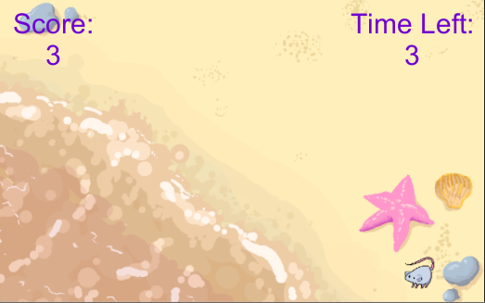
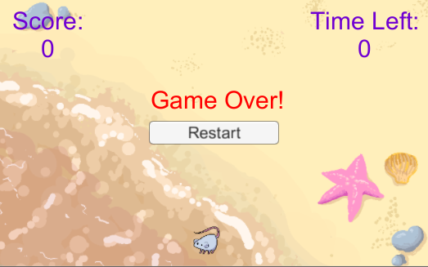
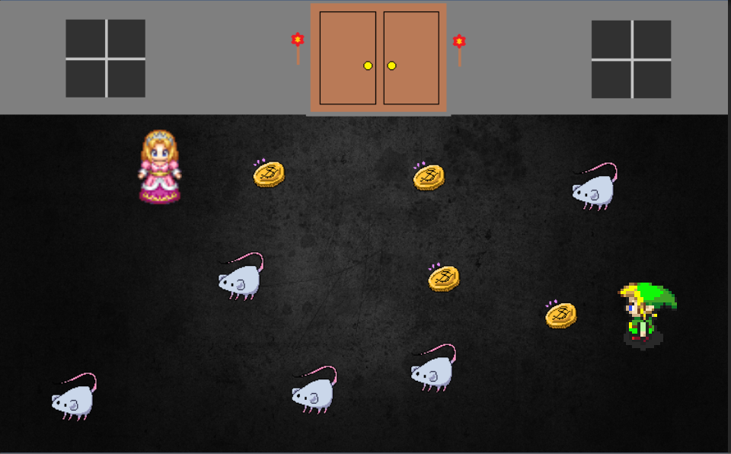
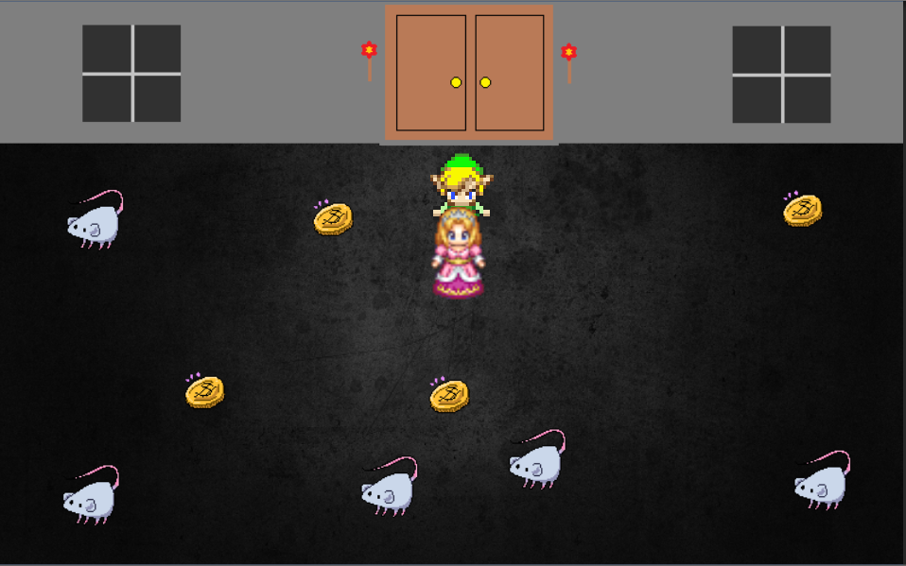
We’re currently working on the basics in Unity - UI in the first two screenshots and character movement in the rest.)
Sprite Sources:
- Link: http://zeldauniverse.net/forums/index.php/Thread/26188-Element-of-the-Hero/
- Girl Sprite: http://www.rpg-maker.fr/index.php?page=characters&type=femmes

