Ryan McHenry and Andrew Berg
CIS 487 Game Design 1
Professor Bruce Maxim
19 October 2015 (Updated: 6 November 2015)
Elmac the Gem Hunter
Brief Story:
Elmac is a robot that loves gems. He loves them so much he will travel all the way to Egypt to find them. The main issue is Elmac is only programmed to move and jump. However he moves with such force enabling him to move certain parts of the pyramid that have never been explored before. Amongst his quest he must avoid all traps or his robot heart may malfunction. What he uses the gems for one may wonder? Nobody really knows but the man who built the machine. That man is unknown.
Appearance:
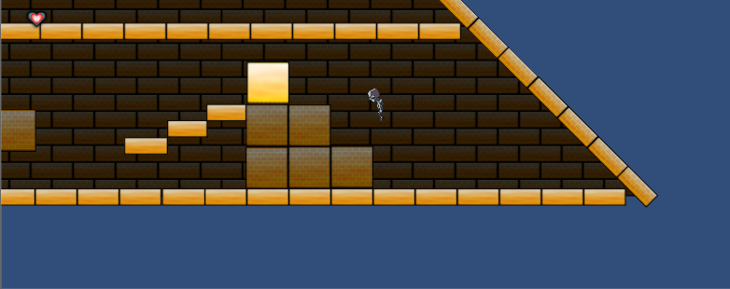
Because the game resides on the inside of a pyramid, most of the elements have a yellow theme to them. Certain distinct parts have different shades, or colors to make them stand out for certain purposes. Most everything is made up of blocks just like a pyramid would be, and the entire level is built like one to give the player the feel that they are inside the structure. The entire level is built using simple blocks and simple designs because it is simply a basic game. Almost all of what is seen is Andrew’s own custom art that was then imported into the game. From all the blocks, chests, and health, to the background of the pyramid. We also designed the blocks so that it is easy to visually distinguish between moving and stagnate ones.
Ingame Structures and Objects (Art Designed by Andrew)
*NOTE- Robot designs are part of a starter Sprite kit that was not our design.
Block | Movable Blocks | Floor Tiles | Chests | Spike Hazards | GEMS!!! (not included due to time constraints)

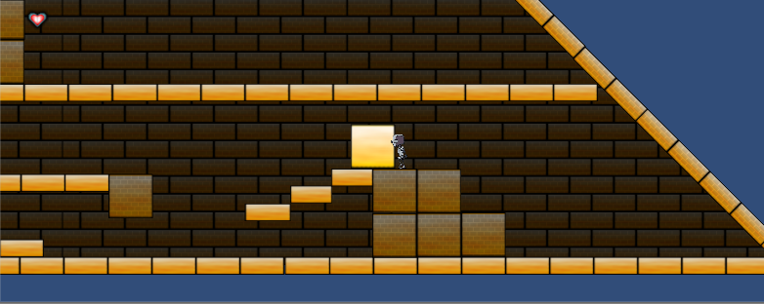
Player roles and actions:
The player controls the robot Elmac on his journey through the pyramid to get to the top to collect the gems to beat the level. The player can move left and right; pushing movable blocks while doing so and can jump over obstacles or onto other blocks. The specific control set is listed below:
Keyboard Function | Control
[<-] [->]  (left and right arrow keys) | Move Elmac left or right (You can push movable blocks in the direction your traveling)
[Space Bar] | Jump

The entire goal is to get to the chest located in the pyramid. This is accomplished by solving several block puzzles to climb to the top of the pyramid. They also must avoid spike hazards and make difficult jumps on their journey to the top. Figuring out how to get to the next layer of the pyramid is the name of the game here.
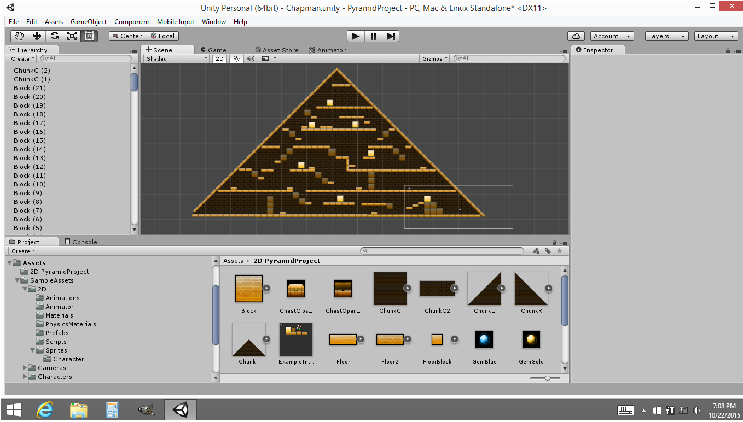
Strategies and motivations:
The general strategy of the game is to move up throughout the pyramid without losing health. Spikes are the basic obstacle to prevent you from doing so. Moving some blocks next to spike hazards will punish you if you need to move them back. Some difficult jumps will have to be made but the difficulty curve is generally seamless (Punishing players less in the beginning whilst creating challenges for them near the end). Health management throughout the pyramid is the absolute focus going into the game. A lot of the motive is built upon simply completing the level and then doing so again whilst losing less health. Eventually, you’ll have the entire maze figured out (since every element of the game is deterministic except for the player) and the replay ability becomes more about being consistent. 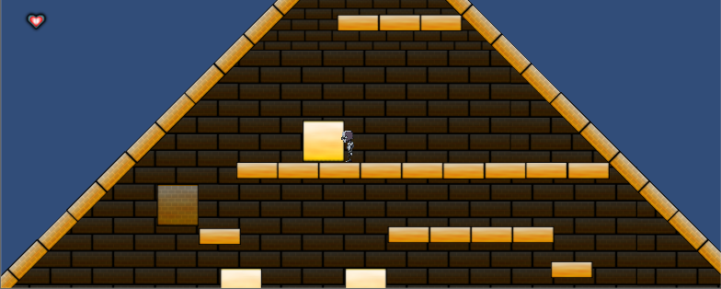
Level summary/story progression:
The main story progression is just getting to the chest of gems, which is what the robot is programmed to do. Since we were not focused so much on story and very much so on level design, lots of effort was put toward making an interesting level. The goals for the level design were to teach the player how to play the game, without directly teaching them how to play the game. In other words by simply knowing the controls, the player will know how all the elements of the game works simply by level design. This is accomplished by first letting the player know they can jump with that obstacle first, then forcing them to push a block, since that is the only way to get to the next objective. The start is linear for the sake of player learning. Once everything is learned, everything is put together in different puzzles to get to the top. Jumps become harder, finding out how to get to certain areas also becomes harder for a smooth and seamless difficulty curve.
Software/Hardware Specifications:
Recommended:
OS: Windows XP or later
Processor: 1.5 GHz Core2Duo
Memory: 1 GB RAM
Graphics: OpenGL 1.4 or better
Hard Drive: 100 MB available space
Minimum:
OS: Windows XP or later
Processor: 1.5 GHz Core2Duo
Memory: 500MB
Graphics: OpenGL 1.4 or better
Hard Drive: 50 MB available space
Algorithm Style:
2d physics (collision detection, sprite movement)
Static level design

