2D Game Proposal | CIS 487 Fall  October 12th, 2015
A proposal for a two-dimensional, top-down, shoot-em-up game. |  | Shmoo2D (working title)

Eric Anderson | James Nelson
Contents
Version Control 1
Story 2
Background 2
Player 2
Gameplay 2
Enemies 2
Objectives 2
Gameplay 4
Description 4
Playstyles 4
Abilities 5
Currency 6
Scrap 6
Environment 6
Tools 9
Hardware 9
Software 9
Algorithm 9

Version Control
Editor | Date | Version |  | Work Performed
Eric Anderson  James Nelson | September 30th, 2015 | 0.1 | First draft, basic story, ability list
Eric Anderson  James Nelson | October 12th, 2015 | 0.2 | Full rough draft, more story, refined abilities, environment, tools
Eric Anderson  James Nelson | October 16th, 2015 | 1.0 | Finalized all sections
Eric Anderson James Nelson | November 5th, 2015 | 1.1 | Small edits to reflect design changes made during implementation.

Story

Background

In the near future, humanity develops interstellar travel and promptly begins colonizing worlds and contacting intelligent life-forms. You belong to an older race called the "Bleh". Humanity first contacted your elders two decades past under the appearance of peace and collaboration. Since this time, the humans have established numerous bases of "activity" on your systems seven habitable worlds. As time has progressed the humans have continued to increase their local populations and military presence. Some of your elders have become convinced that the humans are here to conquer, either by might or by population attrition. As the child of one of these elders, you volunteer for an experimental program that would allow you to drive the human threat from your home.

Player

The experiment you volunteered for was a success. Not only were your natural abilities enhanced (strength, speed, stamina), but you also have millions of molecular machines in your body that obey your will. These machines automatically restore your health, exo-armor, and energy reserves when they have been depleted. The machines also have the ability to alter your physical body to instill or improve abilities that may help you with your mission. Alterations require large amounts of scrap materials to implement, which you can scavenge on your missions or buy from local vendors.

Gameplay

Your race is not technically at war with the humans, and would stand to lose considerable resources should it come to that. If you can neutralize the human bases without them warning others, you will receive additional funding from your elders. However, if you decide you need to openly attack the humans, the elders will only be able to contribute surreptitiously with small amounts.

Enemies

You will be engaged against large groups of humans. Intelligence suggests that most of the humans you encounter will be soldiers of varying types and abilities. Each human will most likely have a single weapon and maybe some body armor. While humans do have advanced communication systems, you have been outfitted with a special dampening device that interferes with local transmissions.

Objectives

Your purpose is to clear each successive base of any human presence by any means necessary. You will have a few possible routes to this objective – brute force, stealth, or manipulation. To be more efficient you could use some type of base-wide system to wipe out the remaining forces, possibly introducing a poisonous chemical into the air system, or maybe severing the bases oxygen feeds. When complete victory has been confirmed, you will be transported to the next base.

Gameplay

Description
The game will be viewed from the top-down. The player will control the protagonist using either a keyboard or a gamepad. The player will be compelled to exterminate all antagonists contained in the current base. The player will have multiple options concerning how the extermination should be performed.

Playstyles
The user will have four playstyles to choose from. This will be selected using a traditional 'talent tree' setup. The user will also possibly be able to blend two or more trees together at higher progressions. For the time being the playstyles are:

Soldier
This playstyle focuses on weapon damage, area-of-effect damage, and direct survivability. Users who select this style will be granted:

- Increased projectile damage
- Increased attack speed
- More durable exo-armor
- Faster health regeneration

Ghost
This playstyle focuses on stealth and speed. Users who select this playstyle will be granted:

- Double energy
- Significantly longer cloaking
- Faster movement and run speeds
- The ability to blend when not moving

Assassin
This playstyle focuses on stealth and massive single target damage. Users who select this playstyle will be granted:

- Slightly faster movement and run speeds
- Significantly increased phasing time
- Faster energy regeneration
- The assassinate/incapacitate abilities

Overlord (Never Completed)
This playstyle focuses on manipulating enemies and their environment. Users who select this playstyle will be granted:

- The mental manipulation ability
- Manipulated targets have increased damage
- Manipulated targets can be detonated
- Physic shielding that blocks a flat number of attacks

Abilities
The user will be granted several abilities as a default, but will be able to upgrade their effectiveness as they progress through the game.

Movement
Movement will be done along the four axes with the option to walk, run, or creep. Certain talents will increase the speed at which the player can move.

Fire Main Weapon
The user has a single, ammunition-free weapon that is part of the protagonist's body. Certain talents will increase the damage, rate-of-fire, and energy cost of firing.

Cloak
Become invisible for a short amount of time. Certain talents will increase the use-time, decrease the energy cost, or decrease the cooldown of this ability.

Phase
Re-organize the player's matter to allow passage through solid surfaces (not doors or exterior walls). Certain talents will increase the use-time, decrease the energy cost, or decrease the cooldown of this ability, or add interesting side effects like allowing projectiles to pass through.

Assassinate/Incapacitate
Deal massive damage or knock out an enemy at close range who is unaware of the player's presence. Certain talents can extend this range, increase the damage, or decrease the energy cost of this ability.

Mental Manipulation (Never Completed)
Gain complete control of an enemy. During this time the user will be controlling an enemy, the protagonist's body can still be damaged if located. Certain talents will increase the time of control, the distance of control, and special effects like exploding the enemy.

Blend
While not moving, blend into the surrounding environment. Certain talents will shorten the time needed to activate this ability.

Currency

Acquiring Currency
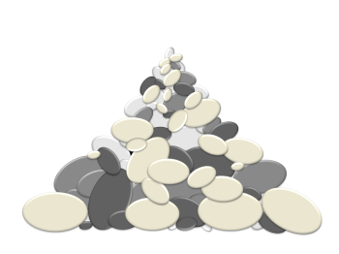
The currency for the game will be scrap materials. These scrap materials will be acquired from dispatching enemies or destroying environmental objects. The player will have to physically contact the scrap material to acquire it. More difficult enemies will drop higher amounts of scrap material.

Scrap

Spending Currency
Currency can be spent using the pause menu. In the pause menu the player will have access to their talent tree. It will cost a medium amount to unlock each branch. When a branch is unlocked the player will gain abilities pertinent to that branch. Talents themselves will also cost varying amounts to unlock. More impactful talents will cost more scrap material to enable.

Environment

Characters
There will only be one protagonist, but there will hopefully be several variations of antagonists.

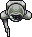

Protagonist

Antagonists

Maps
The maps will be top-down, created by using the "Tiled" program. The maps will consist of repeated floor, edge wall, and corner wall tiles. Doorways and switches will be part of the environment as well, but they will need to be interactive and therefore must be implemented individually.
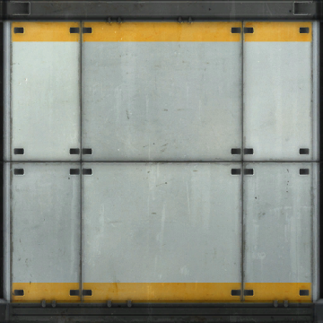
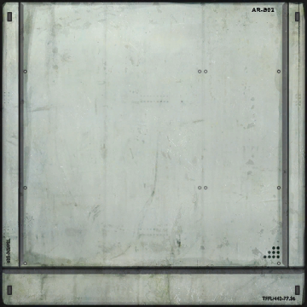

Floor

Edge-Wall

Corner-Wall

Objects
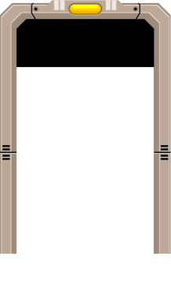
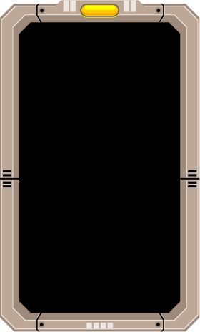
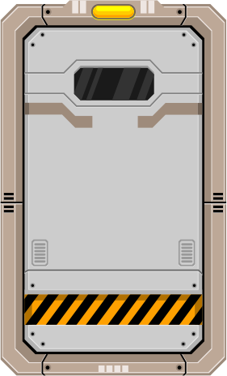
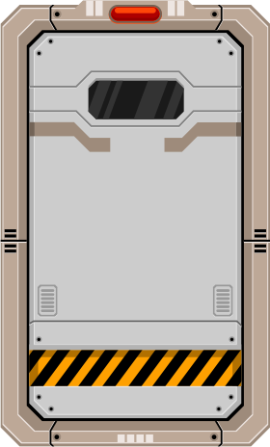
There will be a few objects that the player can interact with during gameplay. The two most common objects the player will come across are doors and switches. Switches are only bound to specific doors, but they may perform other functions as time goes on.

Door

Switch

Example Room
This is what a finished room looks like:

Example HUD
This is what the Heads-Up-Display will look like:
Armor Bar
Energy Bar
Ability Cooldown Indicators
Currency Amount
Health Bar

Tools

Hardware

Development
There is no special hardware being used in the creation of this product. Development is being performed on two laptops owned/licensed by the creators.

Play
Any functional computer created within the last ten years should be more than adequate.

Software

Development

Game Engine
Unity 5.2

Map Creation
Tiled 0.14.1

Image Creation
Inkscape 0.91

Image Alteration
Gimp 2.6

Team Collaboration
Google Drive

Play
The target platform for the product is any Windows XP or newer device, excluding mobile devices.

Algorithm

The product will be created using two-dimensional sprite rendering and unity's rigid body physics. Some operations will necessarily violate physics, but the vast majority of actions will be performed by the physics engine.

