S.C.S. Navon Pitch Write Up
Story Abstract:
Trace, a sous chef (second in command in a kitchen), aboard the S.C.S. Navon, an interstellar Space Cruise Ship. The ship is on it’s maiden voyage, a 2 week cruise across the Milky Way. After one week, the ship is attacked and boarded by SPACE PIRATES, led by Captain Jack Metalbeard, to loot the new, luxurious cruise ship and its wealthy passengers. Trace is caught off guard when a space pirate invades the kitchen, but he’s able to fend for himself with his kitchen utensils. After the short scuffle, the ship’s intercom comes on and announces that all passengers and staff need to make their way to the escape pods. Knowing that danger is ahead, Trace arms himself with an unlimited supply of kitchen knives and meat cleavers and his trusty rolling pin. Trace is forced to blind search room to room for the escape pods or signs that will lead him there. In each room, Trace will face many dangers: pirates, pitfalls, sharp objects, electrical wires, though some can be used as deadly traps for pirates. Through his endeavor, word is passed to Captain Jack Metalbeard of a fierce rogue warrior (that’s you; crazy, right?) cutting through his men. He’ll see personally to your destruction. Will you make it off the S.C.S. Navon alive?

Gameplay:
- SCS Navon will be a 2D side-scrolling, action platform game.
- Level progression is nonlinear.
  - Is now linear
- Stealth will be a key role in avoiding conflict

Appearance:
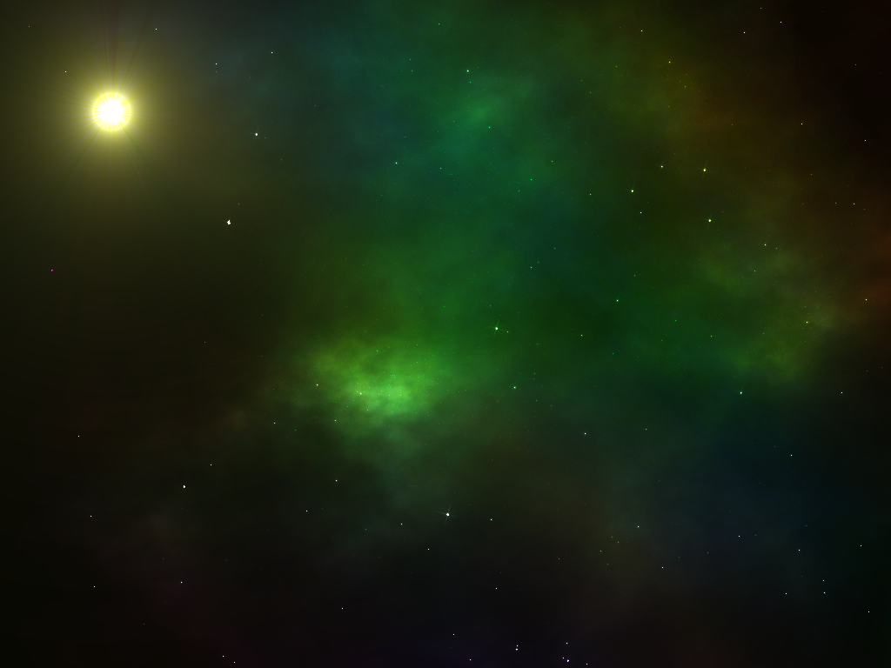

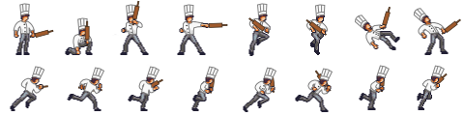

Player’s Role/Action:
- Take control of Trace, the sous chef, and his weaponry of kitchen utensils and the mighty Chef’s rolling pin. With your tools, you shall eliminate your the threat that is the Metalbeard and his band of Space Pirates, explore the S.C.S Navon in its time of peril, solve puzzles, and escape the chaos.
- Character actions will include basic platforming movements such as running, jumping, ducking/crouching, and fighting. Plus, projectile weaponry with a cooldown functionality that adds a bit of challenge to the player actions.
Strategies/motivations:
- Motivation for the player is to merely survive the tragedy as Trace has a dream a becoming a real chef. Otherwise, the consequences will be being killed in action or being enslaved by Metalbeard.
- Player must plan his or her actions wisely as some battles can be won with the given arsenal. However, other encounters may require a bit of espionage and the use of the environment surrounding the player (such as expelling your foes into deep space).
Level Summary:
- Enter the fray against Space Pirates that will wield swords and plasma/energy weaponry.
- Travel through various obstacles such as pitfalls, harmful hazards, and space deconstruction.
- Taking cover behind useful hiding spots.
- Interact with the key objects as you progress throughout the ship.
- Not every battle should be fought, so you must avoid conflict as necessary or as much as possible.
- Eventually face off the main antagonist, Captain Jack Metalbeard, in an epic boss battle.

Hardware Specifications:
- Windows XP (Service Pack 3) or newer
- 512 MB RAM
- 1 GHz Processor
- Any HTML5 compatible browser
- Updated graphics card drivers

Software Specifications:
- Any HTML5-compatible browser; make sure that the desired browser is updated to the latest version. UPDATE: Firefox is recommended.
Algorithm Style:
- Enemy patrol routes are defined in various areas of the ship
  - Use of invisible barriers.
  - Line of Sight tool in Construct 2
- Object interaction such as keys to reach unexplored areas of the ship
  - Put item in inventory
    - Key
  - Unlock door when in possession
- Stealth and Lighting
  - Darkened rooms
    - Minimal Lighting
    - Pirates have flashlights (Line of sight)
- Platform-style movement
  - A--Left
  - D--Right
  - W--Jump
  - S--Crouch
  - F--Melee attack
  - E--Open door (when holding right key)
  - Click and Aim--Knife throw
  - Hold click (charge bar) and Aim--Meat Cleaver throw (more powerful)
Summary
The most important lesson we learned during our design and development process is to not be too ambitious. Though making a good, compelling game is important, but we still need to be time conscious. In our design process, we wanted to make many rooms so that getting to the end could be more adventurous, but this was not so. The game turned to to be totally linear. Construct 2 gave us a good insight that even with a simple game engine, we can still overcomplicate and barely meet a deadline.

