Destiny Ascension
CIS 487 2D Game Design Pitch (Final)

11/5/2014
University of Michigan - Dearborn
Rich Morgan and Brandon Whyte

Executive Summary

The game is set in a world of magic and swords, maidens and knights. You have joined the local militia, taking up arms to defend your hamlet from the rampaging monsters and armies of the neighboring countries.
Your mentor, the old army captain, comes with you on this day’s patrol. On patrol through the outskirts of town, a typical patrol of defending the town’s borders from incursion of local creatures quickly becomes something much more serious as hostile scouts from the giant neighboring kingdom of Ouerlera are encountered. The tutorial battle now takes a new turn!
As the battle unfolds, you learn how to control the game and your allies in order to be able to defeat the enemies that threaten your land. Now that you have seen the different classes and how they work in combat, what role will you choose to become? Will you become the Knight, the battle hardened defender of the realm to protect yo ur friends? Will you become the Warrior, a devastating fighter that lays waste to his enemies in close combat? Will you be the healer, keeping your allies alive in the face of almost certain death? Do you decide to become an Archer, a deadly marksman that rains death on the enemies of the squad from afar? Or, finally, will you choose to be a Mage, a magic wielding warrior that disrupts the enemy formation from afar with spells? The choice is completely up to you, the player.
After the tutorial, your adventure begins. Will you be the savior of the world, one that brings peace to all of the surrounding lands? Or will you be the one that brings the world under your heel, to crush all that stands before you? The choice, and the adventure is yours and the world will never be the same!
For the current iteration of the game, we were forced to make some changes to the game as a whole. Because of time constraints, we instead implemented:
- A Battle (Skirmish) mode. Players can choose a setup for their team and pit them against computer generated opponents. As of this moment, it is simply auto-attacks and seeing the results of your unit choices!
- A preview of what we envision the story mode to be. Should be exciting!

Game Play, Look, and Feel

Appearance:
Brightly colored backgrounds with simple sprites. The game should have the basic look and feel of an older style RPG but with a more tactical and strategy-based setup. The current idea is to have an almost top down camera view of the action so that it looks like the player is looking down at their primary character’s head. This helps to keep the graphics for the game fairly simple, as well as utilizing a look and feel that is fairly common to a lot of the older style games.
Combat maps will be grid-based, both in appearance and in movement. The maps will contain simplified representations of various terrains. Some terrain will be not be accessible to movement, or may otherwise hinder the player and their allies, such as mountains, trees, rivers, etc. The graphics will also be laid out in a block like fashion so that each square on the screen will hold a single graphic. This should help to give the game the retro feeling that we are attempting, as well as make it easier to assemble different areas of the game for exploration and combat. The current plan is for the view to once again have an almost top down look and feel.
A little bit more about the sprites. They should have a more cartoon style of feel rather than a lot of the current ones out there. The idea is to set it up like Final Fantasy IV (or II in the US) where it looks like it is set up for 16 bit graphics. The sprites should be designed and implemented to fit into each block of terrain so that one movement on the board equals one square movement. The idea is to never have a sprite that is over the top of two blocks and create an issue for the game to draw everything.
The following is an idea of how we would like the sprites to sort of look. These are the sprites that we are currently using for the game:
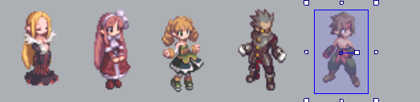
Healer Mage Archer Knight Warrior

Ultimately, the idea is that the game should look like something similar to:
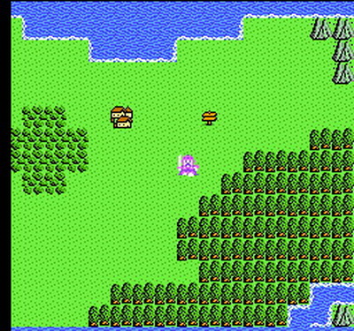

The above screenshot of Dragon Warrior 4 is sort of how we envision the overworld screen to look when the player is patrolling the kingdom or moving to the next questing location.
As for the combat movement phase, this is sort of how we envision it looking. We currently do not have a sprite for the player character, but it may just show the player character rather than the entire squad. These particular sprites are standing in:
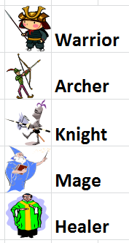
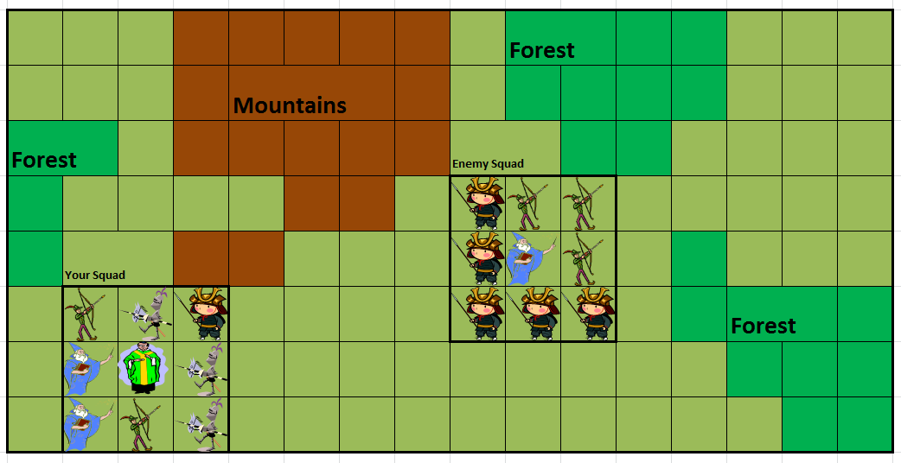

Here is a final screenshot from our current iteration in the Construct 2 Engine. Right now, the only portion that we have developed is the beginning setup of how the Battle Stages will work and be handled by the game engine.
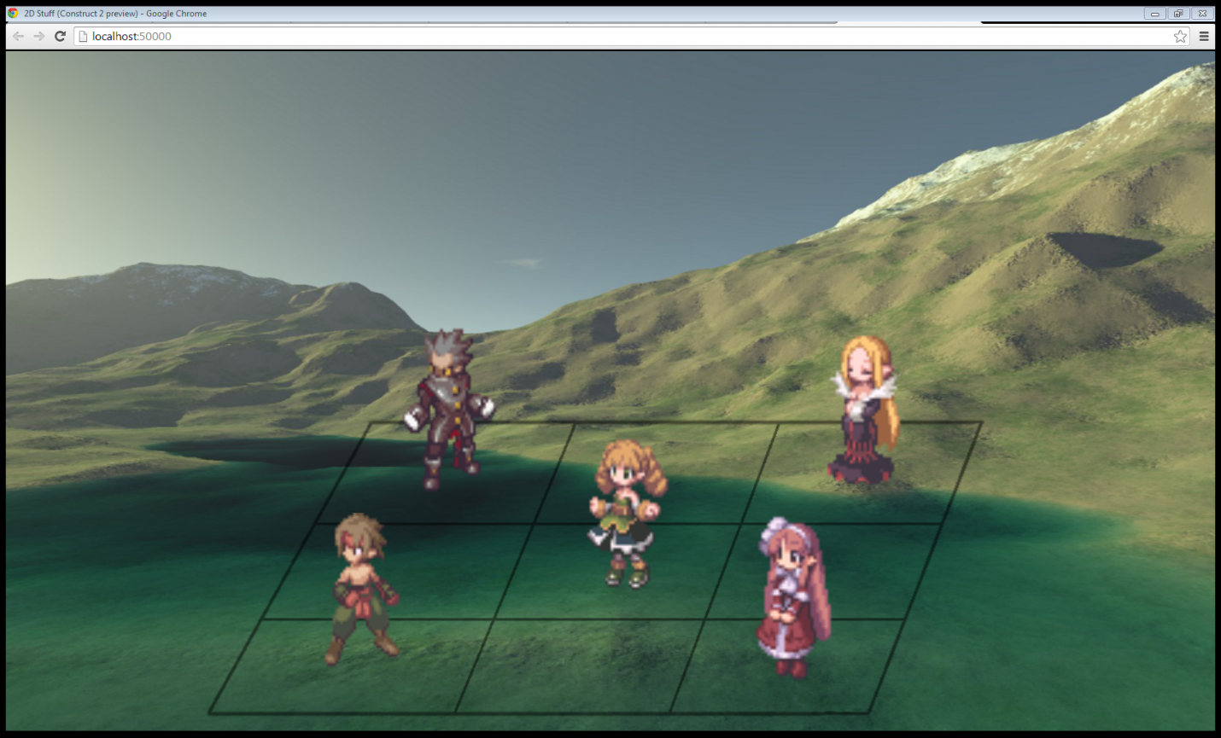

The game looks very similar to the way the layout above is set up. The characters are still arranged in a three by three grid; however, the battle over map is currently removed from the game. It will be implemented in a later version of the game when Story mode is available for play. Here are some current Screenshots of the game:
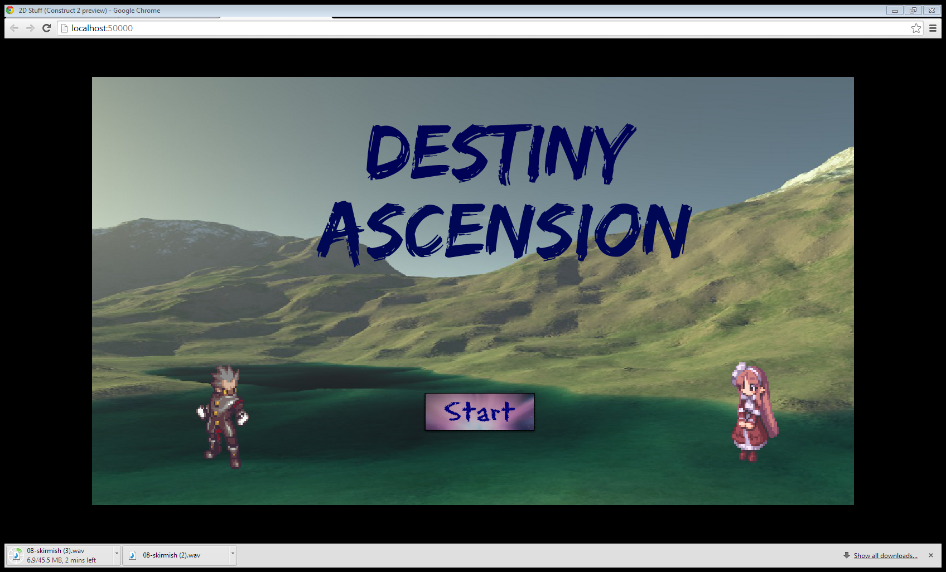
Above is the title screen for the game. The start button transitions to another screen that allows the player to choose which version of the game that they want to play. For right now, the story mode only shows the story as has been written thus far and then loops back to the Mode Select screen.

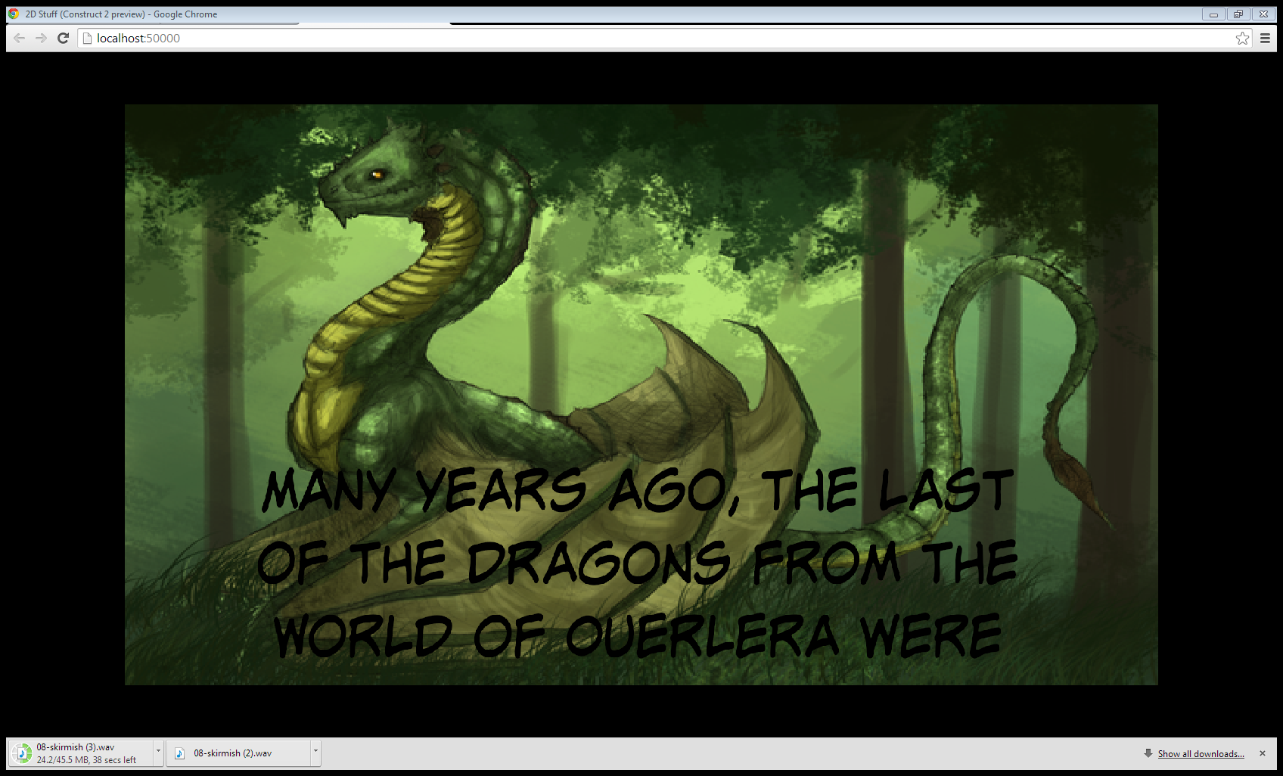
The above is a splash screen that tells the current story as it is written.

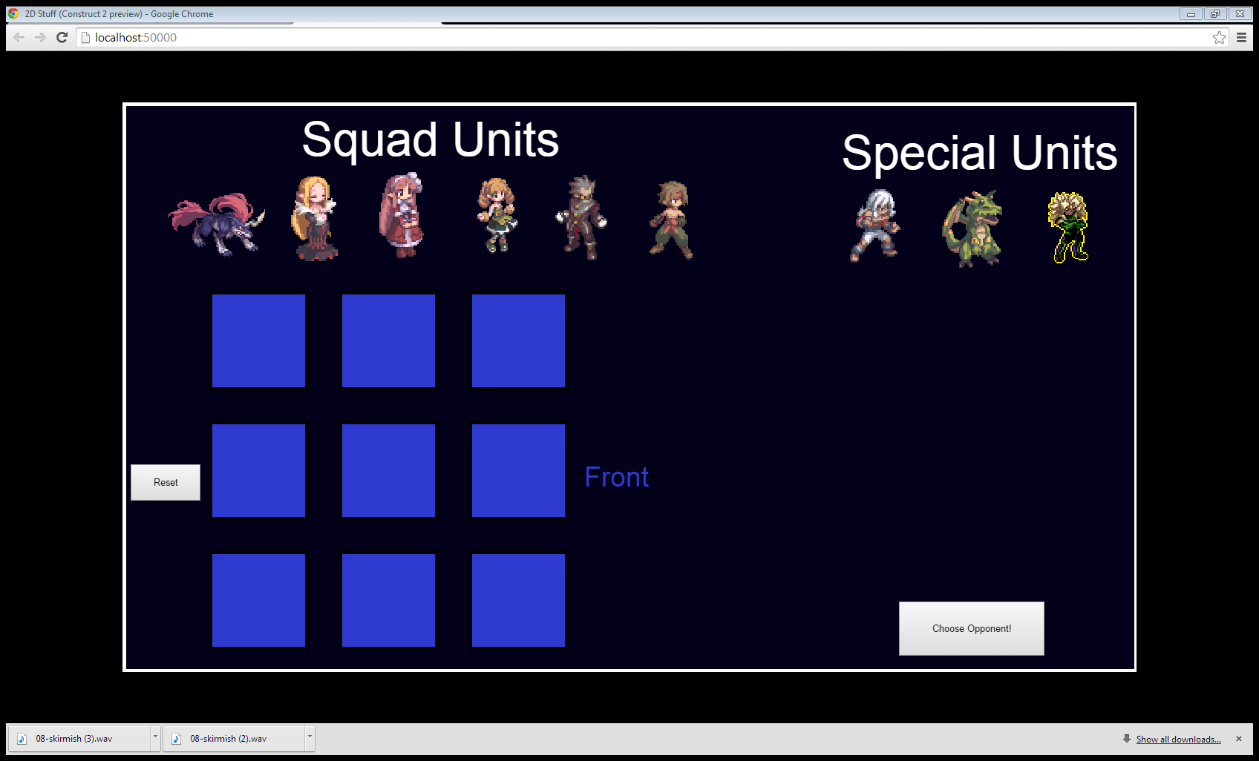
The above screen shows the Unit Select Screen for the Skirmish/Battle Arena mode. Any of the units on the screen can be chosen to make the full group of nine. For the purposes of the current version, the Main Character, Dragon and Hero characters are not balanced. Of those three, the Dragon and Hero can only be chosen once and they take up the entire map.
Once the player is done choosing their units, the player can then click Choose Opponent. It should be noted that the player does NOT need to fill the entire map. If they want to, they can use between 1 and 9 units, provided they do not choose a Dragon or Hero character. Once the Choose Opponent Button is clicked, it pulls up a screen with several options. From here, the player may:
- Choose another player controlled squad to fight against.
- Fight a group of nine wolves.
- Fight the Main Character (he brings two healers to the fight).
- A Special Developer’s challenge.
- Fight a Dragon.
- Fight the Hero.
These options allow the player to play the game that they choose to play against. The Hero and Dragon are not currently balanced for this gameplay mode! They will, most likely, annihilate any player group that is assembled against them!

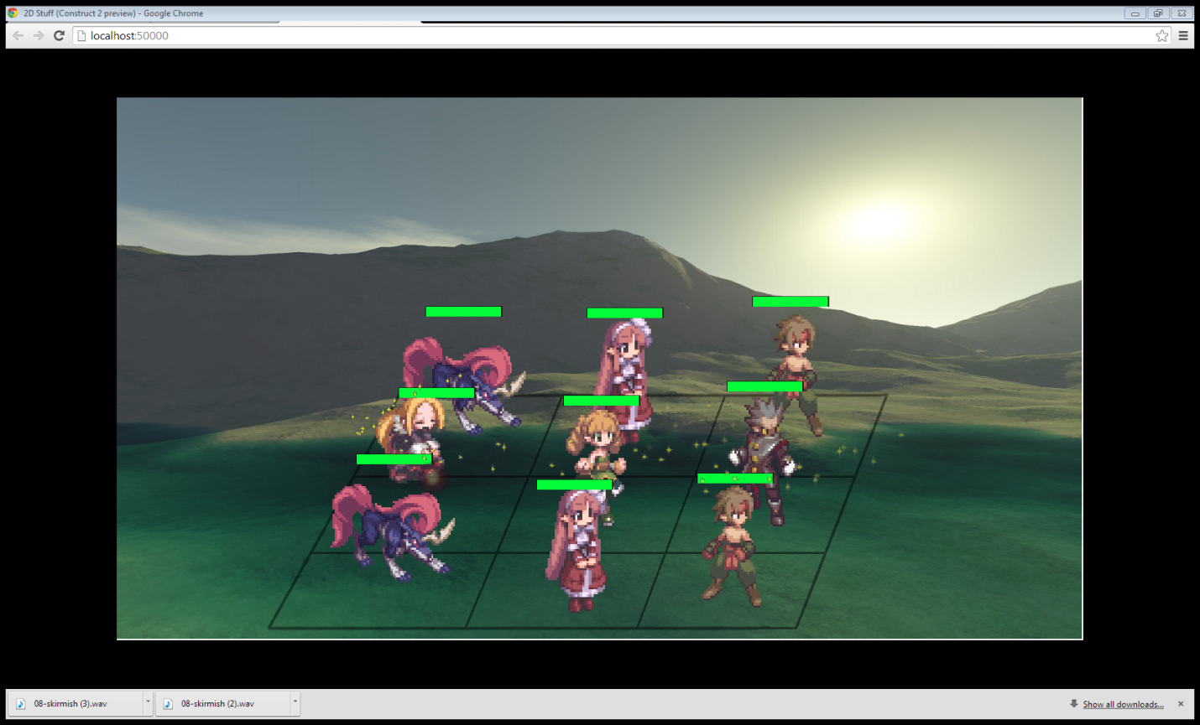
The above is a screenshot of battle in action. It is currently a Healer that is casting, as can be told by the sparkles on the map. After the healer’s action is done, the melee characters will charge, the Archer will shoot and the Mages will cast. The next view will show the results of the current group’s attack on the second group. The units there will be damaged by the current attacking units when the sprites show up on the screen. The arrows and fireballs will also hit at this time, doing the damage. Next, the other side will do the exact same actions in the exact same order. This is how the second phase of combat will work in the final story version of the game.
Player Role and Actions:
The player takes on the role of a young fighter in the local militia. In battle, however, they will command various different allied units in addition to their own. Combat will consist of two phases: Movement Phase followed by an Action Phase. In the movement phase, a squad commander (whoever is the currently acting one) will be able to move a maximum of a set amount of spaces from their current location. After this movement, the squad commander then has the option to perform an action, such as an attack on an enemy squad that is within range. The player will control each of the allied units through these phases. An exception to the allied control being given to the player may be the tutorial battle that starts the game.
The player will have several types of units to command and outfit their squad with as they see fit. These units will include:

Archer: This class of unit is designed to be a ranged marksman. They will not have very strong defenses versus enemy units that are in melee combat, but they will have a strong ranged attack to deal damage to enemy units from afar.

Healer: A healer is the salvation of a group that has been wounded during the course of a battle. They do not have an attack, but they do have an ability to heal their allies for an amount based on their level.

Knight: Primarily a defensive unit, this class is a melee unit that is built to take a punishment. They have an ability that increases the chance that an enemy will attack them rather than their allies in the squad. In addition, they have a larger amount of hit points and defense, but not a strong attack or damage amount.

Mage: A ranged spell caster, this unit slings spells at enemies from afar. They do not have a lot of hit points, so they cannot take a lot of damage. However, their spells will have different effects based on the type that they use. Their damage amounts are also rather high in order to balance their low amounts of hit points.

Warrior: A strong melee unit that specializes in doing damage at close range. They have a medium amount of hit points, but their melee attack is much stronger than the comparable Knight class.

These are still the final versions for the player role in the game. As of right now, however, with the current iteration, the player’s role is to choose their squad and the ones that they will be fighting in a skirmish.

Strategies and Motivations:
The player’s motivation will lie in two main categories: One will be story driven and the other will be battle driven. The strategies employed to accomplish both victories in the battle, as well as moving the story forward will revolve around the tactical-style, squad based combat that the player will take part in. The player will be given control over both the composition of the squad, as well as the squad’s actions on the battlefield. This will present many varying strategies that allow the player to take part in combat in the way they choose to.
We hope to include a limited AI that should help the game to challenge the player and make gameplay more interesting. It won’t be anything too extreme, but an AI that can properly use cover or try to stay out of range of the squad if they are Archer focused is something that we would like to include.
Ultimately, the player will have to adjust group composition and take into account the levels of his followers in order to properly field his team in the game. The ultimate hope is that there will not be simply a ‘best’ squad layout to use, but a bunch of them that will allow a player to play the game the way that will choose. This doesn’t mean that a terrible composition will still necessarily be viable, but just about any setup and combination of units should at least stand a chance.
The current player motivation is simply to have fun and beat up on other units.

Level Summary and Story Progression:
A “level” will consist of a battlefield, upon which the player has certain conditions that will result in either victory or defeat. The player must achieve the victory conditions in order to progress on to the next level. Doing so will also cause the story to advance, as the battles play a role in the outcome of the story.
There will also be a different level in between combat. This level will be something used to bridge the gaps between battles, as well as to provide additional information relating to the story of the game. This serves to help increase player knowledge, as well as motivation, as the player progresses through the game.
The player and all of his units will level up, mostly through combat, but also through completing parts of the storyline. As the game progresses and the units gain experience, they will gain levels which will increase their abilities, like how much damage they can do to opposing units or how many hit points they have. The mages may get different spells that unlock as they progress through levels, but this has not yet been decided on. In the end, each class’ abilities will scale fairly linearly, which should help to keep the leveling process simple. A cap of a certain number of experience points that can be earned may be added in order to keep the game interesting.
There are currently no different levels, but there are different levels of difficulty and squad setups. Depending on the characters that the player chooses to either be on their squad or to fight against, the level and difficulty can increase or decrease dramatically. As of right now, this is where the primary difficulty of the game is going to come from. Otherwise, for the final setup of the game, the levels and difficulty will be as stated above.

Development Specification

Hardware:
The game will be developed on a windows machine, with a target market of the windows store. The game will require:
1. A Windows based Operating System (This counts Windows Phones, Xbox Live, Windows PCs, etc.)
2. Some kind of device to render graphics. All that should be required is a simple on mother board graphics card. (The graphics are going to be pretty basic, only 16 bit or so, so any hardware should be able to do it.)
3. A basic monitor to display the game.
4. A keyboard and/or mouse interface to control the character.

Software:
The game will be developed using the Construct 2 engine, and will run on any device utilizing the Windows OS.
The game will require an HTML5 capable web browser for both development and playing.

Algorithm Style:

Entirely event driven (Construct 2)
Sprite Animation
AI Combat Controls
Combat animations, damage, etc. will be determined by type of squad units used
Player-controlled squads can be modified. This is in order to allow the players a certain amount of customizability for how they play the game. This means that the game is going to need to be able to adjust for how the player has his squad configured.
Player movement on the map will be determined by the player, but will be within the limitations of the squad commanders “Movement” statistic each movement phase. This will be set by a combination of the movement of the hero character and the movements of the rest of the members of the squad. Certain units will only be able to attack when they are in melee range. This will play into all of the game algorithms for both enemies and the player squad. The game will need to be able to check to see if allies/enemies are in range for attacks and then be able to resolve the action correctly.
Only a few levels, but multiple combatants per level, with multiple combats per opponent likely needed.
Nothing has changed about the algorithms, hardware or software in the game. However, the combat system is incredibly robust. The combat system, as it is currently implemented, should have no difficulty in running the final game. The other part that we can most certainly use is the unit select screen for being able to choose your squad composition. The logic can be used here, but we would need to remove the ability to select the Main Character, Dragon or Hero.

Known Bugs:
- Occasional projectile miss.
- Occasional double arrow hit.
- Occasional double wolf hit.

All in all, through making this game, we learned a lot about both Construct 2 and how to not, once again, bite off more than we could chew. For some reason we always seem to try to make a project that has a scope that is way more ambitious than we can possibly complete in time. In addition, we have both decided that Construct 2 simply isn’t an engine that we like to use. It didn’t have enough of the capabilities that we required in order to make the game the way that we truly wanted to be able to make it. We were able to implement a game close to what we wanted to be able to make, but we were not able to make the complete game that we had envisioned.
Despite this, we found that Construct 2 most certainly has a place for smaller and simpler projects. Games that use a side scrolling technique or ones that are better able to utilize the strengths of this engine will benefit from the large library of FAQs and walk-throughs that are available online at Scirra’s website.

