Escape from Esipov

CIS 587 2D Game Pitch

Professor Maxim – Matt Fielden

Contents
Executive Summary 2
Game Play Look and Feel 2
Appearance 2
Player Roles and Actions 3
Strategies and Motivations 3
Level Summary & Story Progression 4
Level 1 – “Exploration” 4
Level 2 – “Stealing for Science” 4
Level 3 – “Run for your life” 5
Development Specification 5
Hardware 5
Software 5
Algorithm Style 5
Video Presentation 6
Youtube Link 6

Executive Summary

Escape from Esipov is set in the year 3418, where mankind is engaged in a planetary arms race. Johnny, captain of the science research and exploration vessel, Fiona, has been exploring the outer rim for the past 3 years when the Fiona encounters some serious mechanical trouble. Low on fuel and desperate to land before further catastrophe, Johnny navigates to the nearest planet, Esipov. Upon landing, roughly at best, Johnny begins to diagnose the problem and realizes the materials he has left on his ship will not be enough to complete the repairs. Frustrated, Johnny sets out to explore Esipov in search of any materials that can be of use to him. Unfortunately for Johnny, materials are not the only thing that he encounters on his journey…
Playing as Johnny, you must navigate the planet of Esipov gathering materials, while avoiding the native wildlife, who seem less than thrilled of your appearance. Upon successful completion of your objectives, you may repair the ship, and return to Earth to detail your journey and findings.

Game Play Look and Feel

Appearance

Escape from Esipov is a side scrolling, arcade style beat ‘em up. Each playable level is set on the planet Esipov, a luscious, green planet with an atmosphere similar to Earth’s. For each level, the setting is very similar, giving the impression that the player is playing Johnny’s entire exploration of the planet. In general, there are an abundance of trees, overgrown vegetation and plants on the planet. There are a few small creatures, reminiscent of Earth’s birds and rabbits that are strewn throughout the levels. Additionally, Johnny encounters several distinct enemies along his journey ranging from human sized Screechers, to building sized Speeders.
For the interface, the player sees Johnny’s basic information such as Health, Shield, Weapon, and Ammo in the top left of the screen. In the top right of the screen, there is a basic list of objects that Johnny needs to complete to advance to the next level.
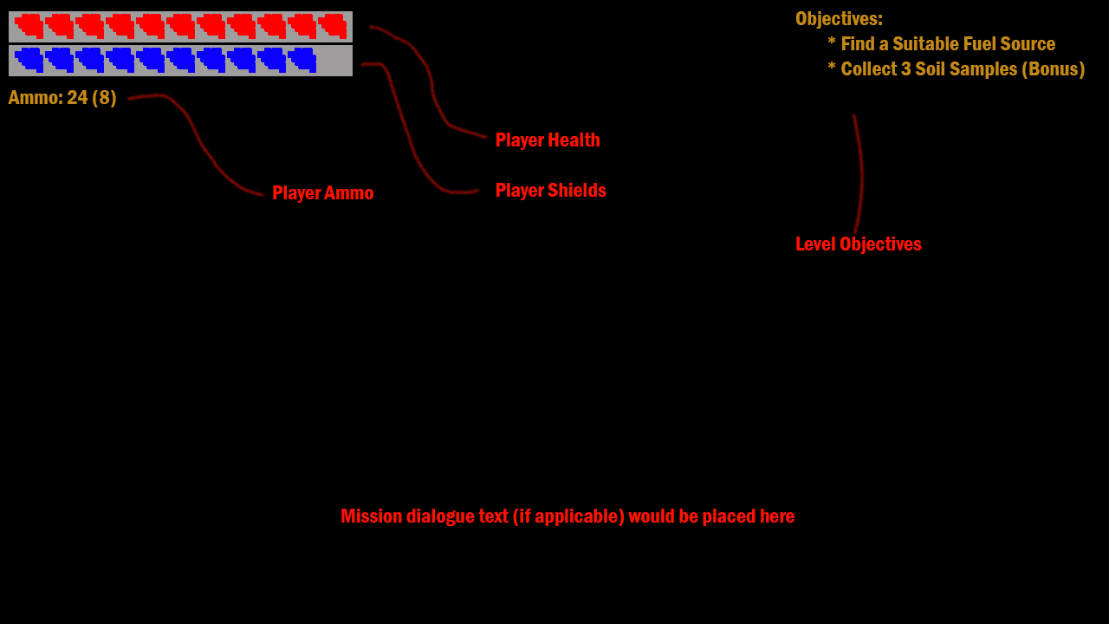
Figure 1 - User Interface
For controls, the player will be able to move Johnny in four directions to navigate. Additionally, Johnny will have two actions always available, Jump and Shoot/Punch. In certain situations, Johnny will also be able to perform an action, such as opening a door or a box.
To display movement, Johnny and the enemies will all have different sprites that will have various states of animation, such as stationary, moving, attacking, and dead.

Player Roles and Actions

The player controls Johnny, the captain of the downed ship. Johnny’s mission is to retrieve the materials he needs to repair his ship, and return to the ship in safety so that he can leave the planet and return home.
Throughout the levels, Johnny will encounter enemies that he must fight, using his blaster pistol or by punching. He will also encounter obstacles that will require him to jump over, and he will gather materials by performing an action on them. After gathering the materials, they will go into his backpack, it is assumed that Johnny can hold everything he picks up in his backpack.

Strategies and Motivations

The general strategy employed throughout the game will be to follow the mission objectives in the top right corner of the screen. Objectives will be important to the progression of the level, and the player will not be able to advance to the next level without completing the main objectives. Some levels may have optional bonus objectives that will add to the player’s score.
The player should be motivated to complete the objectives and progress through the level so that they can repair the ship and escape the planet. Along the way, enemy kills will grant points, and player deaths will subtract points. At the end of each level and at the end of the game, the player’s points will be saved to a local leaderboard, encouraging players to replay the game to improve their scores.

Level Summary & Story Progression

There are three playable levels in the Escape from Esipov. Each level will move the player one step closer to the final goal of fixing the ship and returning to Earth.

Level 1 – “Exploration”

In the first level, Johnny sets out to obtain some metal or Esipov equivalent material and encounters some very minor resistance in his way in the form of Screechers. Johnny must progress through the level safely, obtain the metal and head on out to his next objective. The first level is designed to get the player up and running with the game. It will introduce the controls, the basic premise of the game, the overall objective of the game, and provide some basic enemies that the player should be able to dispose of easily without getting frustrated as caused by repeated failure/death

Level 2 – “Stealing for Science”

In the second level, Johnny must find a suitable replacement for the fuel that was lost when his fuel tank encountered the mechanical trouble and lost all of the excess fuel supply. In his journey, Johnny must identify the suitable replacement by using his portable express science kit that he picked up from the downed ship. Once finding the fuel, Johnny must now find his way back to the ship. This level will be moderately harder than the first level for various reasons. Causal games should have the basics picked up by now and should be able to handle the harder difficulty of enemies and more serious, hardcore gamers will quickly tire of the ease of the first level. In this situation, the player would most likely not continue playing the game, because it is too easy. The second level will also introduce the first bonus objectives that the player can complete for additional points and possibly to alter the endgame story.

Level 3 – “Run for your life”

In the final level, Johnny is trying to find the ship but is having trouble. Because of the nature of Esipov, there are no distinguishable landmarks that Johnny can use to navigate. In his exploration, Johnny finds some heavy resistance and several colonies of Esipov inhabitants whom are extremely annoyed with Johnny’s presence. After fighting past all of the enemies, Johnny can safely return to his ship where he can repair the fuel tank, refuel, and escape the planet Espiov. In the third and final level, Johnny and the player are introduced to the first boss like creature, being a leader of the Speeders and a very formidable foe. This boss will take careful planning and execution to conquer without dying. This additional difficulty should serve to make the game not a walk in the park while definitely still being beatable. The goal here is to satisfy the hardcore players’ desire to be challenged, while not being so challenging that the casual player gives up out of frustration.

Development Specification

Hardware
Escape from Esipov will run on PC hardware. It will require Windows XP or greater, recommended to use a Dual Core Processor, and have at least 2 GB of RAM. For input, the keyboard and mouse will be utilized

Software
Escape from Esipov will be a standalone executable program that does not require any additional software to be present on the machine

Algorithm Style
The algorithms used in Escape from Esipov will be designed in such that they take into careful consideration the complexity of the various operations, both time complexity and space complexity. The quicker the algorithms can process, the quicker the game can be played at. A minimum of 30 FPS will be targeted as the final game running speed.

Video Presentation

Youtube Link
http://www.youtube.com/watch?v=zDk5md2oU6M

