Team Members:
Shane Kiracofe
Evan Cole

Assignment 2, 2D Game Part 1
Game Title: Venting

Abstract of the Game Story
The game begins with the main character playing video games at night. Over time he gets sick of the annoying practices in video games. He decides to go out and find the source of these practices and get his money back. This journey will take him to four companies with the first three giving clues to the actual source and the fourth company being the final stage and home to the source. Here there is a plot twist revealing the source – a single man. When beaten there is a sunrise and the source has finally been brought to light.
The game's story is supposed to be a parody of all of the annoying practices my friends and I see in video games. The companies and the final boss are obviously references based off of real companies and a certain person. Also, the enemies are references to game series that have been plagued by these practices.
Gameplay Look and Feel
- Appearance

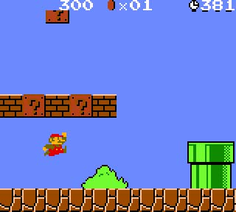
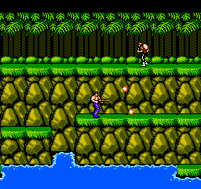
Super Mario
Contra

The game will be a platform/side-scroller type of genre.
Similar examples would include games like Contra and Super Mario.
You can only move left, right, and up (jump).

Your health bar will be dollar signs ($) and every time you are hit they take a little more of your money.
There will be power-ups.

There will be four levels, each of them have different sprites and background depending on the story.
- AE
  - Brown and black background
  - Monsters will be just generic army soldiers and space marines

- DLC
  - “Unfinished” background, it would look like an image that has not finished loading. Half-cut/distorted images.
  - Monsters will look like biohazard symbol
- SSDD
  - The background would look like an office space. A sleeping guy would represent the company’s laziness.
  - Monsters will look like guitars and fish (cod)
- Faux News
  - The background would resemble the backstage. The boss scene will take place at the news desk.
  - Monsters will be corporate office employees

- Player Roles and Actions
The game is similar to Contra; you can shoot in 8 directions.
To kill enemies, you need to shoot them down.
Up arrow key shoots up, right shoots right, left shoots left, down shoots down.
Simultaneously pressing two adjacent arrow keys would shoot diagonally.
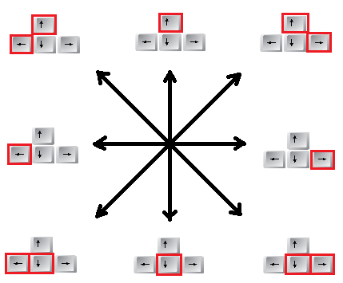

You can move through the levels by moving left/right, jumping up.
Using the WASD keys would move your character.
W = jump up,
A = move left,
D = move right
- Strategies and motivations
Strategies:
Dodge enemy shots and avoid collisions.
Kill as quickly as you can.
Get the power-ups (if available)
    - Multi-shot (shoots three bullets at once)
    - Quick-shot (shoots bullets quickly)
    - Invincibility
    - Restore dollar signs
Motivation:
For the player to have a way to “vent” their frustrations with the industry and/or to get to the end of this ridiculous story
- Level Summary/Story Progression
The game will be broken up into four levels (in order):
- Intro
- SSDD (Same Shit Different Day) – Activision
    - At the end of the level the main character discovers that the company is only the catalyst of this one practice that promotes repetition
    - He moves on to the next company on his list
- DLC (Don't Load Content) – Capcom
    - At the end of the level the main character discovers that much like the previous company (level) this company is only the catalyst of the other practice locking out content on the disk
    - He moves on to the next company on the list
- AE (Annoy Everyone) Games – EA Games
    - The main character believes his search is ending since this company is promoting both of the previous companies (levels) practices and must be responsible
    - At the end of the level the main character discovers a weird icon in the company, a FauxNews symbol
    - Determined to find the connection between the two companies he heads out
- FauxNews
    - Nearing the end of the level a major revelation is made. All the annoying practices in the industry are from a single man – The Lawyerman (Jack Thompson)
    - He is trying to cause disinterest in video games by promoting bad practices in the industry as one last attempt to crash the industry
    - After beating this final boss there is a sunrise and while not being able to get his money back he does bring to light the source of these bad practices
Development Specifications
- Hardware
Required to play:
  - Keyboard with WASD and arrow keys
  - Microsoft Windows PC with DirectX9
  - Standard .wav capable sound card
  - Graphics card supporting 16-bit color
- Software
Windows XP, Vista, 7, or 8
Microsoft Visual Studio Professional 2010
DirectX9 SDK
Microsoft Paint/GIMP
- Algorithm Style
Your character will be fixed center and the map will scroll in the direction you move your character.
The background and environment will all be tiled.
The main character and enemies will all have basic “hit boxes”.
  - May be elaborated on if time permits

