2D Game Write-Up
“Suicide Golf”

Justin Hawke and Michael Ingrody

I. Executive Summary

Storyline
“You have been kidnapped by Tiger Woods.”
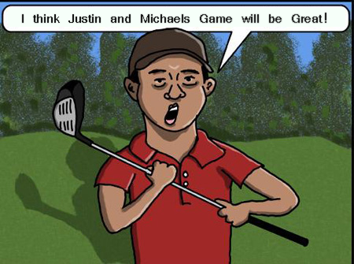

… a deranged psychopath who is freakishly adept at the game of golf. However, due to his excellence at the sport, he has been ostracized by the golf community—fans and players alike. Since he can no longer partake in the activity that once shaped his soul, he has taken up a new sport: Putt-putt golf. In order to find a worthy opponent, Tiger has designed a rigorous test to stratify the best players from the rest of the players. Manage to best him at his psychotic game if you ever want to see the light of day again.
Appearance
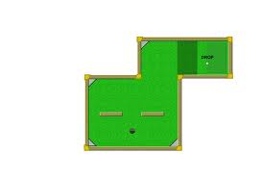The Game will utilize a top down view of each hole.

Players will be able to select the color of their ball they will play with

We will utilize either
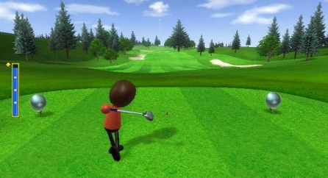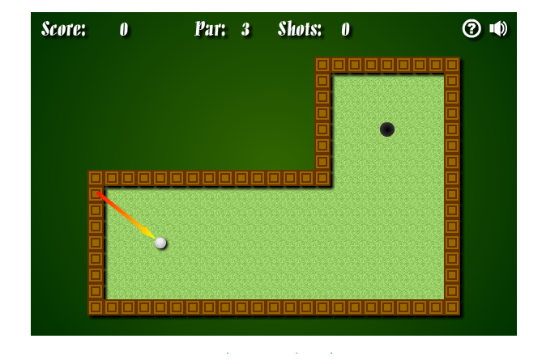mouse controls or keyboard controls

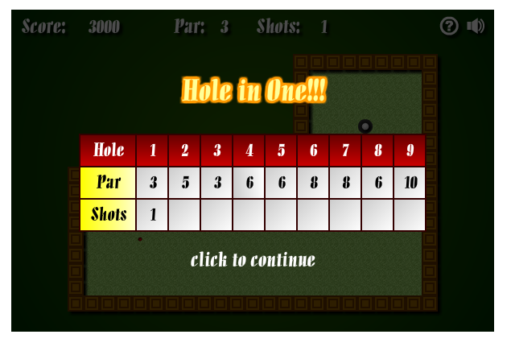Between each round your score will be shown with your opponents score and par for the hole.

Textures:
The hole and how it affects the ball 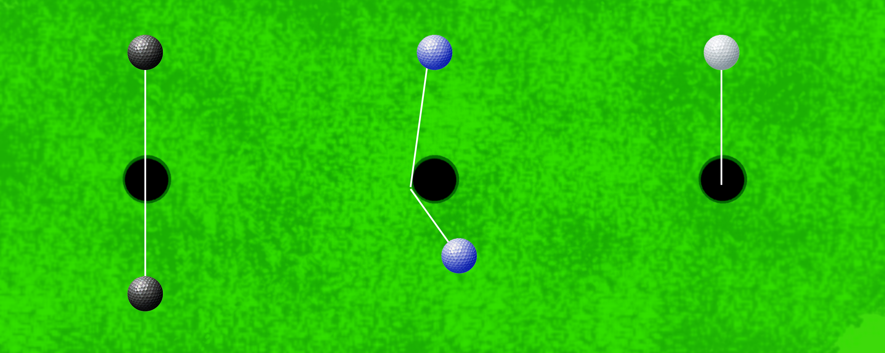

Player Roles and Actions
- The goal of the game is to score lower than Tiger Woods.
- The score of Tiger Woods is determined by a random number generator based on the par score.
- The player controls direction of the ball and power of the swing.
- There will be a short line representing the vector of travel to assist players in aiming the ball.
- The direction is controlled with the arrow keys.
- For the power of the swing, the player must stop a moving line on a rectangular power bar using the [spacebar]. The first stop determines the power of the swing – the higher up on the bar, the more powerful the swing. After this, the line descends on the bar and the player must stop the line at a certain point. If it is exactly center, the ball will travel on a straight line. If not, the ball trajectory will be off-center by a few degrees. This will have a more profound impact when the ball travels farther.
- The player avoids obstacles and attempts to sink the ball in the hole.
- The ball must be traveling slower than a certain speed to ensure that it won’t skip over the hole.
Strategies and Motivations
- Motivation: To score par or less on each hole while simultaneously beating the opponent’s score.
- Strategy: Find the most efficient path from the starting point to the hole.
- Strategy: Activate switches that make it easier to reach the hole.
- Strategy: In holes with two paths, the shorter one will be harder to traverse and therefore the player can take a risk for a reward. Otherwise, they can choose the longer—but safer—path.

II. Level Summary/Story Progression
There are 9 different holes.
Each hole has different obstacles and a constant number that represents the “par” of the hole.

Level Walkthrough
Level 1
- Basic putt-putt green with no obstacles.
- U-shaped design.
Level 2
- Basic putt-putt green with slopes.

Level 3
- Irregular shaped obstacles, narrow pathways, rounded obstacles.

Level 4
- Moving obstacles.
Level 5
- Conveyor belts.
Level 6
- Ice.
Level 7
- Slopes up to plateau of ice.
Level 8
- High friction
Level 9
- Invisible obstacles
- Last one collided with will stay visible until next collision

III. Development Specification
Hardware
- The computer must be able to run DirectX 9

- The user must have a standard input keyboard

Software
- DirectX 9

- Requires the executable file to run the game

Algorithm Style
- Friction will be determined by the surface the ball rolls on (low – ice, medium – putting green, high – sand)
- Gravity will play a role when the ball travels on a slope.
- Random number generators will be used to determine the opponent’s score.
- The walls will use standard angle reflection upon collision. This will consist of negating either the X or Y value of the balls path.
- Holes will use planetary gravity to influence the ball’s path of travel.

