2D Game Pitch: Steam Wars
CIS 487
Jared Baker & MICHAEL GREENLEAF

Executive Summary

Abstract
The protagonist Hiro will fight through a continuous onslaught of futuristic steam punk foes (Crimson Melee, and Turret). Hiro is armed with a katana for close quarter combat and hand gun that can be used for ranged attacks.

Game Style
This is a single player, arcade style side scroller game.

Licensing
The game is based on steampunk a sub-genre of science fiction characterized by a setting in which steam power predominates as the energy source for industrial technologies, inspired by industrial civilization during the 19th century. However the twist is somewhat of a future land in which power sources like fossil fuels are no longer a viable source and only the wealthiest and most powerful people in the world have access to them which has regressed society to steam power.

Game Play

Appearance
- General Techniques
  - Hiro and two enemy types are first modeled in 3D using the Blender open source 3D content creation suite.
    - This approach streamlines the animation process and allows easier scaling of character models without the loss of resolution.
    - The use of Blender’s animation tools allows for smoother animations by calculating armature paths in a way that Adobe Photoshop cannot.
    - 3D modeling also helps create more realistic shading on character models that is more difficult to achieve with more traditional image editors.
  - 3D models are obtained from BlendSwap, a blender community, and meshes are modified to personal taste.
    - All models are royalty free and the creators gave permission to use their models even in commercial applications.
  - 3D models are rigged, textured, and animated by Michael.
  - Stills from the animations are imported to Adobe Photoshop in order to turn the 3D model animations into 2D sprite sheets.
- Concept Art
  - Background and Heads-Up Display (HUD)
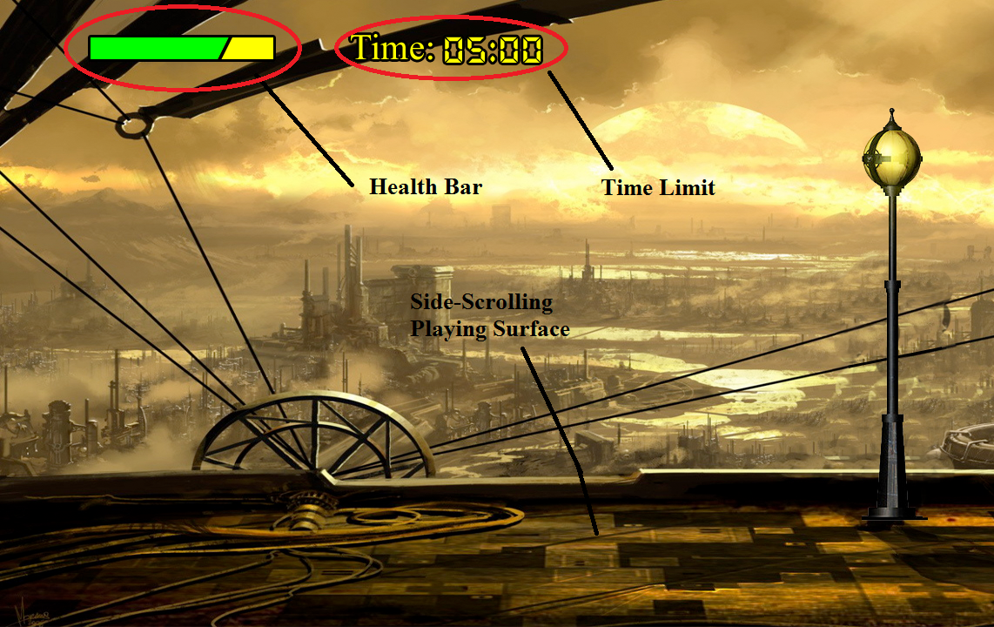
  - Final Version:
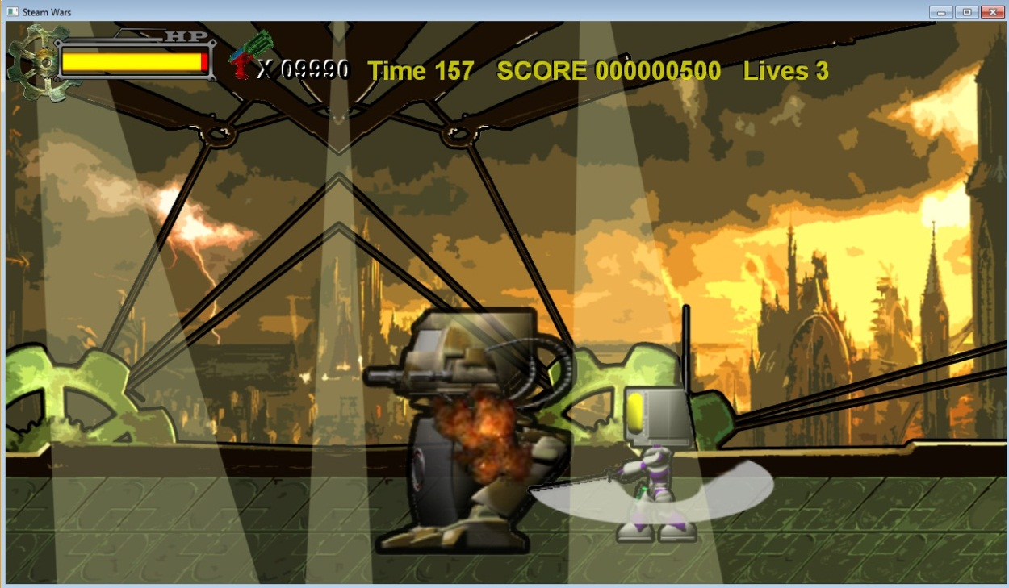
  - Hiro
    - Animations
      - Idle
      - Move
      - Attack-Shoot
      - Attack-Slice
      - Jump
      - Block
      - Take Damage
      - Death

  - Final Version
  - Crimson Melee Enemy
    - Animations
      - Idle
      - Move
      - Attack-Punch
      - Take Damage
      - Death – Sliced
      - Death – Shot

  - Turret Defense Enemy
    - Animations
      - Idle
      - Move
      - Crouch
      - Attack-Shoot
      - Take Damage
      - Death – Sliced
      - Death – Shot
  - Final Version

Player role
The “player” is the character controlled by the user. The player’s goal is to attain the highest score possible by killing enemies while avoiding being killed given the allotted time frame for the level.

Actions
Move: Keyboard arrow keys or A/D. Horizontal and jump movement will be supported.
Attack: Mouse left-click. Hiro will perform a sword strike (if time allows we will implement a separate animation for a combo attack.)
Update: time did not allow for a combo attack.
Attack: Mouse right-click. Hiro will shoot his handgun. We plan on only allowing a set number of bullets so the player is not reliant on ranged attacks. Additionally the player will come across some foes which render the range attack useless.
Update: It was more fun to just let the player fire away, so the player was given a large number of bullets.

Move
The player will be capable of moving in one of three directions, horizontally (left/right), and vertically (jump).
The player will have the ability to attack while moving.
The player will not be able to attack while in the air jumping.
Update: player can attack while in the air.

Attack
The player will attack by clicking the left / right mouse buttons anywhere. The player character’s projectile will move across the screen horizontally and will disappear after hitting an enemy. If multiple enemies are on the screen only the first enemy hit by the projectile will have damage inflicted.

JUMP
Pressing the Space Bar will allow Hiro to vertically jump but it will be up to the player to control movement in the air.

Other Controls
Pause: Pressing the P key will cause the game to pause during play.
End Game: Pressing the Escape key will cause the game to terminate.
Update: escape key functionality not implemented.

Enemy role
Enemy characters are controlled by the AI. Each enemy’s goal is to attack and kill the player. Enemies cannot attack one another and cannot damage one another. Enemy characters will chase the player, and attack the player with their weapons.

Actions
Chase: The enemy will attempt to stay within an optimal attack radius of the player.
Attack: The enemy will attack the player.

Difficulty
Difficulty scaling will be implemented to progressively make enemies spawn with a greater amount of hit points and faster movement.
Movement speed: The speed at which the enemy moves.
Attack speed: The speed at which the enemy’s weapon moves.
Health: The number of hit points the enemy starts with.
Update: difficulty scaling not implemented, though framework for it was coded.

Enemy Types

Crimson Melee
Crimson Melee are steam punk cyborgs equipped heavy fists and will spawn at various intervals with randomly scaled attributes based on the number of enemies currently dispatched.
Update: attributes are not randomly selected.

Turret Defense
Turret’s are a mechanized gatling gun with impenetrable armor mounted to deflect all frontal attacks. It will shoot multiple projectiles in a stream which will spread making the player have to move to avoid the incoming attack or block the incoming projectiles.
Update: The projectiles travel in a straight line.

Weapons

Katana
The katana attack will be a horizontal swipe. Combo attacks with the katana will have a separate animation and deliver more damage. However in using a combo attack (i.e. button mashing) the player will be left open to attack as the recovery from a combo is longer than a standard attack.
Update: no combo attacks were made.

.50 cal Steam pistol
This is a ranged weapon which can be used to attack enemies from a distance. Ammunition will be limited and will only be replenished after certain in game milestones have been achieved.
Update: ammo is never replenished, though the starting ammo count is very high (10000 bullets).

Pickups
Pickups will drop out of dispatched enemies. Pickups cannot be applied to enemies. Pickups will spawn at a completely random interval, but will be influenced more heavily as the game gets more difficult.
Steam Boost (White Canister): The player’s movement speed is slightly increased and attack damage for all attacks is doubled for a few seconds.
Health (Green Canister): The player’s health points will be increased by a few points, proportional to the life of the enemy that it spawned from.
Update: no pickups were coded.

Levels
Randomized waves of enemies will appear throughout each level. Tougher enemies are more likely to appear in higher levels. Enemies can spawn on either side of the player off screen. At most three foes may be present on screen at any given time.
In order to pass each level, the player is required to kill a certain number of enemies. Higher levels will require a larger number of kills to pass the level.
The player will receive a health bonus and a score bonus for passing a level.
There is no limit to the number of levels. The game ends when the player’s health decreses to zero.
See Appendix B for screen transitions.
Update: multiple levels were not created.

Story Background
The year is 2496, civilization is falling apart. Three years earlier the Tachicoma virus infected all machines linked into the national network. Machines have become self-aware and organized into colonies away from humans. The organized colonies have separated into two competing factions. The RT090 which seeks to destroy the human race and acquire what remains the world’s last bit of power, and the TM553 which defends the human race.
After a combat program installation to his ROM Hiro, a mere house bot and member of TM553, has been sent on a scouting mission. Although he has been upgraded to defend himself in combat Hiro lacks any form of stealth and is quickly identified by the RT090. After breaking free from the scrap yard Hiro must fight his way out of the enemy encampment to report his mission intelligence.

Story Progression
This game is intended to be classified within in the arcade genre, and thus does not outline a story progression throughout the game. The objective is to beat your own best score, or to beat someone else’s best score, not to “finish” the game decisively.

Strategies

Sword attacks
Sword attacks can affect Crimson Melee from any direction.
Sword attacks will only damage Turret if it is attacked from behind.
Sword attacks trade attack range for power.

Gun Attacks
Crimson Melee can be shot from any direction.
Turret can only be show from behind.
Gun attacks trade power for range.

Scoring
Points are awarded for every enemy killed. Points awarded will use a mathematical formula to award points based on the length of time the enemy was alive and the difficulty of the enemy.
Multiple kills resulting from a single attack are awarded points multiplied by a bonus factor. The bonus multiplier is compounded after each kill and is set to zero if the player is damaged with an enemy attack.
A level clear bonus will be awarded. The bonus will be proportional to the level number passed.
A remaining health bonus will be awarded when a level is cleared. The bonus will be proportional to the number of health points the player has remaining.
Update: each enemy type has a unique score value that remains constant. There is no level clear bonus. Remaining health is not converted into a higher score.

Sound Effects
Hit: Plays when an armed weapon collides with an opponent.
Gun: Plays when Hiro fires her gun or the Turret fires his gun.
Slice: Plays when Hiro uses her sword.
Death: Plays when armed weapon dies.
Pickup: Plays when the player collides with a pickup.
Update: no sound effects for pickups as none were implemented

Development Specification

Target Platform

Software
- Microsoft® Windows® XP or later
- DirectX 9 or later libraries.

Hardware
- Modern desktop or laptop
- Keyboard

Hit Testing

Collisions
Collisions will be calculated using the bounding box overlap method. This will be the case for both melee and projectile attacks.

Algorithms/AI

Algorithm Style
  - Structure
    - The basic structure follows the examples given in the Kelly (2011) book. Our code contains the following central classes:
      - Game Class
      - Sprite Manager
      - Sprite Class
        - Player Controlled Character Class
        - Crimson Melee Enemy Class
        - Turret Defense Enemy Class
        - Projectile Class
      - Input Class
      - Audio Class
    - The Sprite Manager controls all sprites. It handles the animations for each sprite based upon each sprites action, such as attacking or taking damage.
    - Each enemy class contains enemy-type specific AI.
    - The player controller class contains code that assigns keyboard input specific actions like attacking and movement.
    - Audio cues produced from enemy and player actions are handled within their respective classes.
  - AI
    - General Enemy Instructions
      - Default animation = Idle.
      - If status = is hit
        - Animation = Take Damage
        - If attack type = slice
          - Health -= 4
        - If attack type = shoot
          - Health -= 1
      - If health <= 0
        - If attack type = slice
          - Animation = Death-Sliced
        - If attack type = shot
          - Animation = Death-Shot
    - Crimson Melee Enemy
      - If Main character is within 3/5 the game window width.
        - If no collision
          - Move towards Main character
        - Else if status = normal
          - Begin attacking Main Character
    - Turret Defense Enemy
      - Default: Idle
      - If Main character is further than 3/5 the game window width
        - Move towards Main character
      - If Main character is less than or equal to 3/5 the game window width
        - If not crouching
          - Animation = crouch
        - If crouching & status = normal
          - Animation = Attack-Shoot

      - If Main character attack from front
        - Damage nullified
      - Else if Main character attack from behind

Appendix B
Screen transitions

ART & SOUND Credits
- Cityscape:
  - Bingo Mango
    - http://bingomango.tumblr.com/
    - http://www.tumblr.com/tagged/cover-photo?before=1346783507
  - & Michael Greenleaf
- Sprites:
  - 3D Model Meshes:
    - Crimson Melee
      - Paul Dunne
    - Turret
      - Sebastian Lague
    - Hiro
      - Alisson Farias
      - Michael Greenleaf
    - Katana
      - Krzysztof Zwolinski
    - Steam Pistol
      - Christian Nietsche
  - Model Texturing, Rigging, & Animation
    - Michael Greenleaf
  - 3D Model conversion to sprite:
    - Michael Greenleaf
- Background Music:
  - Capcom : Mega Man X "Palace Grounds"
- Sound Effects:
  - Freesound.org

