2D Game Pitch
CIS 587
Davin Moilanen

Executive Summary

Abstract
The player battles for survival in a combat arena. The player is armed with a flying disk that can be thrown to attack opponents or held up to block incoming attacks. The disk always returns to its owner after being thrown.

Game Style
This is a single player, arcade style game.

Licensing
The game is based on the flying disk competitions in the TRON movies. It is also inspired by the TRON: Deadly Disks game for Intellivision.

Game Play

Appearance
A 2-D, top-down view of the arena and players will be displayed. The visual elements will be slightly foreshortened to provide a rudimentary illusion of depth.
Animated bitmap sprites will be used to represent the player and enemy characters.
The players’ movements will be constrained by arena boundaries, which will be visible at all times (non-scrolling).
No obstacles to movement will be present in the arena.
See Appendix A for a visual representation.

Player role
The “player” is the character controlled by the user. The player’s goal is to attain the highest score possible by killing enemies while avoiding being killed.

Actions
Move: Keyboard arrow keys or W/A/D/S. Horizontal, vertical, and diagonal movement will be supported.
Attack: Mouse left-click. The player’s flying disk will be launched toward point clicked.
Block: SPACE key. The player cannot move, change direction, or throw while blocking.

Move
The player will be capable of moving in one of eight directions, horizontally, vertically, and along both diagonals. This means that multiple key down events will need to be processed as one.
The player will have the ability to attack while moving.
The player will not be able to attack while blocking, nor will blocking be possible while the disk is in flight.

Attack
The player will attack by clicking the left mouse button anywhere within the arena boundaries. The player character’s disk will travel to the exact location clicked, and then it will return to the player.

Block
Pressing the block key will halt movement and continue blocking until released. The player character will block in the direction it was facing when the block key was pressed. Diagonal blocking will not be allowed.

Other Controls
Pause: Pressing the P key will cause the game to pause during play. The game will also pause automatically whenever it is deactivated (e.g. if another application is activated) during play.

Enemy role
Enemy characters are controlled by the AI. Each enemy’s goal is to attack and kill the player. Enemies cannot attack one another and cannot damage one another. Enemy characters will chase the player, attack the player with their weapons, and dodge the player’s attacks.

Actions
Chase: The enemy will attempt to stay within an optimal attack radius of the player.
Dodge: The enemy will attempt to dodge the player’s attacks.
Attack: The enemy will attack the player.
Block: Enemies will not be capable of blocking in the demo software.

Difficulty
Intelligence: The more intelligent the enemy is, the more sophisticated its decisions will be.
Movement speed: The speed at which the enemy moves.
Throwing speed: The speed at which the enemy’s weapon moves.
Health: The number of hit points the enemy starts with.

Enemy Types

Warrior
Warriors are armed with a flying disk, and come in three classes:
Red: Low intelligence, low movement speed, high throw speed, high hit points.
Orange: Medium intelligence, very high movement speed, low throw speed, low hit points.
Yellow: High intelligence, high movement speed, medium throw speed, high hit points.

Guard
Guards are yellow warriors armed with a stun pole instead of a flying disk. The stun pole cannot be thrown, but it deals more damage than a flying disk when it contacts the player. The guard will attempt to stay within attacking range of the player. When in range, the guard will attack by charging the player.

Weapons

Disk
This weapon is carried by the warrior enemy type and the player.
The disk is harmless to opponents while being held by its owner. When thrown, the disk becomes armed and deals damage to opponents that it collides with. The disk is armed while in flight, which includes the return trip back to its owner.
The disk travels at a constant speed when thrown. It travels to the point at which it was aimed, and then travels at the same speed back to its owner. It will follow the owner’s movements on its return trip so that it always returns to its owner’s hand.
The disk can also be used to block attacks. The disk can only block in one direction at a time, horizontally or vertically, but it becomes significantly larger when blocking. This creates an effective shield against attacks from one quadrant.
When a disk is blocked by an opponent, it is disarmed and floats slowly back to its owner. A disarmed disk is rearmed the next time it is thrown.
If a disk collides with a wall, it behaves as if it were blocked.

Stun Pole
This is a melee weapon and cannot be thrown. It deals more damage than the disk. Only enemy guards carry this weapon.
When this weapon is blocked it becomes disarmed for a period of time, after which it is automatically re-armed.

Pickups
Pickups appear the arena at random intervals and are applied when the player collides with them. Only two pickups can be present on the screen at once and appear in one of two pre-defined locations. Pickups cannot be applied to enemies. There will be a maximum number of pickups per level.
Invincibility (White): The player becomes invincible for a few seconds.
Speed Boost (Green): The player’s movement speed and throw speed are multiplied for a few seconds.
Health (Blue): The player’s health points will be increased by a few points.

Levels
Randomized waves of enemies will appear throughout each level. Tougher enemies are more likely to appear in higher levels. Enemies appear at one of four spawn points in the corners of the arena. At most four enemies may be present in the arena at any given time.
In order to pass each level, the player is required to kill a certain number of enemies. Higher levels will require a larger number of kills to pass that level.
The player will receive a health bonus and a score bonus for passing a level.
There is no limit to the number of levels. The game ends when the player’s health decreses to zero.
See Appendix B for screen transitions.

Story Background
As in the TRON movies, the player is a metaphorical representation of a security program, designed to protect its host operating system. The arena battles waged are representative of its efforts to protect the host system from hostile programs.

Story Progression
This game is intended to be classified within in the arcade genre, and thus does not outline a story progression throughout the game. The objective is to beat your own best score, or to beat someone else’s best score, not to “finish” the game decisively.

Strategies

Overthrow
Flying disks are armed during their entire round-trip unless they are blocked. By throwing beyond the actual target point, both the outbound and inbound trip can score hits on opponents.
Also, since enemies are limited in how often they can dodge an attack, if the enemy dodges the outbound trip, the return trip has a better chance of not being dodged.

Guided Return
Flying disks track their owner so that they always return to their owner’s hand. Since the player is free to move about during the disk’s flight, the disk can be “guided” toward a target on its return trip. Specifically, the player maneuvers so that the target is directly between the returning disk and the player character.

Fast Opponents
Some of the enemies are quite fast and are skillful at dodging attacks. The player can move in close and overthrow to increase the chances of a hit. Proximity to an enemy also makes the player easier to hit, so blocking the enemy’s attacks becomes important.

Disarming Opponents
Blocking an opponent’s weapon will effectively disable it for a period of time. Some enemies run so quickly that they outrun their blocked disk, which moves much more slowly than an armed disk.
A blocked stun pole will be disabled for a significant period of time.
Staying close to the walls can also tempt an enemy to overthrow into a wall, which will also disarm a flying disk.

Scoring
Points are awarded for every enemy killed. The points awarded for each kill are proportional to the enemy’s intelligence level.
Multiple kills resulting from a single attack are awarded points multiplied by a bonus factor. The bonus multiplier is compounded after each kill during a single attack and is reset when the attack concludes.
A level clear bonus will be awarded. The bonus will be proportional to the level number passed.
A remaining health bonus will be awarded when a level is cleared. The bonus will be proportional to the number of health points the player has remaining.

Sound Effects
Hit: Plays when an armed weapon collides with an opponent.
Block: Plays when an armed weapon collides with a blocking weapon. Also plays when a flying disk collides with a wall.
Pickup: Plays when the player collides with a pickup.

Pixel graphics
Each character will have a set of ten, 32x32-pixel art images that represent movement in each of the four principle directions of travel (up/down/left/right). To simplfy the animation, only the character’s legs will move.
LEFT/RIGHT: Each horizontal direction will have an associated two-frame animation. A two-frame animation trick, in which neither leg appears to be in the foreground, will be utilized in order to minimize the number of animation frames necessary.
UP/DOWN: Each vertical direction will have an associated three-frame animation.
The player and each of three classes of enemies will each have their own character animation loop. A base tile sheet will be color-shifted to different hues for each character.
See Appendix A for the character animation sheet layout.

Vector graphics
The arena background will be comprised of vector graphic lines rendered onto a background bitmap.
Disk weapons will be represented by ellipses.
Stun pole weapons will be represented by rectangles.
Pickups will be represented by unfilled ellipses and will be animated to appear as if they are rotating and bobbing.

Development Specification

Target Platform

Software
Flash versions supporting AS3.

Hardware
Modern desktop or laptop computer (made within the last 5-8 years)
Keyboard
Mouse

Hit Testing

Collisions
Armed weapons will collide with opponents by hit testing the character sprite’s pixels against the weapon’s bounding box. Each weapon is a simple shape, so its bounding box should be a sufficient approximation of its true shape.
Blocking weapons will collide with armed weapons using bounding box hit testing.
The player will collide with pickups using bounding box hit testing.
Flying disks will collide with walls using world boundary testing (no hit testing).

exclusions
Since characters may be able to sustain more than one hit before expiring, and the weapons do not disintegrate upon impact, a mechanism will need to be developed that only registeres the initial intersection of character and weapon as a hit. If this mechanism were to be omitted, then the characters would sustain damage on every frame that ticks while the weapon passes through the character. As soon as the weapon and the character are no longer touching, the weapon will be able to damage the character on the next hit.
Characters can pass through one another without colliding.
Since there are no obstacles in the background, the characters will be constrained to world boundaries, and hit testing against walls will be unnecessary.

Algorithms/AI

IQ Test
Since each enemy type will have a different level of intelligence, all of the algorithms (with the exception of “avoid walls”) will be preceeded by an “IQ test” which will determine whether or not the algorithm is allowed to proceed. The IQ test will essentially be a weighted random number test. Each IQ test will have a bar set based on how important or advanced the action is. The higher the bar, the less likely the enemy will be to pass the test. The higher the enemy’s intelligence, the more likely it will be to pass the test.

Minimum action delay
The frequency with which an enemy can perform a given action will be limited by a minimum delay threshold. A frame counter will count up to a minimum threshold before an action is allowed. The higher the enemy’s intelligence, the lower the minimum threshold will be. There will be independent delays for attacking, dodging, and other maneuvers. This will prevent the enemy from being too skillful or appearing unnatural in its movements.

Manuevers
Note: the following maneuvers are in order of precedence.

Avoid Walls
Enemies will avoid running into walls.
IQ bar: none

Dodge
Enemies will dodge incoming attacks from the player. The attacking weapon must be within a certain radius for the dodge to take effect. The dodge will generally be perpendicular to the incoming attack vector. For example, if the enemy is being attacked from the left, it will dodge up or down. If the attack is from the lower right, the enemy will dodge to the upper right or lower left.
IQ bar: high

Chase
Enemies will try to stay within a certain radius of the player in order to make effective attacks.
IQ bar: medium

Wander
Enemies that fail to perform any of the previous maneuvers will stay active by wandering aimlessly.
IQ bar: low

attack
Before attacking the player, the enemy must pass an IQ test.
IQ bar: high

Targeting

Exact throw
An exact intercept point will be calculated by finding quadratic roots, if any exist.
IQ bar: very high

Approximate throw
The player’s velocity and current distance will be used to calculate an approximate leading shot.
IQ bar: high

Direct THROW
The enemy will throw directly at the player’s location without attempting a leading shot.
IQ bar: low

Wild Throw
The enemy will at a point near the player’s current location, with a randomly generated inaccuracy added in.
IQ bar: none

Overthrow
When a flying disk is thrown, the enemy will have a chance to add a percentage increase to the calculated throw distance. This effectively increases the strength of the attack because there are two potential hits – one on the outbound trip (throw) and on on the inbound trip (return).

Charge
The charge is only performed by guards who are armed with stun poles. When a guard is within attacking range of the player, it will charge the player in a straight line at an accelerated speed.
Although attack actions in which a weapon is thrown are independent from movement actions, this is obviously not the case for charge attacks. For this reason, once a charge is begun, it will override all other maneuvers until it has been completed.
IQ bar: none

Appendix A
Arena schematic
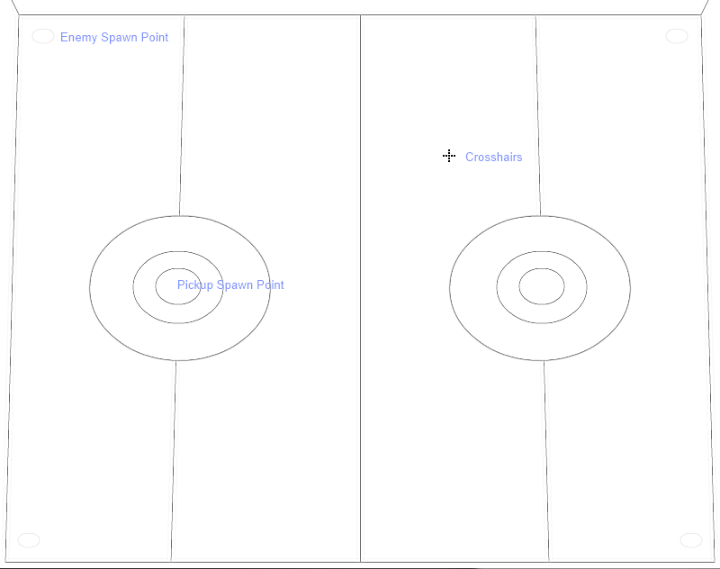
Character animation sheet layout

Appendix B
Screen transitions

