Game Pitch Document v2.0
2011
Artwork and Design by Carlos Devoto
CIS 587
10/19/2011
Contents
Revision Notes 3
Executive Summary 4
Plot Abstract 4
Game Summary 4
Game Play Look and Feel 5
Appearance 5
Player Roles and Actions 5
Level Progression 5
Strategies and Motivations 6
Development Specifications 6
Hardware and Software 6
Algorithm Style 7
Story Board 8
1. Title Screen 8
2. Main Quest Description 9
2. Chapter 1 Introduction Screen 10
3. Chapter 1 Game Screen 11
4. Chapter 2 Introduction Screen 12
5. Chapter 2 Game Screen 13
6. Chapter 3 Introduction Screen 14
7. Chapter 3 Game Screen 15
8. Chapter 4 Introduction Screen 16
9. Chapter 4 Game Screen 17
10. Chapter 5 Introduction Screen 18
11. Chapter 5 Game Screen (Boss Level) 19
12. Game Over Screen 20
Character Study - J. Alfred 21

Revision Notes
Feedback | Provided By | Revision
The title graphic doesn't appear too "barbaric", but  rather futuristic. | Mike Papo | Modified the “Prufrock” and “Game Over” graphics to appear as though made from burnished bronze, somewhat similar to the logo for the new Conan movie.
Is this correct? player speed < difficulty speed (slow player vs. increased speed of responsibilities)  Will this accommodate to the fairness of the game as one decreases while the other increases? | Mike Papo | Game will be tested thoroughly to ensure that this mechanic does not make the higher levels too difficult. The character speed, while it declines as the character advances, will never become so low that the character is incapable of dodging responsibilities. Also, as stated in the strategy section, moving slowly has its advantages in that it allows for more precise positioning of the character within the narrow gaps that appear between large clusters of responsibilities. A higher speed makes the character too sensitive to the slightest key press, thereby making the character more likely to crash at the higher levels.
One could make use of images to accompany the text images. This would broaden the audience. | James Montante | None. While this is a great suggestion, I do not feel that I have the time or the creativity to create compelling graphics to accompany the 40+ textual images that I plan to create for the game. Also, the textual banners present a very narrow silhouette (~16px) when viewed along the horizontal plane. Adding anything but the tiniest of images would alter this dynamic and make balancing the game a much greater challenge.
The game should include some sort of power-up, perhaps in the form of junk food or something similar. | Josh Lovatt | In thinking this through, I came up with the idea of an “Upgrade Graphics Card” power-up, since having the latest greatest graphics card is extremely important to video game enthusiasts. This power-up will appear at intervals and will be rendered as a textual image in order to maintain visual consistency, but using a different color in order to create differentiation. When the character collects this power-up by moving through it, he will be placed in “god mode” for a period of about 10 seconds. While in this mode, the character’s monitor will light up like the gates of heaven, the background will darken, the responsibilities will fade, and the character will be able to traverse right through responsibilities as though they do not exist. I feel that placing the character in “god mode” instead of restoring lives better reflects the solipsistic nature of his existence.
Initial screen shots at 800x600 resolution make it very difficult to see that the character is holding a game control, and a lot of the artwork details are lost. | Louis Devoto | I will scale the game and all of its graphics up from 800x600 to 1024x768 resolution.

Executive Summary

Plot Abstract
You are J. Alfred, an obsessed and goofy-looking video game junkie who will do anything to avoid the sea of responsibilities which threaten to pull you away from your fantasy RPG game, in which you play a slab-muscled barbarian named Prufrock.

Game Summary

But we had forgotten that alongside Orwell's dark vision, there was another - slightly older, slightly less well known, equally chilling: Aldous Huxley's Brave New World. Contrary to common belief even among the educated, Huxley and Orwell did not prophesy the same thing. Orwell warns that we will be overcome by an externally imposed oppression. But in Huxley's vision, no Big Brother is required to deprive people of their autonomy, maturity and history. As he saw it, people will come to love their oppression, to adore the technologies that undo their capacities to think and act.
--Neil Postman, “Amusing Ourselves to Death”
“Prufrock” explores the perspective that, beyond merely providing simple entertainment, video games are an artistic medium that can be used to express a point of view. Part gaff, part social commentary, “Prufrock” takes a tongue-in-cheek look at some of the views espoused by Neil Postman in his 1985 book, “Amusing Ourselves to Death”. Taking hyperbolic license, the game attempts to humorously showcase the stark contrasts which exist between video game players and the heroic characters that they often portray in video games. The name “Prufrock” is itself a reference to the main character of a famous T.S. Eliot poem, “The Love Song of J. Alfred Prufrock”. In Eliot’s poem, J. Alfred Prufrock is a frumpy, middle-aged guy who tries to come to grips with his own inability to lead a meaningful existence in the modern world. In short, J. Alfred Prufrock is the very antithesis of the characters usually portrayed within the heroic fantasy genre.
The game begins with a heroically scored and flowery introduction which is meant to lull players into believing that they are about to embark on a typical, immersive fantasy RPG quest. When the action begins, however, the player is surprised to learn that the protagonist of the tale is not the slab-muscled barbarian described in the intro, but rather a goofy-looking guy named J. Alfred, who is himself playing the fantasy RPG game that was described in the intro. In other words, the player is playing a character who is himself playing a video game. The intent here is to hold up a mirror to the person who is playing the game, thereby forcing that person to reflect on the ways that he or she is actually spending his/her time. The goal is to accomplish this in a light-hearted manner evocative of the now-famous “World of Warcraft” episode from the “South Park” TV series. The decidedly non-heroic goal of “Prufrock” is to help J. Alfred dodge a series of real-world responsibilities thereby allowing him to continue playing his fantasy RPG game unmolested.
To keep the game interesting, the main character evolves as the game progresses from a thin and healthy teen-ager to a slow and obese middle-aged man who requires an oxygen tube to breath. The responsibilities which J. Alfred must dodge also evolve in comical ways to reflect his changing circumstances. The fifth and final chapter is a boss level, which includes a surprise villain.

Game Play Look and Feel

Appearance
The game will employ two distinct art styles in order to showcase the contrasts between J. Alfred and his barbarian alter-ego, Prufrock. For the introduction, the chapter headings, and the main soundtrack, a style will be chosen to convey the gritty, heroic feel of a dark fantasy epic. For the actual game itself, the art will be cartoonish and comical, interspersed with high-pitched, whiny voice recordings of J.Alfred blurting out things that a typical video game player might yell up to his mother from the basement of their home, such as “I’ll be right up, mom, just let me finish this level!!”. These two distinct styles of art are depicted within the story board mock-ups that follow at the end of this document.

Player Roles and Actions
The game controls are deliberately kept simple, in order to appeal to casual gamers, and also for comical contrast to the highly elaborate controls typical of a fantasy RPG game. You can move your character up, down, left, right, and diagonally using the arrow keys, but you may never navigate off the screen. Your main goal is to dodge a series of responsibilities which appear as textual banners at random positions on the right side of the screen, moving rapidly towards the left side of the screen. Every time you are struck by a responsibility, you lose a life and are temporarily placed in an “AFK” state (i.e. “Away From Keyboard”). If you lose all three of your lives during the course of the game, you lose the game and must start over. Each level has a “responsibility quota” associated with it. Once you have successfully dodged this number of responsibilities you advance to the next level. For each responsibility that you dodge, you add 10 points to your score. If you can manage to complete all five of the levels, you win the game.
At periodic intervals, a special “Graphics Card Upgrade” power-up will appear at a random position on the right side of the screen, moving right-to-left just like the responsibilities. Colliding with this power-up will place the character in “god mode”, allowing him to traverse through any and all responsibilities without harm for a period of about 10 seconds.

Level Progression
As you progress through the levels, the following changes occur:
- Your character slows down to reflect your increased obesity, and failing health.
- The rate at which responsibilities are generated increases, which means that there are typically more responsibilities to contend with on the screen at any one time.
- The speed of the responsibilities increases.
- The nature of the responsibilities change to reflect J. Alfred’s changing circumstances. In the first level, he is a high school student with responsibilities typical of a healthy, well-adjusted teen-ager. By the second level, we find J. Alfred unemployed and out of school, living in his parents’ basement. By the third level, J. Alfred rarely moves from his video game console, and his parent’s are growing increasingly perturbed by his lack of initiative. By the fourth level, J. Alfred is out on skid row, trying to make ends meet while still playing his video game. By the fifth and final level, poor J. Alfred has finally gone around the bend; he hallucinates a nightmarish college lecture about video game design. The textual responsibilities provide a good vehicle for the unveiling the story of J. Alfred’s tragicomic life.

Strategies and Motivations
As with the game controls, Prufrock is deliberately simplistic in terms of engaging players at the strategic level. This contributes to the comical effect and surprise of the game, contrasting nicely to the somberness of the soundtrack as well as the RPG back-story. Players learn that the best way to avoid large clusters of responsibilities is to make small and precise movements, always moving towards the largest open space on the screen. This means that, paradoxically, the slower and more ponderous J. Alfred of the fifth level is actually easier to control than the young and erratic J. Alfred of the first level. This produces good balance as the player progresses through the levels, since the responsibilities come faster and more frequently. Players will also learn that staying towards the center of the screen keeps them from getting boxed into a corner, thereby giving them the best chance for survival. Finally, players will have some interesting choices to make about whether or not they should go after a power-up that appears in a remote or difficult-to-reach section of the screen.
In terms of motivation, players are pulled along primarily by schadenfreude, since each successive stage of the game brings startling and comical changes to the appearance of J. Alfred as well as to his circumstances in life, as reflected by the responsibilities which he must dodge. The chapter headings for the fantasy RPG game that J. Alfred is playing seem to be building towards some sort of grand heroic climax, which makes everything that is happening to J. Alfred seem all the more absurd and banal by comparison.

Development Specifications

Hardware and Software
Prufrock will be developed using Adobe Flex 4.5.1 SDK and tested using Adobe Flash Player 10. As such, it can generally be to run on any hardware/software platform that supports Adobe Flash Player 10 with the following exceptions:
- The game relies on keyboard events, so it will not run well on gesture-based mobile devices.
- The game is optimized for displays with screen resolutions of at least 1024x768 pixels.

Windows
- 2.33GHz or faster x86-compatible processor, or Intel® Atom™ 1.6GHz or faster processor for netbooks
- Microsoft® Windows® XP (32-bit), Windows Server® 2003 (32-bit), Windows Server 2008 (32-bit), Windows Vista® (32-bit), Windows 7 (32-bit and 64-bit)
- Internet Explorer 7.0 and above, Mozilla Firefox 4.0 and above, Google Chrome, Safari 5.0 and above, Opera 11
- 128MB of RAM (1GB of RAM recommended for netbooks); 128MB of graphics memory

Mac OS
- Intel Core™ Duo 1.33GHz or faster processor
- Mac OS X v10.6 or v10.7
- Safari 5.0 and above, Mozilla Firefox 4.0 and above, Google Chrome, Opera 11
- 256MB of RAM; 128MB of graphics memory

Linux
- 2.33GHz or faster x86-compatible processor, or Intel Atom 1.6GHz or faster processor for netbooks
- Red Hat® Enterprise Linux (RHEL) 5.6 or later (32-bit and 64-bit), openSUSE® 11.3 or later (32-bit and 64-bit), Ubuntu 10.04 or later (32-bit and 64-bit)
- Mozilla Firefox 4.0 or Google Chrome
- 512MB of RAM; 128MB of graphics memory

Solaris
- 1600 MHz Sun™ UltraSPARC® IIIi or faster processor
- Solaris™ 10
- Mozilla Firefox 4.0
- 2GB of RAM; 128MB of graphics memory

Android
- ARMv7 processor with vector FPU, minimum 550MHz, OpenGL ES 2.0, H.264 and AAC HW decoders
- Android™ 2.2, 2.3, 3.0, 3.1, and 3.2
- 256MB of RAM
- Android web browser
- BlackBerry PlayBook and a version of the BlackBerry® Tablet OS that supports Adobe® Flash® Player 11

Flash Access Clients
- Microsoft® Windows XP (32 bit), Windows Vista® (32 bit and 64 bit), or Windows 7 (32 bit and 64 bit)
- Mac OS X v10.6, v10.7 (32 bit and 64 bit) Linux®: openSUSE® 11.3 or greater (32 bit and 64 bit); Red Hat® Enterprise Linux (RHEL) 5.6 or greater (32 bit and 64 bit); or Ubuntu 10.4 LTS or greater (32 bit and 64 bit)s

Algorithm Style
The Prufrock game will be built upon the function reference state machine framework created by Jeff Fulton and Steve Fulton, and described in their book “The Essential Guide to Flash Games”. Small modifications will need to be made to the framework in order to better accommodate the following game elements:
- The BasicScreen class does not provide an adequate framework for creating screens that contain large foreground images, and which can be closed by simply pressing on any key or mouse button. I intend to create a BasicImageScreen class for this purpose.
- I also intend to slightly alter the progression of game states to better reflect the needs of my game. For instance, I intend to have the “level in” state take place before the “new level” state, since performing initialization for the next level prior to showing the “level in” screen causes elements from the next level to be displayed prematurely to the user.
- Finally, I also intend to enrich the framework with more callbacks to the Game class at specific game states. Why, for instance, does the framework lack a callback to Game for the “game over” state? This would provide the perfect hook to enable the Game instance to perform a clean-up operation on its resources.

In terms of physics, Prufrock will employ simple, fixed-velocity movement for both the main character and the responsibilities that the character must dodge, since this best reflects the cartoonish arcade style of the game play.

Story Board

1. Title Screen
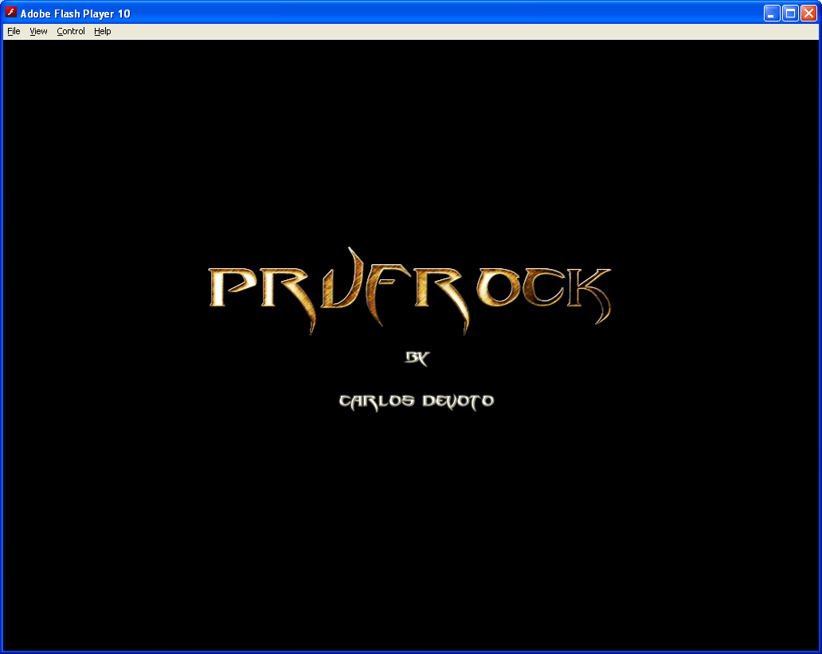

2. Main Quest Description
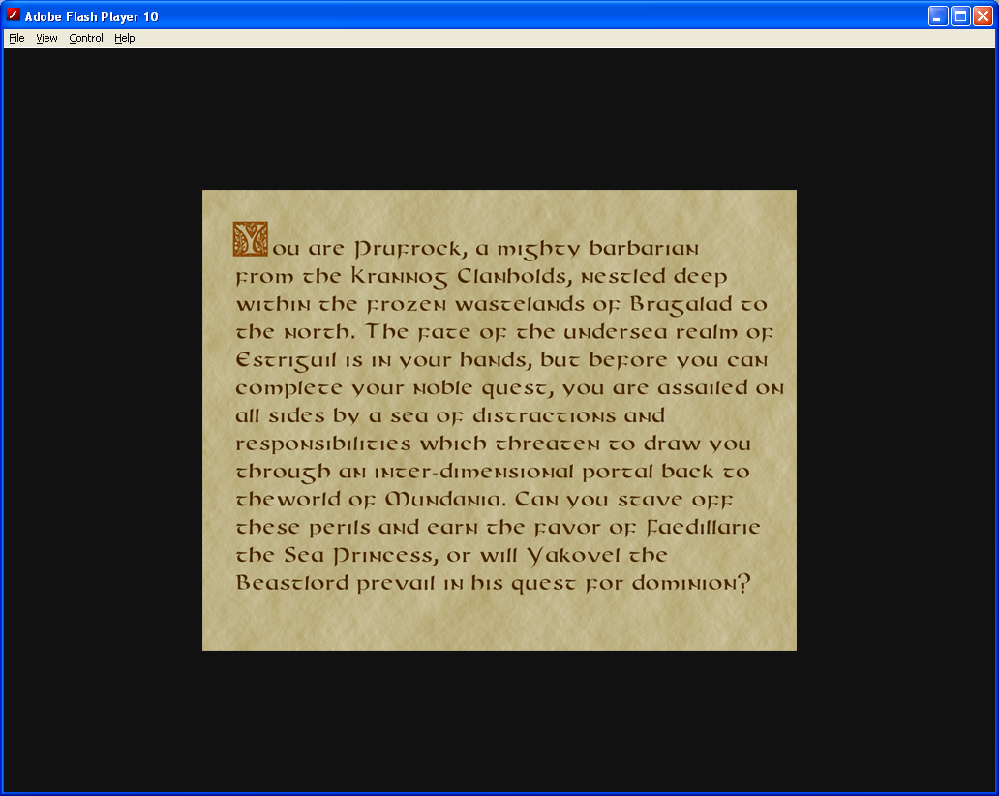

2. Chapter 1 Introduction Screen
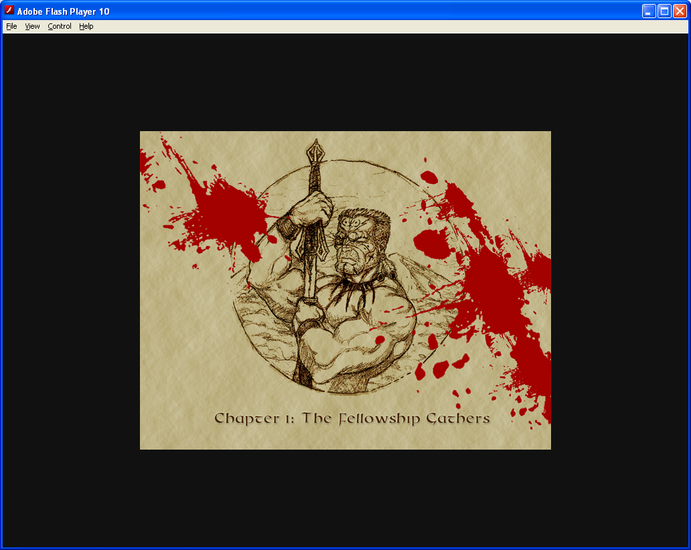

3. Chapter 1 Game Screen
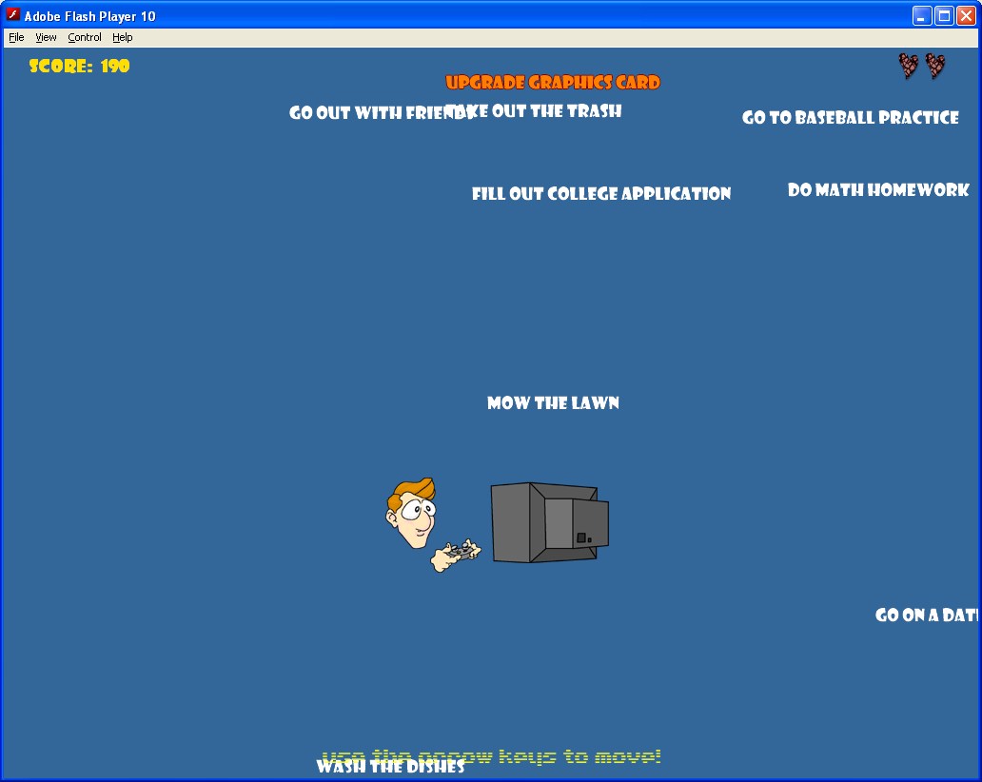

Chapter 1 Game Screen – Power-Up Mode
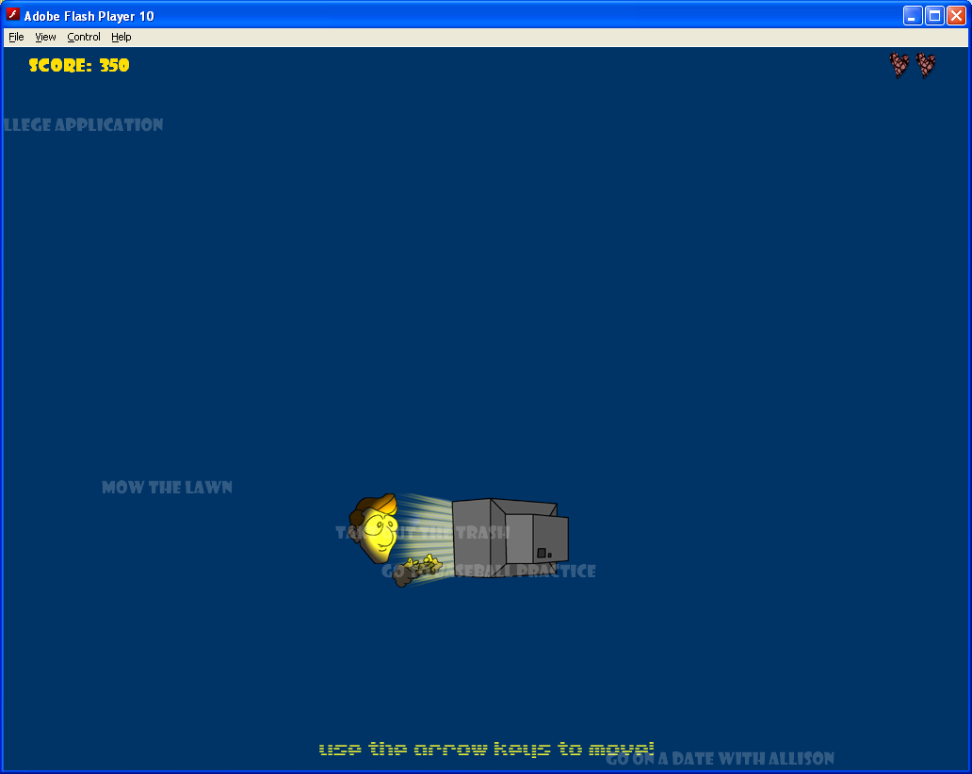

Chapter 1 Game Screen – Character Death (AFK)

6. Chapter 2 Introduction Screen
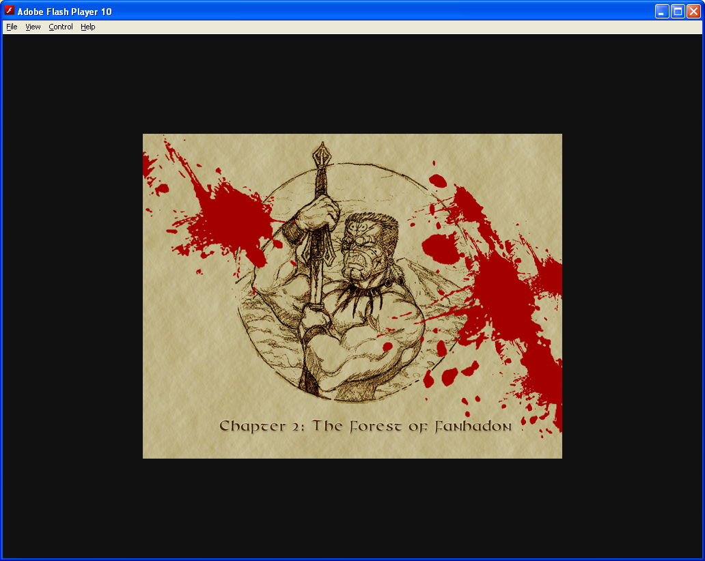

7. Chapter 2 Game Screen
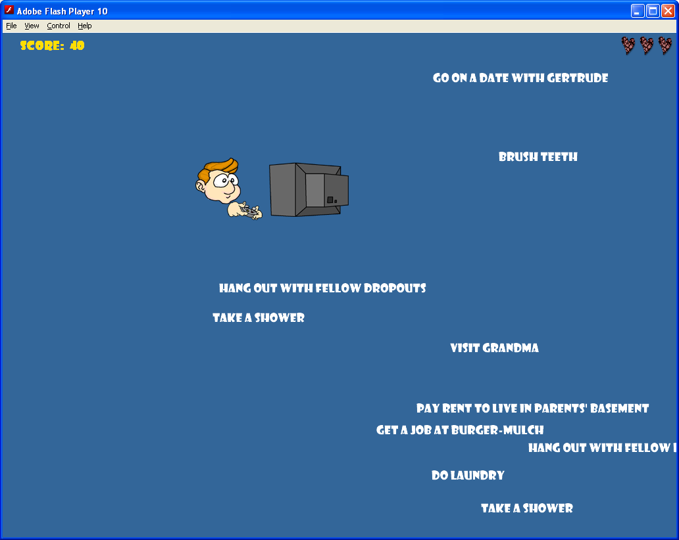

8. Chapter 3 Introduction Screen
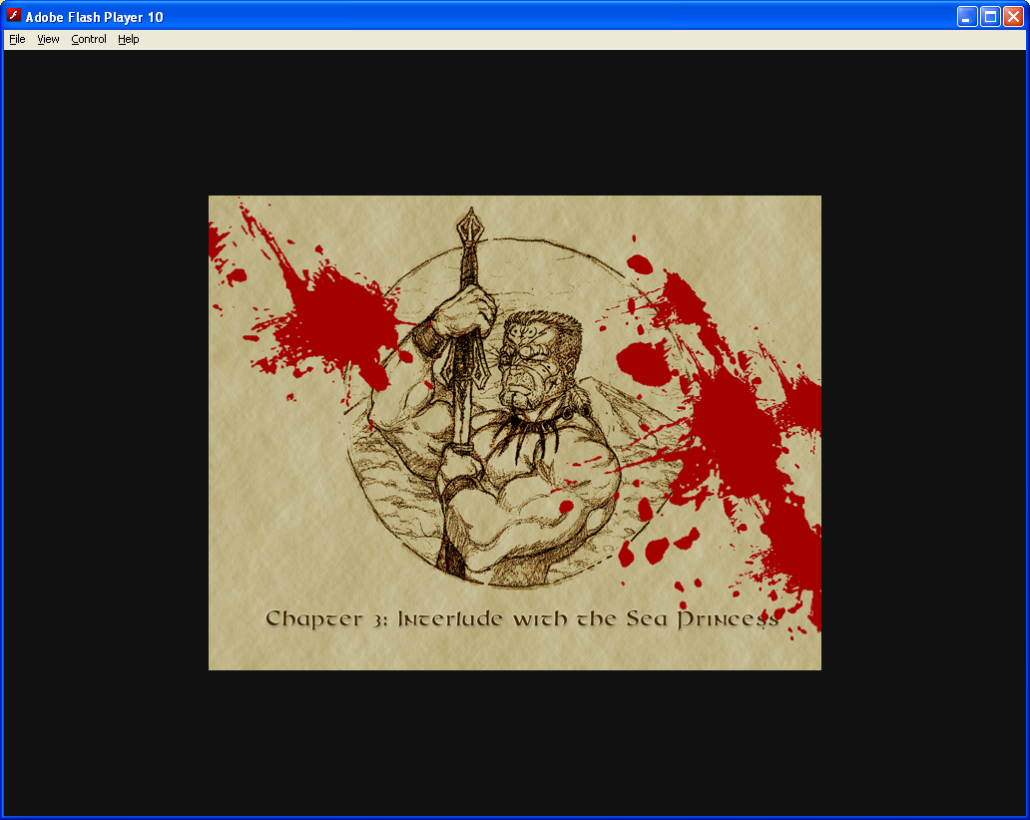

9. Chapter 3 Game Screen
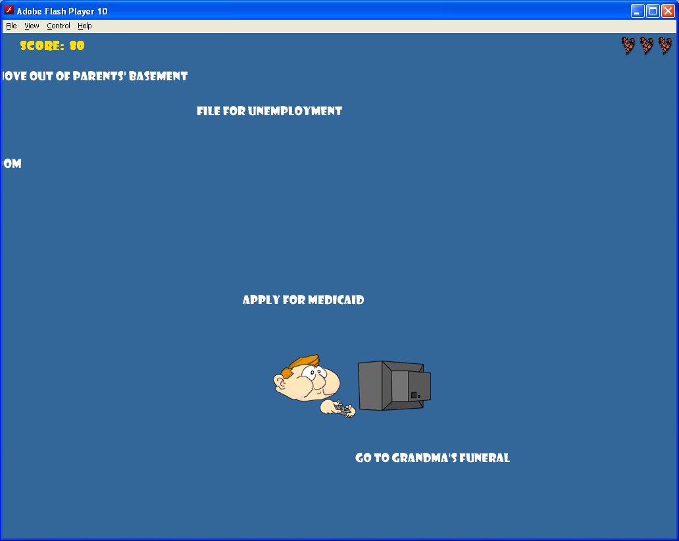

10. Chapter 4 Introduction Screen
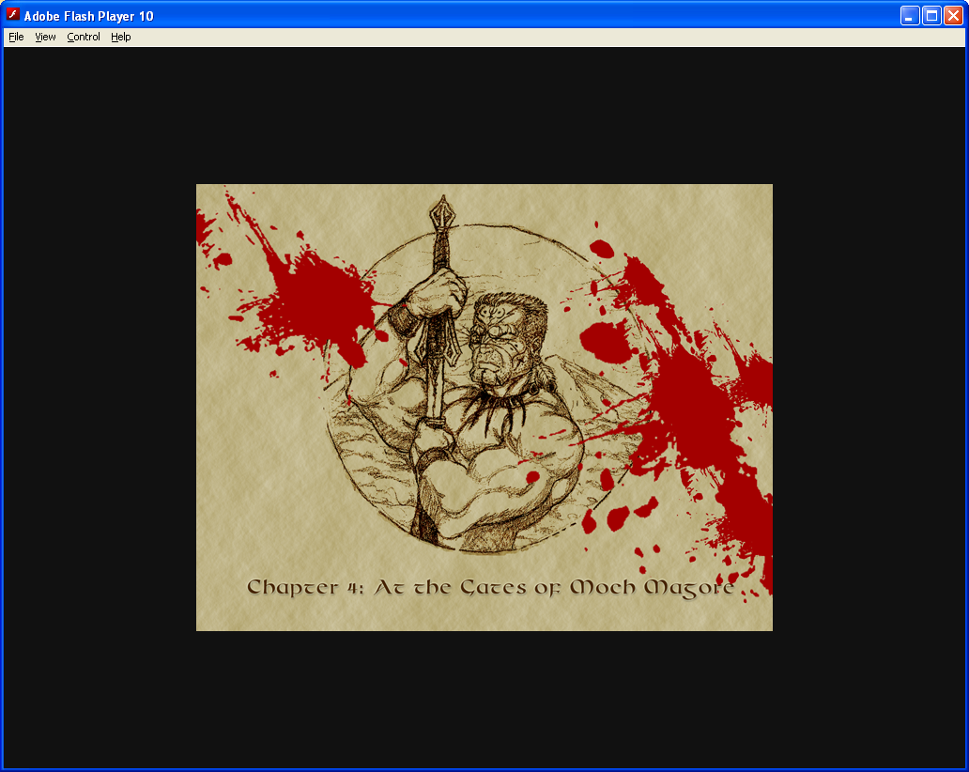

11. Chapter 4 Game Screen
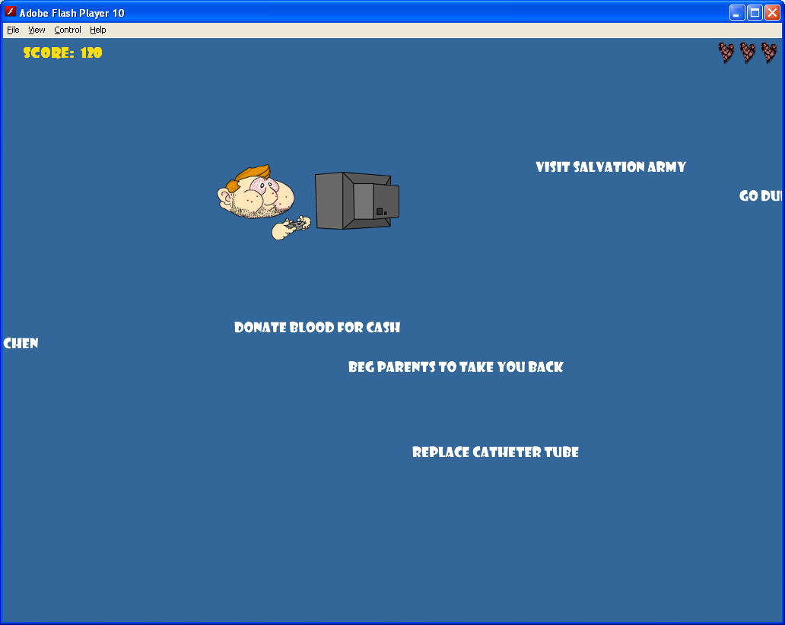

12. Chapter 5 Introduction Screen
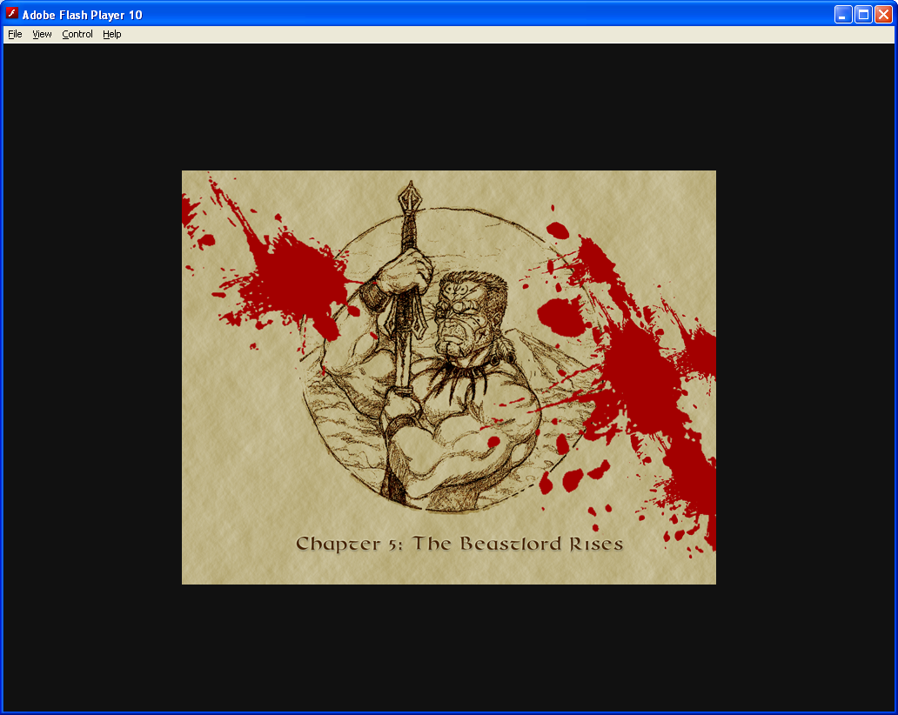

13. Chapter 5 Game Screen (Boss Level)
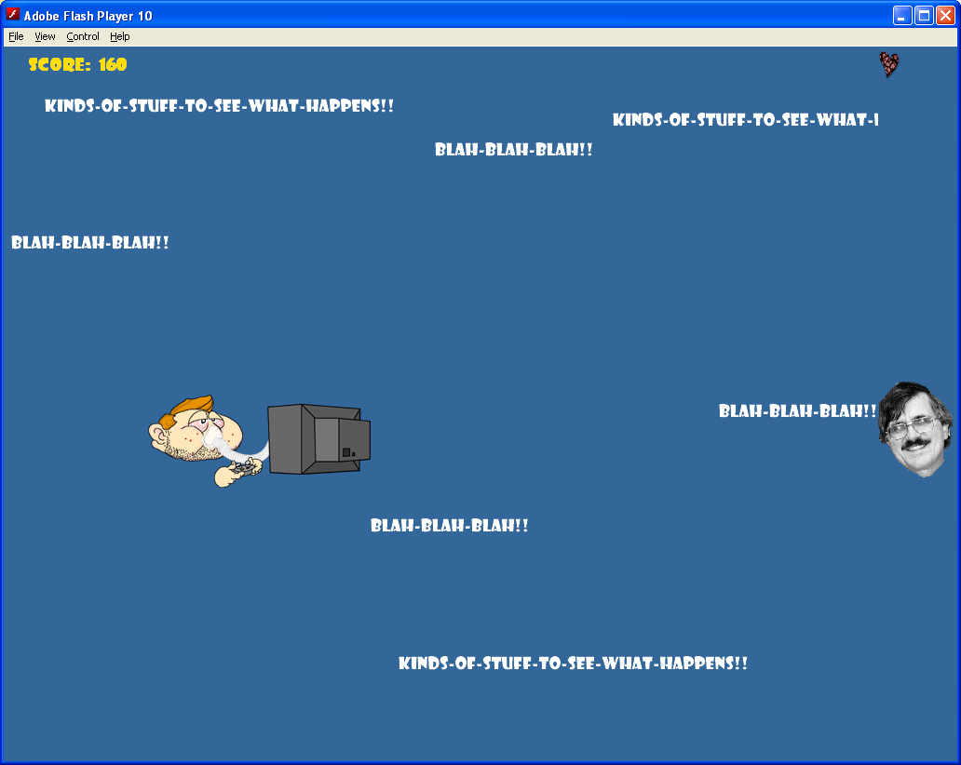

12. Game Over Screen
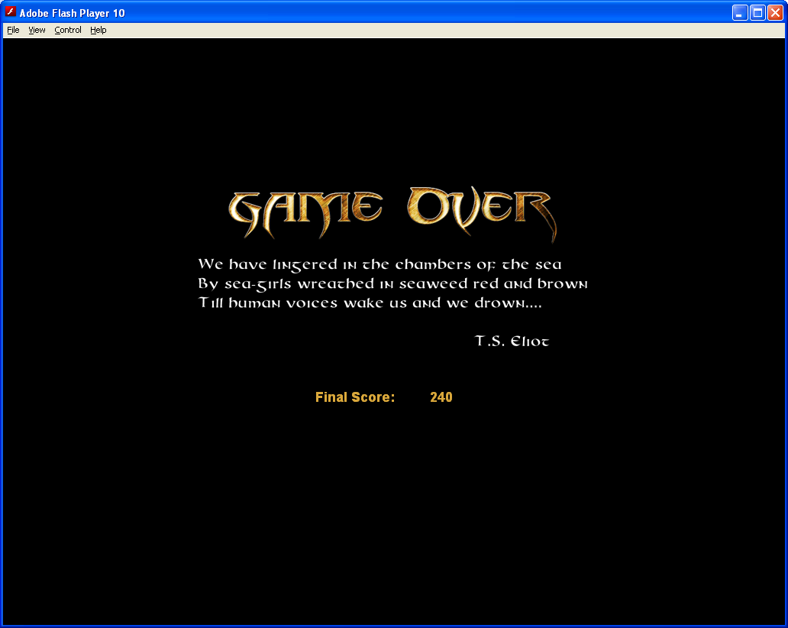

Character Study - J. Alfred
