2D Game Design Document

Zombie Joust

CIS 487: Computer Game Design

Dr. Maxim



Matthew Portelli Vincent Shaw

Executive Summary

Abstract of Game Story
An evil overlord has plans for world domination. He is raising and army of undead minions to do his bidding and only one man stands in his way, The Red Knight. A zombie plague threatens the once peaceful kingdom and The Red Knight is fixed on stopping it. His only chance is to defeat the evil overlord in a jousting competition, but first he must joust his way to the top of the ladder.

Game Play Look and Feel

Appearance
The game will be played from the side view perspective, where the player and his/her opponent can be seen clearly. The scenery will consist of a fixed background with some animated elements to enhance ambiance (i.e. twinkling stars), and the setting is that of a fantasy realm. The appearance and sound should produce and ominous mood overall.
The physics in the game will give players a feeling of acceleration and momentum as their mount transitions from a trot to a gallop.

Samples of character models and backgrounds for the levels can be seen below.

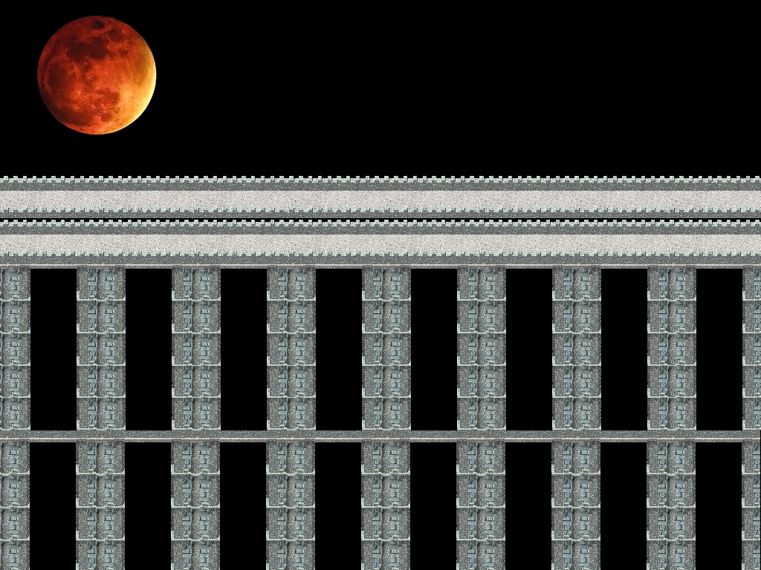
Final Boss Stage: Bridge to the Underworld

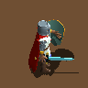
The Red Knight

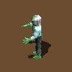
Braineater

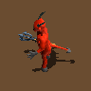
The Evil Overlord

Player Roles and Actions
The player assumes the role of our protagonist, The Red Knight. He/she will compete in a series of jousting matches with the ultimate goal of reaching the evil overlord and finally defeating him to save your kingdom. In each jousting match the player must charge down his/her lane to intercept their opponent. At the moment of intersection, the player must execute an attack to knock his/her opponent off their mount.

Strategies and Motivations
The motivation for defeating the evil overlord is to prevent the zombie plague and return peace to your kingdom. The strategy is to defeat each of the three underlings and use their body parts to create the Death Lance. The Death Lance is the only weapon that can defeat the evil overlord as it is a manifestation of his own dark magic.

Level Summary/Story Progression
The player must defeat three underlings before he/she has a chance to vanquish the evil overlord. The rewards for each of the underlings will be a piece to the Death Lance, which is the only weapon that can kill the evil overlord.

Stage 1 Braineater: The player must defeat this opponent in order to obtain the skull piece for the Death Lance.

Stage 2 Bonecruncher: The player must defeat this opponent in order to obtain the spine piece for the Death Lance.

Stage 3 Fleshripper: The player must defeat this opponent in order to obtain the hip bone piece for the Death Lance.

Final Boss: The player must defeat the evil overlord himself on his home turf, The Bridge to the Underworld.

Development Specification

Hardware

Keyboard
Mouse
Screen with resolution 1024 x 768 or greater
CPU: 1.0 GHz processor
Memory: 512 Mb Ram

Software

Windows XP or later operating system
DirectX9.0c or later installed on the machine

Algorithm Style
The game will run inside of the main game loop. The loop will check for input from the mouse and keyboard and act accordingly. The main game loop will also update the positions of the characters on the screen and check whether or not the “attack” key was pressed within the precise timeframe to knock the opponent off their mount.

