Name
A final name has not yet been chosen.
Working titles:
- Bug Huntin’
- Little Tommy

By: Craig Crowder and Chris Kulczyk

Executive Summary

Abstracted Story Line:
Little Tommy’s in a pickle. He’s left alone all day in a dirty house with nothing to eat. His house is full of bugs and rats. Trash is everywhere. With nothing to eat and vermin everywhere, how will he survive?!? He needs to find his Mommy.
Little Tommy is a smart boy. He can find ways to keep himself entertained! He’s goin’ Bug Huntin’!!! Armed with whatever he can find in his house (a rattle, a hammer, a baseball bat), Little Tommy will fight his way through an army of bugs and rats trying to find his Mommy!
Bugs are fun! They go “SPLAT” when he whacks them. And, they leave a great big pile of bug guts behind when he pounds them!
Little Tommy doesn’t like rats – they nibble and bite! If he gets too many bites, he’ll die. AND, he can’t whack the rats. It’s better just to run away from them.
But, Bug Huntin’s tiring work! He has to keep up his strength, but there’s nothing to eat in this dirty old house! Lucky for him, bug guts are packed with protein! He can eat those!

The Player’s Perspective:
The player must play a little kid who is trapped in a dirty house all alone. This house is infested with bugs and rats. The player must kill all the bugs in the level to progress to the next level and, eventually, get out of the house. The player collects bug guts as they kill the bugs which can then be used to regain health, increase speed, strength, or to use a bug bomb to kill all the bugs in an area. All this must be done while avoiding rats which can attack the player, causing them to lose a life, or kill the player.

Game Play Look and Feel

Appearance
Visual:
Information presented to the player will be across the top of the game and will be called the Player Display (PD). That information will include:
- Little Tommy’s Life Points, or Health
- Jars for storing “Bug Guts”
- Players current score
- The current level and the name of the level (Bedroom, Living Room, etc…)
- Time since the beginning of the level, if needed
Below the PD, the Field of Play will be presented. The view presented to the player is a top down, overhead view, of a room in Little Tommy’s home. Each level will be presented as a different room in his house. Furniture and trash are present in the room. Bugs will be displayed on the Field of Play. Bugs may be stationary or might move. Speed of movement will depend upon the game level as the player progresses through the levels, the bugs move faster. Rats will move in a straight line across the Field of Play and must be avoided. Little Tommy, the Player Character, has full two dimensional range of movement (up, down, left, and right). Furniture and garbage are presented as obstacles and must be navigated around.

The illustration below is a rough example of the Field of Play in black and white. Unmarked blobs are meant to represent garbage.
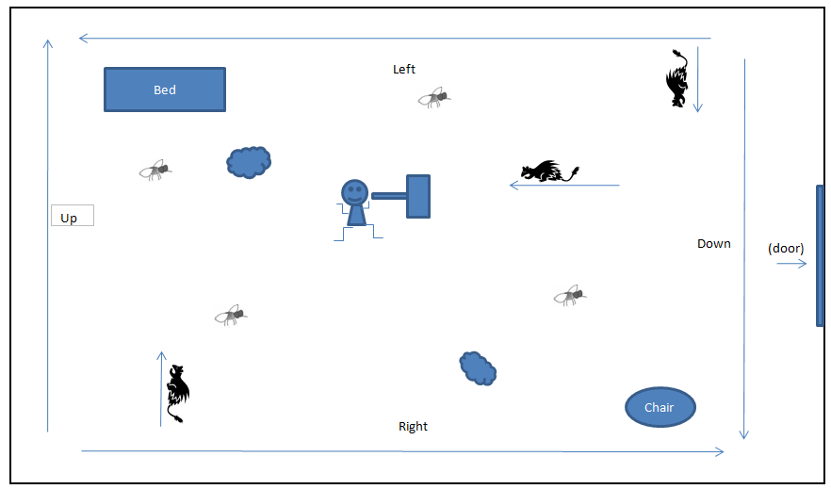

The rats move in one direction only. Bugs change direction at random time intervals.

Audio:
The playing experience will be enhanced by the following audio components.
Background:
- After the introduction sound, background music will play.
- Little Tommy will randomly say things like:
  - “Gotta Move or RATS will EAT me!”
  - “I’m goin’ BUG HUNTIN’”
  - “I want my MOMMY!”

Actions:
- Whacking a bug will be accompanied by a “SQUISH” or “SPLAT” sound.
- Being bitten by a rat will cause Little Tommy to cry out in pain. (“OUCH!”)
- Eating will produce YUMMY sound (“Ummmmm” or “Yummmmm” in a little boy’s voice)
- Swinging the hammer will produce a “BAMM!” sound.
- Death of Little Tommy will produce a specific sound (yet to be determined)

Levels:
- Each level will have an introduction sound.
- At the completion of each level a sound will play.

Player Roles and Actions
Game Interface:
The player assumes the role of “Little Tommy,” the Player Character. The player my use the following keys to move the Player Character and to interact with the game world.
Key Stroke | Action
Left Arrow Key | Move Little Tommy Left
Right Arrow Key | Move Little Tommy Right
Up Arrow Key | Move Little Tommy Up
Down Arrow Key | Move Little Tommy Down
‘W’ Key or Space Bar | Whack (A Bug)
‘E’ Key | Eat (Bug Guts)
‘S’ Key | Boost Speed
‘T’ Key | Thunder Hammer
‘B’ Key | Bomb

Player Character Direction and Movement:
Little Tommy faces either up, down, left, or right. Pressing an arrow key that corresponds to the direction that Little Tommy is facing will cause him to move in that direction. If he’s facing a different direction, the first key press will cause him to change the direction that he’s facing (Left, Right, Up, Down).
Whacking Bugs:
Pressing the ‘W’ key will cause Little Tommy to swing his hammer in the direction that he’s facing. If a bug is in proximity to Little Tommy, it will be smashed. When the bug is killed, Little Tommy takes the remains. He stores the remains in Jars, which are shown in the PD. Killing a bug will add some guts a jar. Little Tommy only has six jars.

Eating Bug Remains:
Pressing the ‘E’ key will cause one jars of bug guts to be consumed for health. No points will be awarded for doing so.
Using Bug Remains for Other Purposes:
Pressing the ‘S’ key will cause two jars of bug guts to be consumed for a boost of speed. For story purposes, the guts will act as a lubricant to make the main character move faster for a limited time. Length is still under debate, which will be determined later to balance game mechanics. It will probably be around 10 seconds. This will not award points, but rather a 2x multiplier for any points accumulated during the speed effect.
Pressing the ‘T’ key will cause three jars of bug guts to be consumed for extra strength to kill rats. For the story, the extra protein will give the main character enough extra strength to kill rats with the weapon. This will also be another timed effect that we will determine length later as well. Once again, it will probably be around 10 seconds long. This will give a decent amount of points just for consuming three jars, along with the points for killing rats. Rats will also be worth a significant amount of points themselves. Another added bonus is that the extra strength allows the main character to squash out more of the bugs guts, meaning 2x as many guts per bug, while the effect remains active.
Pressing the ‘B’ key will cause four jars of bug guts to be consumed and kill every bug in a radius around the player. Each bug killed this way give 5x the normal points, however awards no bug guts.

Scoring:
The player may score points for the following actions:
- Whacking a Bug
- Completing a Level (Bonus!)
- Using Bug Remains (Bonus!)
  - For speed
  - For strength
  - For a bug bomb
This would require having him walk in two dimensions though a room killing bugs (Arrow keys for movement) then the 'W' key (for WHACK) to swing the hammer. The player may also use the Space Bar to swing the hammer. He swings in the direction he's facing. Then, the 'E" key (for EAT) to eat a jar for health. Rats could move randomly or from one side to the other (left to right, top to bottom, right to left, bottom to top) and he has to avoid them - they bite. They move fast. He can't whack a rat. The ‘S’ key is to use two jars of guts for “Super Speed.” Super Speed make’s Little Tommy move really fast! The ‘T’ key is for ”Thunder Hammer.” The Thunder Hammer can kill rats. Eating three jars of guts the Thunder Hammer. . The ‘B’ key is to use a “Bug Bomb.” The Bug Bomb will kill everything within a few steps of Little Tommy. Bug Bombs costs four jars of guts.
- a rat bite costs life
- whacking a bug gets points
- eating bug guts gives back life
- each room is a level (Bedroom, Basement, Living room, Dining room) in some predetermined order
- he can't leave a room until all of the bugs are gone (he can eat the remains or not... but the door won't open until the bugs are dead)
- if he gets out of the house, he finds his mom and the game is over...

Strategies and Motivation
Main motivation is completing the game by getting through each level successfully. This will mean the player needs to avoid losing all his/her health, mainly by avoiding rats. Also, health will automatically be lost after each level, from hunger, if no bug guts are consumed in that level. This gives the player a reason to kill bugs if they do not care about points, as it will be critical for completing the game. Also killing a certain amount of bugs will be required to make a safe path out of the house, or to win the game.
Secondary motivation is getting as many points as possible. The player must outweigh the benefits and consequences of choosing the different uses of the bug guts to maximize their point accumulation.

Level Summary / Story Progression
Each level will take place in a different room of the house. After completing one level, the player will move to the next room in the house until all the rooms are clear. Each area will have its own difficulty, which will be based on bug/rat speed/quantity. Levels will be simple places with open environment, no real obstacles other than bugs and rats.
The story will begin with an intro stating player predicament, i.e. being stuck in a house trapped with bugs and rats. This will be text based, so player will have to read the story and when finished it will take the player into the world.
The game will open to a tutorial, or if we feel the mechanics are easy enough to figure out with no tutorial, we might elect to explain the game mechanics in text. This will be determined towards the end of production, however if we do include a tutorial, it will be rather simple. Once the tutorial level appears, it will be empty at first until a bug appears. Once the bug appears some text will explain that the main player needs to find a way to kill these bugs which will include a bat or hammer being in a corner of the room. After player picks up the weapon by simply running over it, the player will be instructed to kill the one bug in the room. The player will get points and bug guts for doing so which will also be explained to the player at this point. After all this is explained, a rat will appear. The mechanics of the rat will also be explained to the player so the player knows that they need to avoid the rats. Enough bugs will appear in this level to fill one jar with bug guts. This will then lead to the next level.
The transition screen will explain how the player can use the bug guts for different things such as health, speed or strength. This will then open up to the next level with many bugs, and rats will appear throughout. This will leave the player in a bug killing frenzy until the player kills all the bugs to progress to the next level. Between some if not all of the levels a little transition will occur explaining the player needs to move to the next room to kill more bugs.
This will pretty much repeat till the end of the game which will be followed by a story sequence explaining everything and congratulating the player.
Or
Death will occur if the player loses all of their lives. A little animation will be played along with a sound to signal a player’s death. The player will also see a little text explanation of what happened and encourage them to play again. This will then take them back to the main menu.

Hardware and Software Requirements
Intel based PC, with a sound card.
A single core P4 or better CPU.
Windows XP or greater
Direct X 9.0 or greater

Other hardware requirements are yet to be discovered.

Algorithm
The game will include two main loops, one for the menu awaiting player input, and the other for the game play itself. These two loops will be where our game handles the majority of its processing time. The main menu is pretty self explanatory, allowing the player to choose different options. The game loop is where we will be drawing and moving the player, level backgrounds, and NPCs. We will create a class for the player and a class for the bugs/rats. This will allow us to create instances of these and store some common variables for different game uses such as power ups. We will detect when the player is giving input and handle it accordingly by checking for events (player interaction) within each iteration of the loop. We will also have collision detection for detecting if the player hits a bug/rat when they swing the hammer. Bug bombs will be handled by a semi-transparent image of a cloud, and we will run a collision detection algorithm on the cloud and bugs. Conditions for level completion and death will also be monitored and handled accordingly.

