Game Design Document

Hunter Spectre

John Gaffrey
Peter Kinnunen

CIS 487
Fall 2006
Prof. Bruce Maxim

1.0 Executive Summary

1.1 Abstract of game story

The game is visually similar to a game such as Diablo, with an overhead view while adventuring through environments filled with a number of diverse enemies. However, the game is based on shooting using the mouse cursor as a targeting reticule. The overall levels or mazes will be implemented using individual tiles and with the levels walls running in the x and y directions as opposed to running diagonally.

The player will control a masked bounty hunter, a sort of an anti-hero type. Because of the ease of targeting with the mouse, there will be a large number of enemies, each with their own unique abilities mixed together. So the game will take on a more fast-paced arcade feel. The game will be set in a sort of futuristic space Sci-fi setting in a metallic robotic like background, basically a big metallic maze. The player will face enemies ranging from varied monsters, aliens and robots.

1.2 Game play and appearance

This will be single player adventure game. A sort of adventure shooter game like Diablo or in other words a classic Isometric Game. But because of the ease of controls and simple shooting and targeting mechanic, it is also similar to the classic arcade shooters such as the game “Contra”. There will be an emphasis and presenting a number of unique enemies each with strengths and weaknesses attacking the player in swarms or mixed within groups. Strategy may have to come into play for the player when choosing which enemies to destroy first and to conserve ammo.

1.3 Development specification

The game will be developed for Microsoft windows using DirectX. The game will be implements using Microsoft Visual Studio 6.0 and using the programming language C++. The game will use extensively the game engine code included with Andre Lamothe’s book “Tricks of the Windows Game Programming Gurus”. The game will also use some of the bitmaps and sound provided with Andre Lamothe’s book. Some artwork, sounds or tile bitmaps may be collected from the Internet. Taking real-life pictures of certain action figures may also be used to create many enemy frames.

2.0 Product Specification

2.1 Production team description

The team will consist of two. John Gaffrey will do most of the game programming and game features, while Peter Kinnunen work on most of the story, character bios, music selection.

2.2 Target audience

The game is primarily targets towards people who grew up with the classic consoles and who enjoyed games like Diablo, but also classic and easy action shooters like the Contra games. Because of the natural violence associated with this type of genre, there will be the option to remove blood to perhaps increase some appeal to other casual gamers. Overall though the game is designed to be easy to get into and play and easy to learn with simple controls.

2.3 Game play

Because the game will have a more arcade feel, starting the game will simply throw the player immediately into the game after a brief story introduction that may be skipped by pressing enter.

The player will need to traverse a series of maze-like levels connected together in order to reach the exits or passages to the next level. Certain items will also be needed and found along the way, and the player will also have to face an enemy boss at the end. The challenge to the player will come from facing swarms of never ending enemies, each with their own unique abilities that may cause the player to become off balance when trying to destroy them all. Death to the player simply restarts the game since there will only be a few moderately sized levels designed for this game.

The keyboard controls consist of the keys:

‘a’ moves the player to the left
‘s’ moves the player down
‘d’ moves the player to the right
‘w’ moves the player up
‘enter’ pauses the game

The mouse cursor will be a targeting reticule; the player when pressing the primary mouse button will cause the player avatar to shoot at that spot. The player’s avatar also pivots around to face whatever direction the mouse cursor is at.

The player’s weapons will consist of a machine gun, laser gun, and melee saber if there is time. The laser rifle ammo must be found, but shoots slower but more powerful blasts. There will also be extra items that can be found to restore the players HP and ammo.

The player will need to search the maze-like level to find exits to the next level, as well as being able to traverse backwards if the need arises.

There will be music that is to be determined, as well as appropriate sounds for weapons and enemies. The environments will be implemented by using tiles, and there will be some interactivity between the player and enemies and with the environments such as some destructible walls.

The player when traversing the levels will also face about five unique enemies that will also have consequences based on how they are defeated, as well as how they can be defeated with the right weapons.

The user will also be presented in the bottom of the screen a current health percent and ammo total for the current weapon selected. The current selected weapon will also be displayed, and the user will be able to switch using the number keys above the movement keys a,s,d,w.

Upon reaching the end of the game, the player will receive the stories conclusion.

2.4 Production tools

- Microsoft Visual Studio 6

- Microsoft DirectX 8 SDK

- Andre LaMothe’s Game Engine (functions)

- Certain bitmap tiles and sounds/music provided with Andre LaMothe’s book

- Jasc Paint Shop Pro 7

- A digital camera to take pictures of older actions figures which will represent various enemies

3.0 Game Specification

3.1 What is it like to play the game?

This game will be almost the equivalent to playing games like Contra or Diablo. You will control a sprite and move him around in an environment with the keyboard while in turn shooting wherever the mouse is being pointed. In addition it will contain puzzle like elements, having to track down three keys to reach the final boss and also navigating a series of levels designed fairly mazelike.

3.2 Interface mockup
enemy
enemy
enemy
enemy
Health 97%
Ammo 354
Target reticule
enemy
user
enemy
Faces target
Machine Gun
1
Laser
Gun
2
Flame Thrower
3
Energy Sword
4

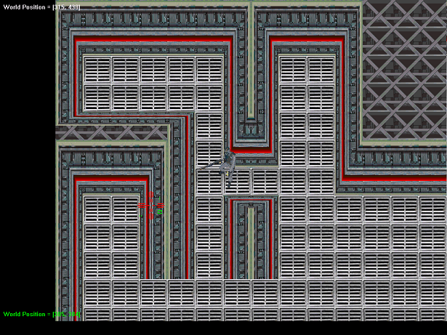
Screen shot of demo, with main character facing current location of cursor/target

Using modified tiles from Andre Lamothe’s book cd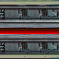

3.3 Summary of story line

The game places you in the role of Hunter Specter, an intergalactic bounty hunter. You have recently landed on planet Zeist, attempting to track down a time space distorter stolen by from a galactic research facility. Armed with your trusty arsenal of weaponry you must fight your way though several levels and defeat the villain, Dazenth.

3.4 Storyboards
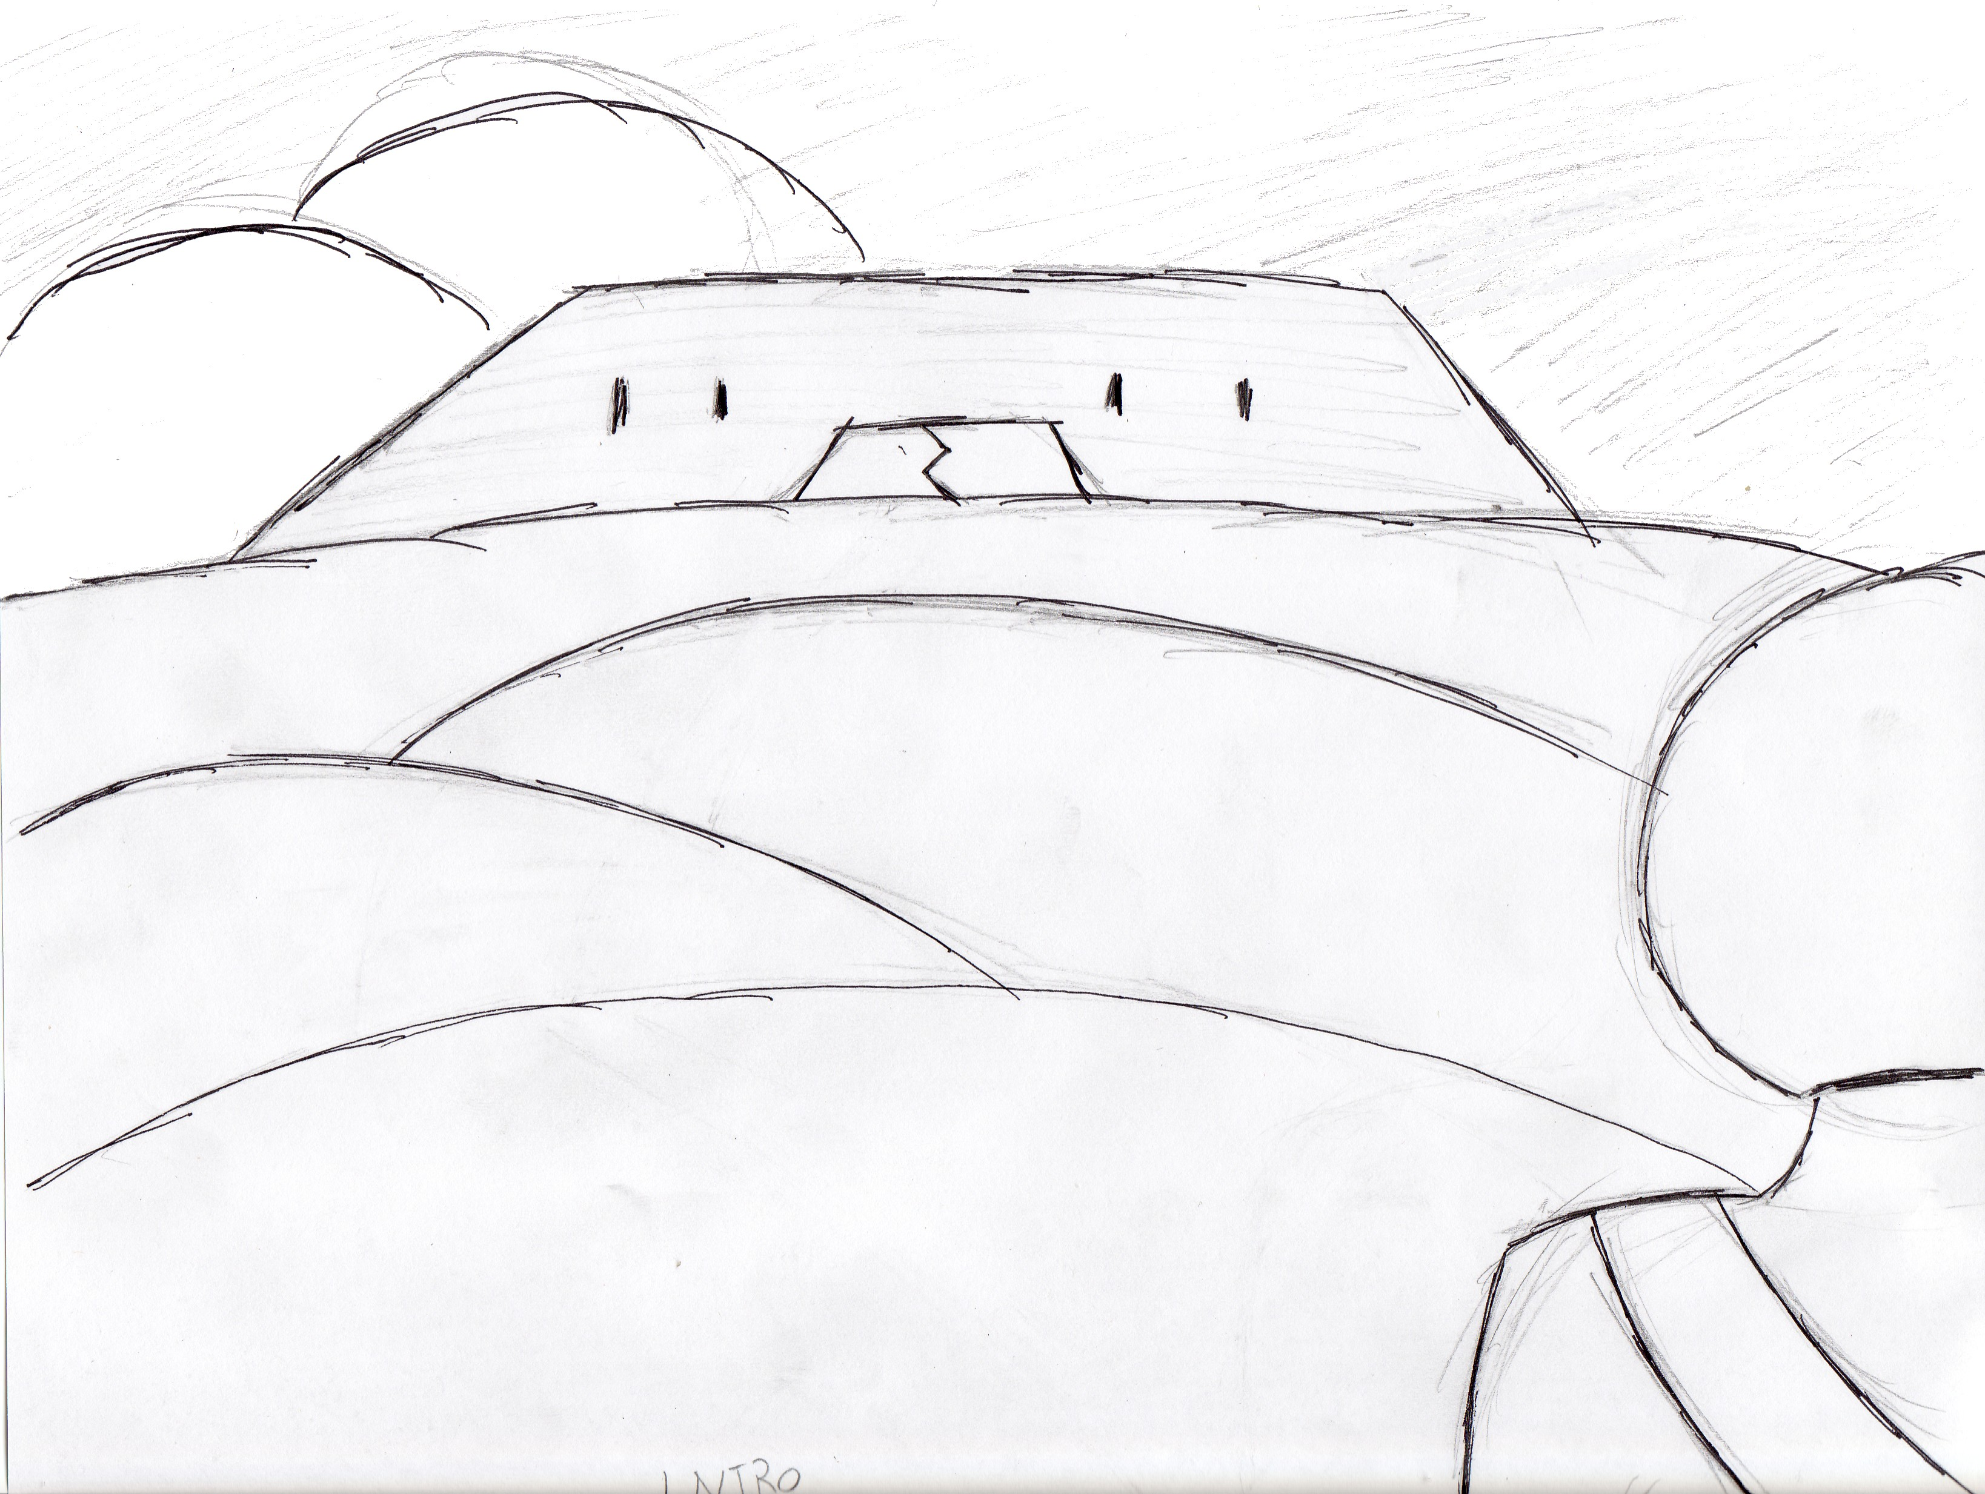
This is the intro scene, where Hunter Specter is viewing the lair of Dazenth
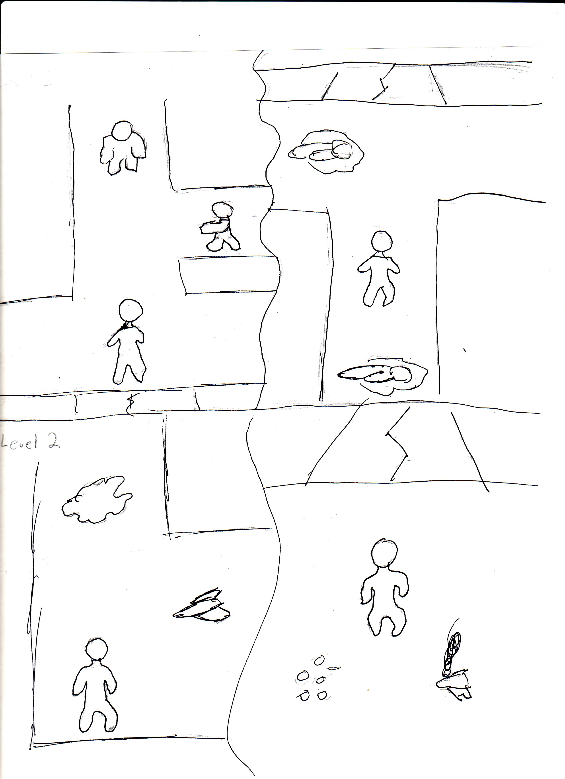
Top: Shows entering Level 1 and encountering the first enemy, the zombies. The following image shows Hunter Specter reaching the second level
Bottom: Show Hunter Specter encountering the defense drone and biomechanical slime and following shows him overcoming them and reaching the third level.

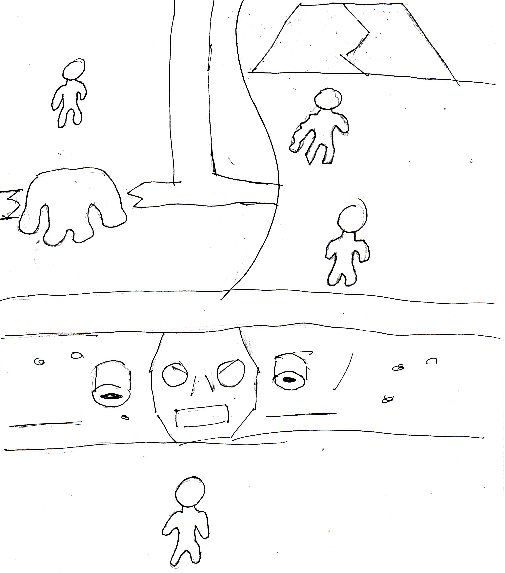
Top: The behemoth is chasing Hunter Specter through a wall in the third level. To reach the Dazenth Hunter Specter must defeat his former partner, the mutated Zed.
Bottom: Hunter Specter is face to face with the machine that houses Dazenth.
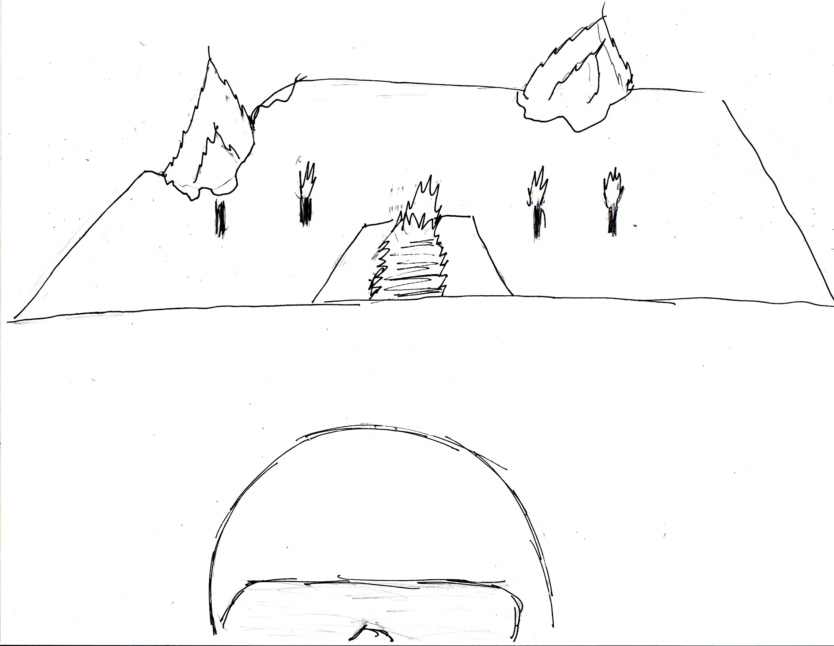
Hunter Specter walks away from the ruins of Dazenth’s lair, his vengeance complete.

3.5 Character bibles

Hunter Specter – This is the main character within the game. Very little knowledge about Hunter Specter is given during the prologue and during the game. He is a typical loner type and relies on no-one other then himself. There is a history with the main character and the main villain Dazenth. Dazenth killed Hunter Specter’s only partner, Zed. Since then he has hunted Dazenth to settle the score.
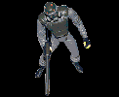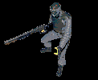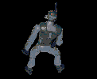hunter spectre

Dazenth– Dazenth is the main villain in this game. He is just a shadow shown at the intro, leaving the player just an idea of who they are chasing. Dazenth is a criminal mastermind and an accomplished scientist. He has managed to create several unique creatures and machines to guard his base and kill all those who trespass. In addition, he himself is no longer human but an amalgamation of machine and man. In addition he has stolen the space-time distorter so he can alter time to gain control of the universe. The only person with the capability to stop him is Hunter Specter.

Zed – Zed was the former partner of Hunter Specter, and was believed to be killed by Dazenth. The truth of the matter is that Dazenth took the body of Zed and managed to revive him. Since then he has been grossly mutated into something else and is set to stand in the way of Hunter Specter.

Zombie – The zombies are test subjects from Dazenth’s experiments. They are now mindless, the only use for them is to patrol Dazenth’s lair and attack any intruders.
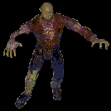zombie

Biomech Slime – These creations are wandering around the Robotic and Bio labs within Dazenth’s stronghold. They are programmed to replicate themselves and absorb physical objects to increase its size.
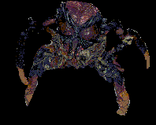slime
Defense Drone – These drones are used to patrol the more sensitive areas of Dazenth’s lair. They are fairly mobile, but they can not take much of a punishment.

Behemoths – These abominations have been unleashed from Dazenth’s biolab upon hearing his sanctum is in danger of being breached. Dazenth’s selective mutations to these monstrosities allow them to take a large amount of punishment and can even force their way though barriers to reach any intruder.
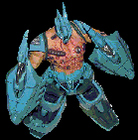behemoth

3.6 Flowcharting
Main Screen
Short Introduction Image and Text giving the game story.
Level 1
Facility Entrance
Lower level enemies
Level 2
Robotics Lab
Enemies become slightly harder
Level 3
Bio-Lab
Enemies are at their hardest
Fight mutant Zed
Final Level
Dazenth Lair
Only one enemy, Dazenth
The boss will take up most of the screen and remain stationary.
Death
Start Game
Ending Cut scene and prologue
Victory
Exit

3.7 Level or scene outlines

Level 1: Facility Entrance
The basic design for this level will be fairly open with mazelike corridors. There will be nothing to noteworthy within the scenery, just the basic tiles for the design. The enemies will consist of only Zombies within this level and a fair amount of health and ammo pickups. To open the access way to the next level the player will have to destroy the command consol within this level.

Level 2: Robotics Lab
This level will become more confined than the previous level. There will be a few open areas but the mainstay of this level will be many corridors. In addition, two new enemies join the ranks of Zombies, the player must contend with Biomech Slime and Defense Drones as well. The health and ammo pickups will be placed more sparingly, but due to the new enemies there is an increased chance of finding pickups off of them. The scenery will also include a few tiles to give you the impression that this area is used for constructing machinery. As with the previous level, a command consol must be destroyed to access the subsequent level.

Level 3: Bio-Lab
This level will almost become claustrophobic, there will be very few open areas and they will not be very big. Instead the player will be forced to navigate a gauntlet of enemies from the previous levels. In addition, there will be several Behemoths that, should they catch wind of the player, they will begin chasing him thought the level and taking any walls out that are in the way. In addition to the broken out walls being added to the scenery, there will be tiles to invoke the idea of a scientific laboratory. To reach the final level the player must defeat the mini-boss, Zed. Zed will continue to hunt the player after being discovered, but upon defeat the doorway to Dazenth’s lair will be open.

Level 4: Dazenth’s Lair
This level will consist of a large boss machine piloted by Dazenth. This level will be very open, only having a few walls for cover that in turn can be destroyed in the battle. The main enemy is Dazenth, but there will be several other enemies entering the level to make it harder for the player. Dazenth’s machine will have a few key weak points that must be targeted to defeat him. Upon victory, the room will be filled with explosions, then the game will go to the ending screen with dialoge.

